**CHAPTER 1**

**INTRODUCTION**

**1.1 INTRODUCTION**

Laser as a communication medium can provide a good substitute for the present day communication systems as the problem of interference faced in case of electromagnetic waves is not there and high deal of secrecy is available. Use of laser in communication systems is the future because of the advantages of the full channel speeds, no communication licenses required at present, compatibility with copper or fiber interfaces and no bridge or router requirements. Besides this there are no recurring line costs, portability, transparency to networks or protocols, although range is limited to a few hundred meters. Also the laser transmission is very secure because it has a narrow beam (any potential eves dropping will result in an interruption which will alert the personnel. Also it cannot be detected with use of spectrum analyzers and RF meters and hence can be used for diverse applications including financial, medical and military. Lasers can also transmit through glass; however the physical properties of the glass have to be considered. Laser transmitter and receiver units ensure easy, straightforward systems alignment and long-term stable, servicefree operation, especially in inaccessible environments, optical wireless systems offer ideal, economical alternative to expensive leased lines for buildings. The laser can also be commissioned in satellites for communication, as laser radar requires small aperture as compared to microwave radar. Also there is high secrecy and no interference like in EM waves. Further, potential bandwidth of radar using lasers can translate to very precision range measurement. For these reasons, they can be used as an alternative to present modes of communication. Laser communication which is both wide-band and high speed [1].

**1.2 PROBLEM DEFINATION**

At a small scale the transmitter and the receiver cannot be place at a large distance. It must be kept at a small distance. The light of the intensity should vary, hence the light must be kept constant in order to the get the transmitted output sound signal at the receiver. Hence a constant light torch is used.

**CHAPTER 2**

**LITERATURE SURVEY**

**2.1 FIELD OF THE INVENTION**

The present invention relates generally to the remote monitoring of usage information and in particular to associated method for transmitting, receiving, storing, processing and digitally re-transmitting the information directly to a remote receiving device via various methods to include personal communications systems using Global Standards for Mobile Communications (GSM), Time Division Multiple Access (TDMA) Technology, Code Division Multiple Access (CDMA), Frequency Division Multiple Access (FDMA) [3].

**2.2BACKGROUND OF THE INVENTION**

Presently, many utility meters are monitored by having an employee visually inspect each meter, and record the usage data. Several methods and devices have been proposed to automatically collect the utility usage data thereby reducing the labor involved in collecting the utility usage data.

In U.S.Pat. No. 4,803,632, Frew, et al.. The device is independently powered and is capable of short range infrared transmission of the utility usage data. A wand is also provided that is capable of receiving the transmitted data. A meter-reading employee uses the wand by placing it close to the monitoring device to receive the data which is electronically stored in a transportable unit carried by the employee. The employee then brings the electronically stored data to the utility company where it is downloaded from the transportable unit and used to calculate the customer's utility usage bill.

U.S.Pat. Nos. 5,010,568 and 5,161,182, by Merrian, et al. disclose a utility usage monitor that connects to the customer's telephone line via a modem. The usage monitor calculates and stores the customer's utility usage data. The utility company periodically calls the monitoring unit, and when a modem connection between the utility company and the monitoring unit is established, the monitoring unit sends the usage data to the utility company and the data is used to calculate the customer's usage bill.

A need exists for a system that is capable of monitoring utility usage and other information on varying reading schedules and different levels of frequency of data interrogation (profiling), and is capable of wirelessly transmitting digital data to a desired remote device. Accordingly, it would be advantageous to provide a data collection device that receives information from utility meters and other devices.

It would further be advantageous to provide for digital transmission of the information to a remote receiving device, and in one embodiment the information should be capable of being transmitted via GSM, PACS, FDMA, CDMA or TDMA digital technology operating at any frequency[2].

It would also be advantageous for the data collection device to provide an interface with telecommunications wiring at a location so as to provide a connection to a cellular, personal communications system or equivalent wireless network.

It would be advantageous to provide a device that is capable of receiving requests for data and is capable of transmitting data using the short message service of the personal communications system protocol [3].

**CHAPTER 3**

**DESIGN DESCRIPTION**

**3.1 BLOCK DIAGRAM**

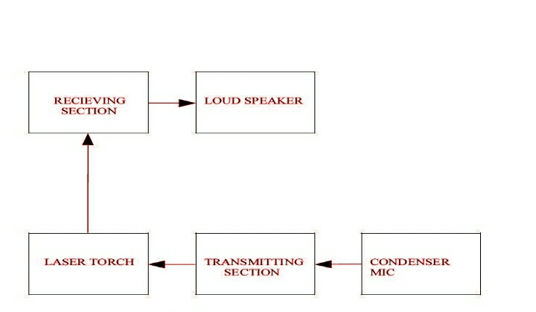

**Figure 3.1** block diagram voice transmission

1. **Condenser Microphones**

*Condenser* means *capacitor*, an electronic component which stores energy in the form of an electrostatic field. The term *condenser* is actually obsolete but has stuck as the name for this type of microphone, which uses a capacitor to convert acoustical energy into electrical energy.

Condenser microphones require power from a battery or external source. The resulting audio signal is stronger signal than that from a dynamic. Condensers also tend to be more sensitive and responsive than dynamics, making them well-suited to capturing subtle nuances in a sound. They are not ideal for high-volume work, as their sensitivity makes them prone to distort.

**How Condenser Microphones Work**

A capacitor has two plates with a voltage between them. In the condenser mice, one of these plates is made of very light material and acts as the diaphragm. The diaphragm vibrates when struck by sound waves, changing the distance between the two plates and therefore changing the capacitance. Specifically, when the plates are closer together, capacitance increases and a charge current occurs. When the plates are further apart, capacitance decreases and a discharge current occurs.

A voltage is required across the capacitor for this to work. This voltage is supplied either by a battery in the mice or by external [phantom power](../phantom-power/).

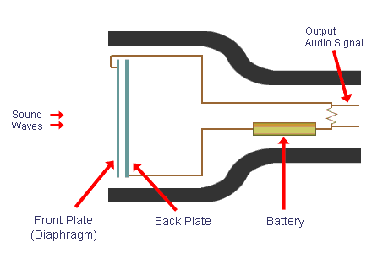

**Figure. 3.2** Internal structure of condenser microphone

1. **TRANSMITTING SECTION:**

When the light from the torch isis emitted on to the phototransistor directly, the sounf from the mic is transmitted with the intensity of the light from the torch.

1. **LASER**

From left to right: [gamma rays](http://en.wikipedia.org/wiki/Gamma_rays), [X-rays](http://en.wikipedia.org/wiki/X-rays), [ultraviolet](http://en.wikipedia.org/wiki/Ultraviolet) rays, [visible spectrum](http://en.wikipedia.org/wiki/Visible_spectrum), [infrared](http://en.wikipedia.org/wiki/Infrared), [microwaves](http://en.wikipedia.org/wiki/Microwaves), [radio waves](http://en.wikipedia.org/wiki/Radio_waves).The word **laser** originally was the upper-case **LASER**, the [acronym](http://en.wikipedia.org/wiki/Acronym) from Light Amplification by Stimulated Emission of Radiation, wherein *light* broadly denotes [electromagnetic radiation](http://en.wikipedia.org/wiki/Electromagnetic_radiation) of any frequency, not only the [visible spectrum](http://en.wikipedia.org/wiki/Visible_spectrum); hence [infrared](http://en.wikipedia.org/wiki/Infrared) laser, [ultraviolet](http://en.wikipedia.org/wiki/Ultraviolet) laser, [X-ray](http://en.wikipedia.org/wiki/X-ray) laser, et cetera. Because the microwave predecessor of the laser, the [**maser**](http://en.wikipedia.org/wiki/Maser), was developed first, devices that emit [microwave](http://en.wikipedia.org/wiki/Microwave) and [radio](http://en.wikipedia.org/wiki/Radio_frequency) frequencies are denoted “masers”. In the early technical literature, especially in that of the [Bell Telephone Laboratories](http://en.wikipedia.org/wiki/Bell_Telephone_Laboratories) researchers, the laser was also called **optical maser**, a currently uncommon term; moreover, since 1998, Bell Laboratories adopted the *laser* usage. Linguistically, the [back-formation](http://en.wikipedia.org/wiki/Back-formation) verb *to* lase means “to produce laser light” and “to apply laser light to”. The word *laser* sometimes is used in an extended sense to describe a non-laser-light technology, e.g. a coherent-state atom source is an [atom laser](http://en.wikipedia.org/wiki/Atom_laser).

1. **RECEIVING SECTION**

Here at the receiver when the light emitted from the torch false on the phototransistor. The sound emitted on the mic will be heard on speaker.

1. **Speakers**

These convert electrical signals toacousticvibrations. It comprises a permanent magnet and a moving coil (through which electrical signal is passed). This moving coil is fixed to the diaphragm which vibrates to produce sound.

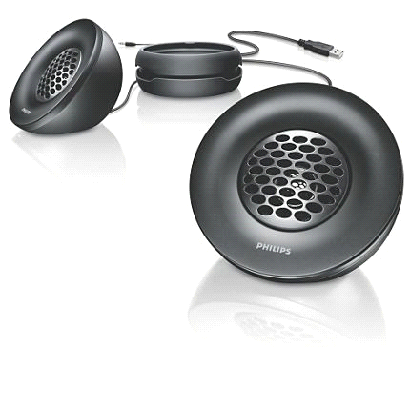

**Figure. 3.3** Speakers

**3.2 SOFTWARE TOOL**

**PCB wizard**

PCB Wizard is a package for designing single-sided and double-sided printed circuit boards.(PCBs).

It provides a comprehensive range of tools covering all the traditional steps in PCB production, including schematic drawing, schematic capture, component placement, automatic rotating, bill of materials reporting and file generation for manufacturing. In addition, PCB wizard offers a wealth of clever new features that do away with the steep learning curve normally associated with PCB packages.

**3.3 HARDWARE TOOL**

**Transmitter**

1. IC 741

2. BC 548

3. BD 139

4. 3 Volts Laser Torch

5.Condenser Mice

6.Resistors- 8.2k,1.8m,15k,1m ,82 Ω,10k

7. Capacitors-1 μF/16v,0.1 μF,470 μF/16v,1000 μF/16v

8. 9v Battery

9.PCB

**Receiver**

1.IC741

2.IC 386

3.2n5777 Photo Transistor

4. 0.5w/8ohm Speaker

5.Resistors-100K,1M,10K

6. Capacitors-0.1 μF (2),100μF

**COMPONENT DESCRIPTION**

1. **IC741**

An **operational amplifier**, which is often called an **op-amp**, is a [DC](http://en.wikipedia.org/wiki/Direct_current)-[coupled](http://en.wikipedia.org/wiki/Direct_coupling) high-[gain](http://en.wikipedia.org/wiki/Gain) electronic voltage [amplifier](http://en.wikipedia.org/wiki/Electronic_amplifier) with a differential input and, usually, a single-ended output. An op-amp produces an output voltage that is typically millions of times larger than the voltage difference between its input terminals.

Typically the op-amp's very large gain is controlled by [negative feedback](http://en.wikipedia.org/wiki/Negative_feedback), which largely determines the magnitude of its output ("closed-loop") voltage gain in amplifier applications, or the [transfer function](http://en.wikipedia.org/wiki/Transfer_function) required (in [analog computers](http://en.wikipedia.org/wiki/Analog_computers)). Without negative feedback, and perhaps with [positive feedback](http://en.wikipedia.org/wiki/Positive_feedback) for [regeneration](http://en.wikipedia.org/wiki/Regenerative_circuit), an op-amp essentially acts as a [comparator](http://en.wikipedia.org/wiki/Comparator). High input [impedance](http://en.wikipedia.org/wiki/Electrical_impedance) at the input terminals (ideally infinite) and low output impedance at the output terminal(s) (ideally zero) are important typical characteristics.

Op-amps are among the most widely used electronic devices today, being used in a vast array of consumer, industrial, and scientific devices. Many standard IC op-amps cost only a few cents in moderate production volume; however some integrated or hybrid operational amplifiers with special performance specifications may cost over $100 US in small quantities. Op-amps sometimes come in the form of macroscopic components, (see photo) or as [integrated circuit](http://en.wikipedia.org/wiki/Integrated_circuit)[cells](http://en.wikipedia.org/wiki/Cell_(EDA)); patterns that can be reprinted several times on one chip as part of a more complex device.

The op-amp is one type of [differential amplifier](http://en.wikipedia.org/wiki/Differential_amplifier). Other types of differential amplifier include the [fully differential amplifier](http://en.wikipedia.org/wiki/Fully_differential_amplifier) (similar to the op-amp, but with two outputs), the [instrumentation amplifier](http://en.wikipedia.org/wiki/Instrumentation_amplifier) (usually built from three op-amps), the [isolation amplifier](http://en.wikipedia.org/wiki/Isolation_amplifier) (similar to the instrumentation amplifier, but with tolerance to common-mode voltages that would destroy an ordinary op-amp), and [negative feedback amplifier](http://en.wikipedia.org/wiki/Negative_feedback_amplifier) (usually built from one or more op-amps and a resistive feedback network).

|  |
| --- |
|  |

[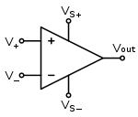](http://en.wikipedia.org/wiki/File:Op-amp_symbol.svg)

**Figure 3.4** Circuit diagram symbol for an op-amp

The circuit symbol for an op-amp is shown to the right, where:

* V_{\!+}: non-inverting input
* V_{\!-}: inverting input
* V_{\!\text{out}}: output
* V_{\text{S}\!+}: positive power supply
* V_{\text{S}\!-}: negative power supply

The power supply pins (V_{\text{S}\!+}and V_{\text{S}\!-}) can be labeled in different ways (*See* [*IC power supply pins*](http://en.wikipedia.org/wiki/IC_power_supply_pins)). Despite different labeling, the function remains the same — to provide additional power for amplification of the signal. Often these pins are left out of the diagram for clarity, and the power configuration is described or assumed from the circuit.

1. **LM386**

**Low Voltage Audio Power Amplifier**

The LM386 is a power amplifier designed for use in low voltage consumer applications. The gain is internally set to 20 to keep external part count low, but the addition of an external resistor and capacitor between pins 1 and 8 will increase the gain to any value up to 200. The inputs are ground referenced while the output is automatically biased to one half the supply voltage. The quiescent power drain is only 24 milliwatts when operating from a 6 volt supply, making the LM386 ideal for battery operation.

1. **Resistors**

A **resistor** is a two-[terminal](http://en.wikipedia.org/wiki/Terminal_(electronics))[electronic component](http://en.wikipedia.org/wiki/Electronic_component) that produces a [voltage](http://en.wikipedia.org/wiki/Voltage) across its terminals that is [proportional](http://en.wikipedia.org/wiki/Proportionality_(mathematics)#Direct_proportion) to the [electric current](http://en.wikipedia.org/wiki/Electric_current) passing through it in accordance with [Ohm's law](http://en.wikipedia.org/wiki/Ohm%27s_law):

V = IR

Resistors are elements of [electrical networks](http://en.wikipedia.org/wiki/Electrical_networks) and electronic circuits and are ubiquitous in most electronic equipment. Practical resistors can be made of various compounds and films, as well as [resistance wire](http://en.wikipedia.org/wiki/Resistance_wire) (wire made of a high-resistivity alloy, such as nickel/chrome).

The primary characteristics of a resistor are the [resistance](http://en.wikipedia.org/wiki/Electrical_resistance), the [tolerance](http://en.wikipedia.org/wiki/Engineering_tolerance#Electrical_component_tolerance), maximum working voltage and the [power](http://en.wikipedia.org/wiki/Power_(physics)) rating. Other characteristics include [temperature coefficient](http://en.wikipedia.org/wiki/Temperature_coefficient), [noise](http://en.wikipedia.org/wiki/Electrical_noise), and [inductance](http://en.wikipedia.org/wiki/Inductance). Less well-known is [critical resistance](http://en.wikipedia.org/w/index.php?title=Critical_resistance&action=edit&redlink=1), the value below which power dissipation limits the maximum permitted current flow, and above which the limit is applied voltage. Critical resistance is determined by the design, materials and dimensions of the resistor.

Resistors can be integrated into [hybrid](http://en.wikipedia.org/wiki/Hybrid_circuit) and [printed circuits](http://en.wikipedia.org/wiki/Printed_circuit_board), as well as [integrated circuits](http://en.wikipedia.org/wiki/Integrated_circuits). Size, and position of leads (or terminals) are relevant to equipment designers; resistors must be physically large enough not to overheat when dissipating their power.

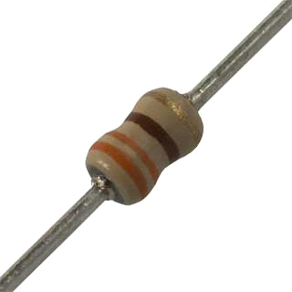

**Figure. 3.5** Resistor

1. **Capacitors**

A **capacitor** (formerly known as **condenser**) is a [passive](http://en.wikipedia.org/wiki/Passivity_(engineering))[electronic component](http://en.wikipedia.org/wiki/Electronic_component) consisting of a pair of [conductors](http://en.wikipedia.org/wiki/Electrical_conductor) separated by a [dielectric](http://en.wikipedia.org/wiki/Dielectric) (insulator). When there is a [potential difference](http://en.wikipedia.org/wiki/Potential_difference) (voltage) across the conductors a static [electric field](http://en.wikipedia.org/wiki/Electric_field) develops in the dielectric that stores [energy](http://en.wikipedia.org/wiki/Energy) and produces a mechanical force between the conductors. An ideal capacitor is characterized by a single constant value, [capacitance](http://en.wikipedia.org/wiki/Capacitance), measured in [farads](http://en.wikipedia.org/wiki/Farad). This is the ratio of the [electric charge](http://en.wikipedia.org/wiki/Electric_charge) on each conductor to the potential difference between them.

Capacitors are widely used in electronic circuits for blocking [direct current](http://en.wikipedia.org/wiki/Direct_current) while allowing [alternating current](http://en.wikipedia.org/wiki/Alternating_current) to pass, in filter networks, for smoothing the output of [power supplies](http://en.wikipedia.org/wiki/Power_supply), in the [resonant circuits](http://en.wikipedia.org/wiki/LC_circuit) that tune radios to particular [frequencies](http://en.wikipedia.org/wiki/Frequency) and for many other purposes.The effect is greatest when there is a narrow separation between large areas of conductor, hence capacitor conductors are often called "plates", referring to an early means of construction. In practice the dielectric between the plates passes a small amount of [leakage current](http://en.wikipedia.org/wiki/Leakage_(electronics)) and also has an electric field strength limit, resulting in a [breakdown voltage](http://en.wikipedia.org/wiki/Breakdown_voltage), while the conductors and [leads](http://en.wikipedia.org/wiki/Lead_(electronics)) introduce an [equivalent series resistance](http://en.wikipedia.org/wiki/Equivalent_series_resistance).

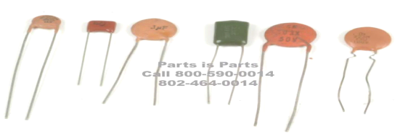

**Figure. 3.6** Different types of Capacitors

**CHAPTER 4**

**CIRCUIT DIAGRAM**

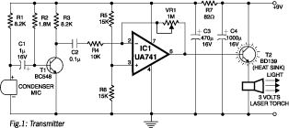

**Figure. 4.1** Transmitter

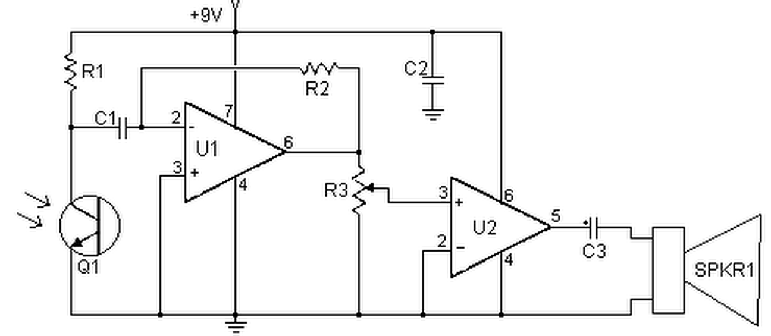

**Figure. 4.2** Receiver

**CHAPTER 5**

**WORKING**

**5.1 WORKING OF TRANSMITTER**

A laser diode needs a certain value of current, called the threshold current, before it emits laser light. A further increase in this current produces a greater light output. The relationship between output power and current in a laser diode is very linear, once the current is above the threshold, giving a low distortion when the beam is amplitude modulated. For example, the 65Onm 5mW laser diode used inthis project has a typical threshold current of 3OmA and produces its full outputwhen the current is raised by approximately 1OmA above the threshold to 4OmA.Further increasing the current will greatly reduce the life of the laser diode and exceeding the absolute maximum of 8OmA will destroy it instantly.In the transmitter circuit the laser diode is supplied via an adjustable constant-current source. Note that the metal housing for the laser diode and the lens also acts as a heat sink. The laser diode should not be powered without the metal housing in place. The increasing the voltage at VR1 reduces the laser current. The setting of VR1 determines the quiescent brightness of the laser beam, and therefore the overall sensitivity of the system. The electric microphone is powered through R1 and is coupled to the non inverting input of IC1 via capacitor. This input is held at a fixed DC voltage to give a DC output to bias.

**5.2 WORKING OF RECEIVER**

The transmitted signal is picked up by the photo detector diode in the receiver. The output voltage of this diode is amplified by the common emitter amplifier around T4. This amplifier has a gain of 20 or so, and connects via VR2 to IC2, an LM386 basic power amplifier IC with a gain internally set to20.This IC can drive a speaker with a resistance as low as four ohms, and 35OmW when the circuit is powered from a 9V supply. Increasing the supply voltage will increase the output power marginally.

**5.3 PROJECT METHODOLOGY**

**TESTING OF CIRCUIT ON BREADBOARD**

When we purchased the component, we found some new things in the market for better implementation of project. The electrician in shop gave us some of his experienced suggestions and those ideas helped us a lot. We mounted the circuits lot of time and then got the output and shown it to our advisor, and were very happy after getting the output.

**PCB DESIGN & LAYOUT:**

For designing the PCB we had various software available. But we decided to go with Express PCB. It did not have all the component outlines we needed, but we had much more flexibility in implementing tracks across the PCB. Also optimization had to be done manually so our skills & knowledge enhanced. But our design came out brilliant. Lastly we took a printout of the PCB on a sheet of glossy photo-paper.

**FABRICATION:**

Our college provided us with a single-sided copper PCB. We then cut the required portion of PCB from the larger part. Then we cleaned the copper surface to remove CuO (Copper Oxide) using a metal scrubber & cleaning liquid. After this we placed the printed PCB layout face-down onto the copper surface and traced the tracks onto the board using an iron. The ironing was done until the side of the paper facing us turned blackish. Now after ironing we immersed the PCB in tray filled with cold water to be able to remove the paper without damaging the tracks. After about 10 minutes we removed the paper gently and dried the top layer using a towel.

**ETCHING:**

Now we took another pot & added some water in it. Then we mixed FeCl3 power which is used for etching copper in the water & then immersed the PCB in it. After continuous stirring for about 7-8 minutes all the excess copper was etched away. We removed the PCB and cleaned it in water. Then we used a scrubber to remove the black traces and our PCB was ready.

**DRILLING & SOLDERING:**

After inspecting the PCB for any errors, we started to drill holes in the PCB for mounting components. One by one we finished all the drilling work. Some components required a larger hole so the drill bit was changed accordingly. Then we inspected all the holes & proceeded towards soldering. During soldering we started to solder all the small components in place first, by fixing them in place and then applying flux to prevent oxidation. We learned how to solder properly using minimum solder wire. Then we moved to the larger components. We also learned IC’s should never be soldered directly to the PCB, but always using a socket. We also cut off excess leads for neatness. Diameter of drilling should be 0.8mm. Alloys commonly used for electrical soldering are 60/40 Sn-Pb, which melts at 188 °C (370 °F), and 63/37 Sn-Pb used principally in electrical/electronic work.

**TESTING:**

Now came the time to see the results of our efforts in front our staff-in-charge, as we connected all inputs & outputs. Initially when we switched on the circuit, we observed only 50% of the output. But after careful examination we found one of our connections to be wrong. We immediately corrected the mistake & tested again. The project worked successfully and our staff-in-charge was very impressed.

**5.4LAYOUT**

**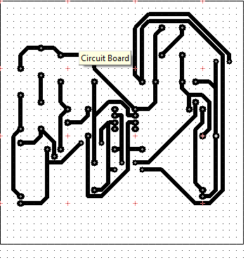**

**Figure 4.7** PCB layout of Transmitter

**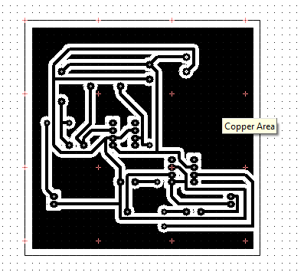**

**Figure 4.7** PCB layout of Receiver

**CHAPTER 6**

**APPLICATIONS**

* Using this circuit you can communicate with your neighbors wirelessly.
* Laser as a communication medium can provide a good substitute for the present day communication systems.
* Use of laser in communication systems is the future because of the advantages of the full channel speeds, no communication licenses required at present.

**ADVANTAGES**

* Using this circuit you can communicate with your neighbors wirelessly.
* Instead of RF signals, light from a laser torch is used as the carrier in the circuit. The laser
* The laser transmission is very secure because it has a narrow beam.

**CHAPTER 7**

**RESULT**

For the lifi system, when the light is emitted from the torch when it falls on the phototransistors, the sound from the mic at the transmitter transmits. The sound signal with the help of the light and output received at the receiver and it can be heard at the speaker the intensity of the sound as the output can vary with intensity of light.

**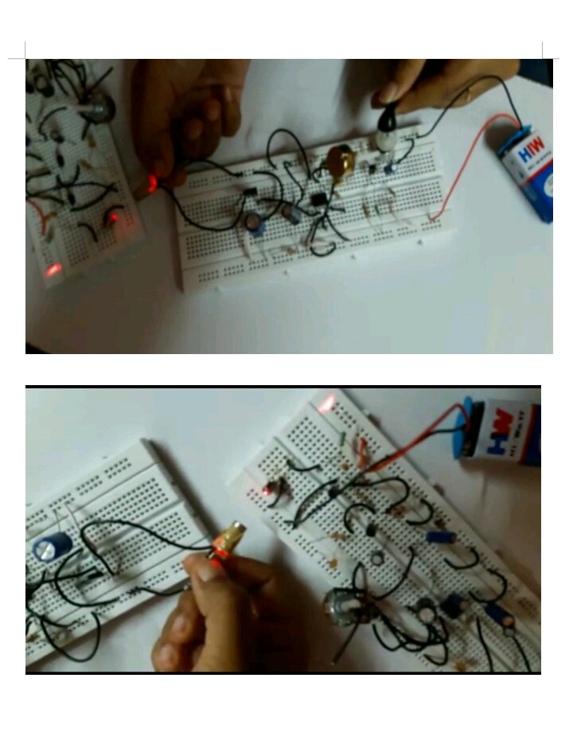**

**Figure 7.1** Output of voice transmission

**CHAPTER 8**

**CONCLUSION**

With the knowledge of new techniques in ‘Electronics’ we are able to make our life more comfortable. One such application of electronics is used in this circuit. “LASER BASED VOICE TRANSMITTER AND RECIVER” Using this circuit we can communicate our neighbors wirelessly. Light from a laser torch is used as the carrier in the circuit. It is a single way communication circuit.

**FUTURE SCOPE**

Using this circuit we can communicate with your neighbors wirelessly. Instead of RF signals, light from a laser torch is used as the carrier in the circuit. The laser torch can transmit light up to a distance of about 500 meters. The phototransistor of the receiver must be accurately oriented towards the laser beam from the torch. If there is any obstruction in the path of the laser beam, no sound will be heard from the receiver. Using this circuit we can communicate with our neighbors wirelessly. It can be used in inaccessible areas. In future it can be commissioned in satellites for communication. It can be used in conference halls.

**REFERENCE**

|  |  |
| --- | --- |
| [1] | National Instruments and the University of Edinburgh Collaborate on Massive MIMO Visible Light Communication Networks to Advance 5G ,  Cambridge Wireless, 20 November 2013. |
| [2] | Pal, G. K.; Pal, Pravati (2001). "chapter 52". *Textbook of Practical Physiology* (1st ed.). Chennai: Orient Blackswan. p. 387. ISBN 978-81-250-2021-9.  Retrieved 11 October 2013. |
| [3] | M.ThanigavelM .Tech CSE DEPT, GKCE, Sullerpet, AP, India-IJERTV21S10048 |
| [4] | [www.alldatasheet.com](http://www.alldatasheet.com) |

**APPENDIX**

**DATASHEET**

* CAPACITOR

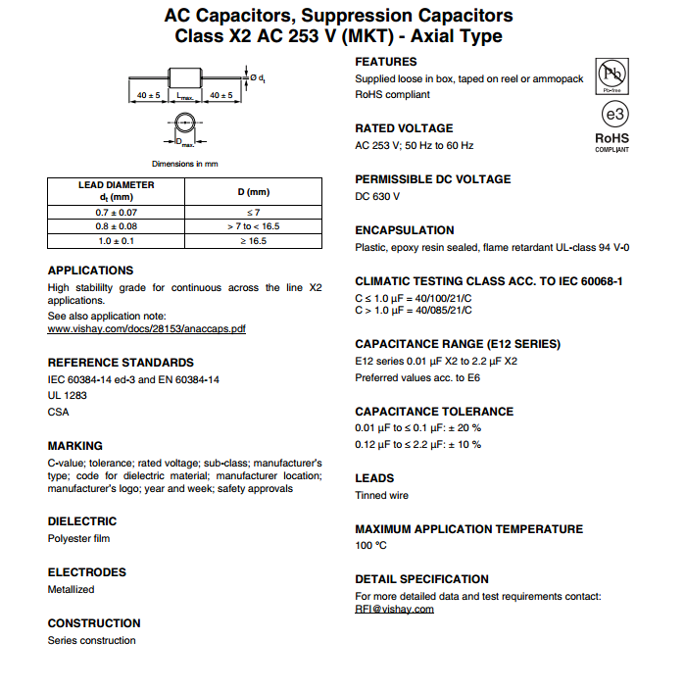

* RESISTOR