Lesson 11 Demo 03

Validating Variables and Securing Secrets in Terraform Code

Objective: To validate variables and secure sensitive data within the Terraform code for enhanced configuration security and reliability
Tools required: Terraform, AWS, and Visual Studio Code

Prerequisites: Refer to the Demo 01 of Lesson 11 for creating access and secret key

Steps to be followed:
- Set up and validate variables
- Secure and manage sensitive data
- Apply configuration and review outputs

Step 1: Set up and validate variables

- Open your Terraform configuration environment and create a file named variables.tf
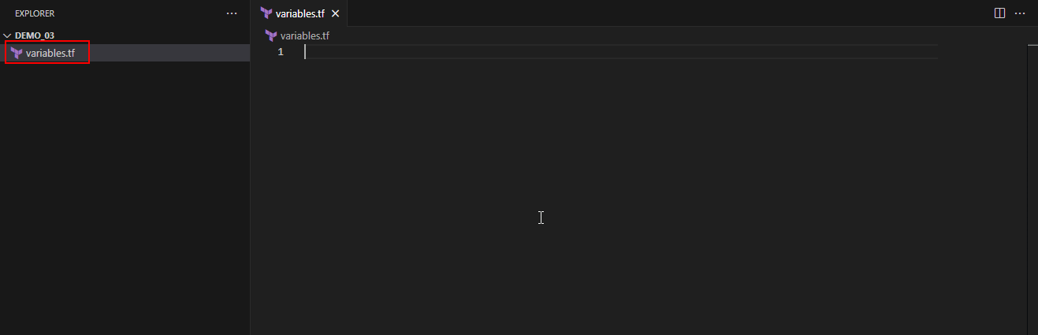
- Open your Terraform configuration environment, create a file named variables.tf, and add the variable for cloud provider choice as shown in the screenshot below:
# Validation for cloud provider choice
variable "cloud" {
type = string
description = "Enter the cloud provider name (aws, azure, gcp, vmware)"

validation {
condition = contains(["aws", "azure", "gcp", "vmware"], lower(var.cloud))
error_message = "Only aws, azure, gcp, and vmware are accepted as cloud providers."
}

validation {
condition = lower(var.cloud) == var.cloud
error_message = "The cloud provider name must be in lowercase."
}
}
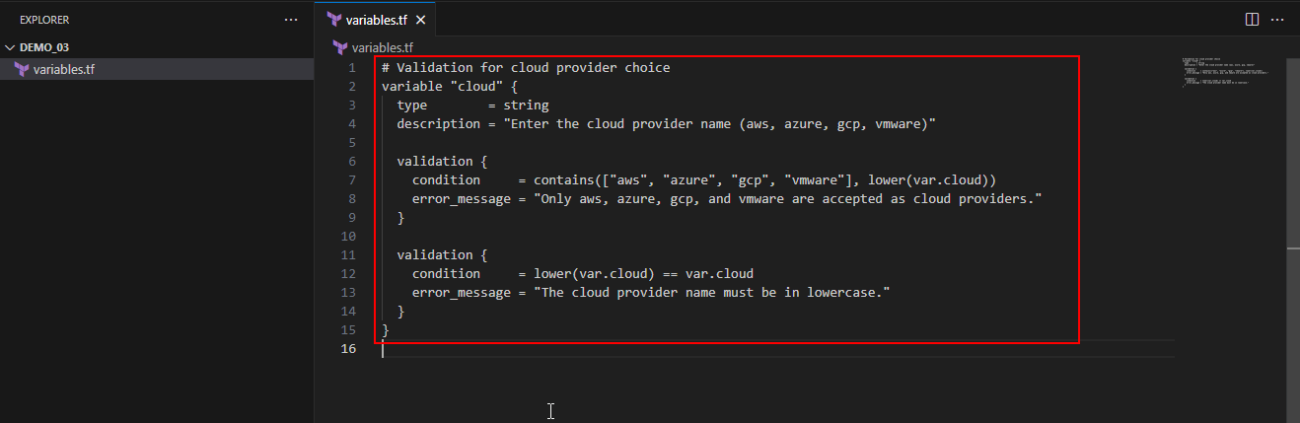

- Add the variable to enforce no capital letters
# Variable for no capital letters
variable "no_caps" {
type = string
description = "Enter a lowercase string."

validation {
condition = lower(var.no_caps) == var.no_caps
error_message = "The string must be in lowercase."
}
}
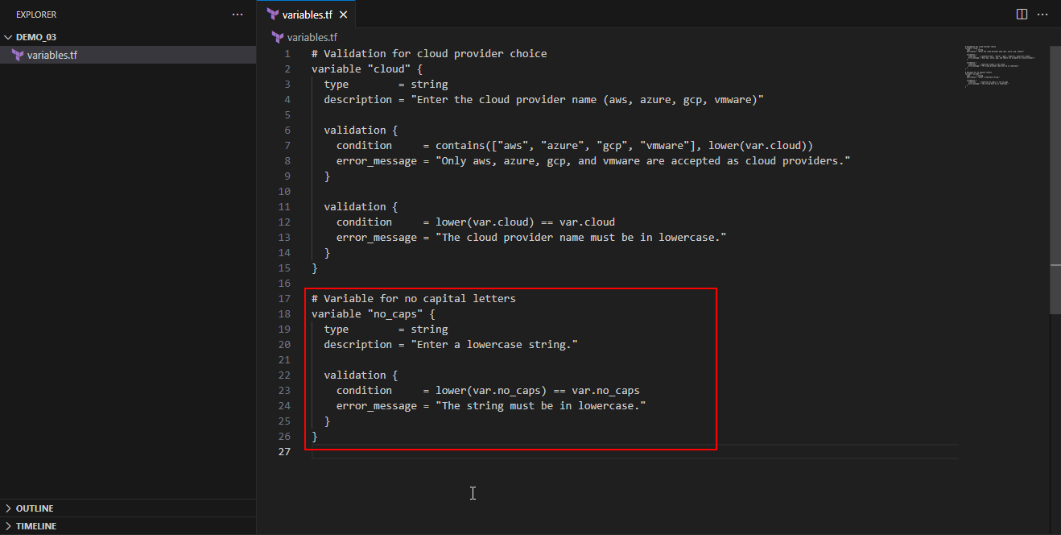
- Add the variable with a character limit as shown in the screenshot below:
# Variable with character limit
variable "character_limit" {
type = string
description = "Enter a string of exactly 3 characters."

validation {
condition = length(var.character_limit) == 3
error_message = "This variable must contain exactly 3 characters."
}
}
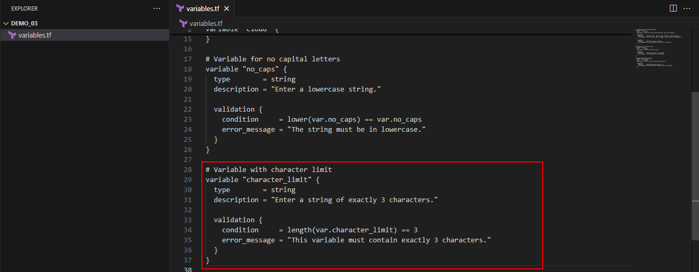
- Add the IP address validation variable as shown in the screenshot below:
# IP address validation
variable "ip_address" {
type = string
description = "Enter a valid IP address."

validation {
condition = can(regex("^(?:[0-9]{1,3}\\.){3}[0-9]{1,3}$", var.ip_address))
error_message = "The input must be a valid IP address in the form X.X.X.X."
}
}
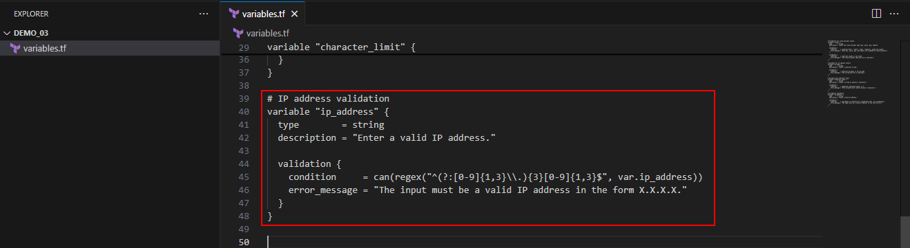
- Add the variable for sensitive data (phone number) as shown in the screenshot below:
# Sensitive data variable
variable "phone_number" {
type = string
description = "Enter a sensitive phone number."
sensitive = true
}
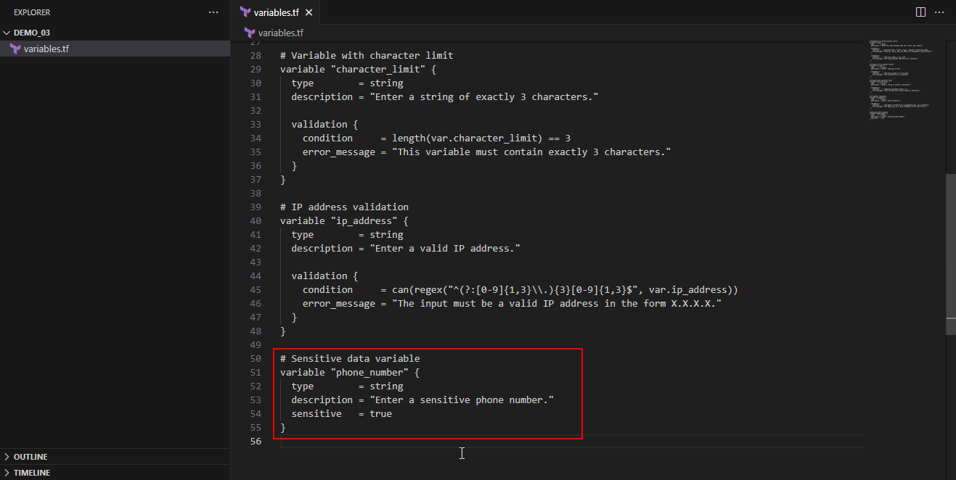

Step 2: Secure and manage sensitive data

- Create a file named main.tf, and add the following block to define local variable for managing sensitive information as shown in the screenshot below:
# Managing sensitive information with locals
locals {
contact_info = {
cloud = var.cloud
department = var.no_caps
cost_code = var.character_limit
phone_number = var.phone_number
}
}
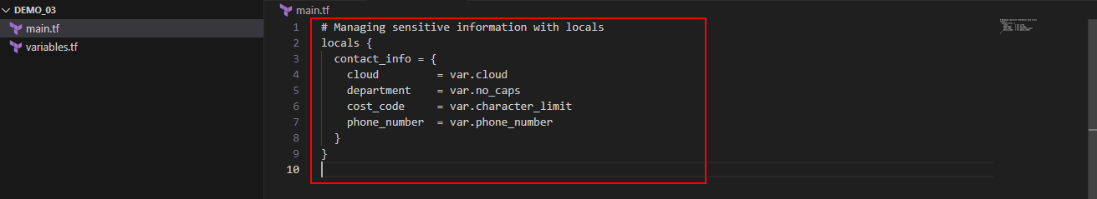
- Add the following block to define output variables for displaying data:
output "cloud" {
value = local.contact_info.cloud
}

output "department" {
value = local.contact_info.department
}

output "cost_code" {
value = local.contact_info.cost_code
}

output "phone_number" {
description = "A sensitive output of the phone number"
value = local.contact_info.phone_number
sensitive = true
}
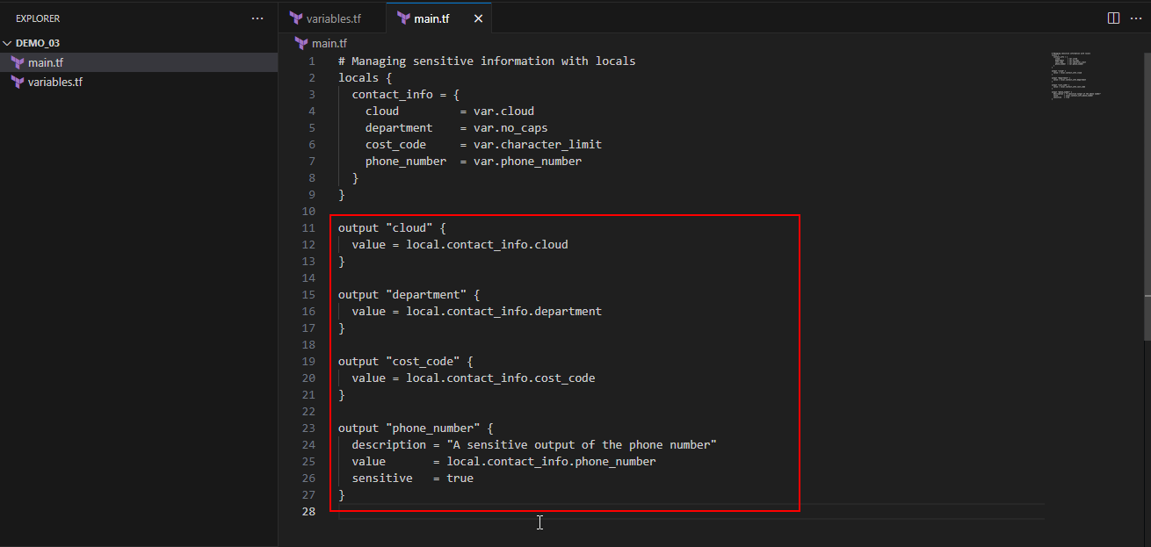
- Initialize the Terraform configuration using the following command:
terraform init
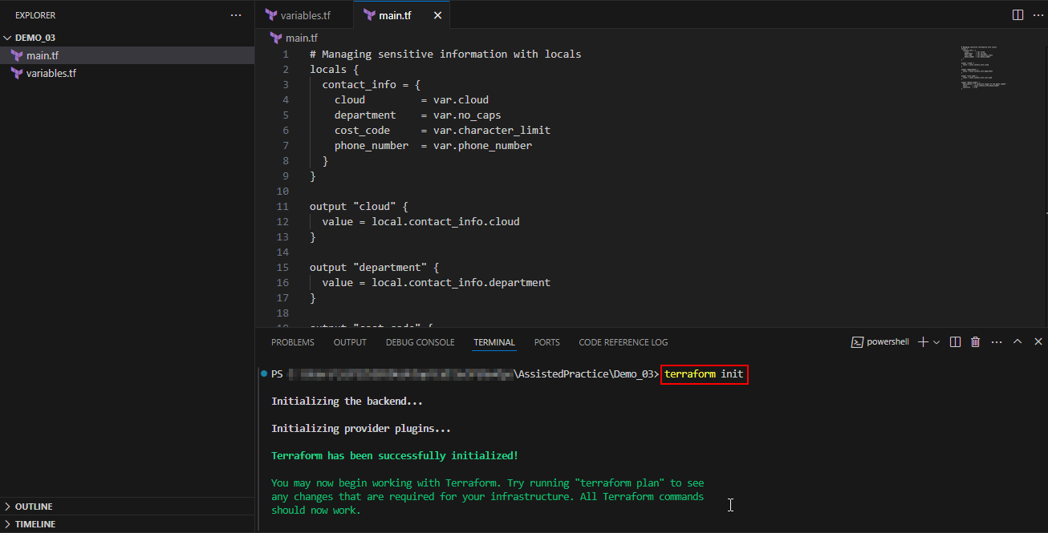
- Use the following command to plan and review the setup for ensuring all validations and sensitive data settings are correct:
terraform plan
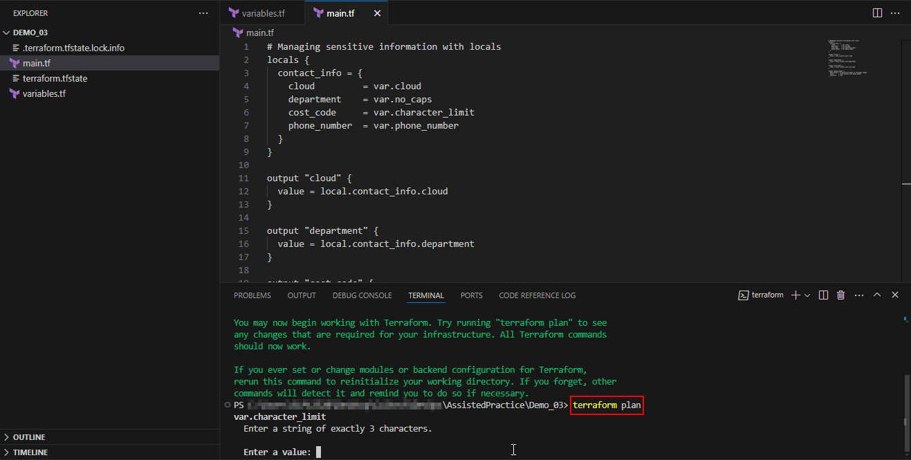
- Add the required input data for the variables as shown in the screenshots below:
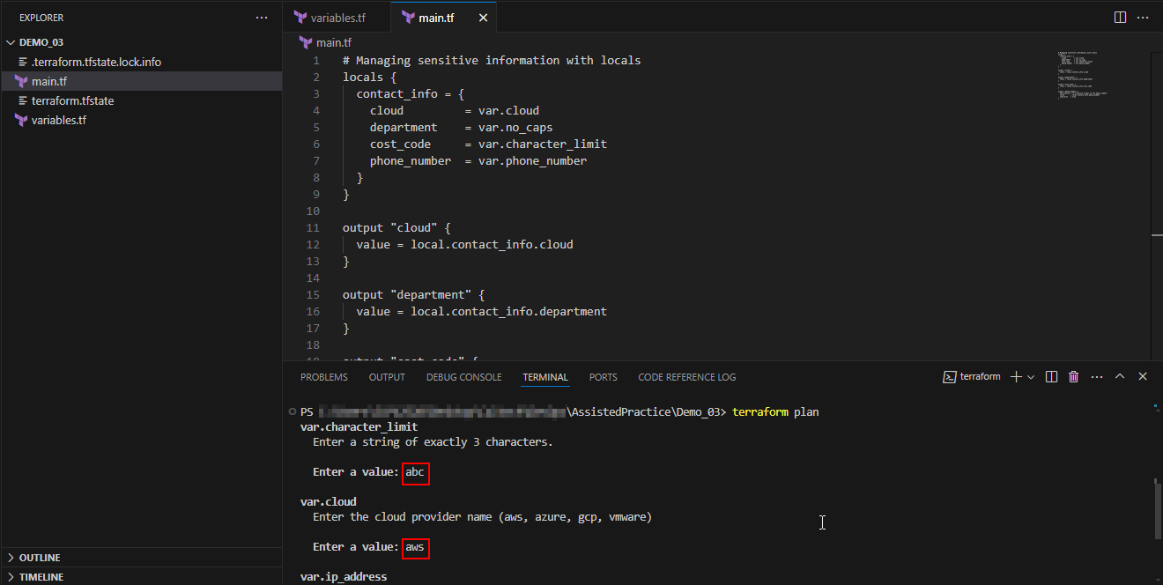
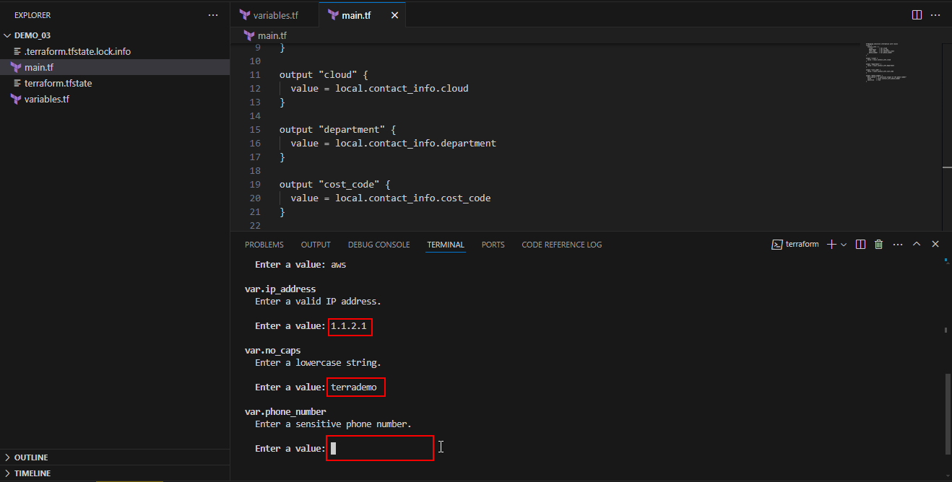
Note: Try entering different values for the inputs, such as 1.23.12.3 for the IP address, and similarly for the other input fields, and observe any errors that occur.

- Apply the configuration using the following command to deploy the changes as shown in the screenshot below:
terraform apply -auto-approve
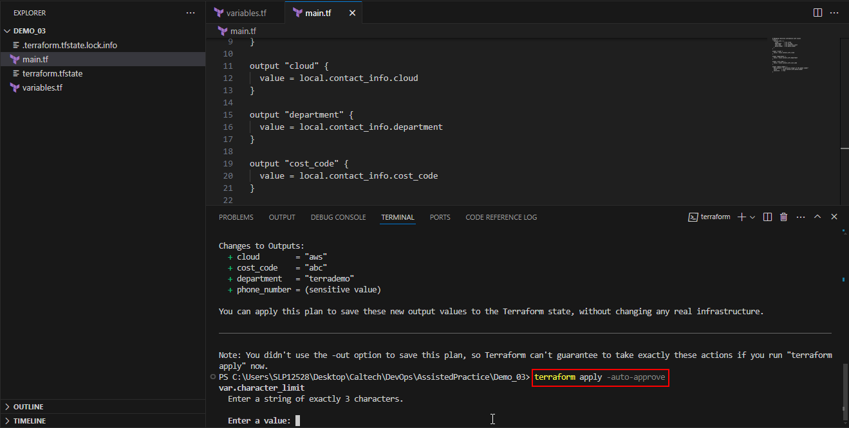
- Add the required input data for the variables as shown in the screenshots below:
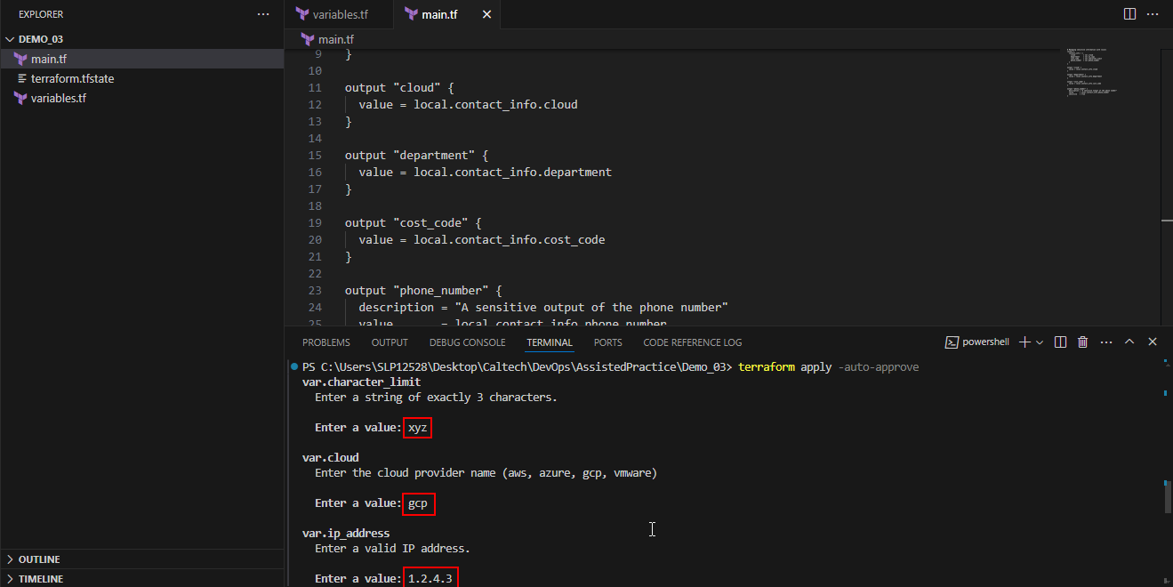
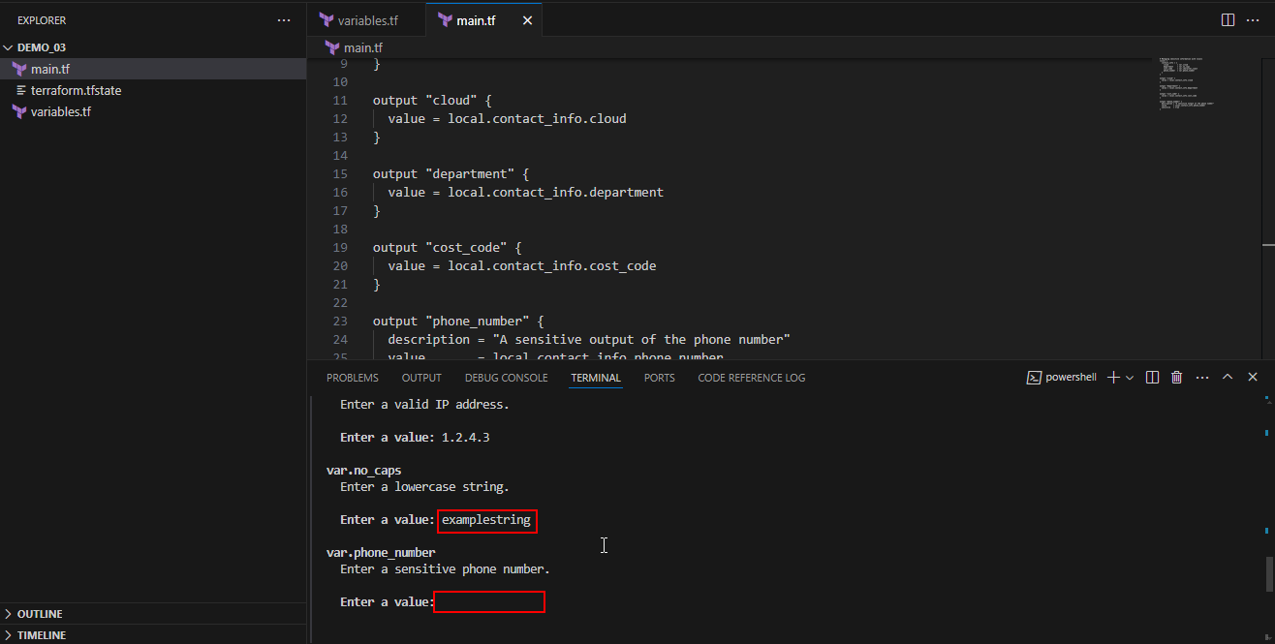
Note: Try entering different values for the inputs, such as 1.23.12.3 for the IP address, and similarly for the other input fields, and observe any errors that occur.

Step 3: Verify and utilize output values
- Check the output values using the following command as shown in the screenshot below:
terraform output
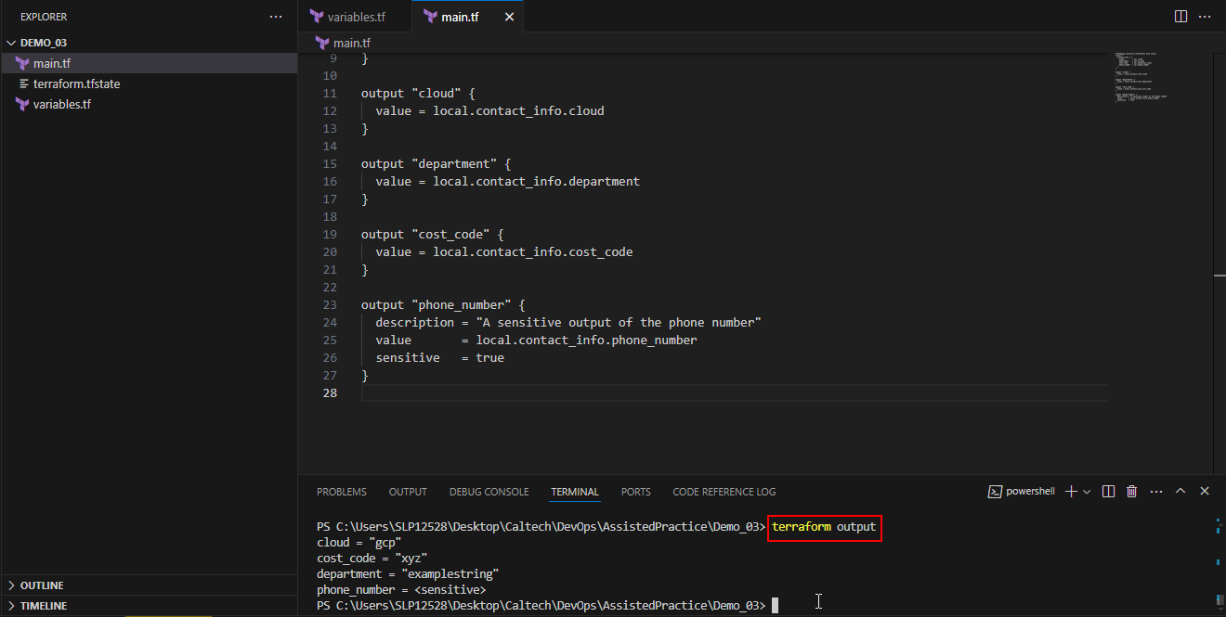
Note: The phone_number is set as sensitive and will not be displayed.

- Execute the following command to display the value of the sensitive phone_number output:
terraform output phone_number
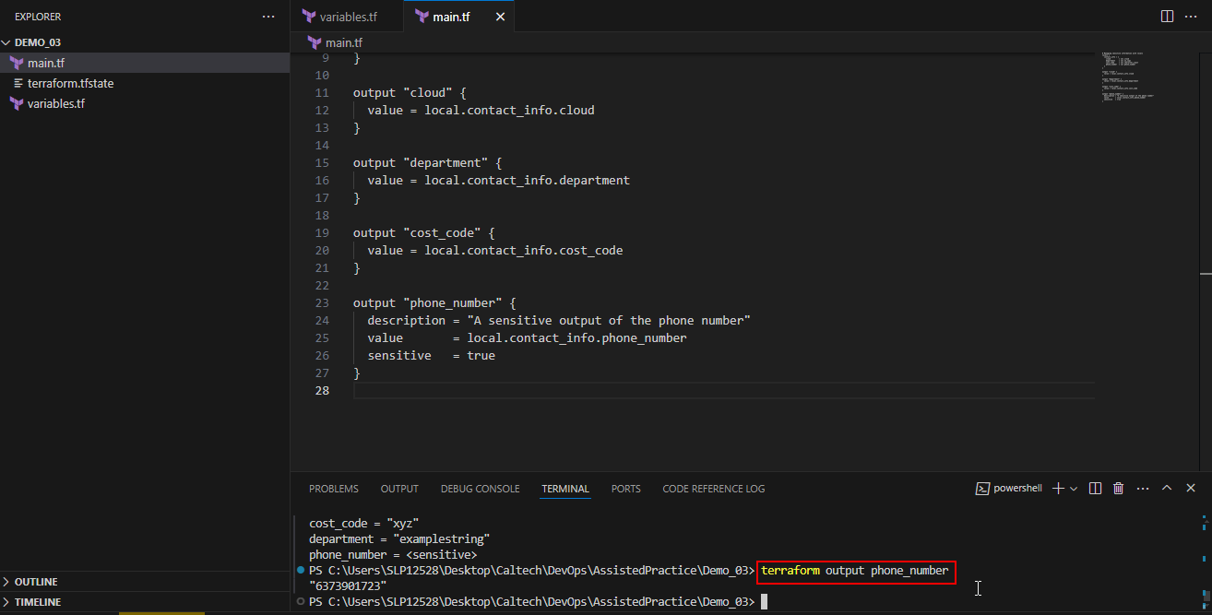
- Review the terraform.tfstate file to ensure access is securely restricted due to the sensitive information it contains
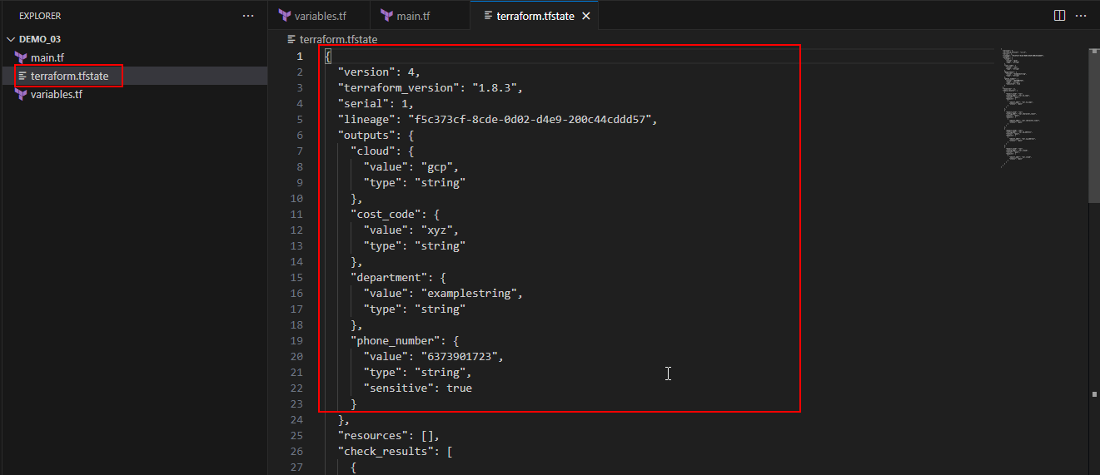
Note: Even though items are marked as sensitive within the Terraform configuration, they are stored within the Terraform state file. It is therefore critical to limit access to the Terraform state file.
By following these steps, you have successfully validated variables and secured sensitive data within your Terraform configuration for improved security and reliability.

