Lesson 11 Demo 04

Working with Collections and Structure Types

Objective: To utilize Terraform collections and structure types for enhanced configuration flexibility and readability
Tools required: Terraform, AWS, and Visual Studio Code

Prerequisites: Refer to the Demo 01 of Lesson 11 for creating access and secret key

Steps to be followed:
- Create and reference a new list variable
- Add a new map variable to replace static values
- Iterate over a map to create multiple resources
- Utilize a complex map variable to simplify configuration readability

Step 1: Create and reference a new list variable

- Open your Terraform configuration environment, create a file named main.tf, and add the following configuration block as shown in the screenshot below:
#Configure the AWS provider
provider "aws" {
# Replace with your actual AWS credentials
access_key = "YOUR_ACCESS_KEY"
secret_key = "YOUR_SECRET_KEY"
region = "us-east-1" # Replace with your desired region
}
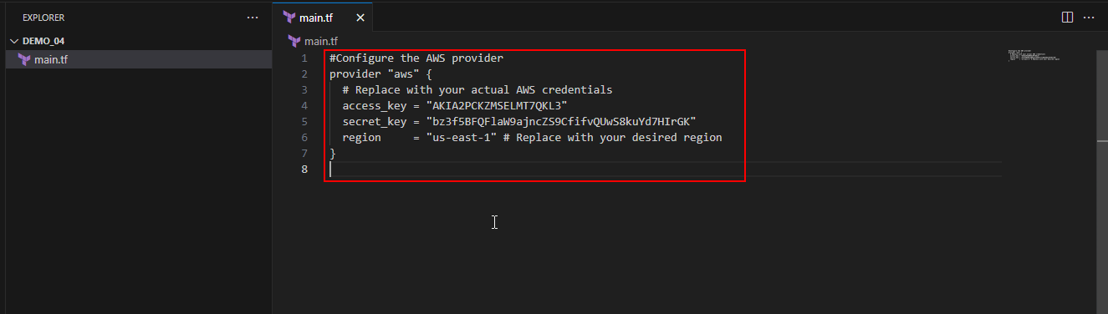
- Create a file named variables.tf, and add the following variable to define a list of AWS availability zones:
variable "us-east-1-azs" {
type = list(string)
default = ["us-east-1a", "us-east-1b", "us-east-1c", "us-east-1d", "us-east-1e"]
}
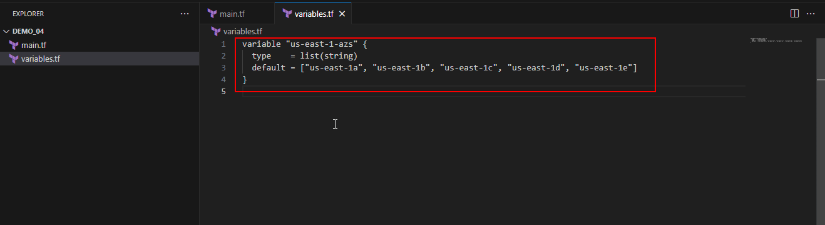
- Utilize the new list variable within a resource definition in the main.tf file as shown in the screenshot below:
resource "aws_subnet" "list_subnet" {
vpc_id = aws_vpc.vpc.id
cidr_block = "10.0.200.0/24"
availability_zone = var.us-east-1-azs
}
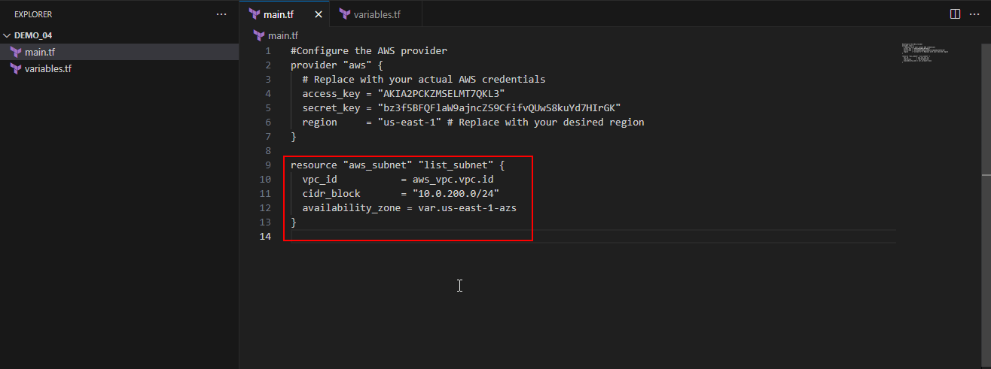
- Initialize the Terraform configuration using the following command:
terraform init
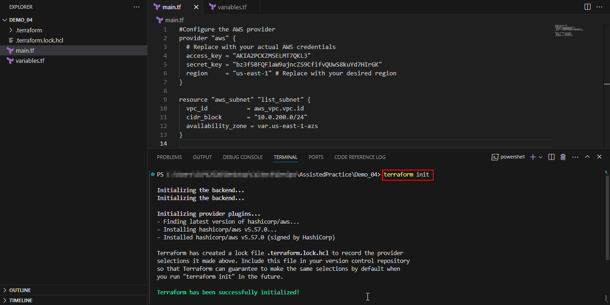
- Execute terraform plan to identify errors in usage, noting that availability_zone expects a single string, not a list as shown in the screenshot below:
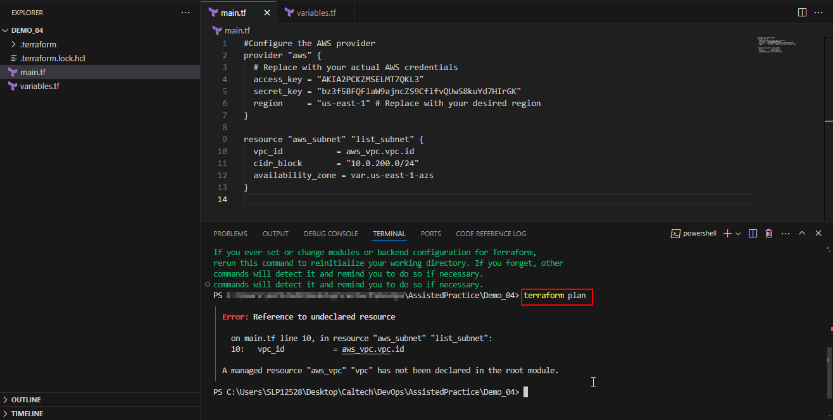
- Correct the resource definition in main.tf to specify an element from the list by its index as shown in the screenshot below:
resource "aws_subnet" "list_subnet" {
vpc_id = aws_vpc.vpc.id
cidr_block = "10.0.200.0/24"
availability_zone = var.us-east-1-azs[0] # Choosing the first availability zone
}
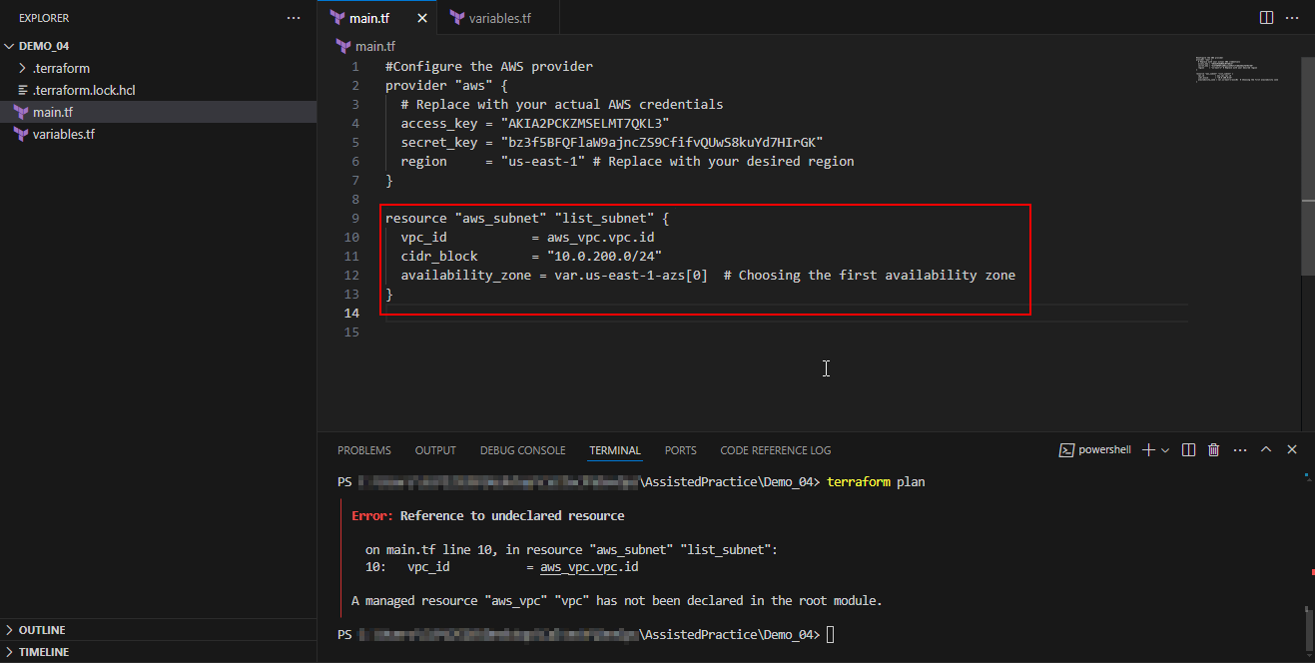
- Add a declaration for the AWS VPC before defining subnets as shown in the screenshot below:
resource "aws_vpc" "vpc" {
cidr_block = "10.0.0.0/16"

tags = {
Name = "MyVPC"
}
}
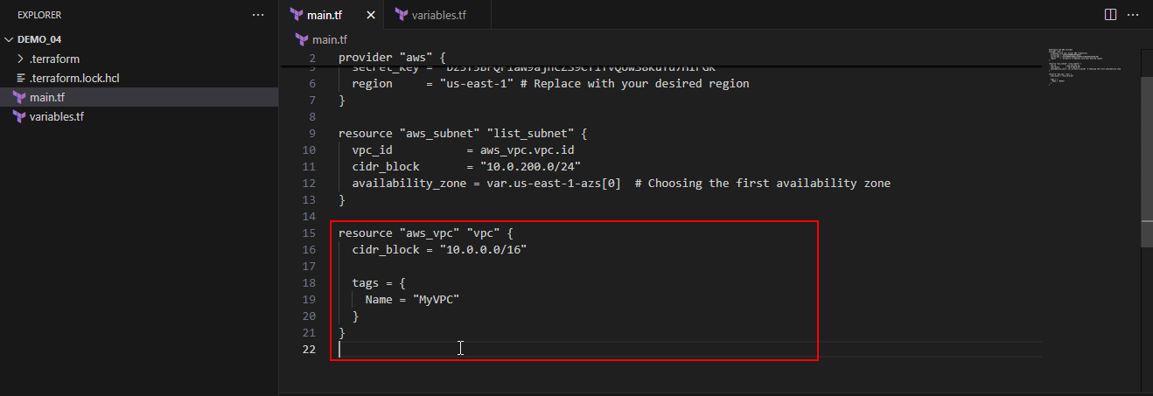
- Plan the deployment using the following command to see the proposed changes:
terraform plan
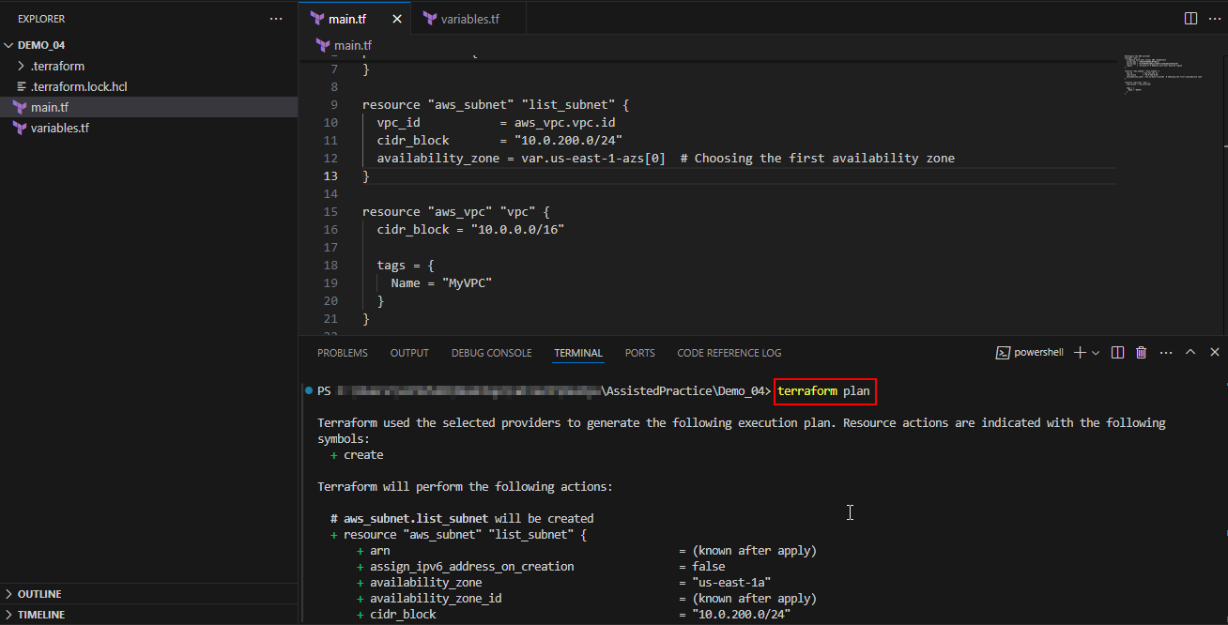
- Apply the configuration using the following command to deploy the changes as shown in the screenshot below:
terraform apply -auto-approve
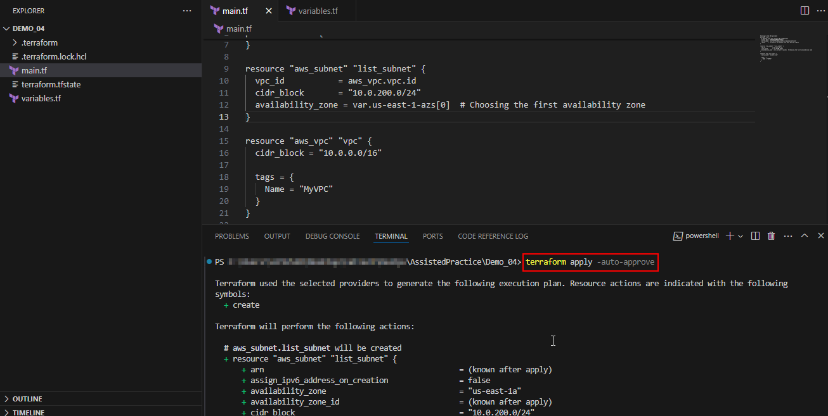

Step 2: Add a new map variable to replace static values

- Update variables.tf to include a new map variable for CIDR blocks
variable "ip" {
type = map(string)
default = {
prod = "10.0.150.0/24",
dev = "10.0.250.0/24"
}
}
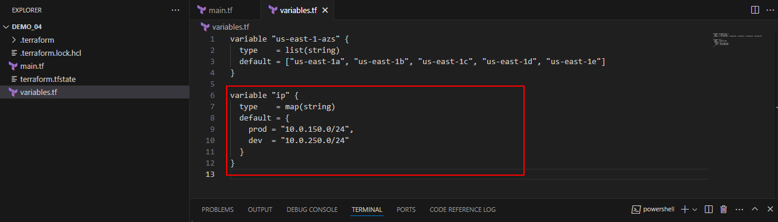
- Modify the subnet resource in main.tf to use this map variable:
resource "aws_subnet" "list_subnet" {
vpc_id = aws_vpc.vpc.id
cidr_block = var.ip["prod"]
availability_zone = var.us-east-1-azs[0]
}
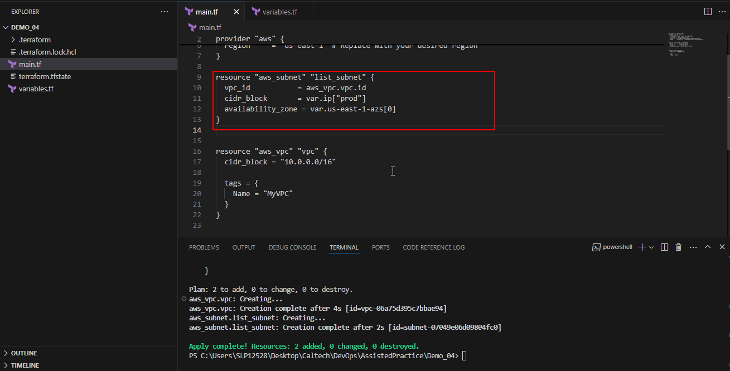
- Plan the deployment using the following command to see the proposed changes:
terraform plan
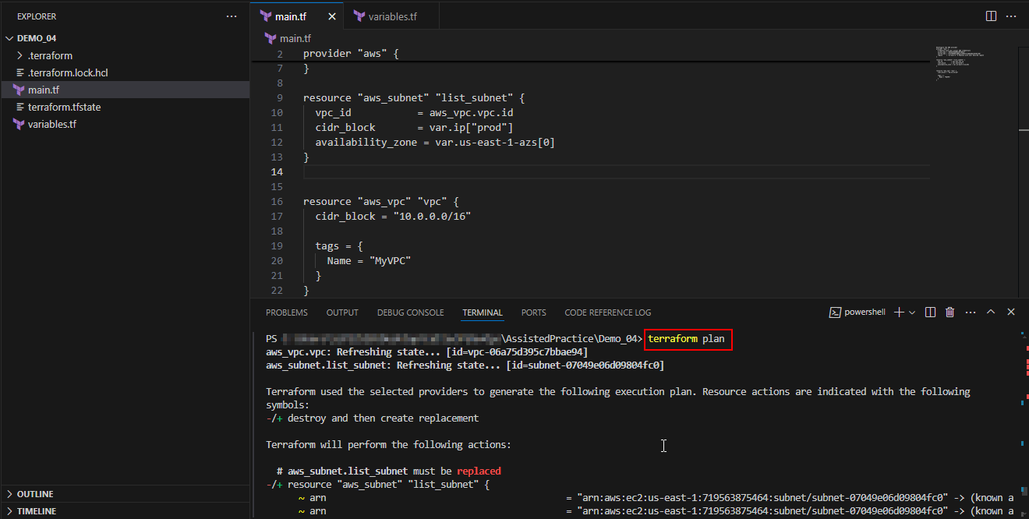
- Apply the configuration using the following command to deploy the changes as shown in the screenshot below:
terraform apply -auto-approve
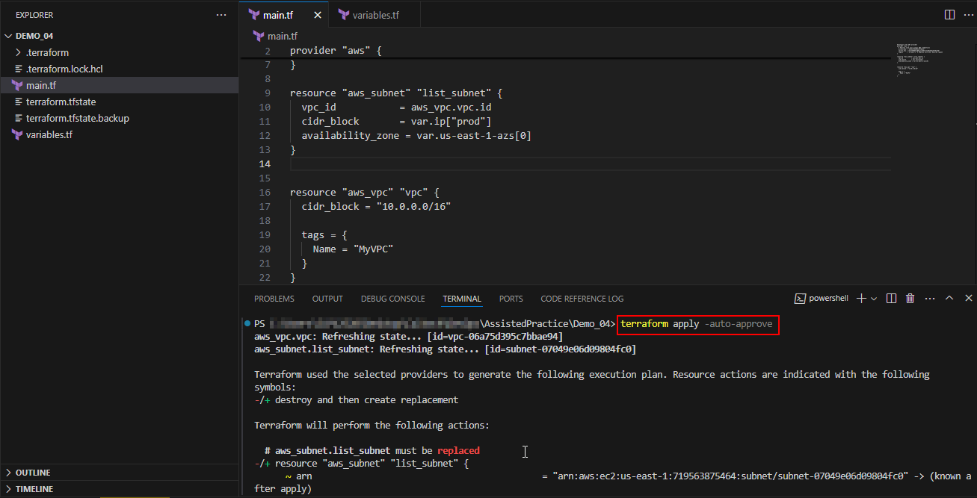
Step 3: Iterate over a map to create multiple resources
- Adjust the subnet resource in main.tf to iterate over the map using for_each:
resource "aws_subnet" "list_subnet" {
for_each = var.ip
vpc_id = aws_vpc.vpc.id
cidr_block = each.value
availability_zone = var.us-east-1-azs[0]
}
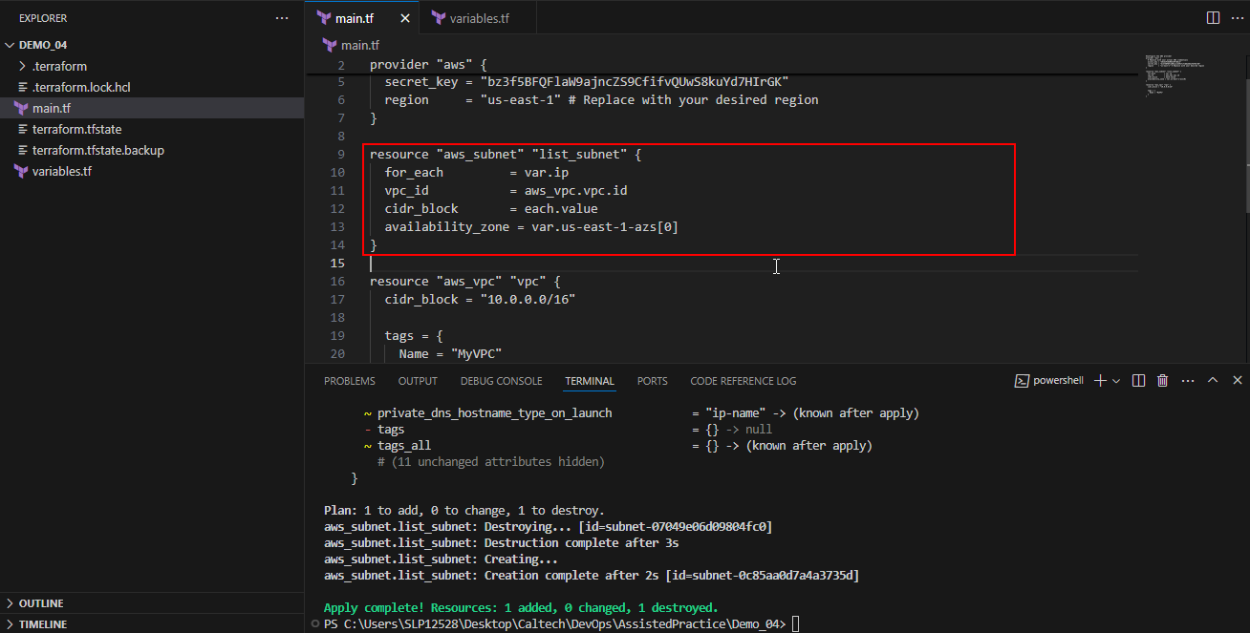
- Plan the deployment using the following command to see the proposed changes:
terraform plan
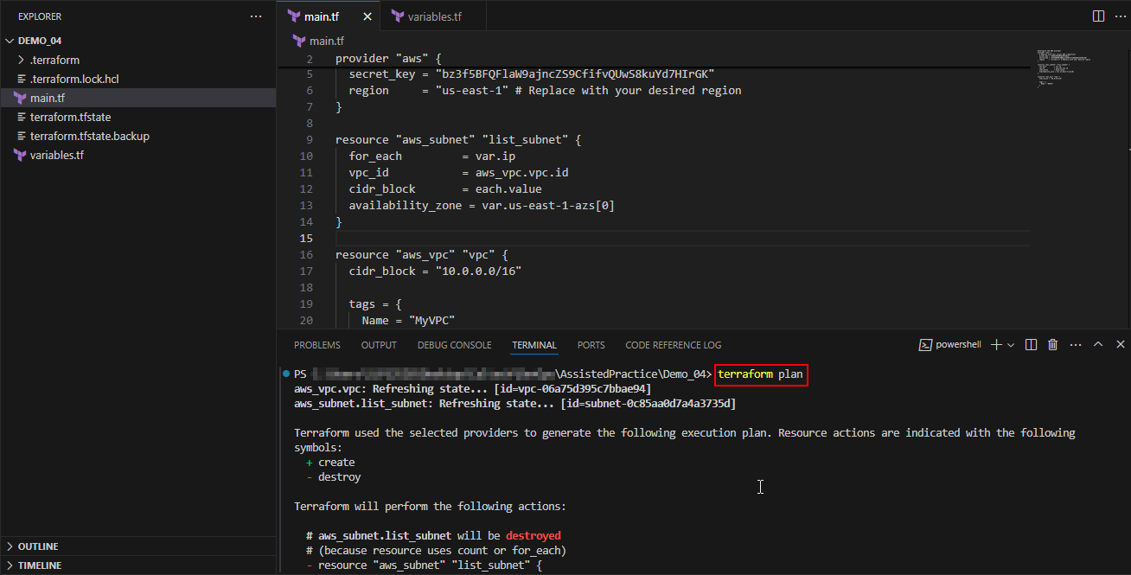
- Apply the configuration using the following command to deploy the changes as shown in the screenshot below:
terraform apply -auto-approve
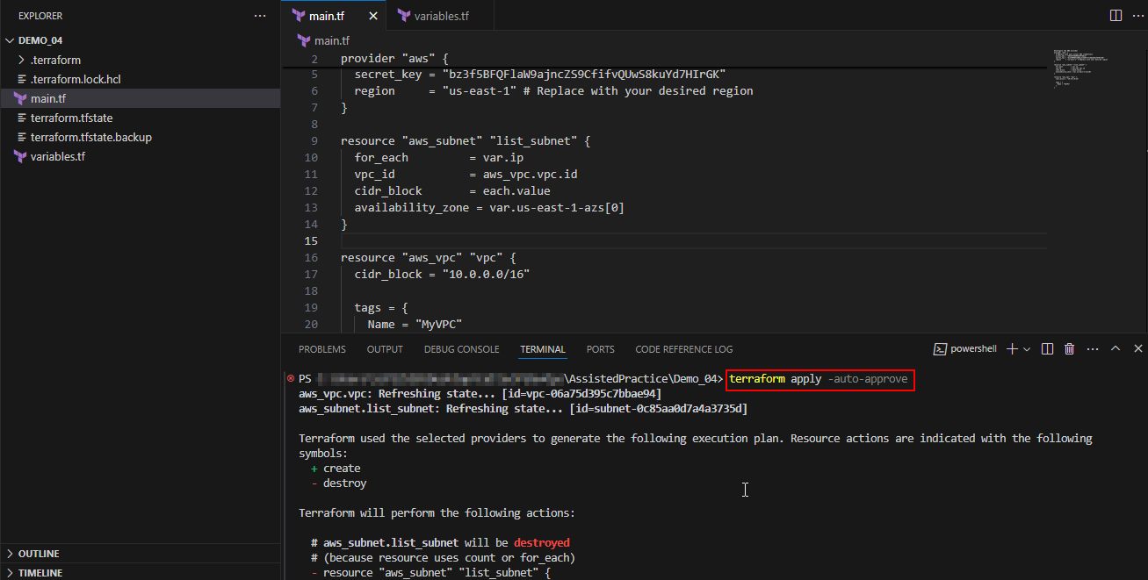
Step 4: Utilize a complex map variable to simplify configuration readability
- Add a complex map of maps in variables.tf:
variable "env" {
type = map(any)
default = {
prod = {
ip = "10.0.150.0/24",
az = "us-east-1a"
},
dev = {
ip = "10.0.250.0/24",
az = "us-east-1e"
}
}
}
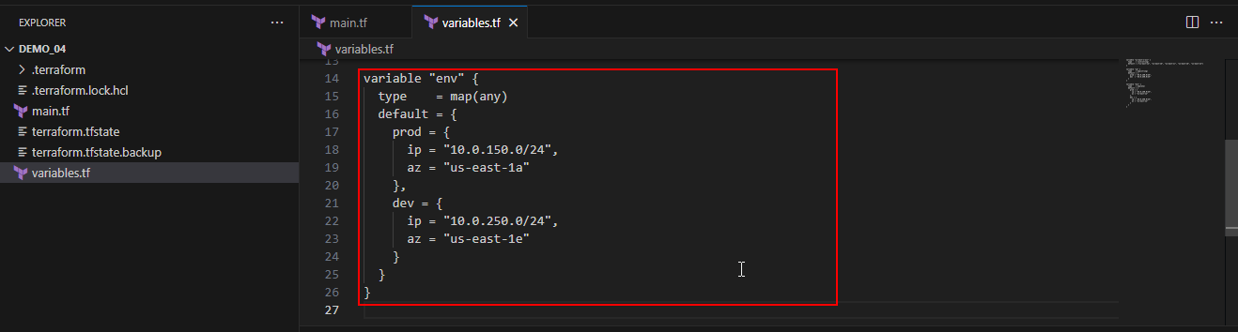
- Modify the subnet definition in main.tf to use the new structure
resource "aws_subnet" "list_subnet" {
for_each = var.env
vpc_id = aws_vpc.vpc.id
cidr_block = each.value.ip
availability_zone = each.value.az
}
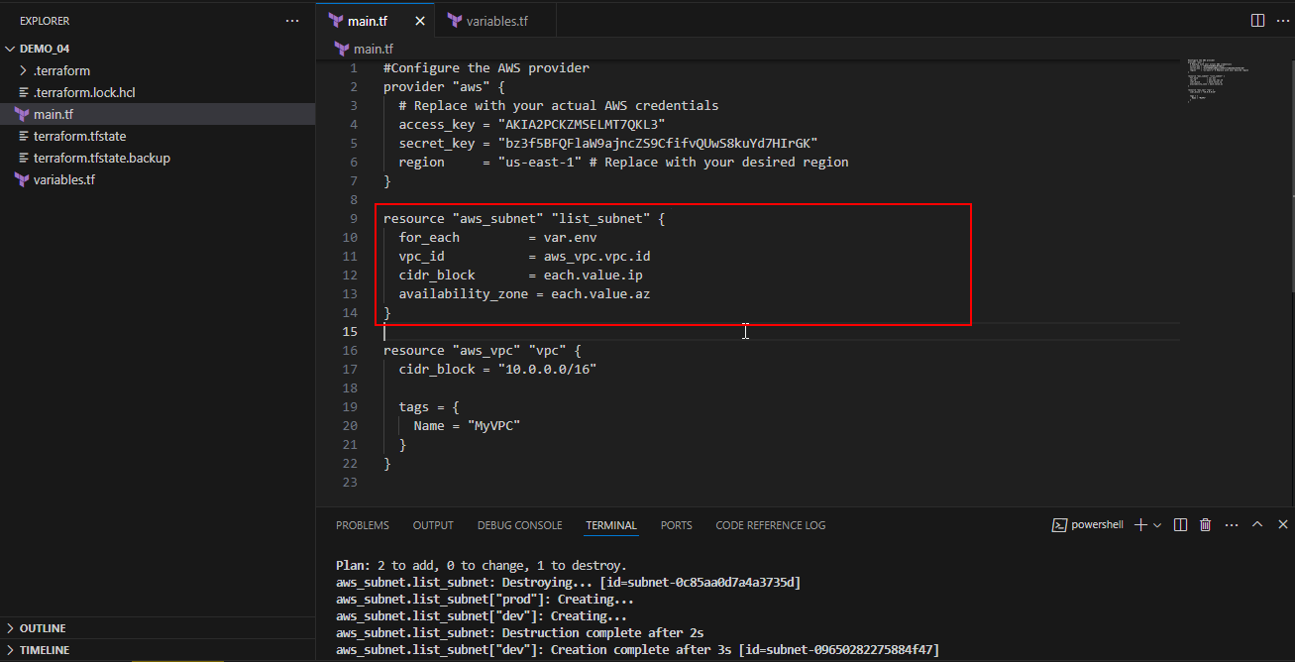
- Plan the deployment using the following command to see the proposed changes:
terraform plan
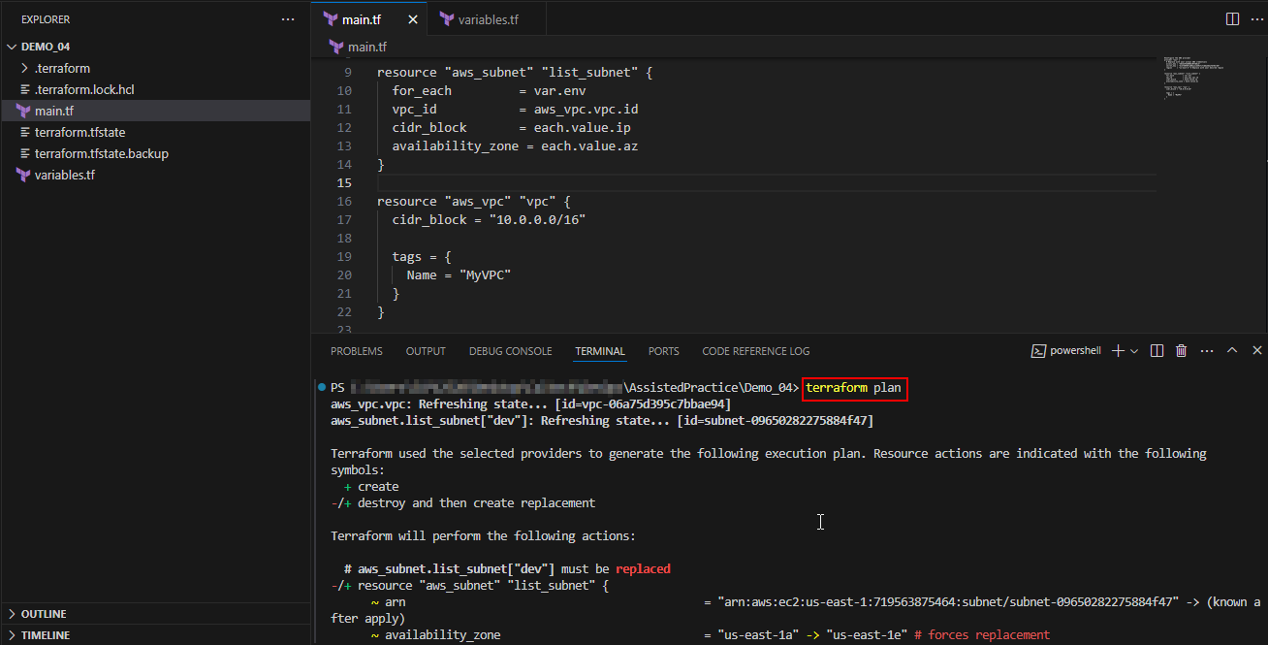
- Apply the configuration using the following command to deploy the changes as shown in the screenshot below:
terraform apply -auto-approve
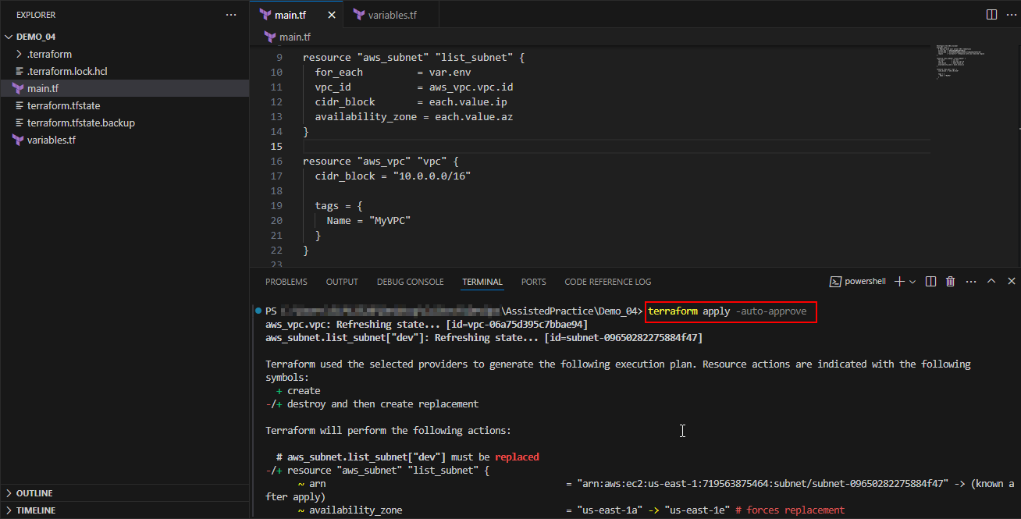
By following these steps, you have successfully utilized Terraform collections and structure types to enhance your configuration's flexibility and readability.

