Lesson 09 Demo 01

Configuring AWS and Random Providers in Terraform

Objective: To configure the AWS and random Terraform providers in the Terraform configuration file for managing cloud infrastructure efficiently

Tools required: VS Code and Linux terminal

Prerequisites: None

Steps to be followed:
- Install the Terraform extension in VS Code
- Create the main Terraform configuration file
- Configure the Terraform providers
- Initialize the Terraform configuration file

Step 1: Install the Terraform extension in VS Code

- Open the provided DevOps Lab

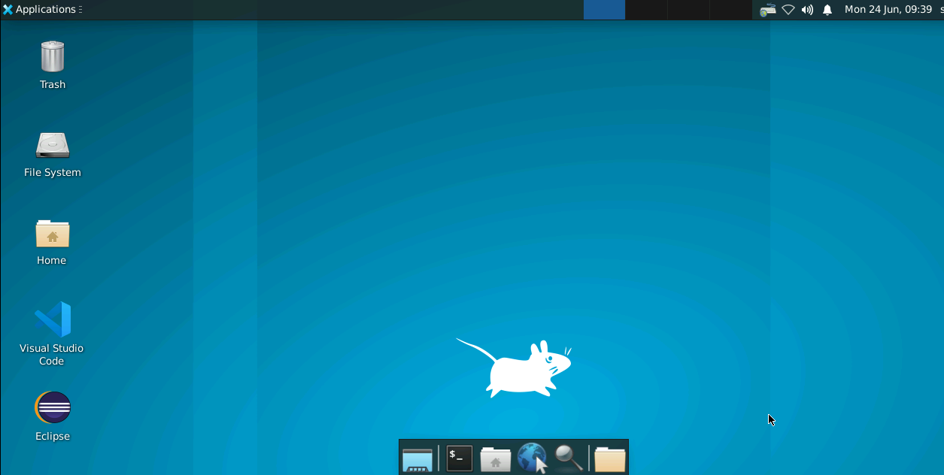
- Create a folder named Terraform

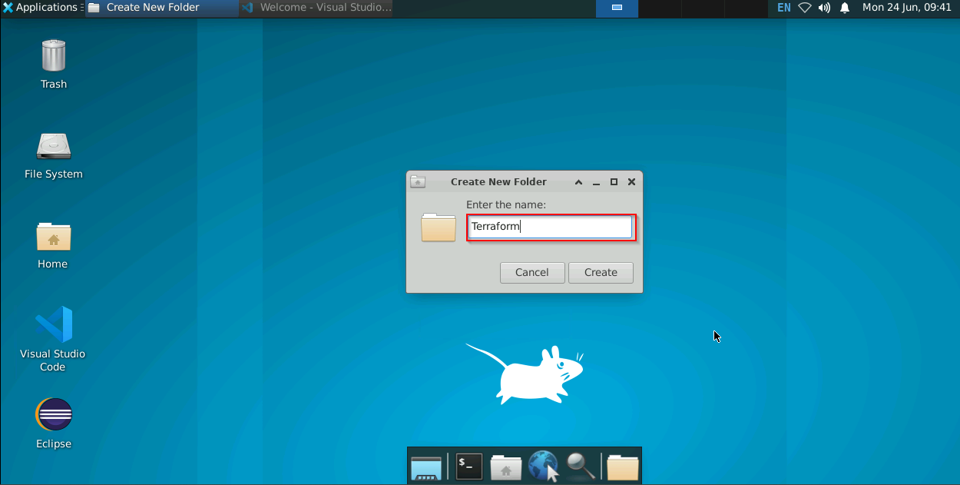

- Open the VS Code editor

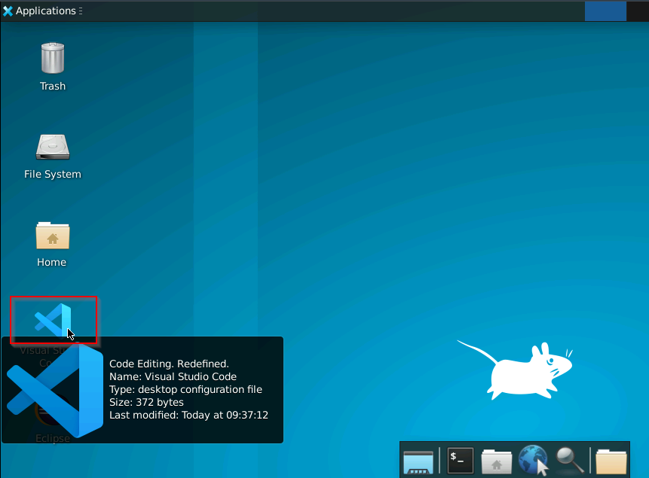

- Go to the Extensions tab and search for Terraform in the search field

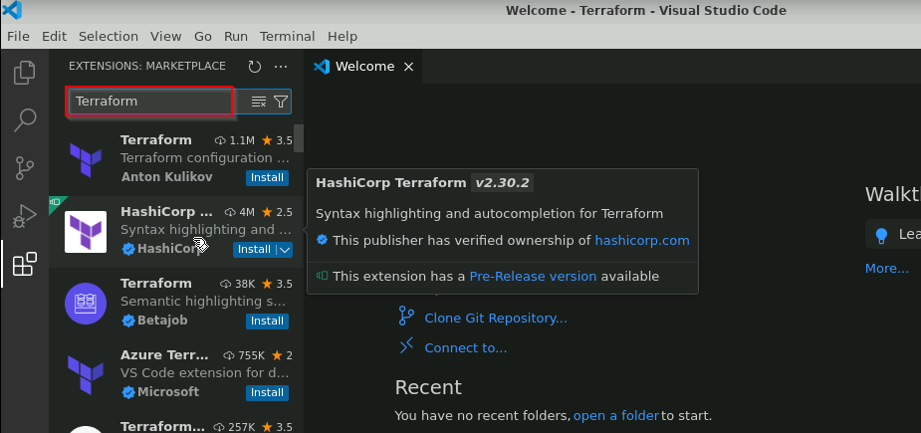
- Click on the Install button to install the latest version of HashiCorp Terraform V2.30.2 extension
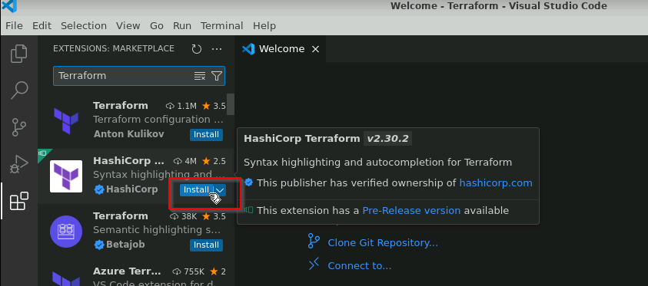

The latest version of the HashiCorp Terraform V2.30.2 extension will be installed on your VS Code editor.

Step 2: Create the main Terraform configuration file

- Click on the File option
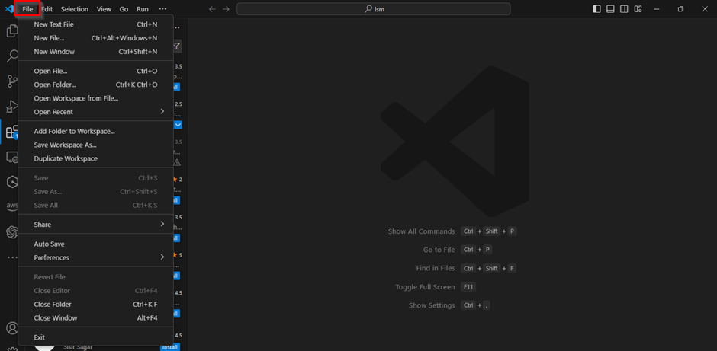
- Select the Open Folder from the drop-down menu to open the Terraform folder
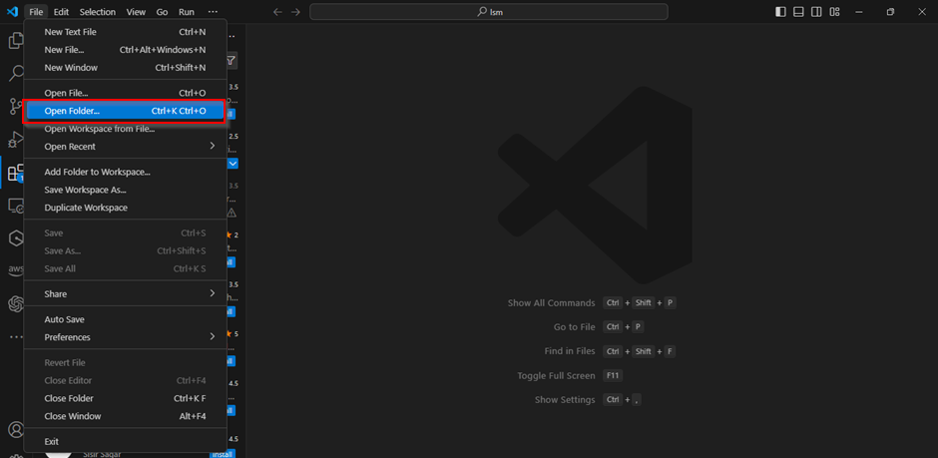
- Navigate to the Terraform folder on the editor and click on the New File option to create the main file
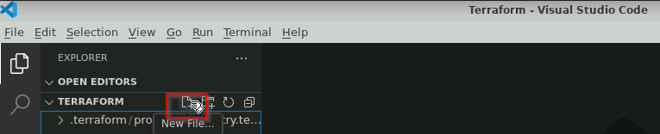
- Enter the name of the file as main.tf to create the main Terraform configuration file
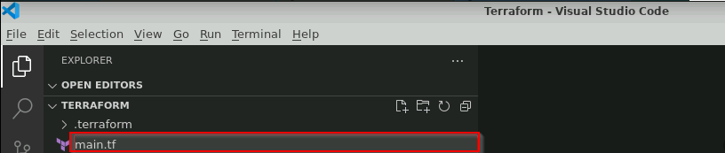
Step 3: Configure the Terraform providers
- Open the main.tf file to specify the Terraform provider version configurations
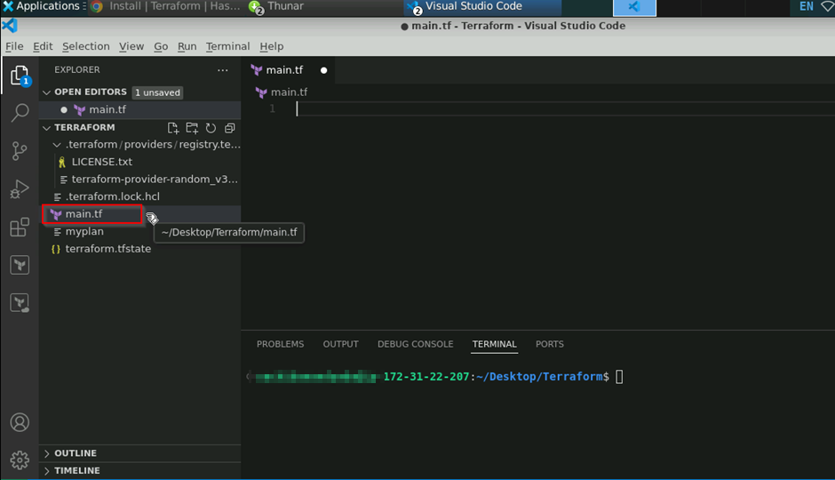

- Enter the following code in the main.tf file to specify the Terraform provider configurations and save it:

terraform {
required_version = ">= 1.0.0"
required_providers {
aws = {
source = "hashicorp/aws"
version = "~> 3.0"
}
random = {
source = "hashicorp/random"
version = "3.1.0"
}
}
}
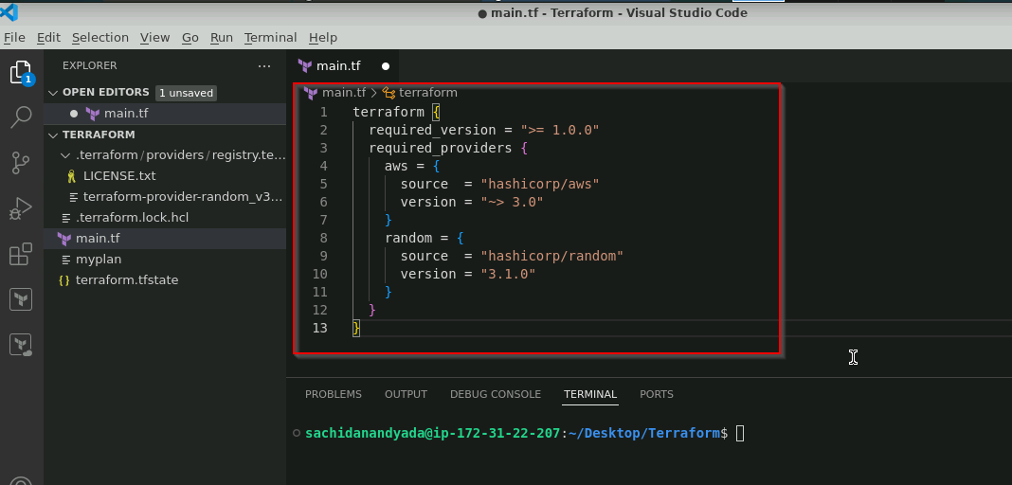

Note: You can get the configuration code of any Terraform provider from the official website of HashiCorp Terraform on the Terraform Registry page.

Step 4: Initialize the Terraform configuration file

- Open the terminal and execute the following command to initialize the Terraform configurations:
terraform init

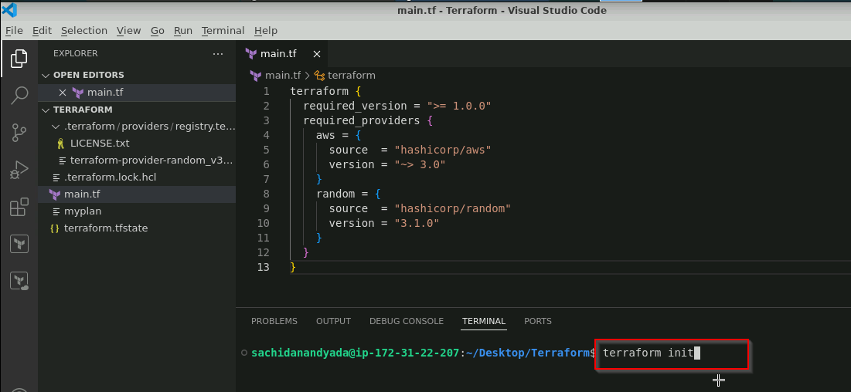

The Terraform configuration file is successfully initialized.

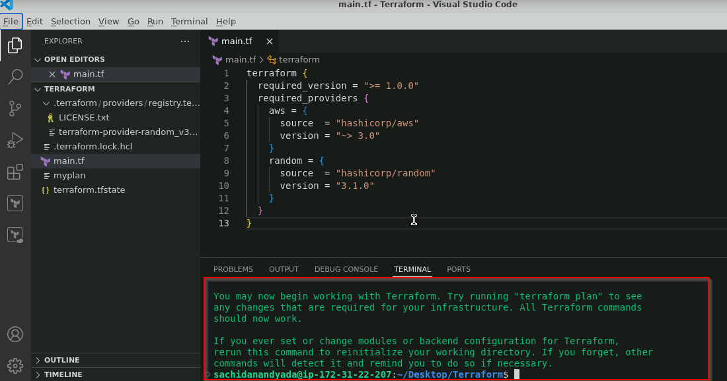

- Execute the following command to verify the installed version of Terraform and its providers:
terraform version
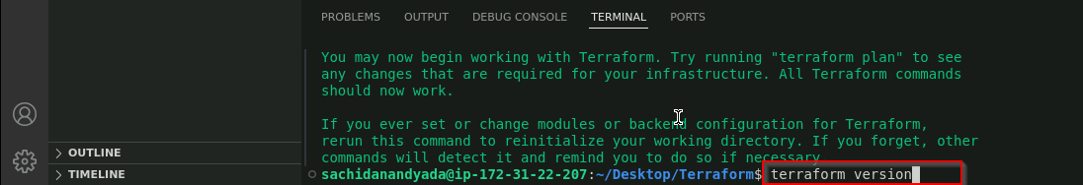

The installed terraform version and its providers is visible.

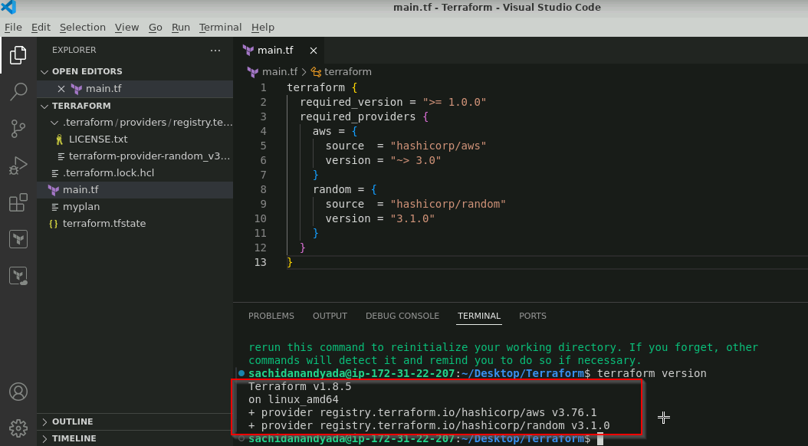

- Execute the following command in the terminal to particularly check the versions of the installed Terraform providers:
terraform providers

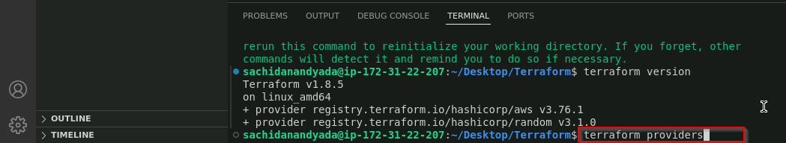

The installed Terraform provider version is visible.

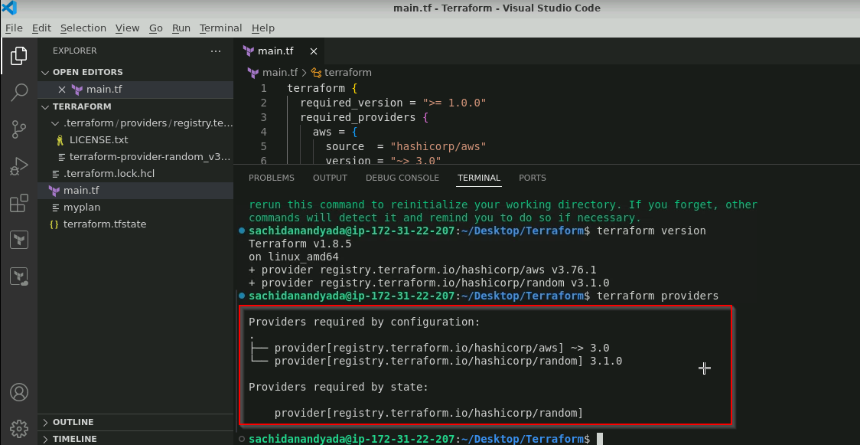
By following these steps, you have successfully configured the AWS and the random Terraform providers in the Terraform configuration file for managing cloud infrastructure efficiently.

