Lesson 10 Demo 02

Authenticating Terraform State Backend
Objective: To authenticate and manage Terraform state using two different backend types, S3 standard backend and remote enhanced backend

Tools required: Visual Studio Code

Prerequisites: Ensure you have created and implemented the AWS access key and secret key before starting this demo. Refer to Lesson 08 Assisted Practice 02 for detailed steps

Note: The folder structure created in the previous demos is used here. It is also included in the resources section of LMS. Please refer Lesson_10_demo_01

Steps to be followed:
- Authenticate S3 standard backend
- Authenticate remote enhanced backend

Step 1: Authenticate S3 standard backend

- Log in to the AWS Management Console and navigate to the S3 service using the search bar

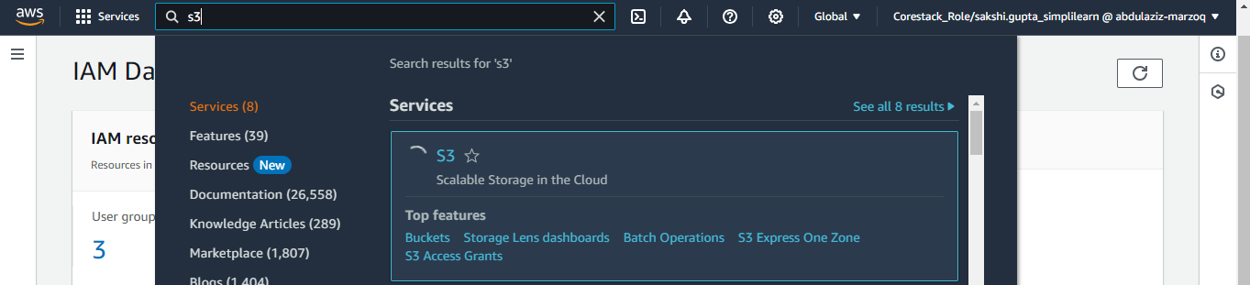

- Click on Create bucket

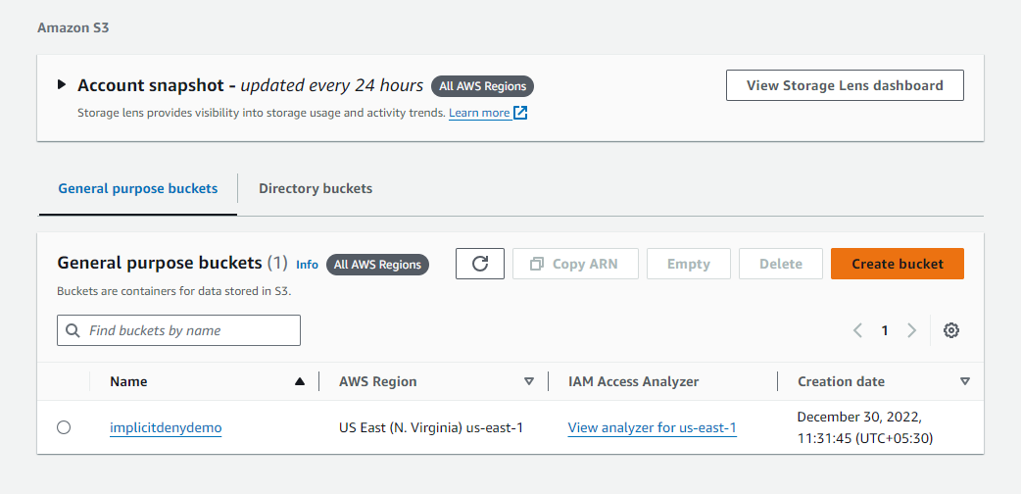

- Name it appropriately for storing Terraform state files

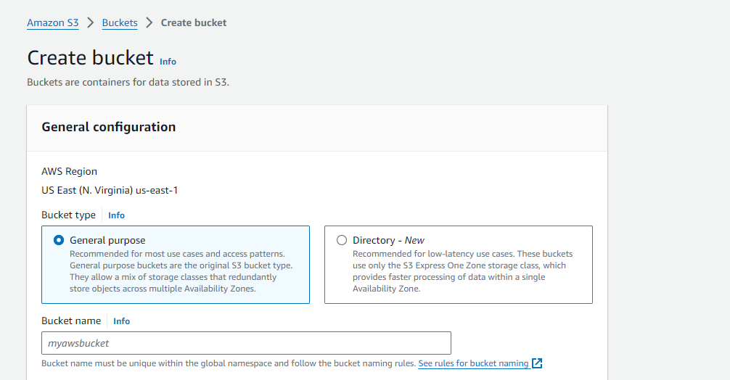
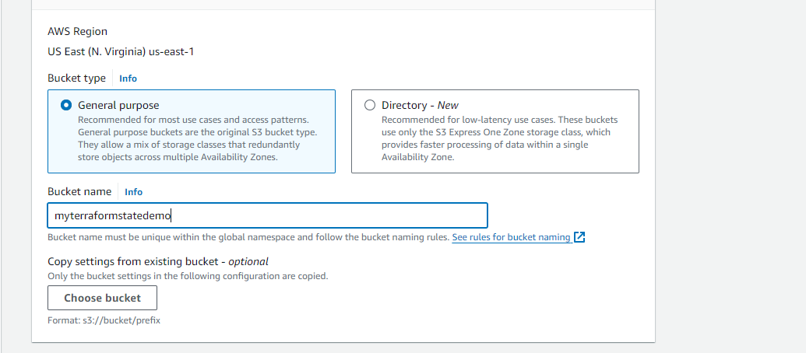

- Retain all the other configurations at their default settings and click on Create bucket

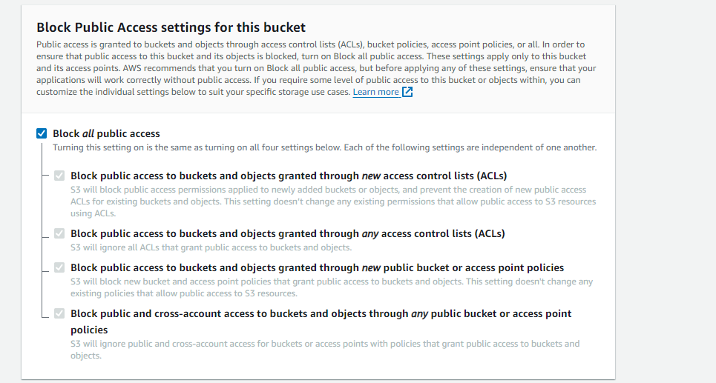

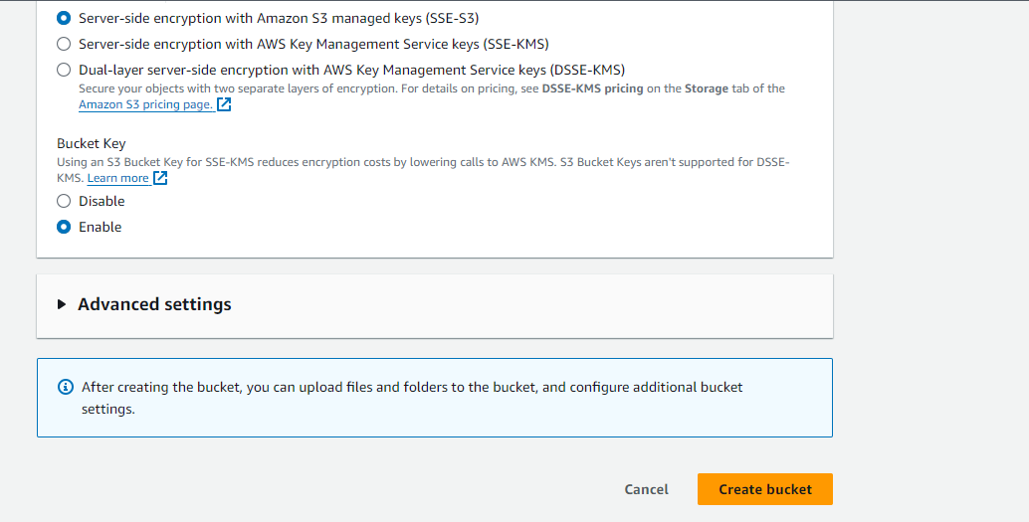

The bucket will be created as shown above.

- Open Visual Studio Code and navigate to the Terminal

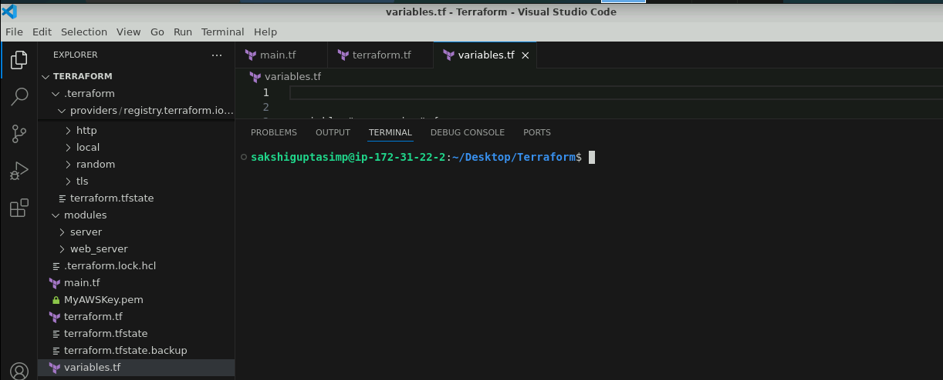

- Clean up any existing infrastructure to prepare for backend configuration by using the following command:
terraform destroy

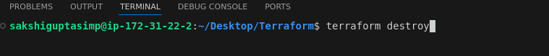

- When prompted, confirm the destruction of resources by typing yes

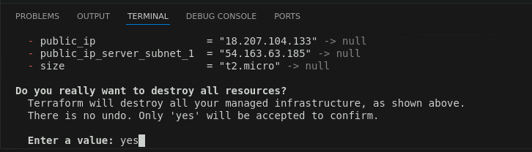

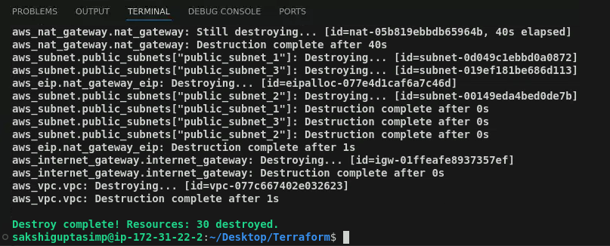

- Go to terraform.tf file and set up Terraform to use the created S3 bucket by using the following code:
terraform {
backend "s3" {
bucket = "myterraformstatedemo"
key = "prod/aws_infra"
region = "us-east-1"
}

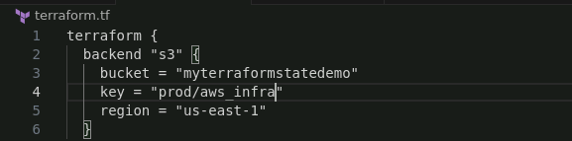

- Format the terraform configuration file by using the following command:
terraform fmt

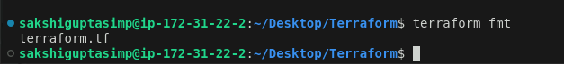

- Set the environment variables for AWS credentials by using the following command:
export AWS_ACCESS_KEY_ID="your-access-key"
export AWS_SECRET_ACCESS_KEY="your-secret-key"

- Initialize the Terraform working directory by using the following commands:
terraform init

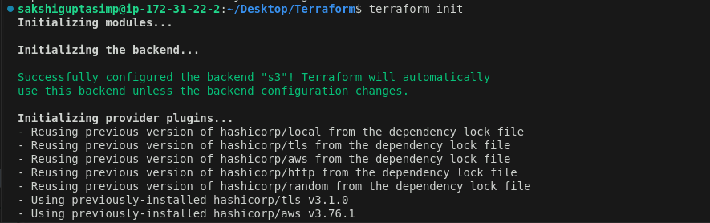

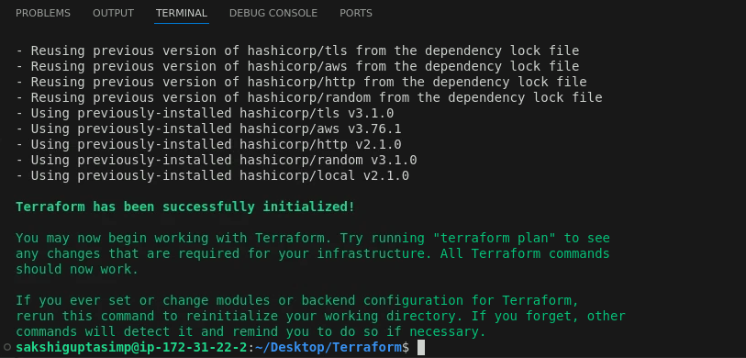

- Navigate to the newly created bucket in the AWS Console and observe that there are no objects yet

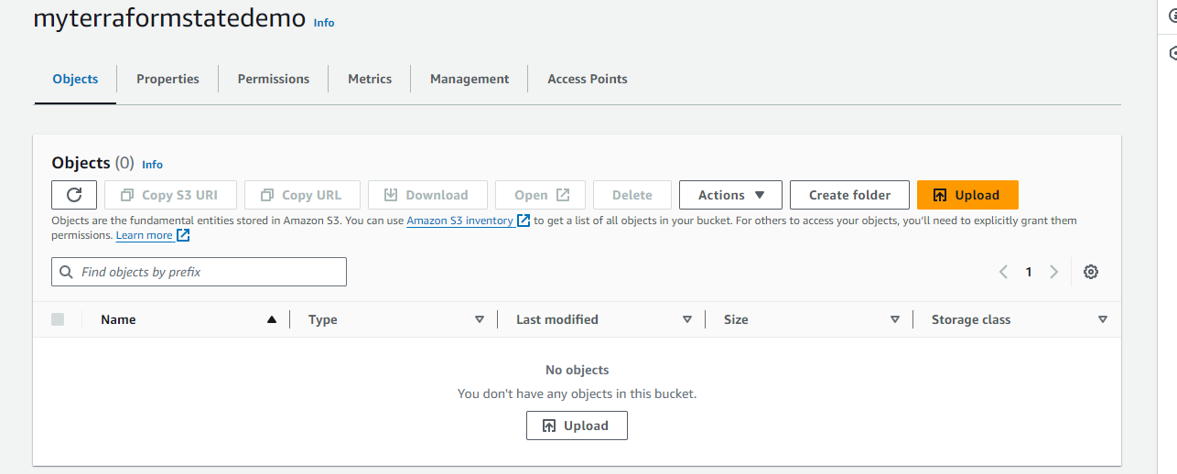

- Navigate to the terminal in Visual Studio Code and update infrastructure resources by using the following command:
terraform apply

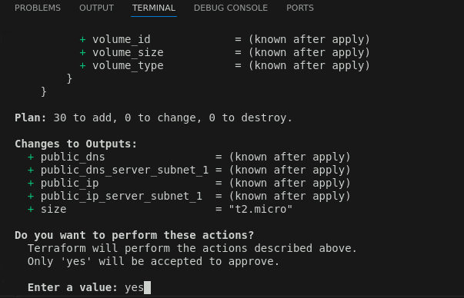
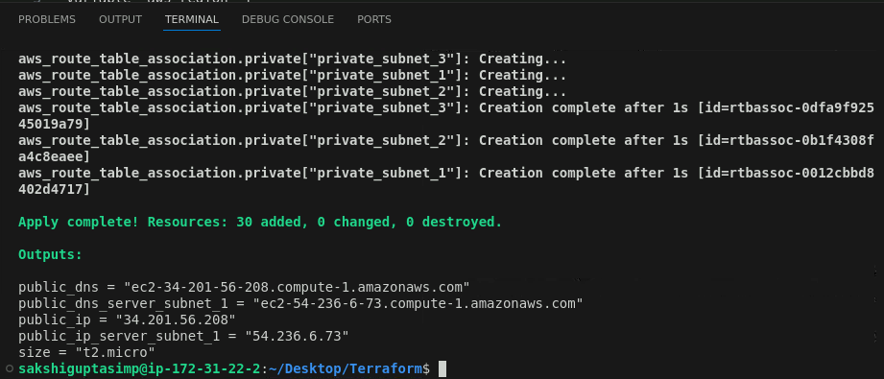

- Go to the created bucket in the AWS Console and observe that object has been added. Click on it to view it in detail.

