Lesson 09 Demo 06

Formatting Terraform Code

Objective: To format Terraform code in canonical format and style based on a subset of Terraform language style conventions for improved readability, maintainability, and consistency across your infrastructure as code projects

Tools required: VS Code and Linux terminal

Prerequisites: None

Steps to be followed:
- Update the unformatted code in the main.tf file
- Format the provided code using the fmt command

Step 1: Update the unformatted code in the main.tf file

- Open the main.tf file previously created

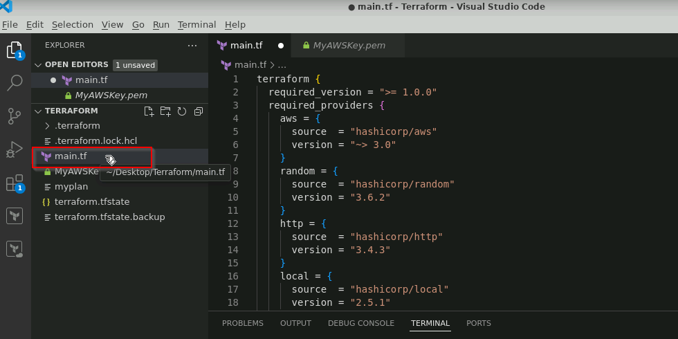

Note: Refer to demos 01 and 02 for the main.tf file.

- Provide the following resource block code in your main.tf and save the file:
resource "random_string" "random" {
length = 10
special = true
min_numeric = 6
min_special = 2
min_upper = 3
}

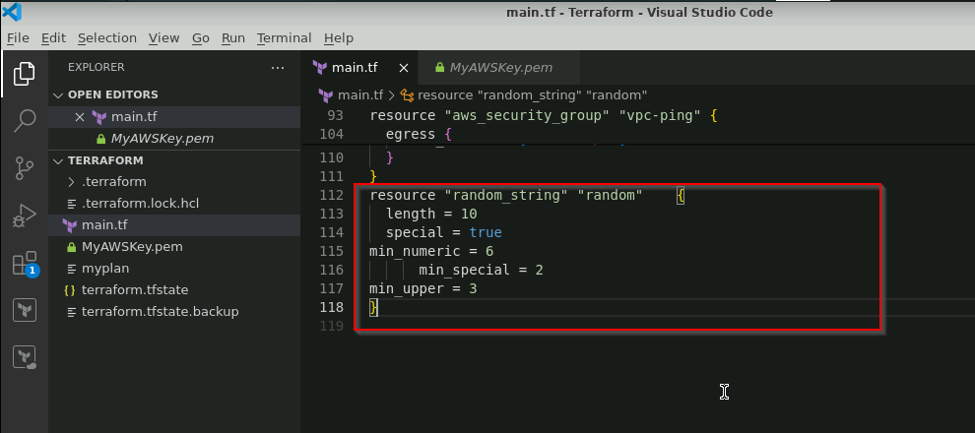
Note: You can observe that the provided code has incorrect spacing and misaligned equal signs. Although this code is technically valid, it looks messy.

Step 2: Format the provided code using the fmt command

- Open the terminal and execute the command given below to format the code:
terraform fmt

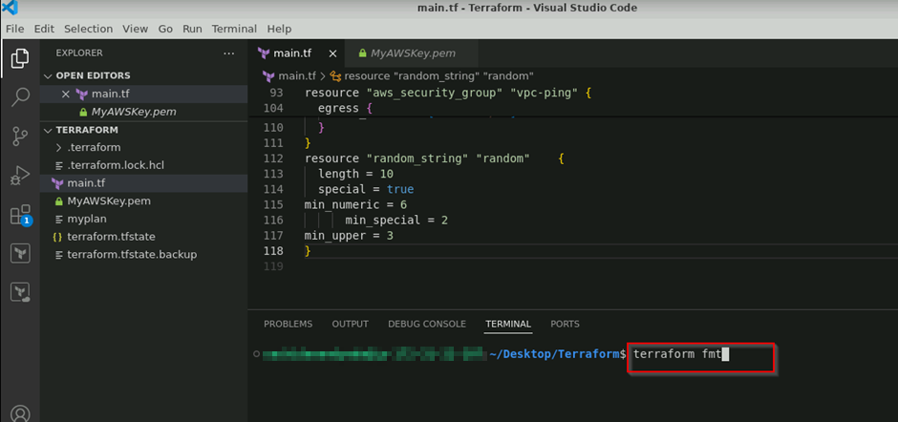

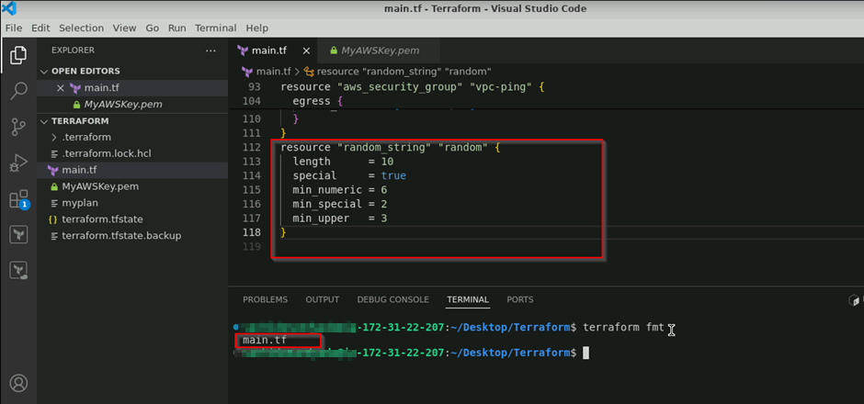

The provided code is formatted according to Terraform language style conventions.

By following these steps, you have successfully formatted the Terraform code in canonical format and style based on a subset of Terraform language style conventions for improved readability, maintainability, and consistency across your infrastructure as code projects.

