Lesson 02 Demo 02

Working With Hosts and Groups

Objective: To work with hosts both individually and in groups for streamlined management and deployment across your network infrastructure

Tools required: Ubuntu OS

Prerequisites: You need to have Ansible, and the nodes connected with it installed to proceed with this demo. Refer Demo 1 of Lesson 3.

Steps to be followed:
- List the hosts present in your host file
- Create a file on the host
- Remove the file from the host
- Create and remove the file on the hosts using the group
- Update the hosts using the group

Step 1: List the hosts present in your host file

- Use the following command to list the hosts in your inventory file:
ansible all --list-hosts
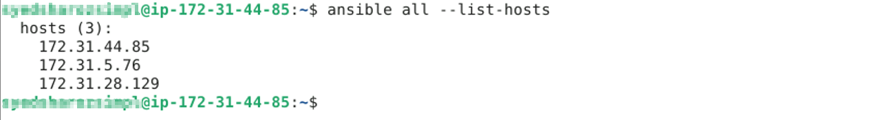

Note: The host list might change as per your system.

Step 2: Create a file on the host

  - Use the following command to list the contents of the current working directory:
ansible 172.31.44.85 -a "ls"

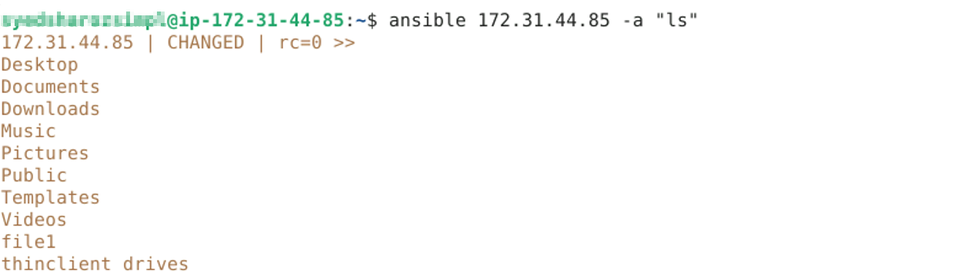

Note: You can create the file on any other host as per your host list.

  - Use the following command to create a file named file1 on the host:
ansible 172.31.44.85 -a "touch file1"
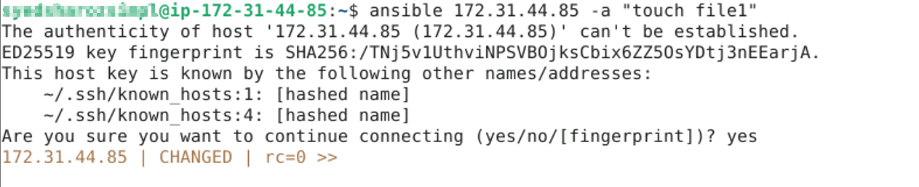

Step 3: Remove the file from the host

  - Now, run the following command to remove the file from the host:
ansible 172.31.44.85 -a "rm file1"


Step 4: Create and remove the file on the hosts using the group

  - Run the following command to create a new file on both the hosts using the group:
ansible dbservers -a "touch Ansible_learners"

  - Use the following command to list the contents of the current working directory of all the hosts present in the group:
ansible dbservers -a "ls"

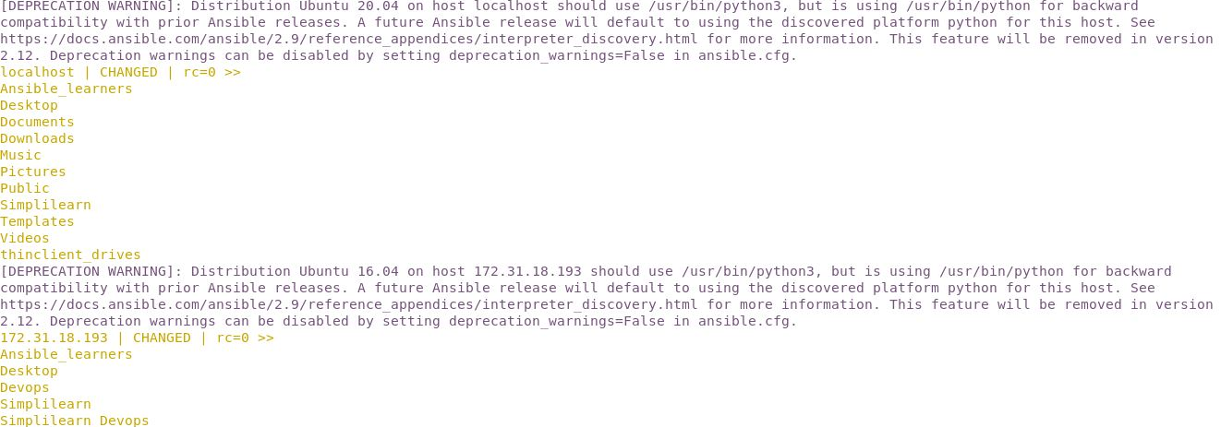

  - Run the following command to remove the file on both hosts using the group:
ansible dbservers -a "rm Ansible_learners"

Step 5: Update the hosts using the group

  - Run the following command to update the hosts using the group:
ansible dbservers -a "sudo apt-get update"

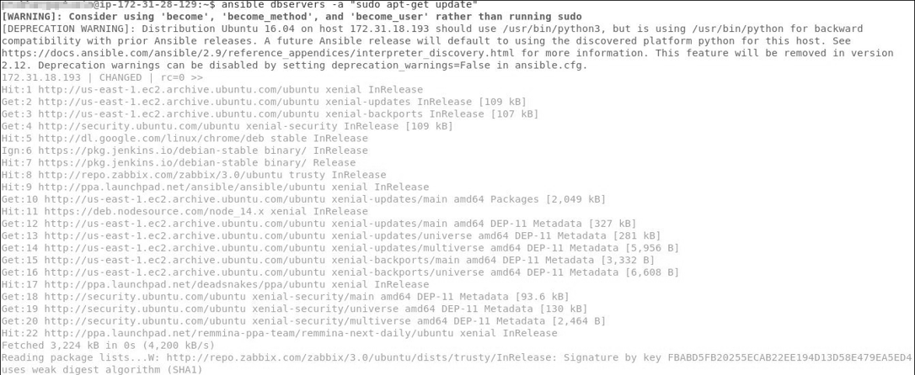

By following these steps, you have successfully worked with hosts both individually and in the group for streamlined management and deployment across your network infrastructure.

