Lesson 08 Demo 04
Creating a Simple HCL Configuration File
Objective: To create a basic HCL configuration file for setting up and managing AWS resources using Terraform

Prerequisites: AWS account with access keys, Terraform installed

Tools required: Terraform, VS code, AWS CLI

Steps to be followed:
- Prepare files and credentials for using Terraform
- Write the HCL configuration in the main.tf
- Validate and apply the Terraform configuration
- Clean up resources

Step 1: Prepare files and credentials for using Terraform

- Create a folder named Terraform on the desktop

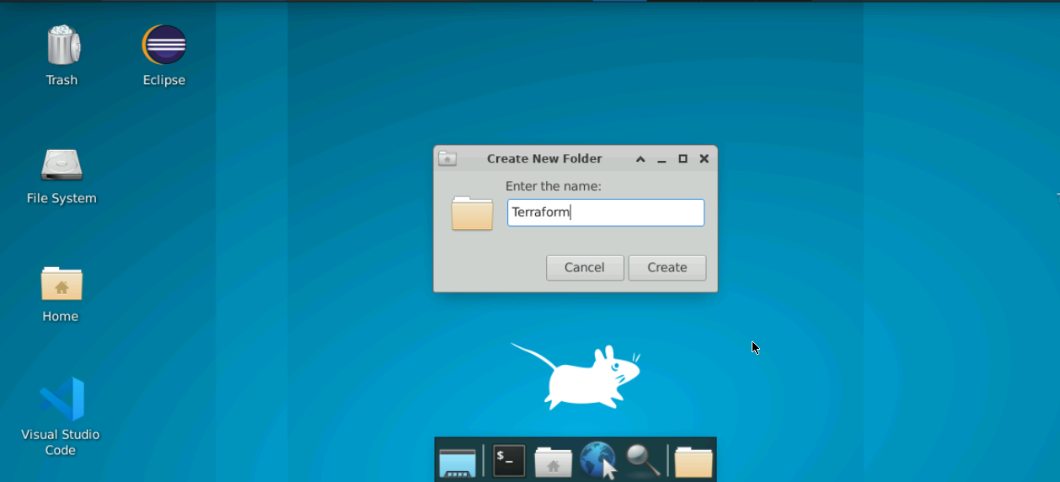

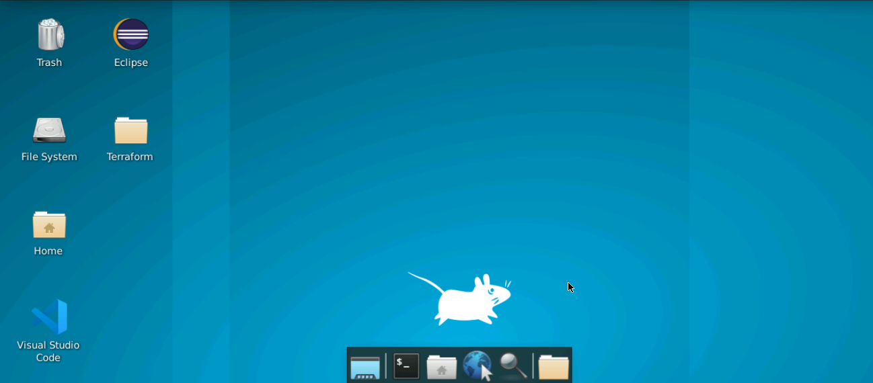

- Double-click on the VS Code editor icon present on the desktop to open it

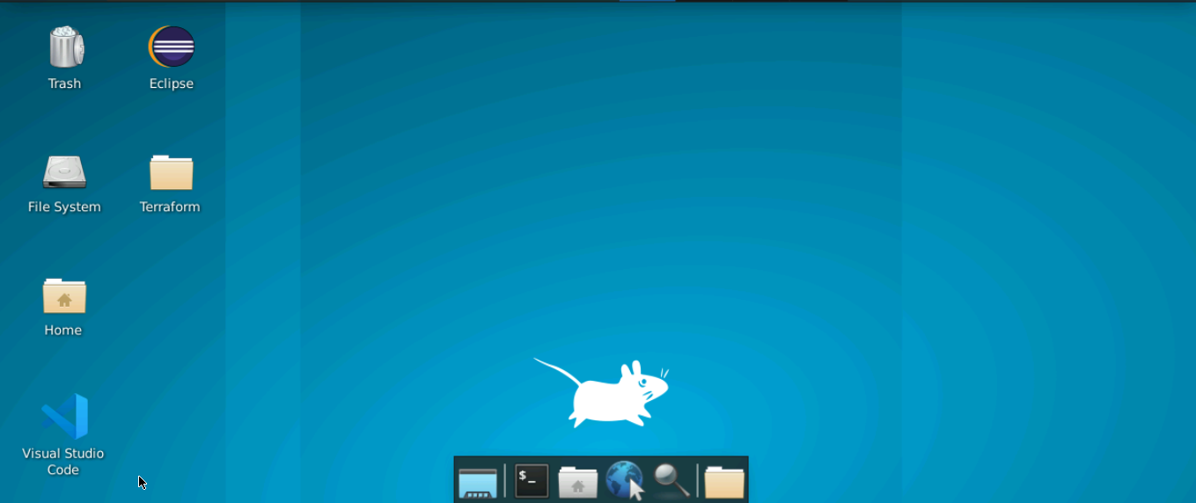

- Open the File option present on the top console

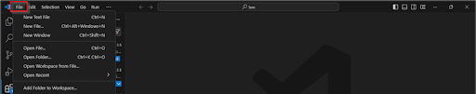

- Click on the Open Folder from the drop-down menu to open the Terraform folder

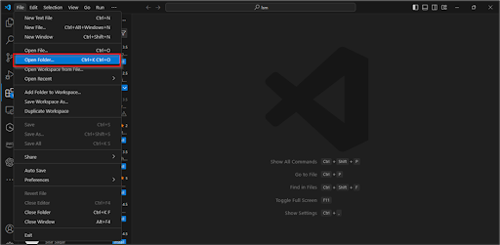

The Terraform folder will be opened in the VS Code editor.

- Navigate to the Terraform folder on the editor and click on the New File option to create the main file

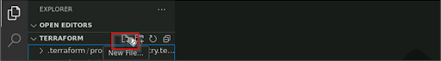

- Create a file named main.tf

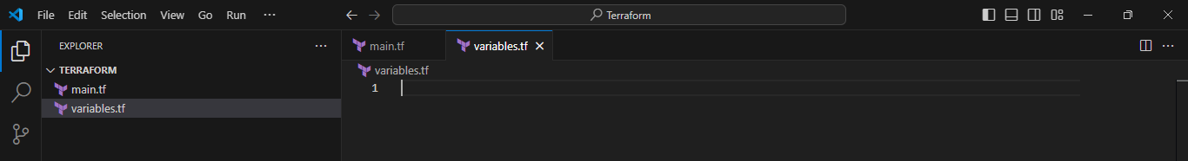

Step 2: Write the HCL configuration in main.tf

  - In the main.tf file, copy the following code to set up the AWS provider:

terraform {

required_providers {

aws = {

source = "hashicorp/aws"

version = "6.20.0"

}

}

}

provider "aws"
{
access_key = "<YOUR_AWS_ACCESS_KEY>"
secret_key = "<YOUR_AWS_SECRET_KEY>"
region = "us-east-1"
}

resource "aws_s3_bucket" "example"
{
bucket = "my-unique-bucket-${random_id.bucket_id.hex}"
}
resource "random_id" "bucket_id"
{
byte_length = 8
}

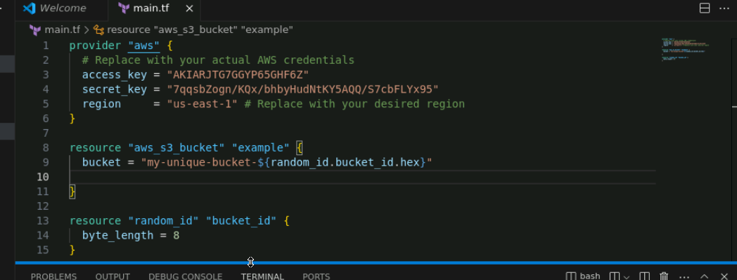

Note: Replace <YOUR_AWS_ACCESS_KEY> and <YOUR_AWS_SECRET_KEY> with your actual AWS credentials.

  - Open the terminal in VS Code and run the following command to initialize terraform:
terraform init

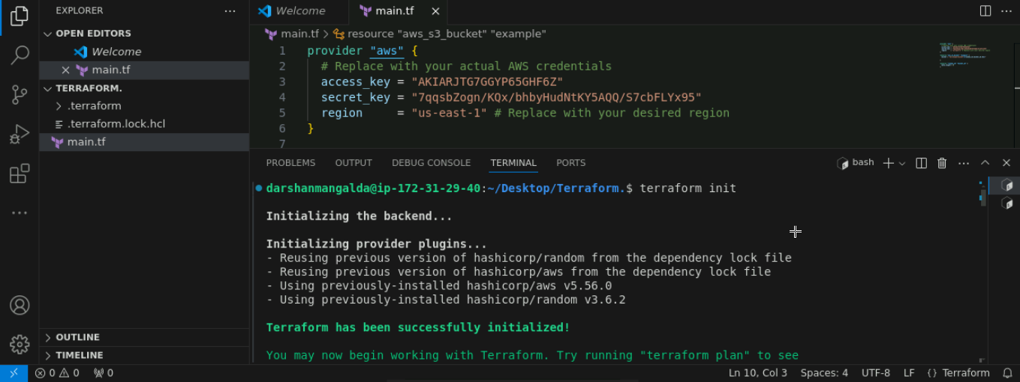

Step 3: Validate and apply the Terraform configuration

  - Run the following command to create an execution plan:
terraform plan

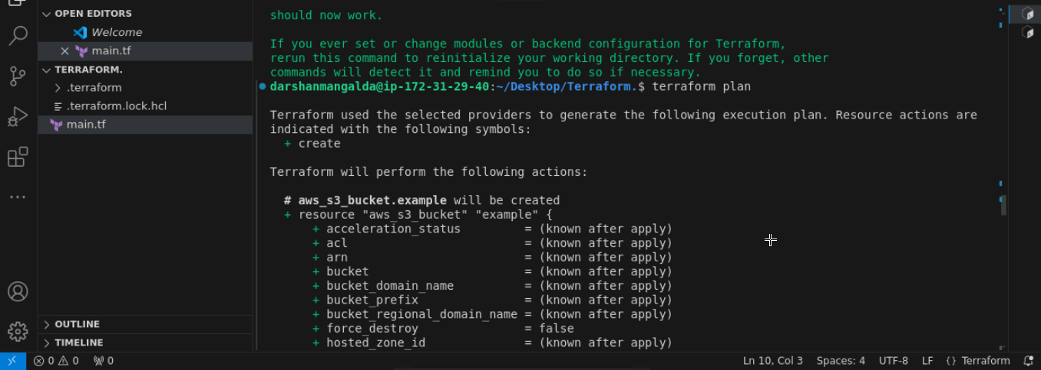

  - Execute the following command to apply the configuration:
terraform apply -auto-approve

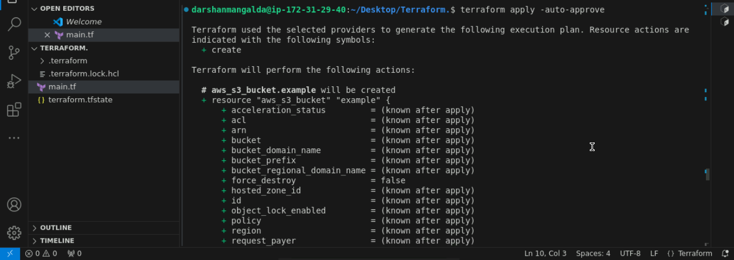

Terraform will provision the resources defined in the main.tf.

Step 4: Clean up resources

  - To destroy the terraform managed infrastructure, run the following command:
terraform destroy -auto-approve

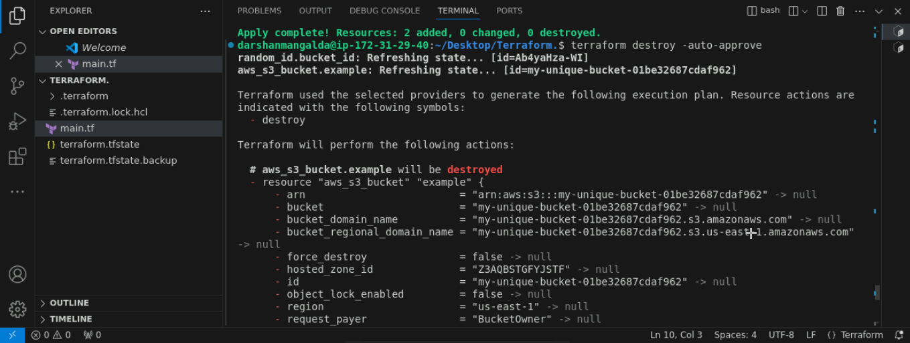

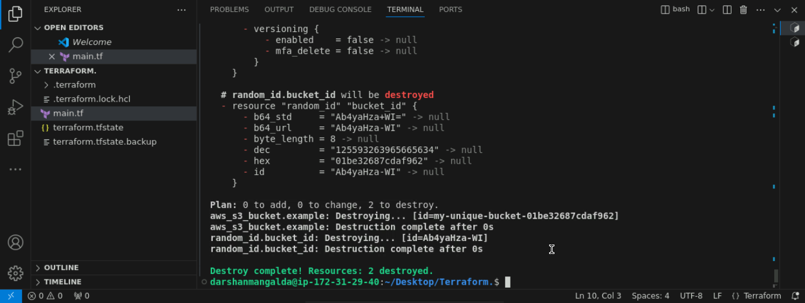

By following these steps, you have successfully created a simple HCL configuration file, initialized Terraform, and managed AWS resources efficiently.

