Lesson 08 Demo 05
Implementing HCL Functions
Objective: To demonstrate the use of HCL functions such as string manipulation, collections, and encoding

Prerequisites: Terraform installed

Tools required: Terraform and VS code

Steps to be followed:
- Prepare files and set up Terraform
- Write the HCL configuration using functions
- Validate and apply the Terraform configuration

Step 1: Prepare files and set up Terraform

- Create a folder named Terraform on the desktop

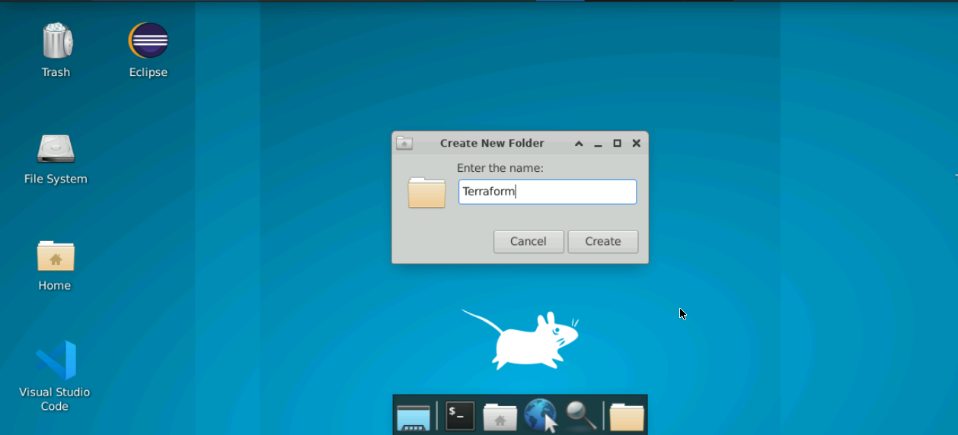

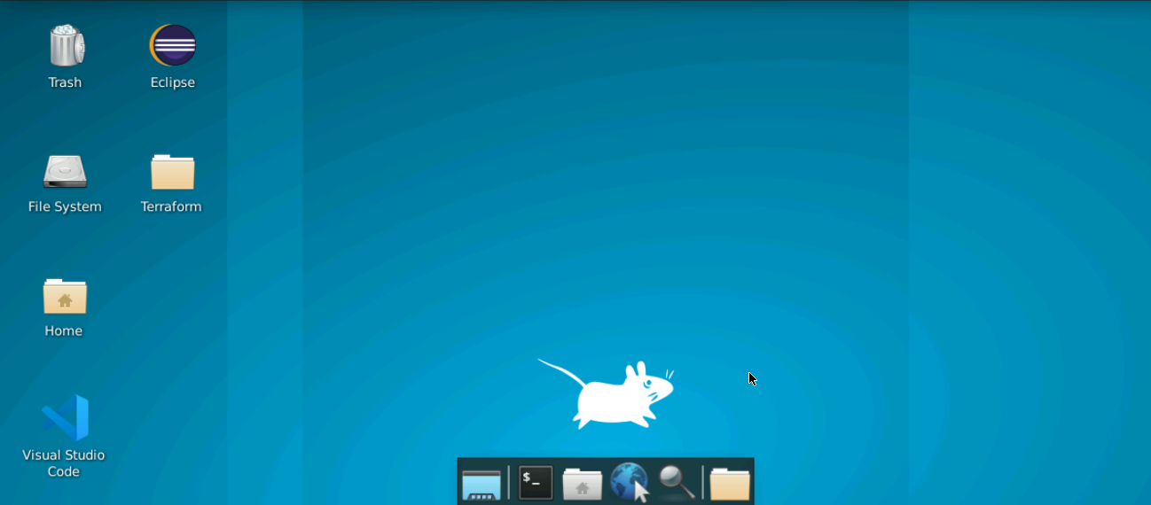

- Double-click on the VS Code editor icon present on the desktop to open it

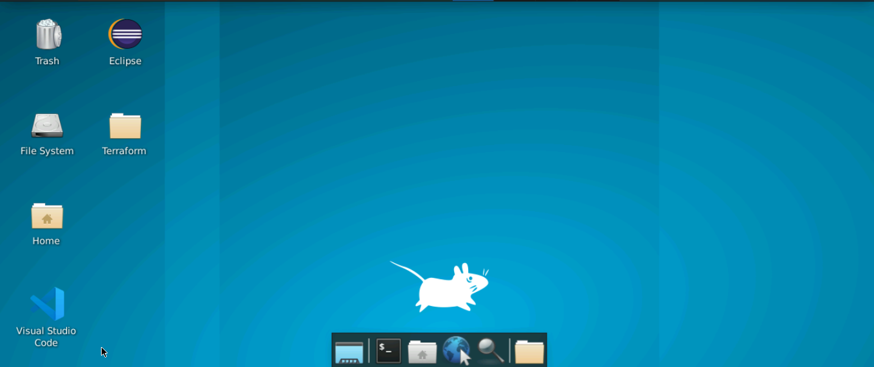

- Open the File option present on the top console

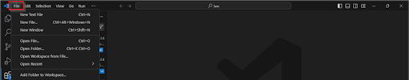

- Click on the Open Folder from the drop-down menu to open the Terraform folder

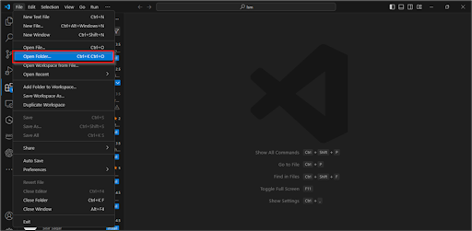

The Terraform folder will be opened in the VS Code editor.

- Navigate to the Terraform folder on the editor and click on the New File option to create the main file

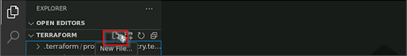

- Create a file named main.tf

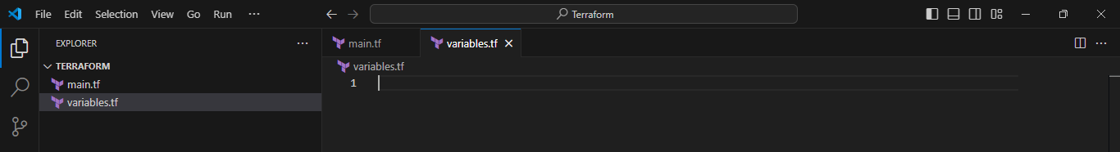

Step 2: Write the HCL configuration using functions

  - In the main.tf file, copy the following code to manipulate strings:

variable "greeting" {
default = "Hello"
}

variable "name" {
default = "World"
}

output "message" {
value = "${var.greeting}, ${upper(var.name)}!"
}

variable "list_example" {
default = ["one", "two", "three"]
}

variable "map_example" {
default = {
key1 = "value1"
key2 = "value2"
}
}

output "first_element" {
value = "${element(var.list_example, 0)}"
}

output "map_value" {
value = "${lookup(var.map_example, "key1")}"
}

variable "text" {
default = "Terraform"
}

output "base64_encoded" {
value = "${base64encode(var.text)}"
}

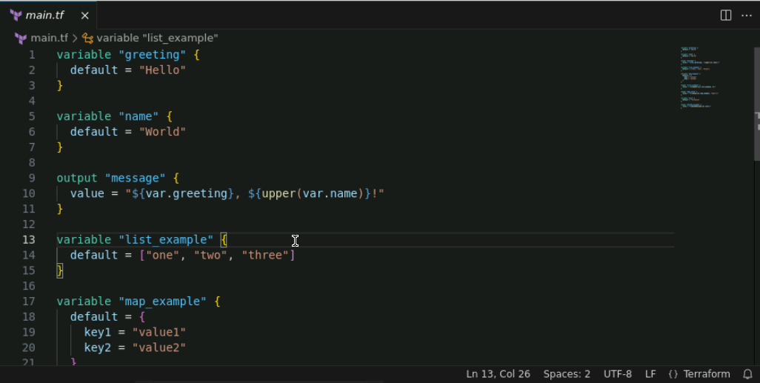

  - Open the terminal in VS Code and run the following command to initialize terraform:
terraform init

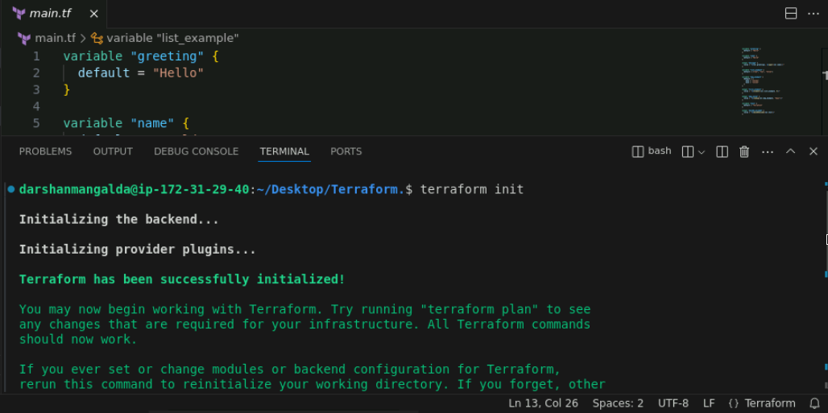

Step 3: Validate and apply the Terraform configuration

  - Run the following command to validate the configuration:
terraform validate

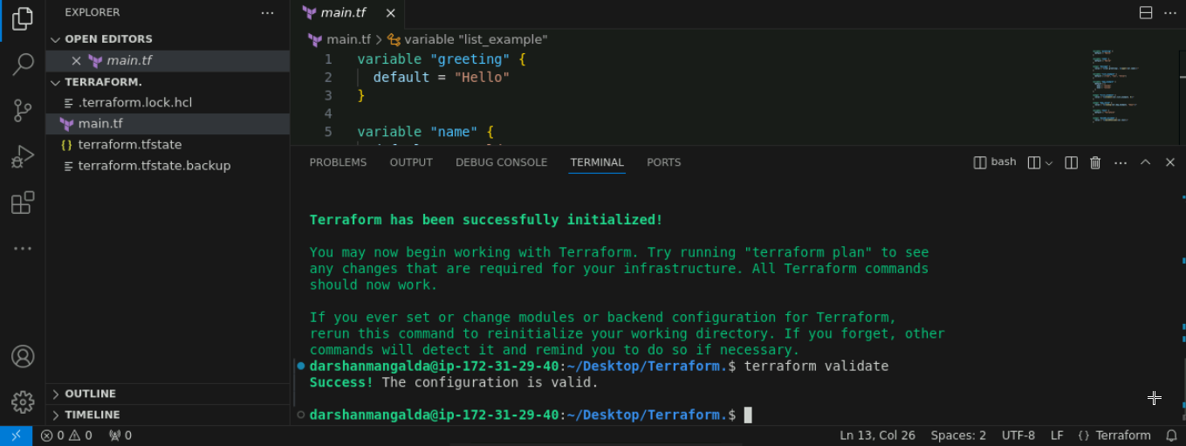

  - Execute the following command to apply the configuration:
terraform apply -auto-approve

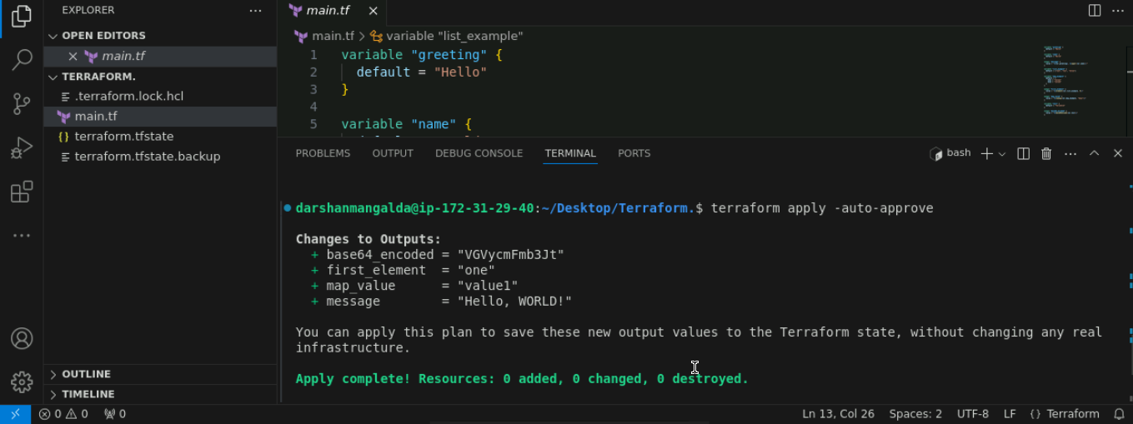

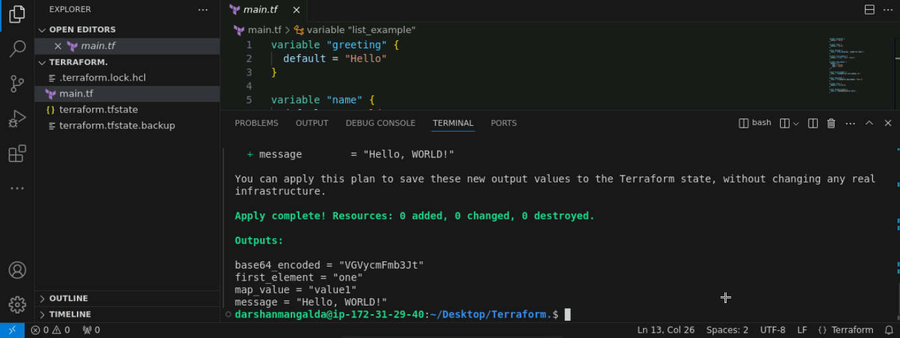

By following these steps, you have successfully demonstrated various HCL functions, including string manipulation, collections, and encoding using Terraform.

====================== My Edits =================================
We can do this on AWS with below code.
Creating instance and giving it a public IP and then fetching it through a variable:
==========
resource "aws_instance" "sl" {

ami = "ami-0ecb62995f68bb549"

instance_type = "t3.micro"

tags = {

Name="SL-Instance"

}

}

output "ec2_public_ip" {

description = "The public IP address of the EC2 instance"

value = aws_instance.sl.public_ip

}

