Lesson 10 Demo 03

Configuring Terraform State Backend Storage
Objective: To configure and manage Terraform state using the AWS S3 backend for ensuring reliable state storage and management

Tools required: Visual Studio Code

Prerequisites: Ensure you have created and implemented the AWS access key and secret key before starting this demo. Refer to Lesson 08 Assisted Practice 02 for detailed steps.

Note: The folder structure created in the previous demos is used here. It is also included in the resources section of LMS. Please refer Lesson_10_demo_01

Steps to be followed:
- Enable versioning on the S3 bucket
- Enable encryption on the S3 bucket
- Enable locking for the S3 backend
- Remove existing resources with the terraform destroy command

Step 1: Enable versioning on the S3 bucket

- Log in to the AWS Management Console and navigate to the S3 service using the search bar

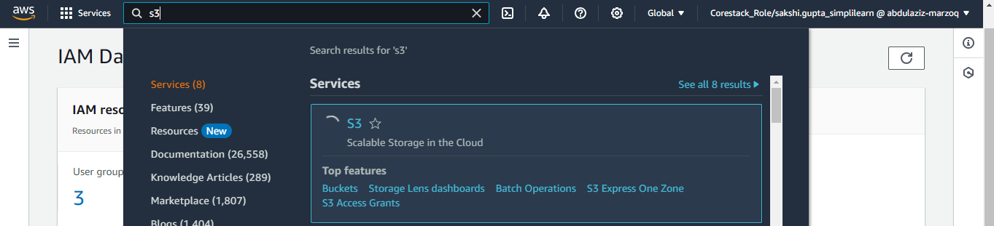

- Click on the previously created bucket named myterraformstatedemo

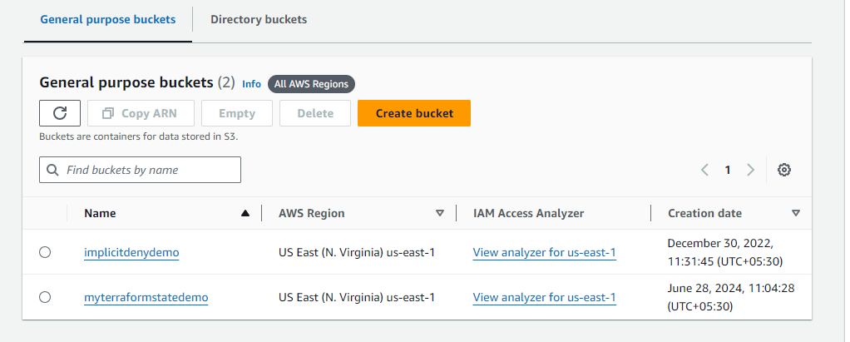

- Click on Properties

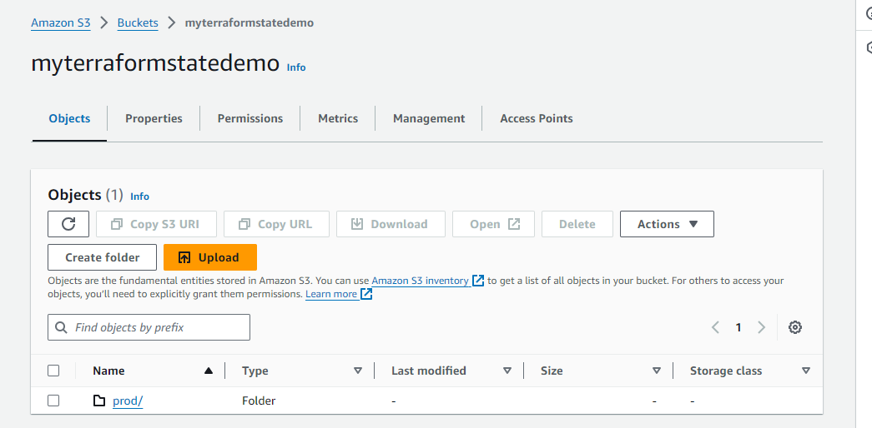

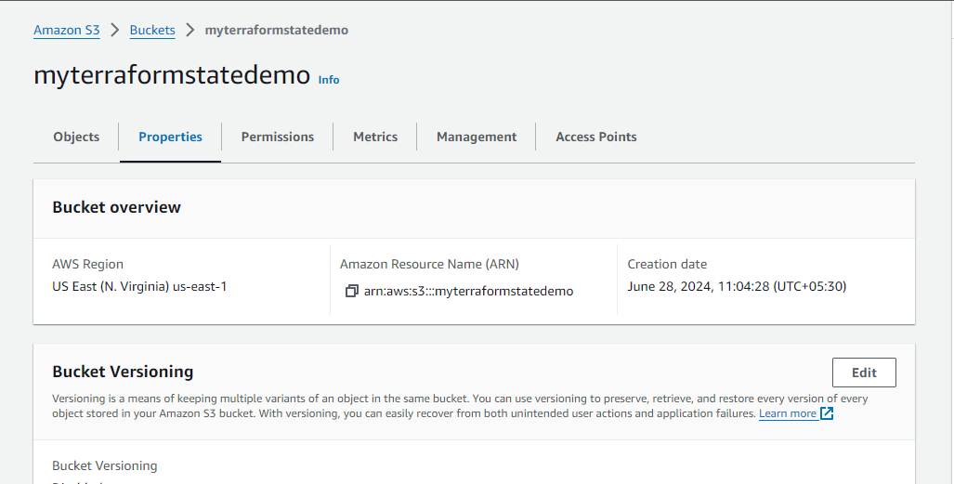

- Scroll down to Bucket Versioning and click on Edit

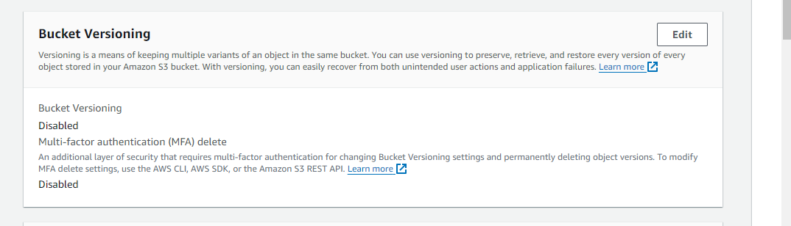

- Select Enable and click on Save changes

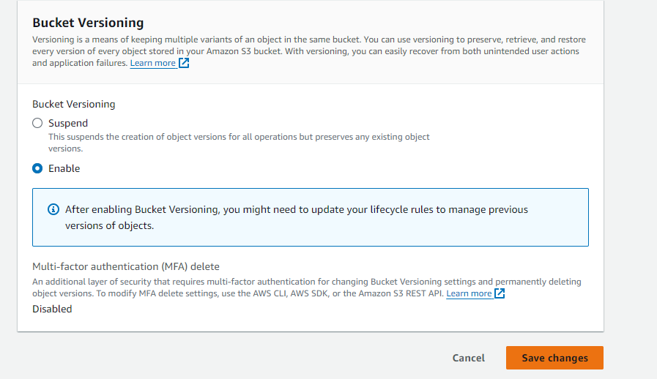

Versioning on the S3 bucket is successfully enabled, and the following message is shown:

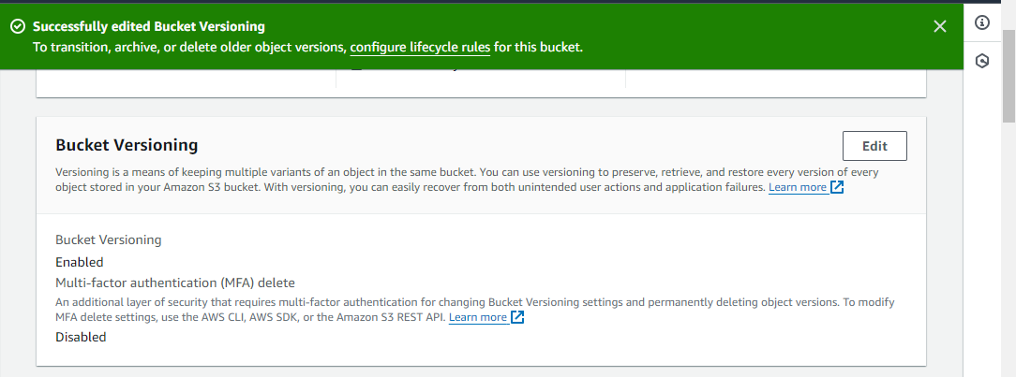

- Make a configuration change in Terraform main.tf file to generate a new state version using the following code:

resource "aws_instance" "web_server" {
ami = "ami-12345678"
instance_type = "t2.small"
subnet_id = "subnet-12345678"
tags = {
Name = "Web EC2 Server 2"
}
}

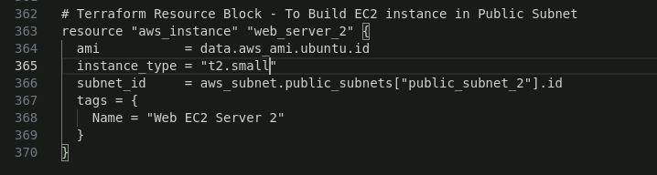

- Execute the following command in the terminal to apply the configuration changes:
terraform apply

- When prompted, approve the changes by typing yes

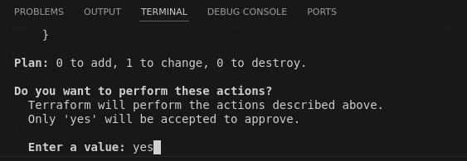

- Go to the Amazon S3 management console and click on the folder named /prod

- Enable Show versions and the newly created versions of the Terraform configurations will appear

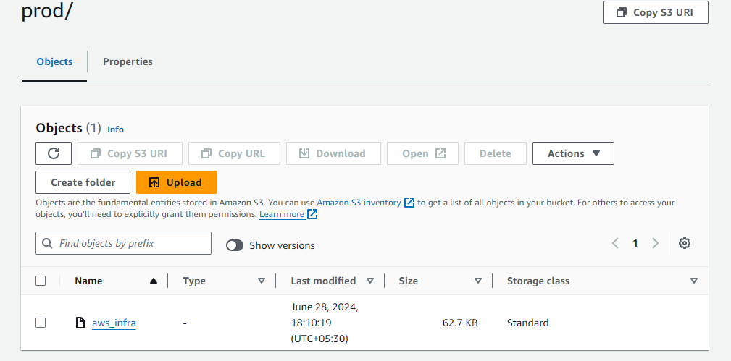

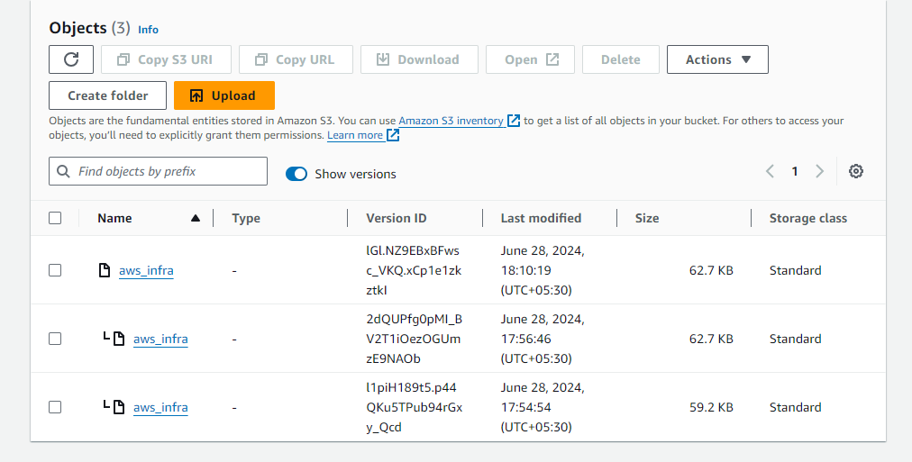

Step 2: Enable encryption on the S3 bucket

- In the Amazon S3 management console, go into the created bucket named myterraformstatedemo, and click on Properties

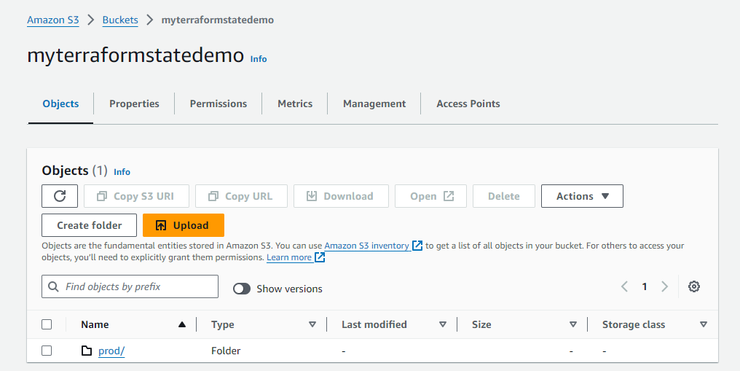

- Scroll down to the Default encryption section and click on Edit

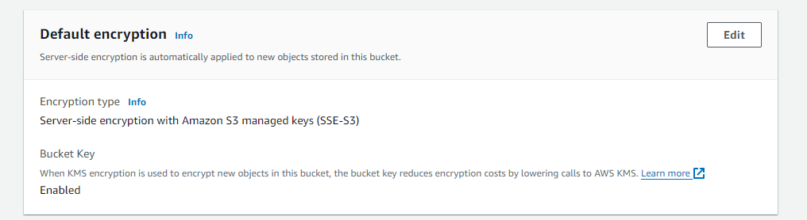

- Make sure the Encryption type is selected and the Bucket Key is enabled as shown in the following screenshot. Click on Save changes.

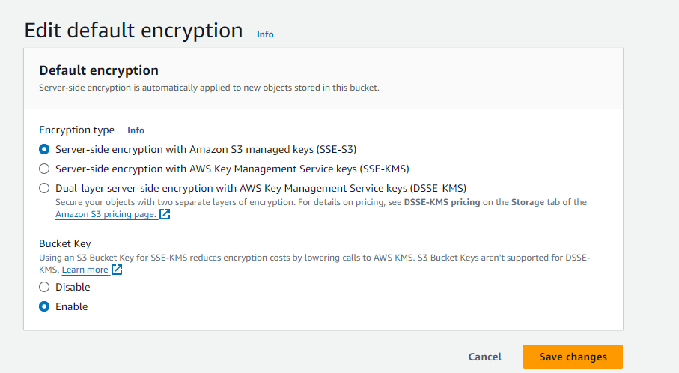

Encryption on the S3 bucket is successfully enabled, and the following message will be displayed:

