Lesson 04 Demo 01

Creating, Validating, and Parsing a YAML File Using Python
Objective: To create, validate, and parse a YAML file using Python for managing configurations or data serialization tasks, ensuring the file is read and validated correctly

Tools required: Linux terminal

Prerequisites: None

Steps to be followed:
- Create a YAML file using Python
- Run the Python file

Step 1: Create a YAML file using Python

- Run the following command to create a Python file:
sudo nano yaml_demo.py

- Add the following code to yaml_demo.py to create, validate, and parse a YAML file:
import yaml

# Step 1: Create a YAML filed
def create_yaml():
data = {
'name': 'Josh',
'age': 36,
'city': 'Springfield'
}

with open('data.yaml', 'w') as file:
yaml.dump(data, file)

# Step 2: Validate the YAML file
def validate_yaml():
try:
with open('data.yaml', 'r') as file:
data = yaml.safe_load(file)
print("YAML file is valid.")
return data
except yaml.YAMLError as exc:
print("Error in YAML file:", exc)
return None

# Step 3: Parse the YAML file
def parse_yaml(data):
if data:
print("Name:", data['name'])
print("Age:", data['age'])
print("City:", data['city'])

if __name__ == "__main__":
create_yaml()
data = validate_yaml()
parse_yaml(data)
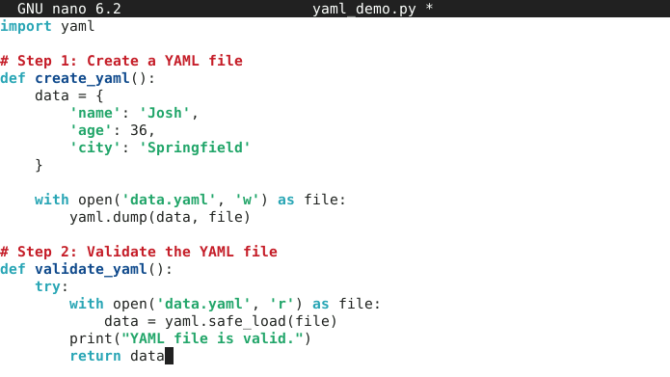

Step 2: Run the Python file

- Use the following command to run the Python file:
sudo python yaml_demo.py
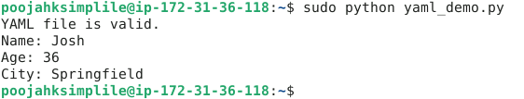
By following these steps, you have successfully created, validated, and parsed a YAML file using Python, ensuring both file reading and validation for configuration management or data serialization tasks.

