Lesson 05 Demo 03

Executing Loops in a Playbook

Objective: To execute loops in a playbook to iterate over a list of items efficiently in Ansible
Tools required: Linux terminal
Prerequisites: None

Steps to be followed:
- Create and execute a playbook

Step 1: Create and execute a playbook

- Create a playbook file named loops.yaml using the following command:
sudo nano loops.yaml
- Copy and paste the below script into the loops.yaml file:
---
- hosts: webservers
become: true
tasks:
- name: loop
debug:
msg: "{{ item }}"
loop:
- one
- two
- name: with_items
debug:
msg: "{{ item }}"
with_items:
- one
- two
- name: with_indexed_items
debug:
msg: "{{ item.0 }} - {{ item.1 }}"
with_indexed_items:
- one
- two
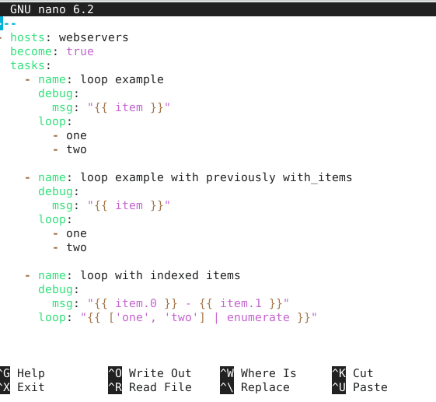

- Run the following command to execute the playbook:
ansible-playbook loops.yaml
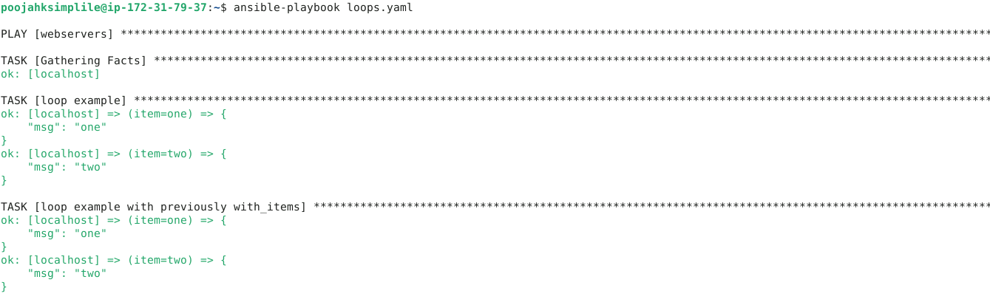
By following these steps, you have successfully executed loops in a playbook to iterate over a list of items efficiently in Ansible.

