Lesson 05 Demo 01

Creating an Ansible Playbook

Objective: To create an Ansible playbook to automate tasks like server setup, application deployment, user management, and cloud resource provisioning
Tools required: Linux terminal
Prerequisites: None

Steps to be followed:
- Create and execute an Ansible playbook

Step 1: Create and execute an Ansible playbook

- Run the following command to create a file:
sudo nano node.yaml
- Copy and paste the below script into the node.yaml file:
---
- name: install nodejs

hosts: webservers

gather_facts: True

become: true

tasks:

- name: add apt key for nodesource

apt_key: url=https://deb.nodesource.com/gpgkey/nodesource.gpg.key

- name: add repo for nodesource

apt_repository:

repo: 'deb https://deb.nodesource.com/node_0.10 {{ansible_distribution_release }} main'

update_cache: no

- name: install nodejs

apt: name=nodejs
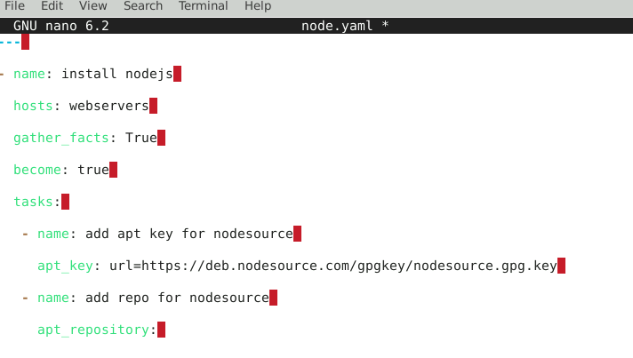

- Run the following command to automate Node.js application:
ansible-playbook node.yaml
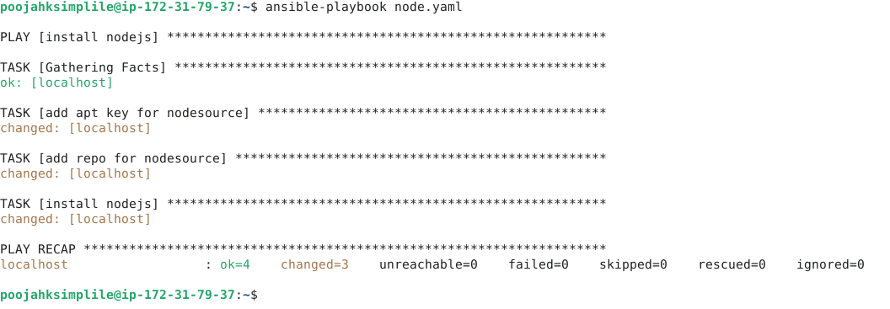

By following these steps, you have successfully created an Ansible playbook to automate tasks like server setup, application deployment, user management, and cloud resource provisioning.

