Lesson 05 Demo 02

Executing Variables in Ansible Playbook

Objective: To execute variables in the Ansible playbook to manage dynamic configurations and settings
Tools required: Linux terminal
Prerequisites: None

Steps to be followed:
- Execute variables in the Ansible playbook

Step 1: Execute variables in the Ansible playbook

- Run the following command to create a file:
sudo nano basic.yml
- Enter the below script inside the basic.yml file:
---

- hosts: all
vars:

salutations: Hello guys!

tasks:

- name: Ansible Variable Basic Usage
debug:

msg: "{{ salutations }}"
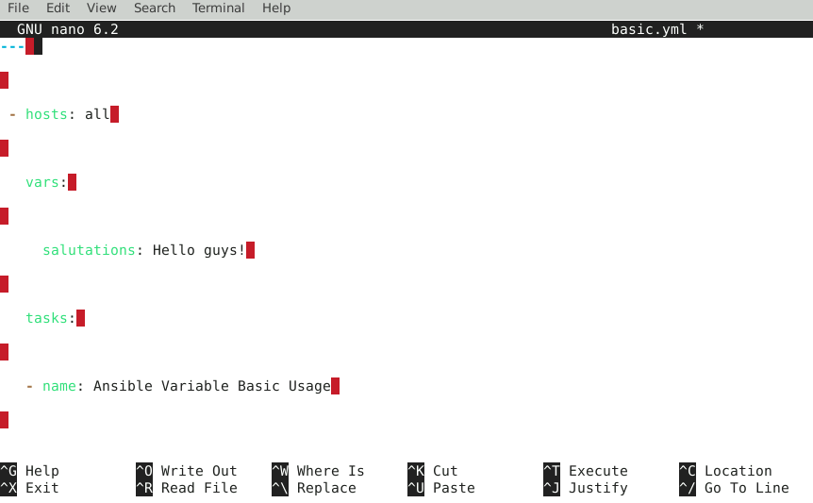
- Run the following command to execute the playbook:
ansible-playbook basic.yml
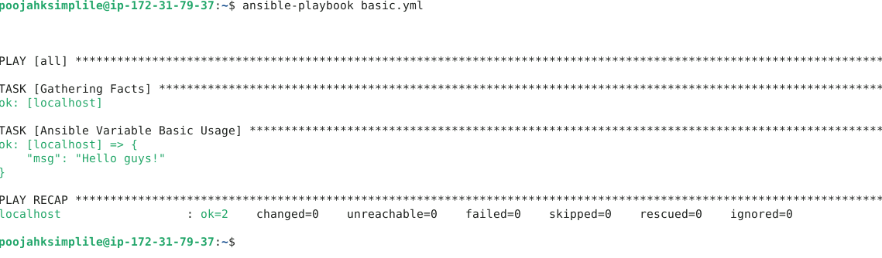
By following these steps, you have successfully executed variables in the Ansible playbook to manage dynamic configurations and settings.

