QUERY 1:-- QUERY 1: WRITE A QUERY TO DISPLAY HOW MANY EMPLOYEES WORK UNDER A DEPARTMENT , COUNTRY AND CITY THEIR AVG SALARY FOR UK AND US ONLY AND ORDER BY SALARY??
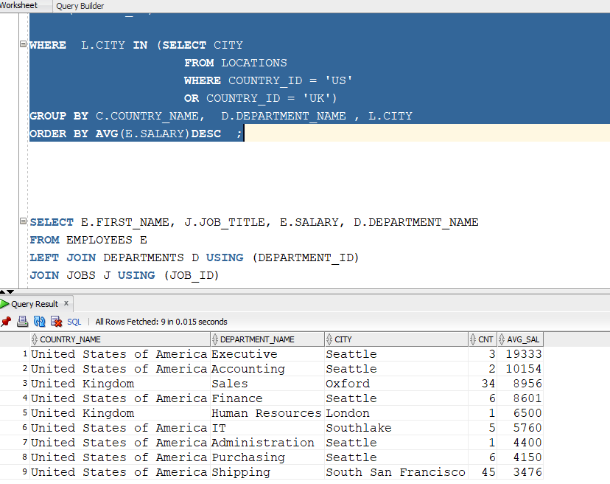

QUERY 2: -- QUERY 2:WRITE A QUERY TO DISPLAY TEAM MEMBERS OF ALEXANDER I.E HAVING SAME JOB AND SALARY EQUAL TO OR LESS THAN ALEXZANDER ??

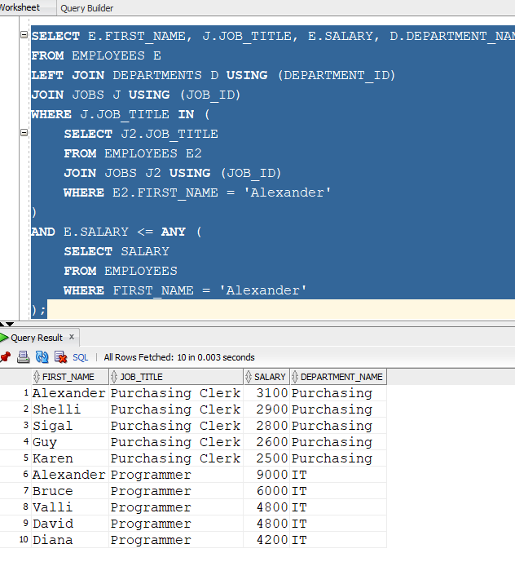

QUERY 3: -- QUERY 3: WRITE A QUERY TO DETAILS OF THOSE EMPLOYEES WORKING IN DEPARTMENT SAME AS LAURA AND EARNING MORE THAN OR SAME AS JHON CHEN???
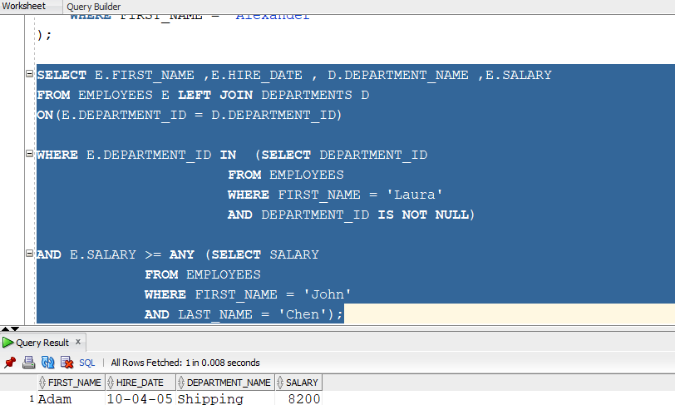

--- QUERY 4:WAQD COUNTRY WISE DEPT COUNT , EMPLOYEES COUNT , AND AVG SAL FOR ALL IN THAT COUNTRY FOR ALL THOSE WHOS HIRE_DATE IS GREATER THAN ADAMS

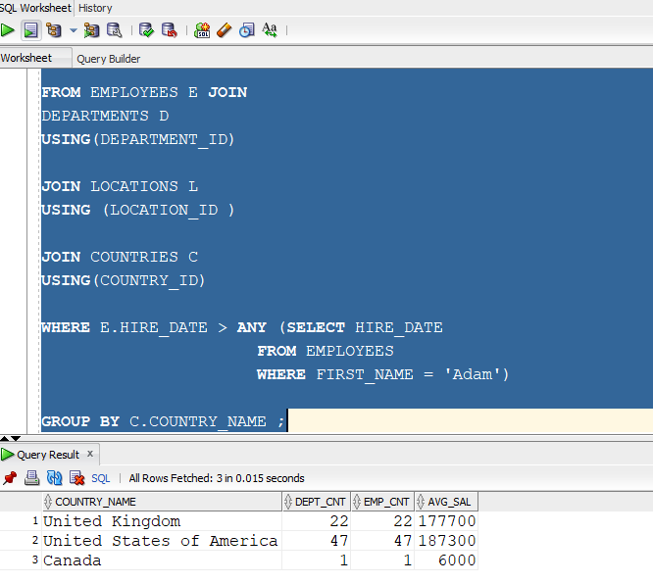

-- QUERY 5:WAQD THE JOB WISE ,COUNTRY WISE , DEPARTMENT_NAME WISE EMPLOYEES AND THEIR SALARY IS GREATER THAN MAX SALARY OF ACCOUNTING
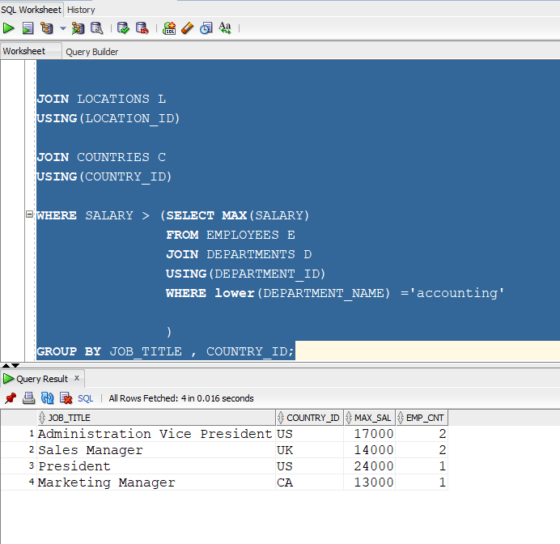

QUERY 6:-- QUERY 6: WAQD THE COUNTRY NAME . EMPLOYEE NAME , CITY , DEPARTMENT_NAME FOR THOSE EMPLOYEES WHOSE NAME LENGHT GRATER THAN ADAMS , AND EMAIL LENGTH GREATER THAN ADAMS EMAIL;
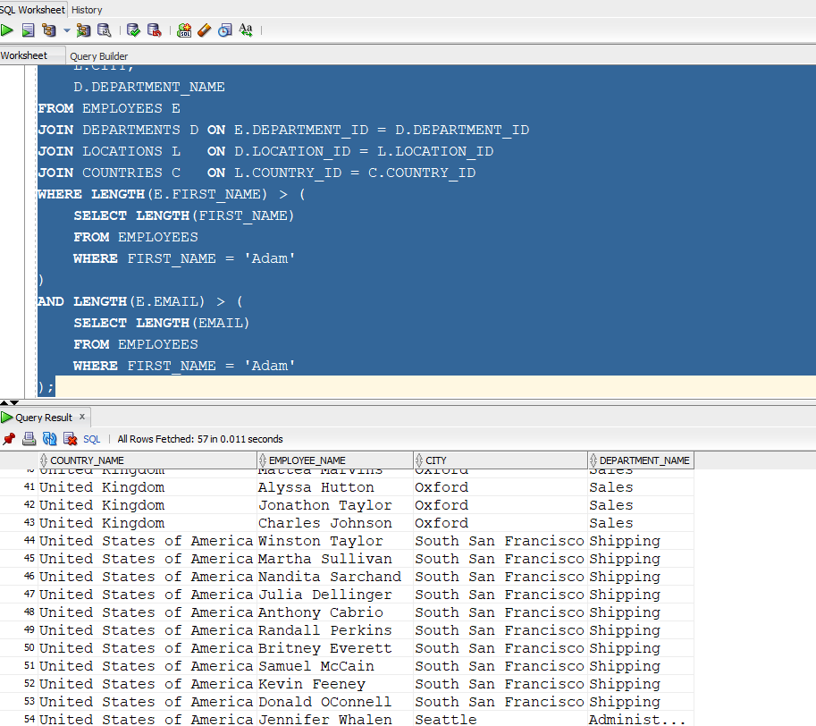

-- QUERY 7: WRITE A QUERY TO DISPLAY EMP DETAILS WHERE MANAGER SAME AS DEPARTMENT MANAGER AND SALARY GRETER THAN AVG SAL OF THERE RESPECTVE DEPARTMENTS
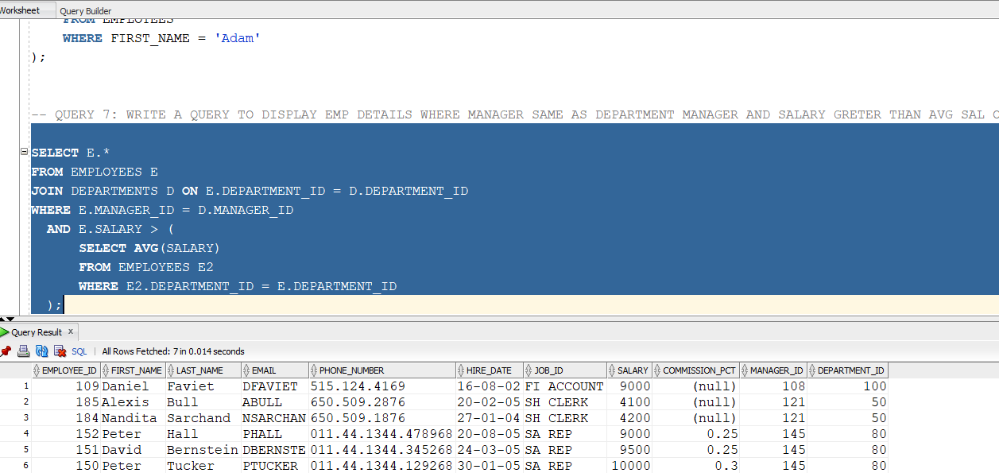

-- QUERY 8: WAQD THE COUNTRY , REGION , CITY , STATE_PROVINCE WHERE NEENA IS LIVING

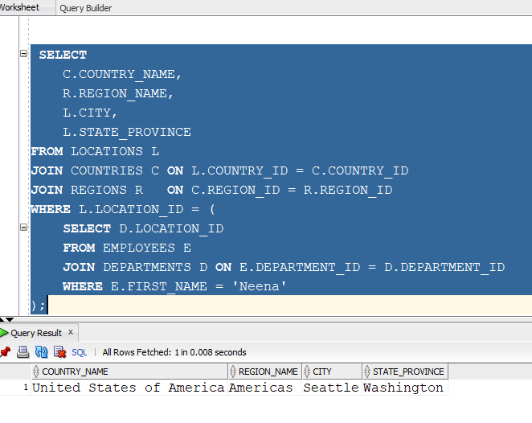

-- QUERY 9: WAQD ALL EMP DET WHO EARN LESS THAN PRESIDENT BUT HIGHER SALARY THAN AVG OF THERE RESPACTIVE DEPARTMENTS

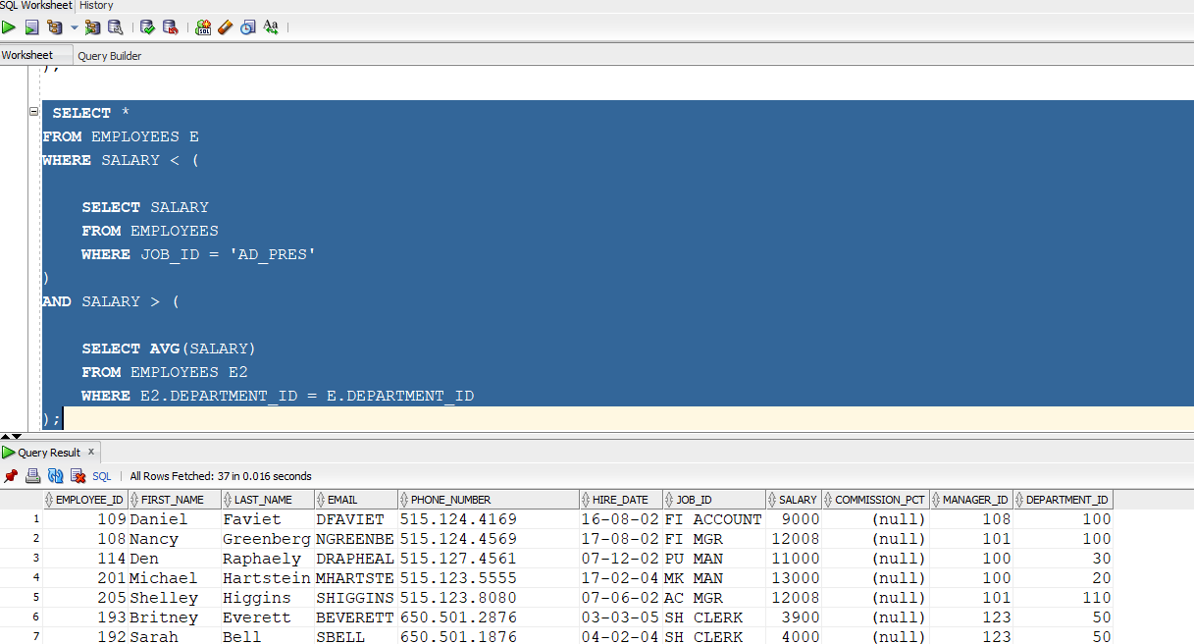

-- QUERY 10: WAQD DPEART NAME WISE COUNT OF EMP WHOSE DEP IS GRTER THAN 20 AND SALARY GRETER THAN MIN SALARY OF THEIR RSPECTIVE JOBS;

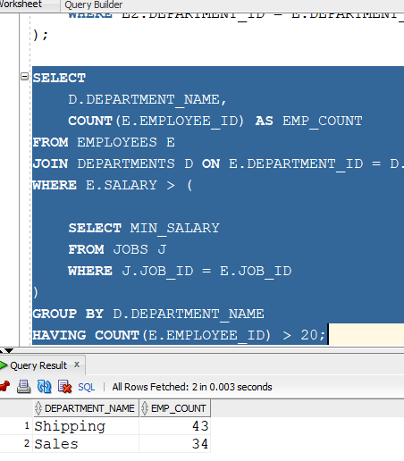

-- QUERYY 11: WAQD THE EMPLOYEE DETAILS WHOSE SALARY IS IN RANGE 4000 AND 8000 AND HIRE DATE SAME IN SAME YEAR AS JHON CHEN
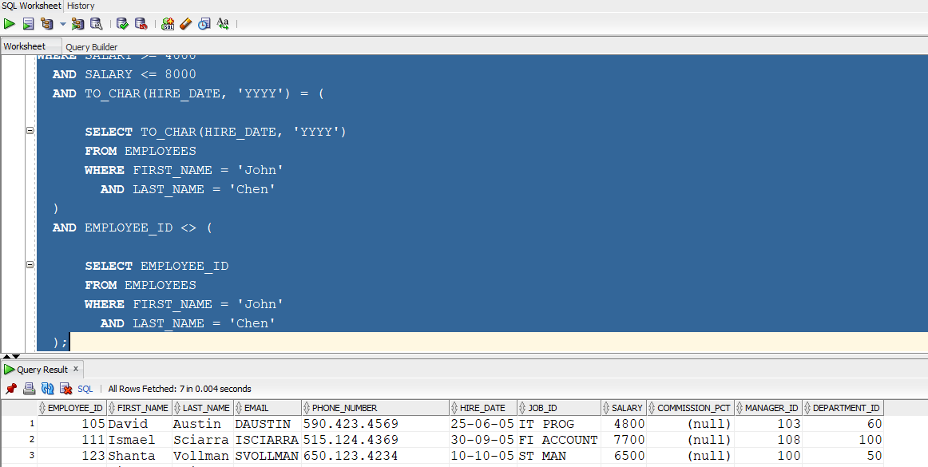

- QUERY 12: WAQD CATEGYS EMP BASE ON MAX SAL AND DEPARTMENTS AND SUM SALARY > 10000 AND COUNT > 1
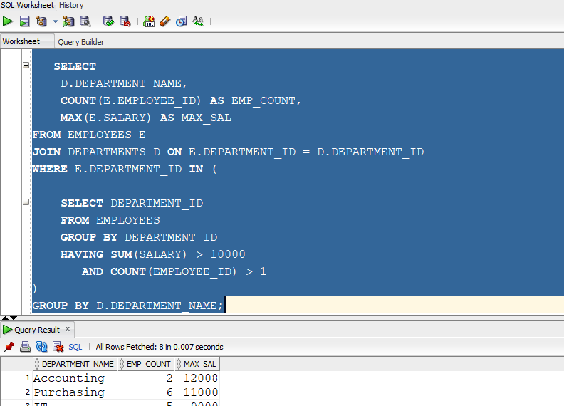

-QUERY 13: WAQD THE DEPARTMENTS AND FIND DEPARTMENTS HAVING MORE THAN 3 EMPLOYEE WITH SALARY ABOVE COMPANY AVERAGE
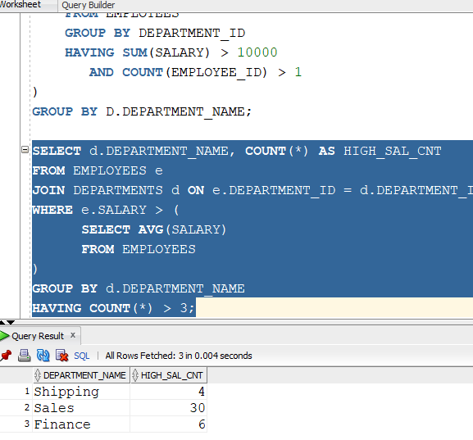

-- QUERY 14: WRITE A QUERY DISPLAY CITY WISE TOP PERFORMERS AND SALARY
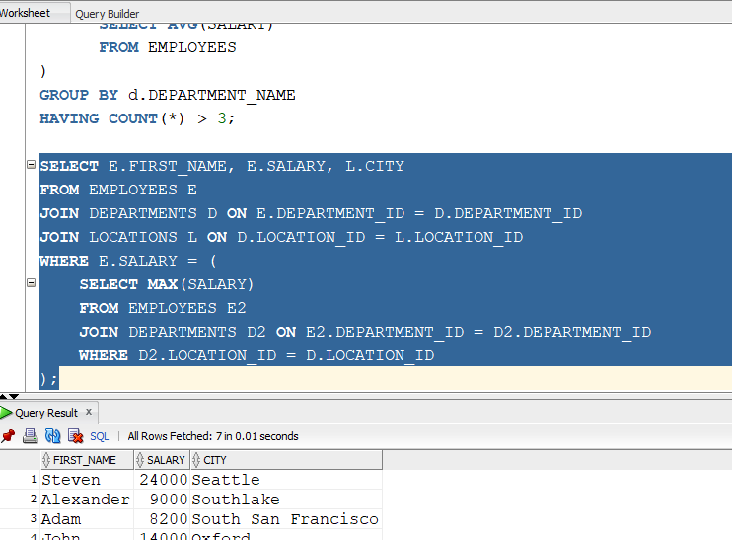

-- QUERY 15: WRITE A Find departments that currently have no employees, but are located in countries where the region is 'Europe'.
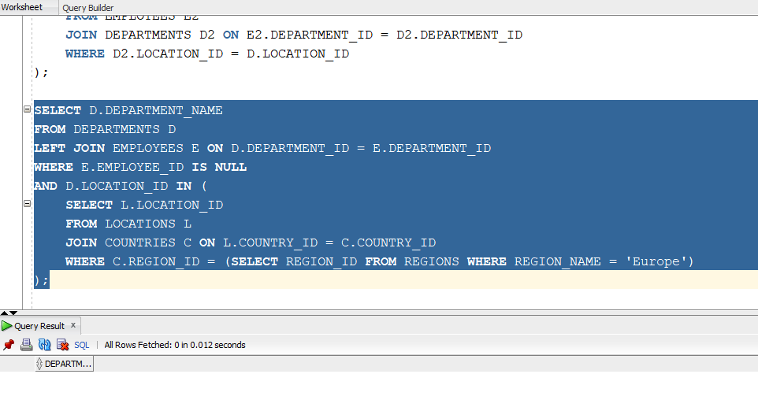

-- QUERY 16:WAQD details of employees working in the same country as the 'Accounting' department.
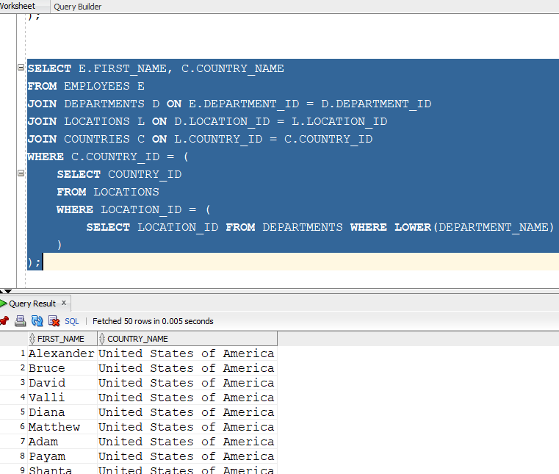

- QUERY 17: List OF employees hired before the President who also work in different countries than the President.
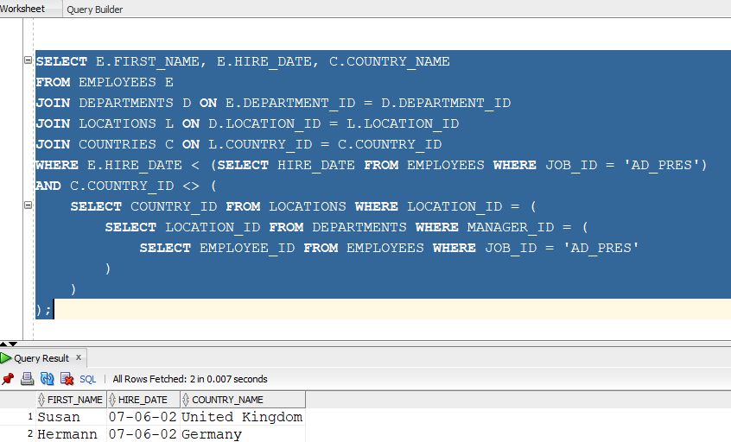

-- QUERY 18:Find the employee with the second-highest salary using a subquery
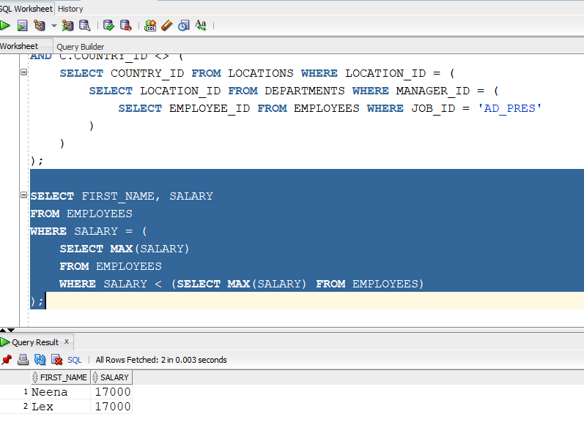

-- QUERY 19:d all employees whose salary is lower than the average salary of the 'IT_PROG' job ID.
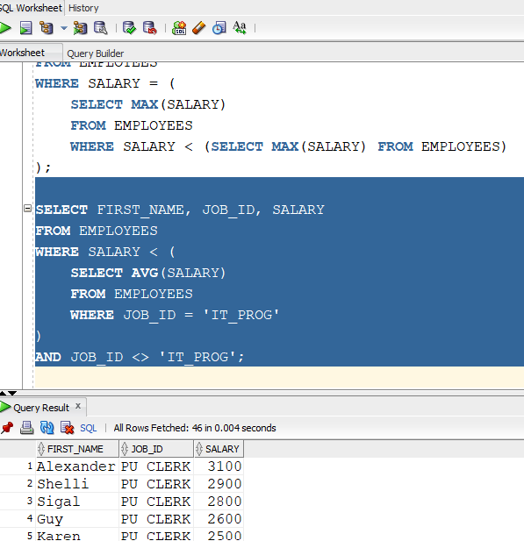

-- QUERY 20: DISPLAY EMPLOYEES WHO WORK IN SAME LOCATION AS DEPARTMENT 50

