QUERY 1: -- 1. WAQD DETAILS OF EMPLOYEES AND DEPARTMENTS THEY BELONG TO, INCLUDING DEPARTMENTS BUT DOESN'T HAVE ANY EMPLOYEES WORKING IN IT
-- AND ALSO EMPLOYEES WHO ARE NOT ASSIGNED TO ANY DEPARTMENT, JOIN ON DEPARTMENT ID AND RETURN THOSE EMPLOYEES WHO ARE HIRED IN YEAR 2003 AND WHOSE SALARY LESS THAN 20000.

-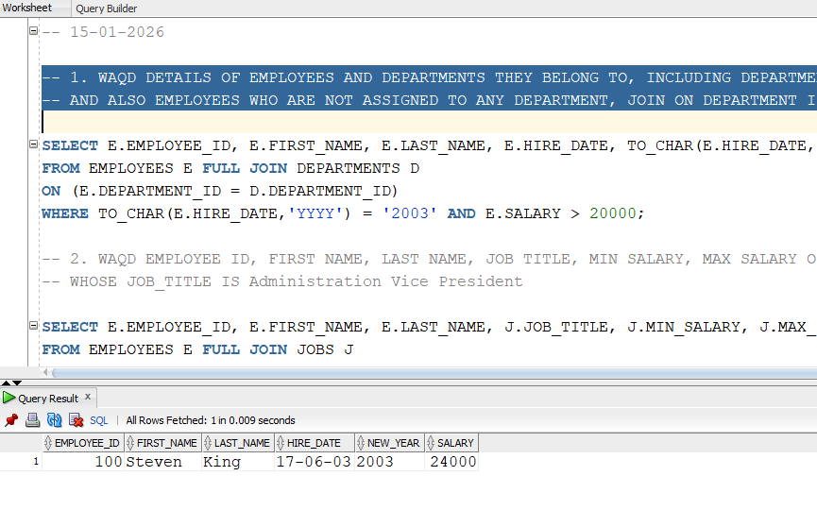

QUERY 2:
-- 2. WAQD EMPLOYEE ID, FIRST NAME, LAST NAME, JOB TITLE, MIN SALARY, MAX SALARY OF EMPLOYEES AND JOBS TABLE, APPLY FULL JOIN ON JOB ID,
-- WHOSE JOB_TITLE IS Administration Vice President
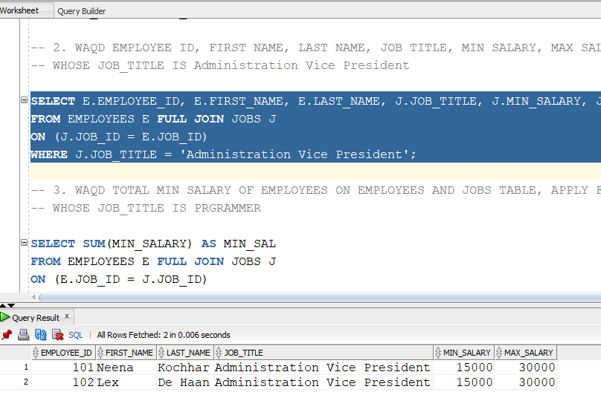
QUERY 3:
-- 3. WAQD TOTAL MIN SALARY OF EMPLOYEES ON EMPLOYEES AND JOBS TABLE, APPLY FULL JOIN ON JOB ID,
-- WHOSE JOB_TITLE IS PRGRAMMER
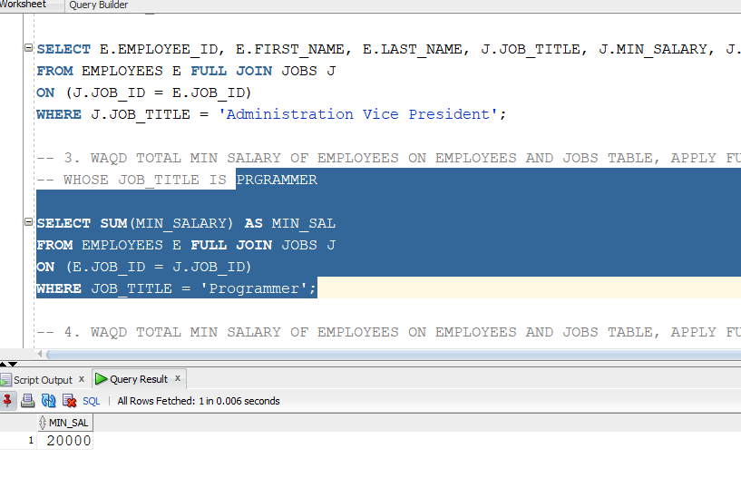

QUERY 4:
-- 4. WAQD TOTAL MIN SALARY OF EMPLOYEES ON EMPLOYEES AND JOBS TABLE, APPLY FULL JOIN ON JOB ID,
-- WHOSE JOB_TITLE IS STOCK MANAGER
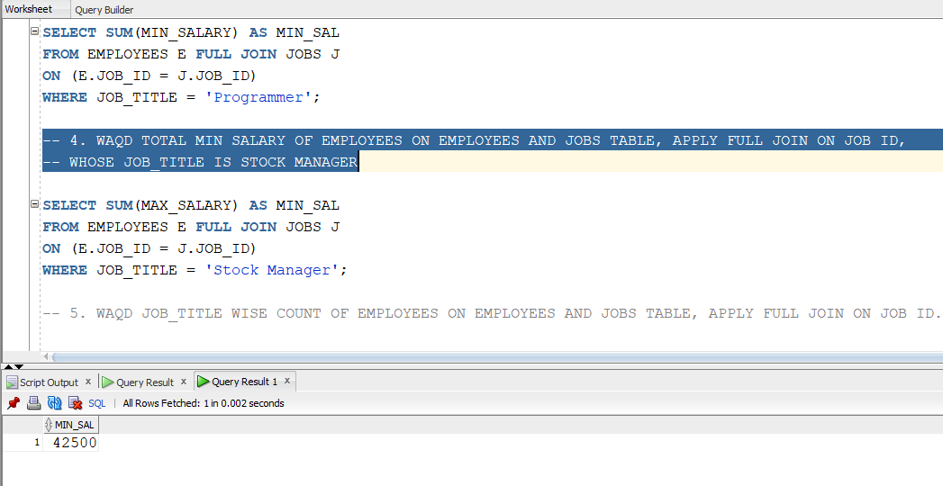

QUERY 5: WAQD JOB_TITLE WISE COUNT OF EMPLOYEES ON EMPLOYEES AND JOBS TABLE, APPLY FULL JOIN ON JOB ID.
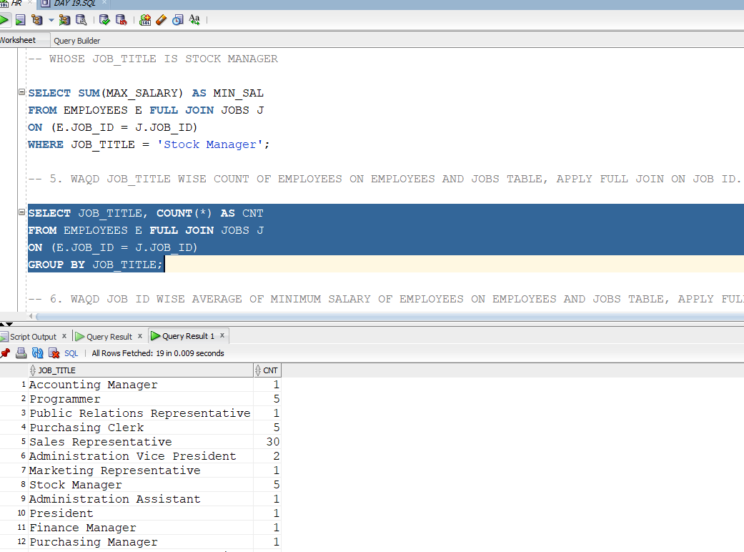

QUERY 6:
WAQD JOB ID WISE AVERAGE OF MINIMUM SALARY OF EMPLOYEES ON EMPLOYEES AND JOBS TABLE, APPLY FULL JOIN ON JOB ID.
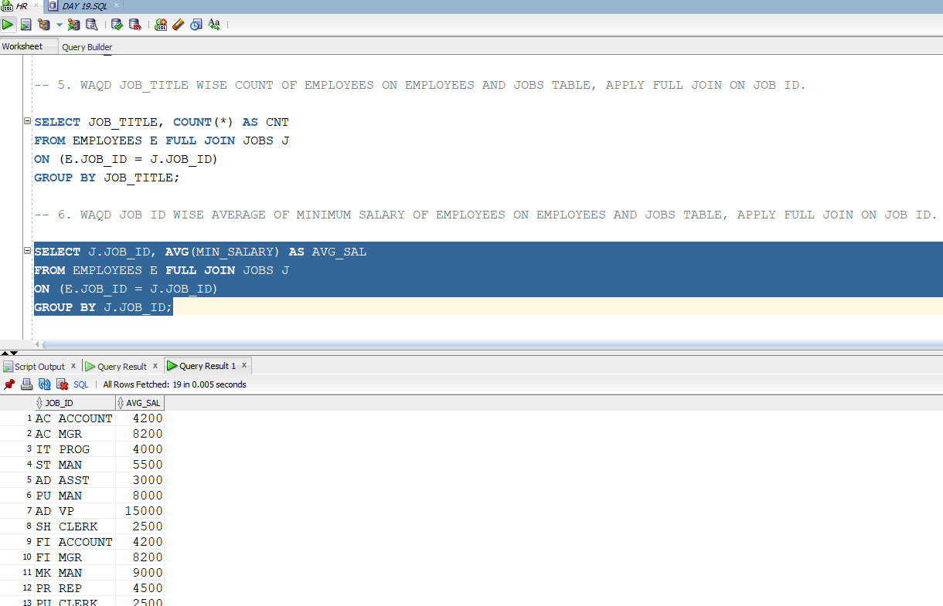

QUERY 7:WAQD EMPLOYEE ID, FIRST_NAME, LAST NAME, JOB_TITLE OF EMPLOYEES ON EMPLOYEES AND JOBS TABLE, APPLY FULL JOIN ON JOB ID, WHOSE AVG MINIMUM SALARY IS GREATER THAN 5000

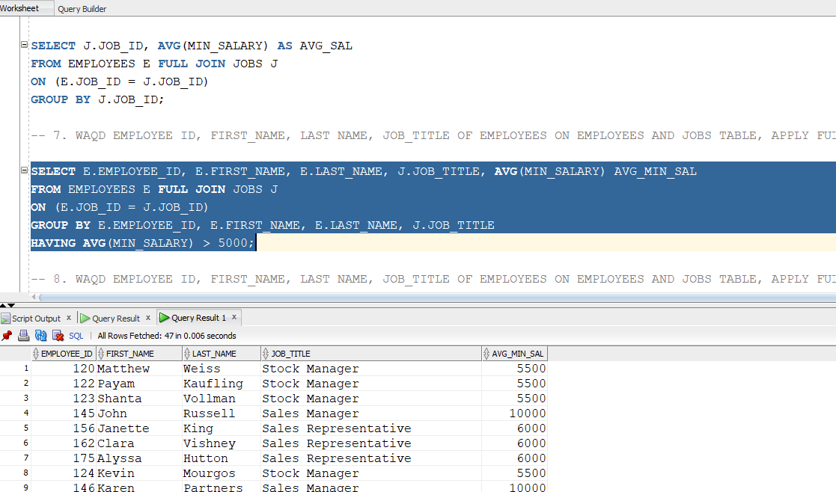

QUERY 8: WAQD EMPLOYEE ID, FIRST_NAME, LAST NAME, JOB_TITLE OF EMPLOYEES ON EMPLOYEES AND JOBS TABLE, APPLY FULL JOIN ON JOB ID,
-- WHOSE AVG MINIMUM SALARY IS EQUAL TO 2008 AND FIRST_NAME START WITH 'J'
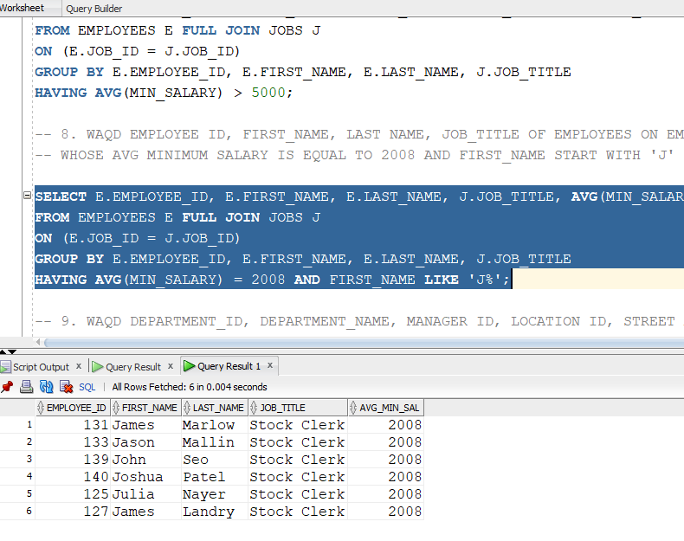

QUERY 9:WAQD DEPARTMENT_ID, DEPARTMENT_NAME, MANAGER ID, LOCATION ID, STREET ADDRESS, POSTAL CODE, CITY, STATEPROVINCE, COUNTRY_ID OF DEPARTMENTS
-- ON DEPARTMENTS AND LOCATIONS TABLE, APPLY LEFT JOIN ON LOCATION_ID
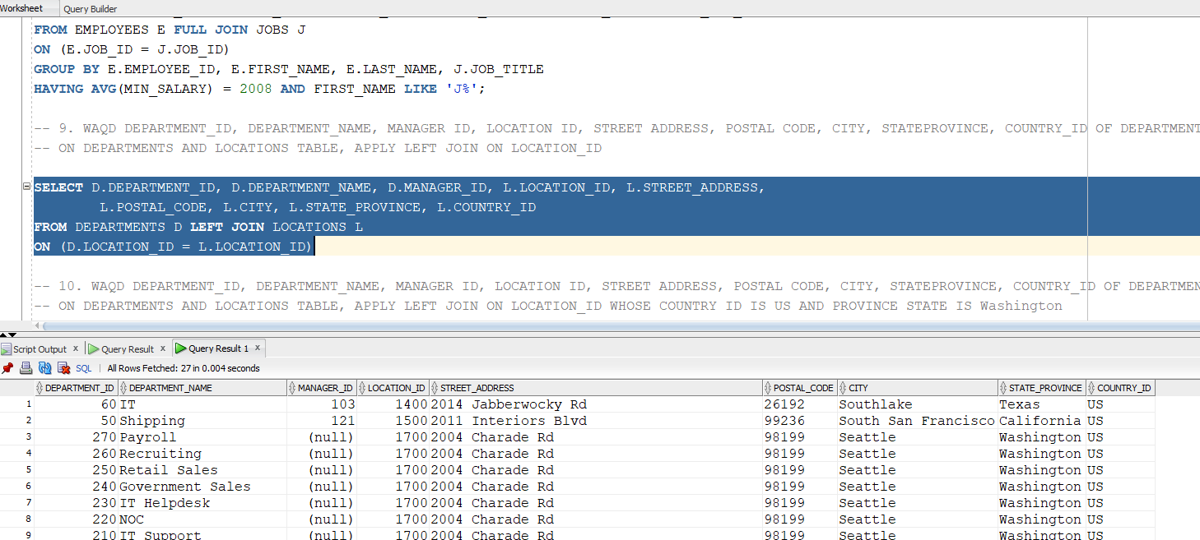

QUERY 10:
WAQD DEPARTMENT_ID, DEPARTMENT_NAME, MANAGER ID, LOCATION ID, STREET ADDRESS, POSTAL CODE, CITY, STATEPROVINCE, COUNTRY_ID OF DEPARTMENTS
-- ON DEPARTMENTS AND LOCATIONS TABLE, APPLY LEFT JOIN ON LOCATION_ID WHOSE COUNTRY ID IS US AND PROVINCE STATE IS Washington
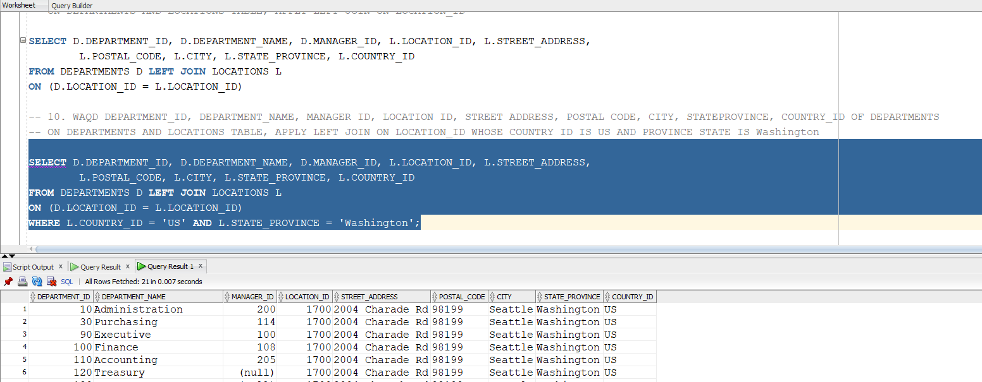

QUERY 11:
WAQD DEPARTMENT_ID, DEPARTMENT_NAME, MANAGER ID, LOCATION ID, STREET ADDRESS, POSTAL CODE, CITY, STATEPROVINCE, COUNTRY_ID OF DEPARTMENTS
-- ON DEPARTMENTS AND LOCATIONS TABLE, APPLY RIGHT JOIN ON LOCATION_ID WHOSE STATE PROVINCE IS NULL
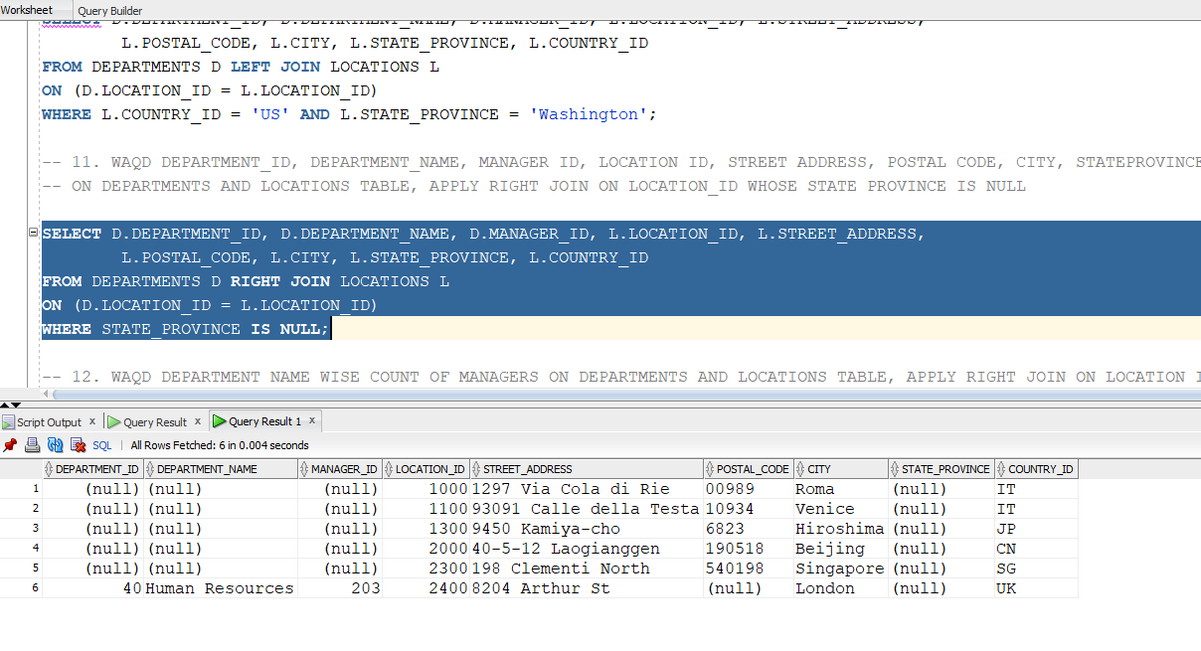

QUERY 12:
WAQD DEPARTMENT NAME WISE COUNT OF MANAGERS ON DEPARTMENTS AND LOCATIONS TABLE, APPLY RIGHT JOIN ON LOCATION ID.
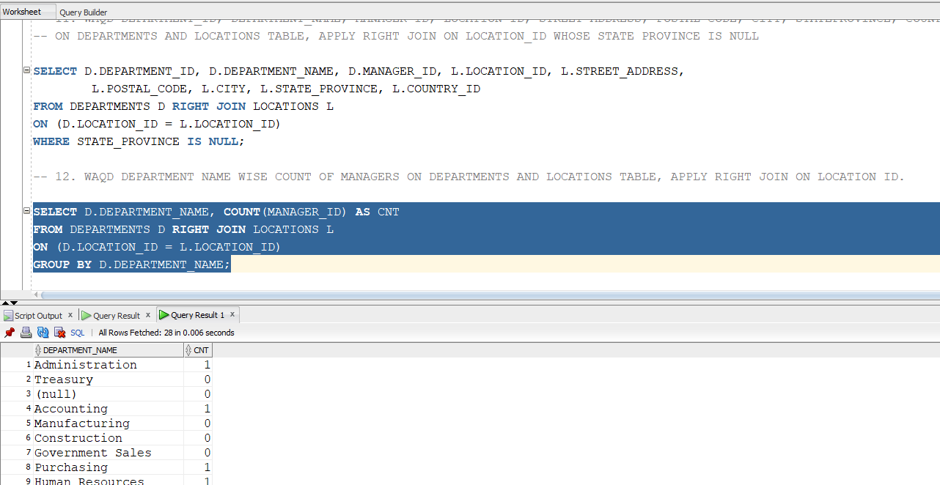

QUERY 13: WAQD 'FIRST_NAME, joined the company on, HIRE_DATE' AS EMP INFO, 'Offered role of, JOB_TITLE, on date, HIRE_DATE AFTER 2 YEARS' AS PROMOTION DETAILS OF
-- EMPLOYEES AND JOBS TABLE, JOIN ON JOB_ID AND INCREMENT SALARY BY 70% AS SALARY AFTER PROMOTION IF SALARY GREATER THAN 10000
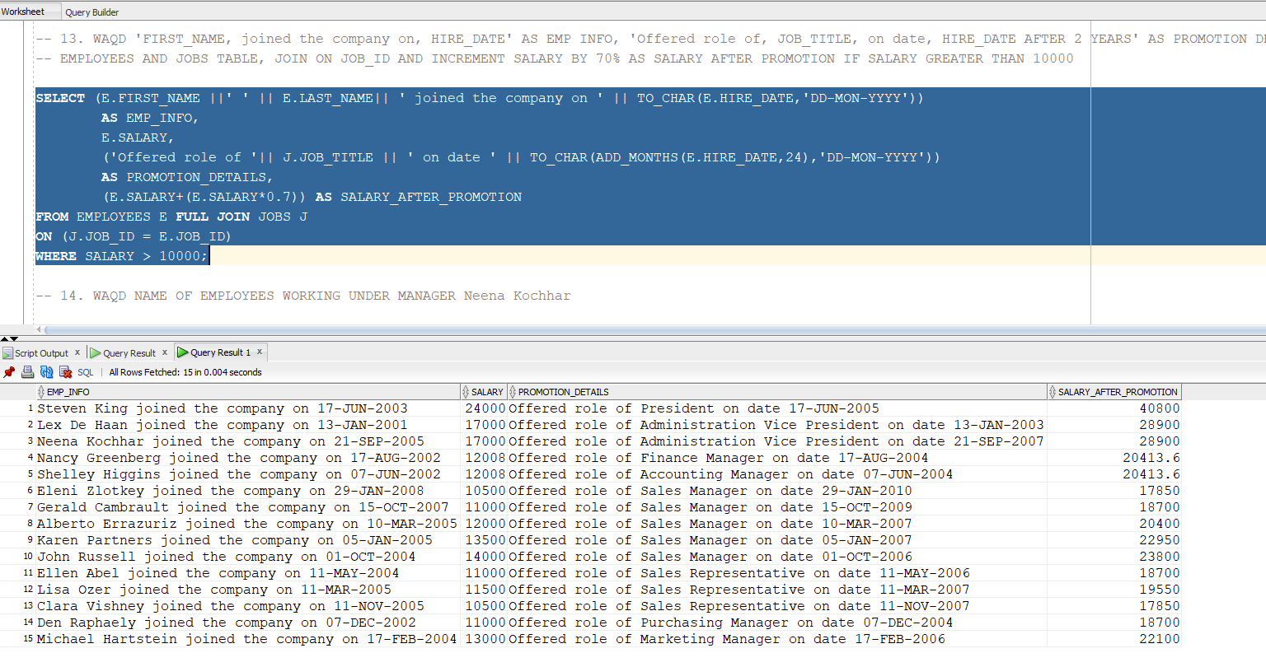

QUERY 14:
WAQD NAME OF EMPLOYEES WORKING UNDER MANAGER Neena Kochhar

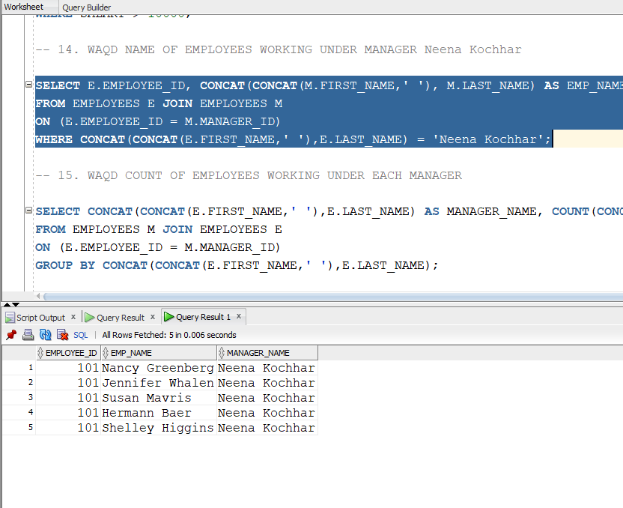

QUERY 15:

-- WAQD COUNT OF EMPLOYEES WORKING UNDER EACH MANAGER

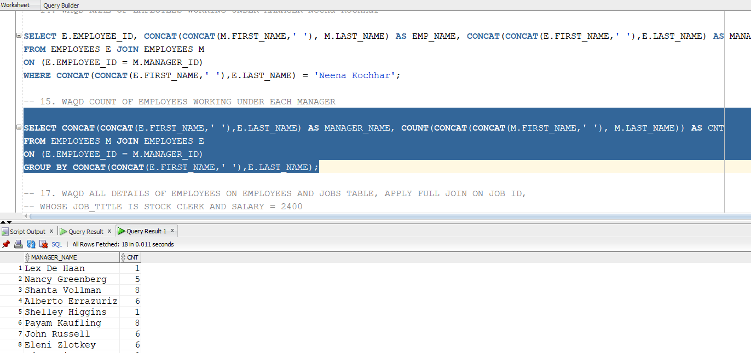

QUERY 16:

-- 16 WAQD DEPARTMENT_ID, DEPARTMENT_NAME, MANAGER ID, LOCATION ID, STREET ADDRESS, POSTAL CODE, CITY, STATEPROVINCE, COUNTRY_ID OF DEPARTMENTS
-- ON DEPARTMENTS AND LOCATIONS TABLE, APPLY LEFT JOIN ON LOCATION_ID
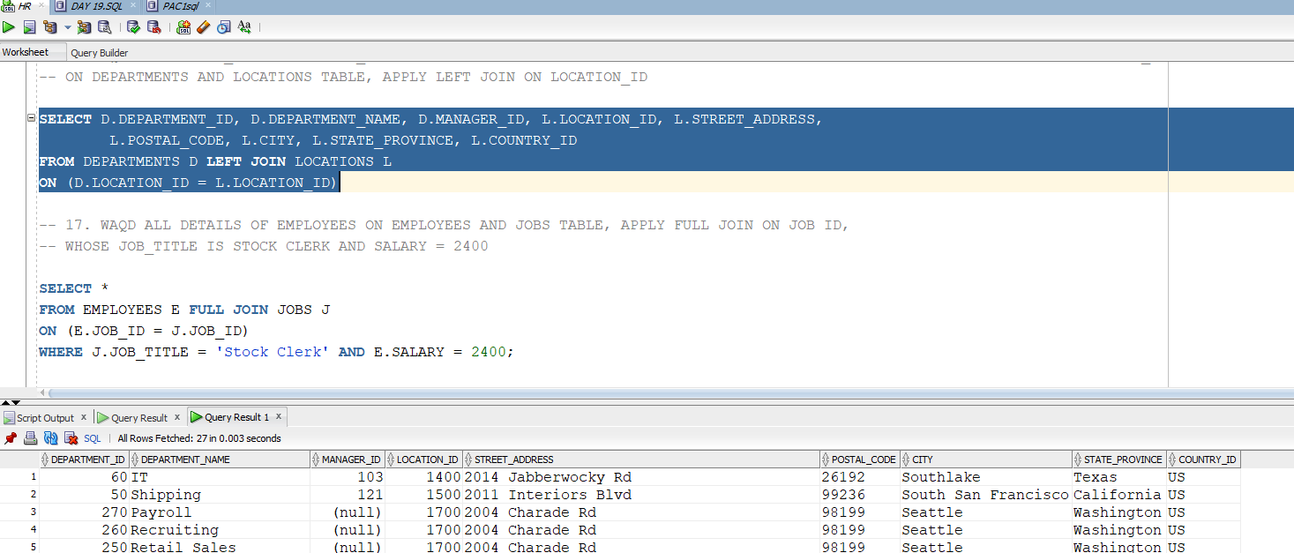

QUERY 17:

WAQD ALL DETAILS OF EMPLOYEES ON EMPLOYEES AND JOBS TABLE, APPLY FULL JOIN ON JOB ID,
-- WHOSE JOB_TITLE IS STOCK CLERK AND SALARY = 2400
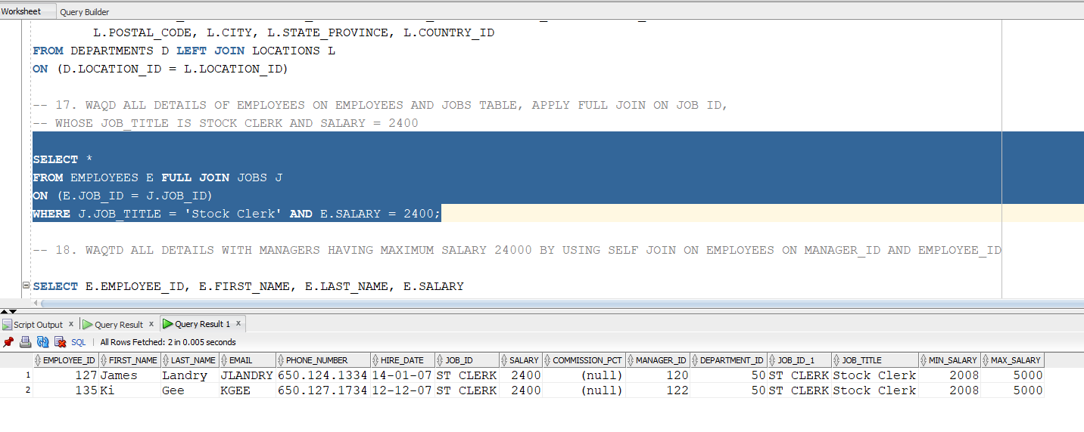

QUERY 18:
WAQTD ALL DETAILS WITH MANAGERS HAVING MAXIMUM SALARY 24000 BY USING SELF JOIN ON EMPLOYEES ON MANAGER_ID AND EMPLOYEE_ID

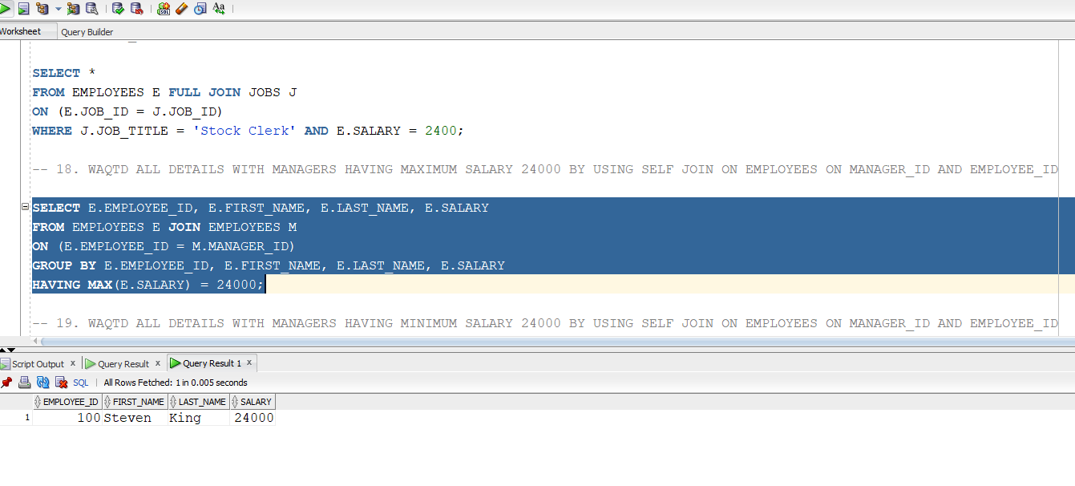

QUERY 19:
WAQTD ALL DETAILS WITH MANAGERS HAVING MINIMUM SALARY 24000 BY USING SELF JOIN ON EMPLOYEES ON MANAGER_ID AND EMPLOYEE_ID

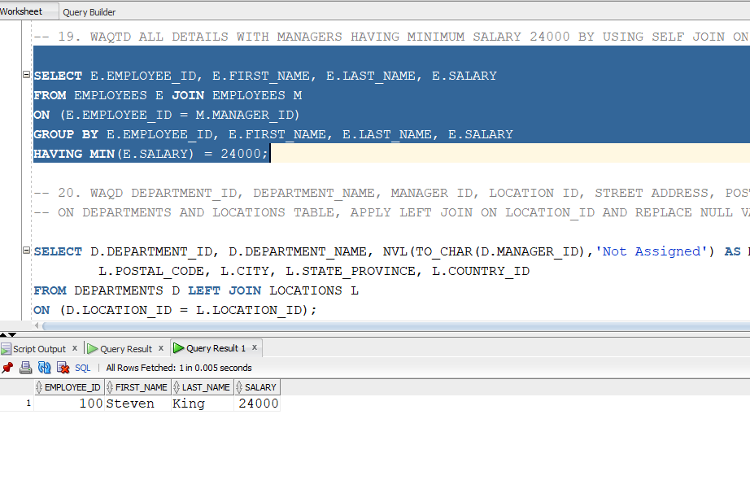

QUERY 20:

-- 20. WAQD DEPARTMENT_ID, DEPARTMENT_NAME, MANAGER ID, LOCATION ID, STREET ADDRESS, POSTAL CODE, CITY, STATEPROVINCE, COUNTRY_ID OF DEPARTMENTS
-- ON DEPARTMENTS AND LOCATIONS TABLE, APPLY LEFT JOIN ON LOCATION_ID AND REPLACE NULL VALUE PRESENT IN MANAGER_ID WITH NOT ASSIGNED
