-- QUERY 1 -Write an SQL query to display employee_id and department_id of employees who: -- 19-1-26
--Work in department 10 OR department 20 AND have a salary greater than 5000
--BUT are not managers.
-- Employees in department 10 or 20
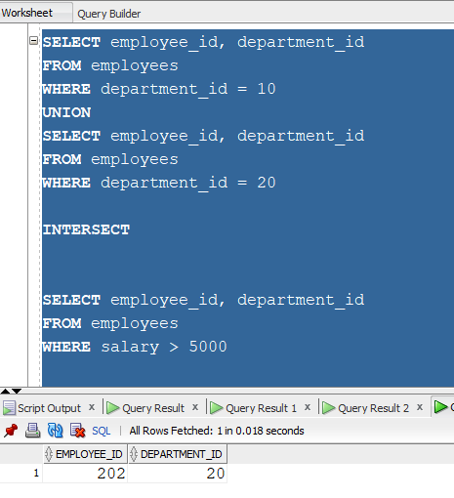

--2)Display the department_id of departments,Having more than 5 employees, OR
--Having total salary > 50000
-- Departments with more than 5 employees
SELECT department_id
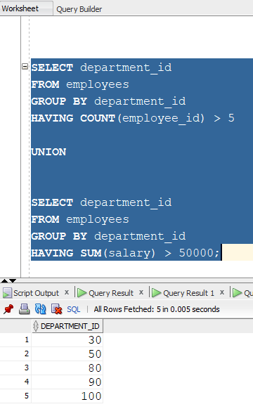

Query 3: Find departments that have more than 5 employees AND total salary <50000.
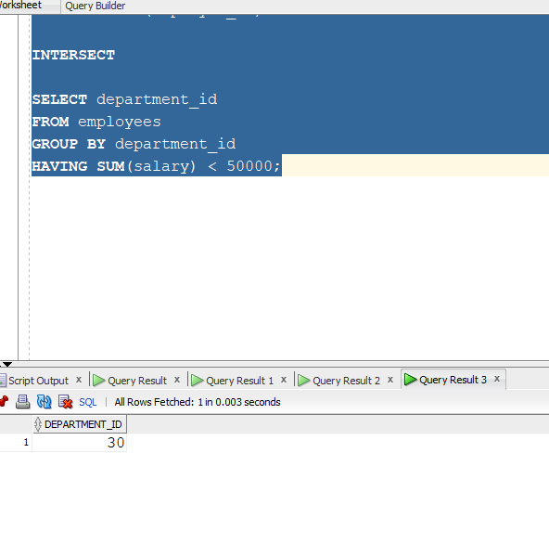
--4)Find departments that have more than 5 employees and remove those who earn 50000?

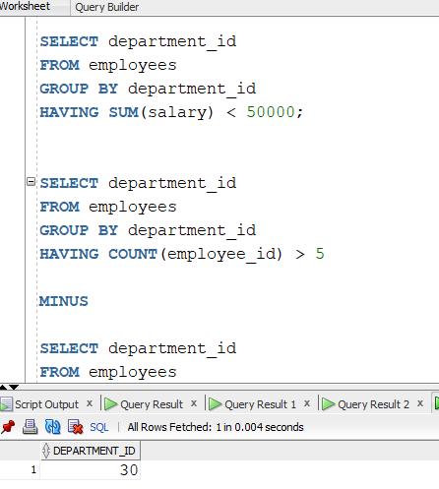

QUERY 5-- Select all country IDs available in the locations table
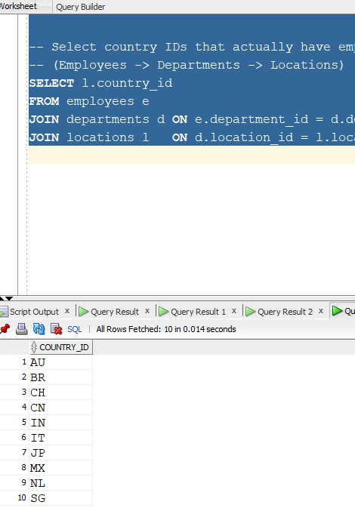

QUERY 6: -—-- DEPT AVERAGE SALARY ABOVE 8000 AND MAX SAL LESS THAN 4000
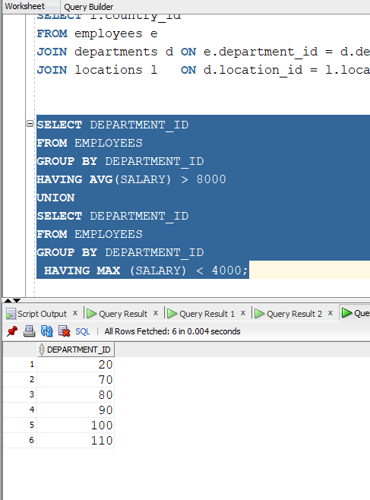

QUERY 7: SELECT JOB_ID FROMS EMPLOEES WHO ARE MANAGERS IN JOBS TABLE

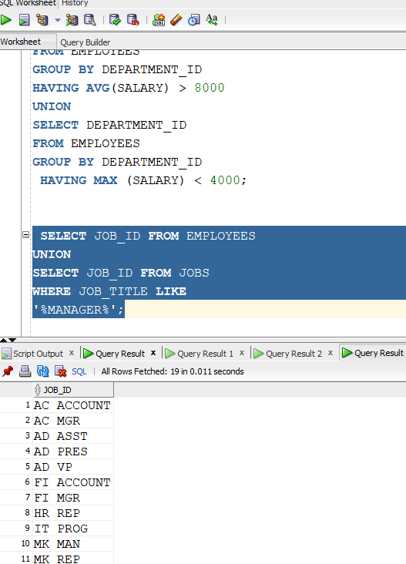

QUERY 8:
WAQD ALL UNIQUE COUNT OF EMPLOYEES JOB ID WISE

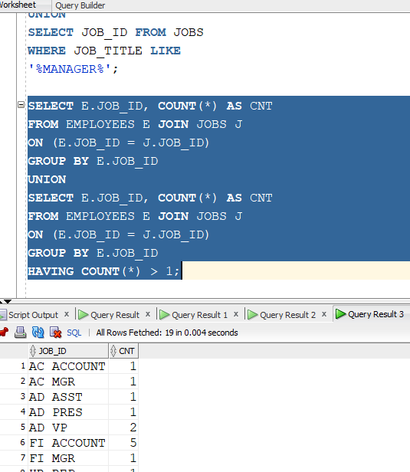

QUERY 9: WAQD DISTINCT EMPLOYEES HIRED IN 2007

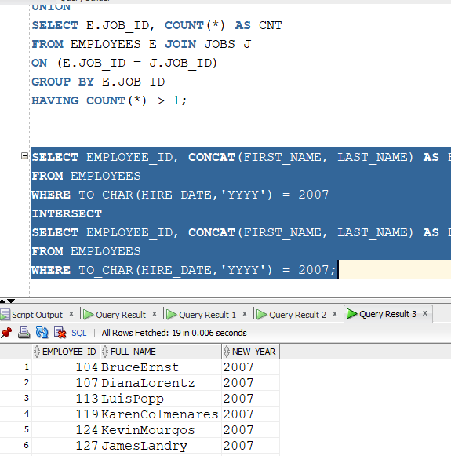

QUERY 10: FETCH EMPLOYEES WHO WORK IN 50 OR SALES 80, BUT WHO NEVER HAD ANY JOB AND WHOSE EMAIL CONTAINS THE LETTER 'A'.

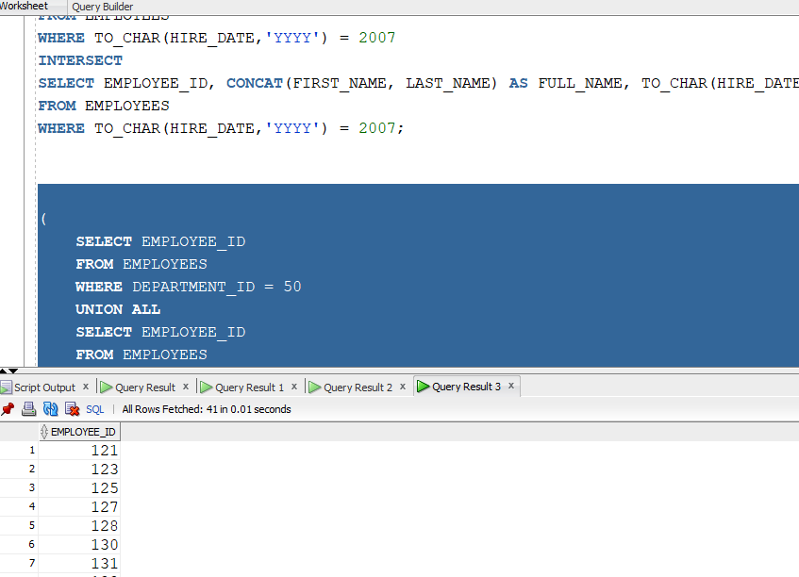

QUERY 11:
-- Employees earning more than 150,000 OR working as IT Programmer
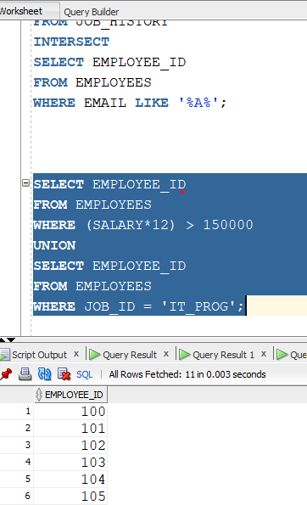

QUERY 12:-- 12. Employees earning more than 80,000 and having a manager
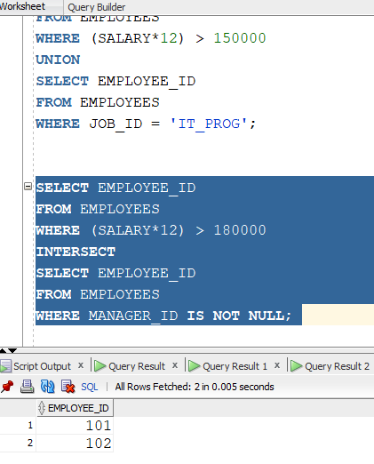

QUERY 13:13.Show employees who either earn more than 15,000 or have been with the company for more than 20 years.
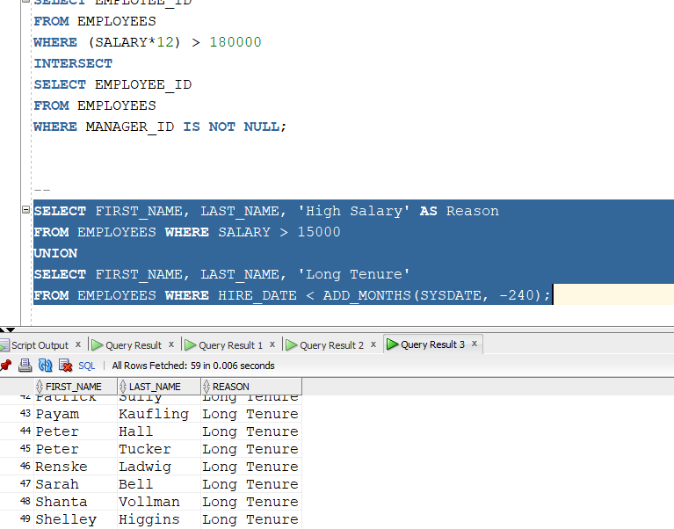

QUERY 14 :-Find cities that host departments with managers, excluding those that host departments without assigned managers
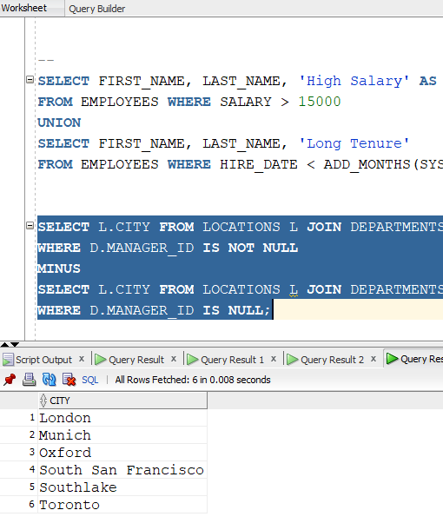

--15.Find job titles that exist in both the United States and the United Kingdom.
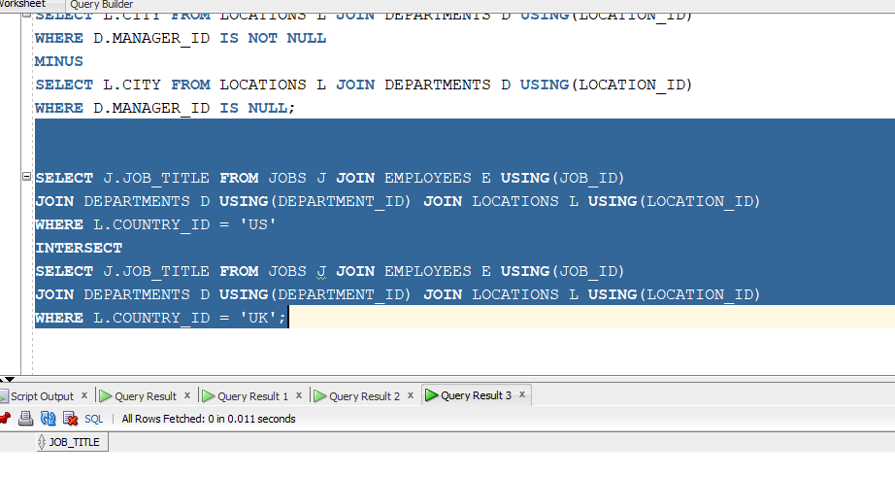

-16--16Identify countries that have locations but do not have any departments named 'IT'.

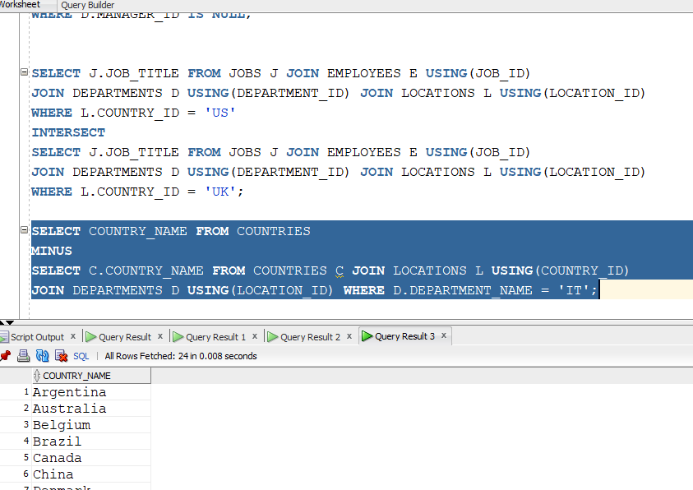

QUERY 17 :Identify employees earning between 5k-10k who are NOT in the Sales department.

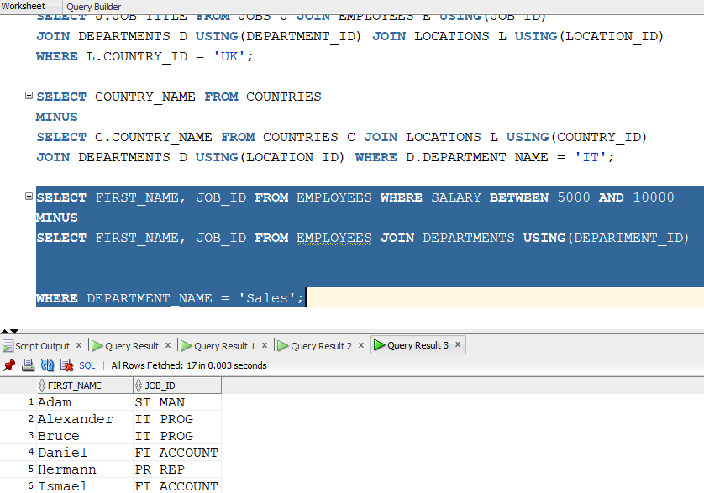

QUERY 18--18 Employees with a 'Junior' salary rank but whose salary is higher than their department average.

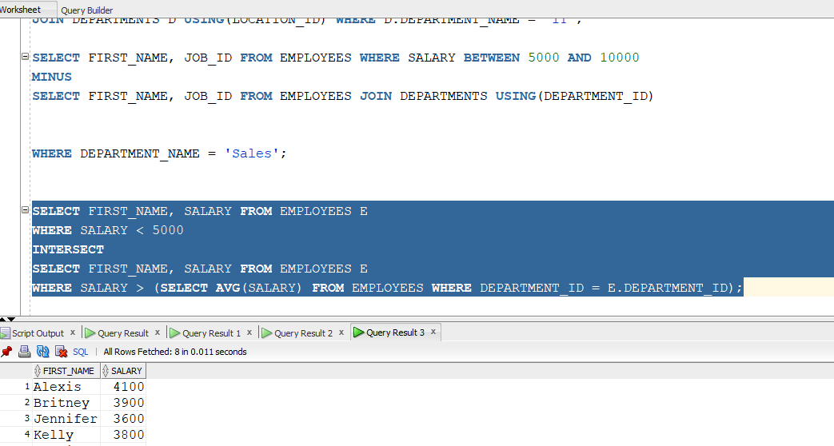

QUERY 19 :FIND cities that host both a 'Shipping' and a 'Sales' department.
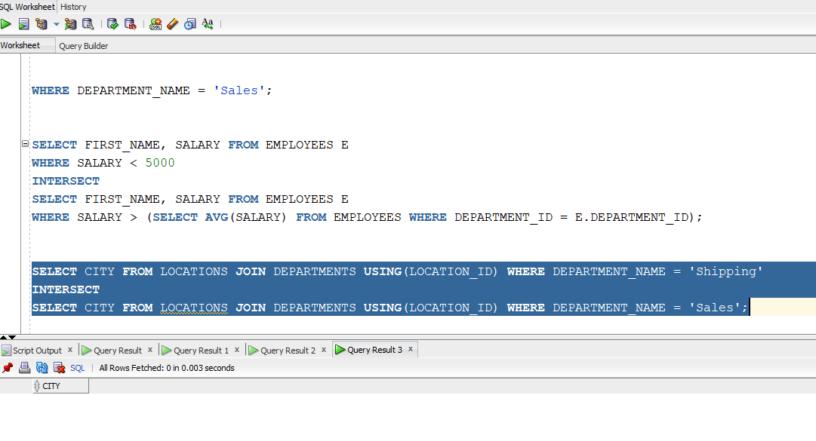

QUERY 20 : Categorize regions by employee count using UNION.

