--QUERY 1: WRITE CASE FOR REVISED SALARY??
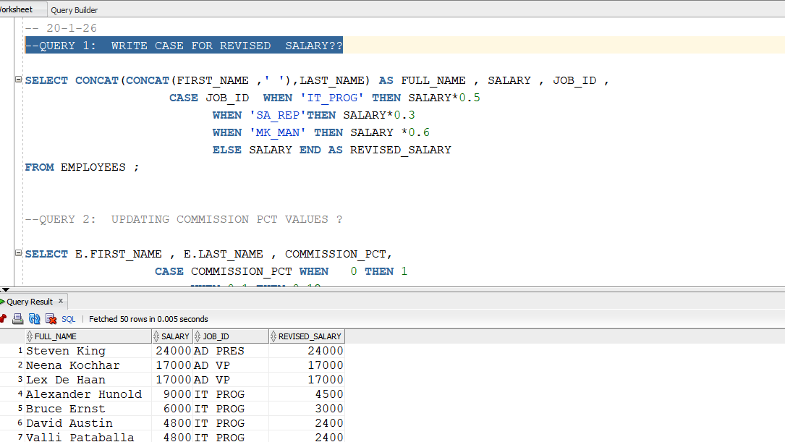

--QUERY 2: UPDATING COMMISSION PCT VALUES ?
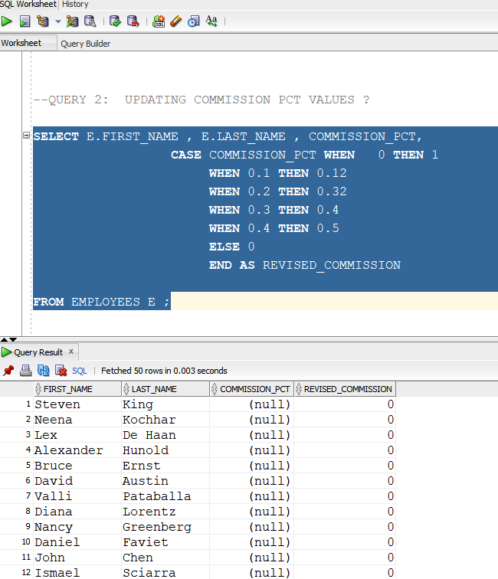

-- QUERY 3: SORT THE ROWS BY USING IT PROG FIRST , THEN SALES AND ST CLERKS ASC ORDER??

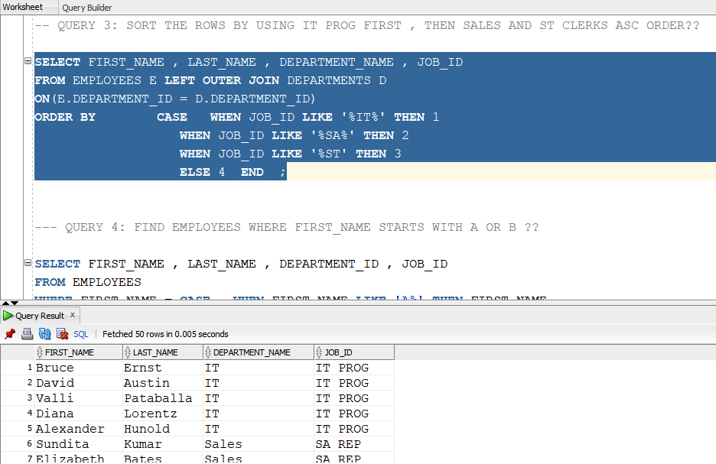

-- QUERY 4: FIND EMPLOYEES WHERE FIRST_NAME STARTS WITH A OR B ??

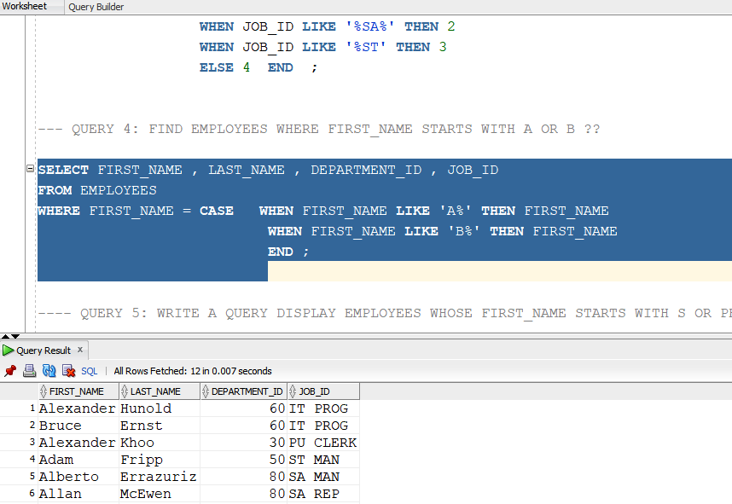

---- QUERY 5: WRITE A QUERY DISPLAY EMPLOYEES WHOSE FIRST_NAME STARTS WITH S OR PHONE NUMBER HAS 515

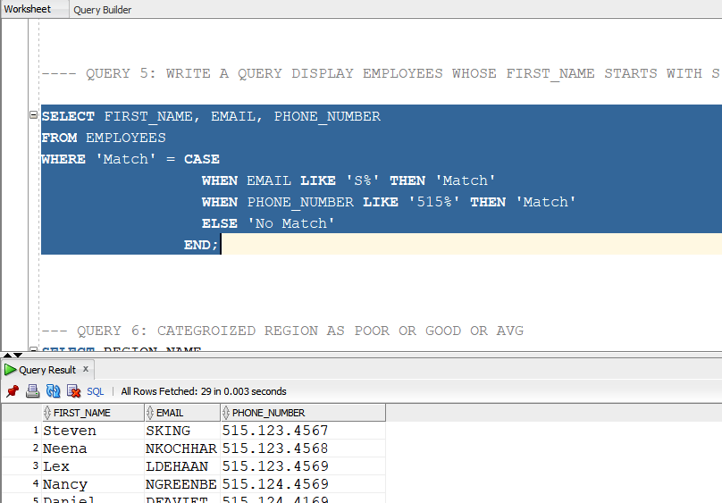

--query 6 :
--- QUERY 6: CATEGROIZED REGION AS POOR OR GOOD OR AVG

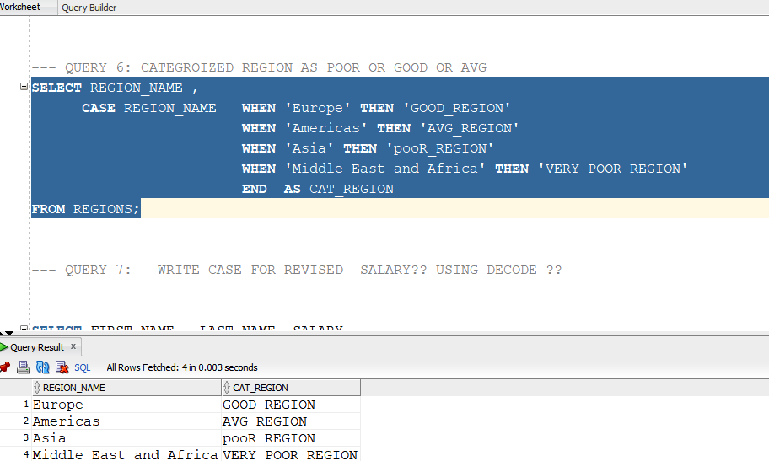

--- QUERY 7: WRITE CASE FOR REVISED SALARY?? USING DECODE ??
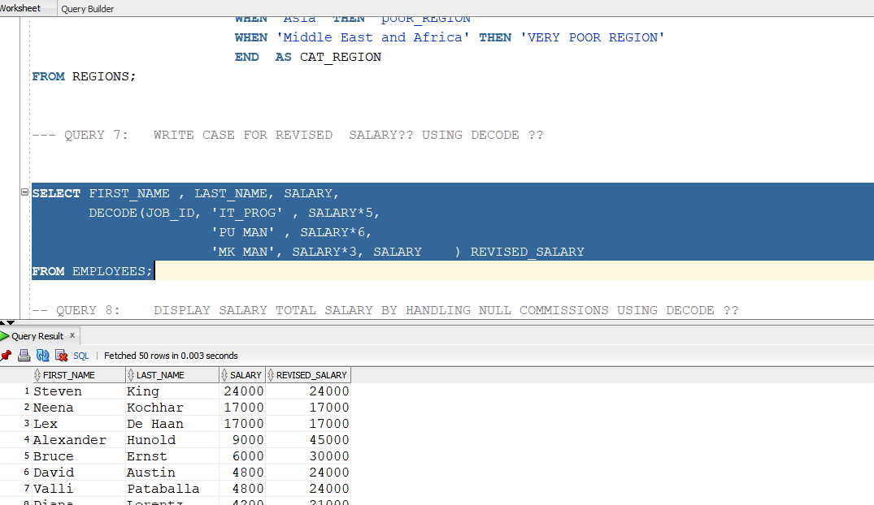

Query 8:
-- QUERY 8: DISPLAY SALARY TOTAL SALARY BY HANDLING NULL COMMISSIONS USING DECODE ??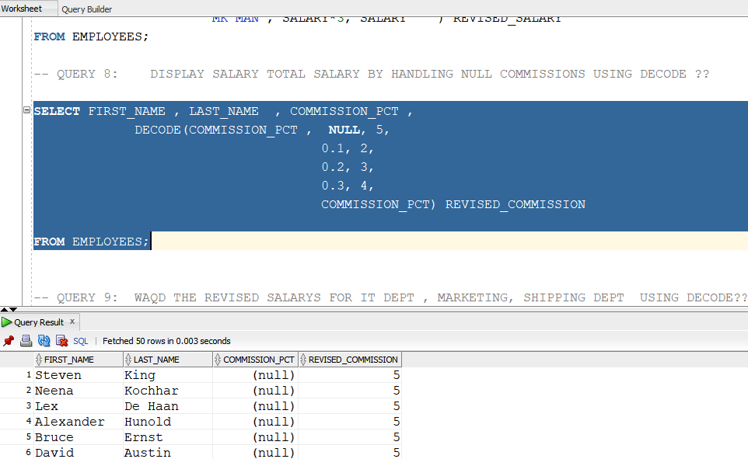

-- QUERY 9: WAQD THE REVISED SALARYS FOR IT DEPT , MARKETING, SHIPPING DEPT USING DECODE??
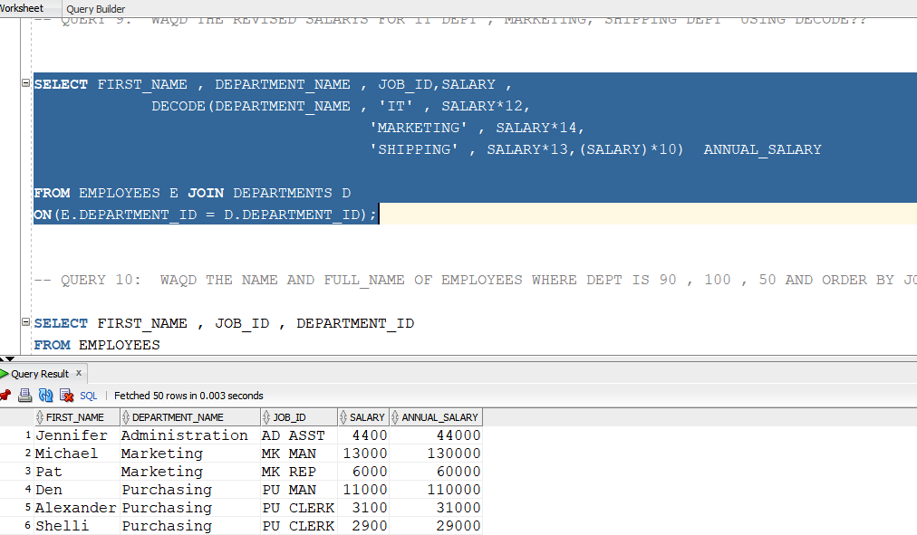

Query 10:-- QUERY 10: WAQD THE NAME AND FULL_NAME OF EMPLOYEES WHERE DEPT IS 90 , 100 , 50 AND ORDER BY JOB_ID
