QUERY 1: CREATE TABLE ORDERS1
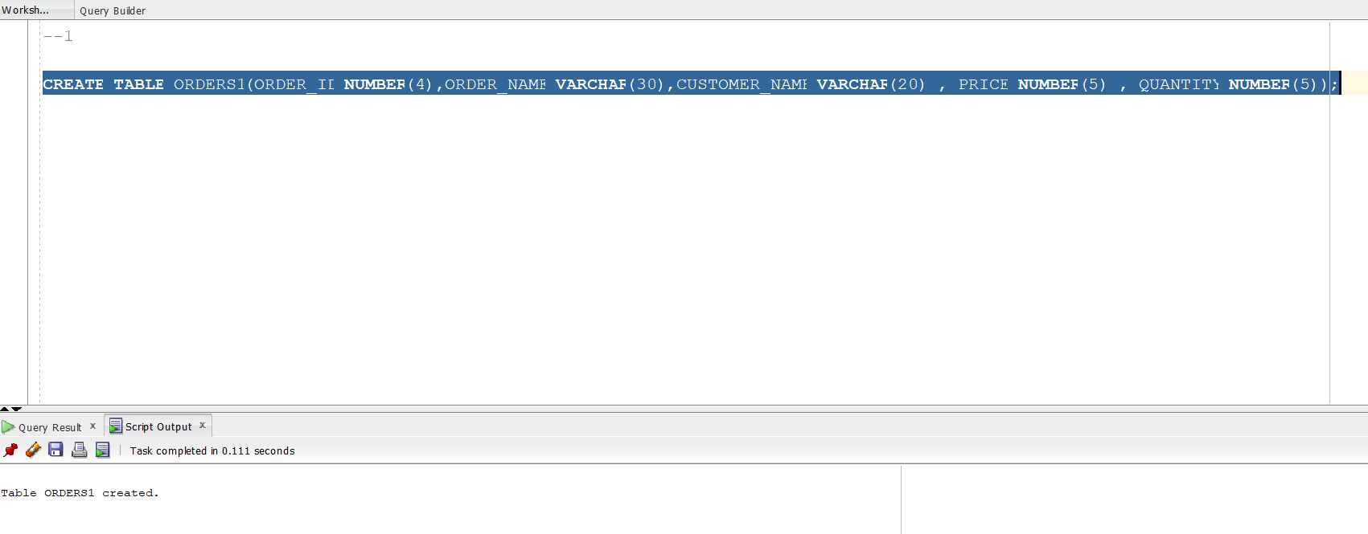

QUERY 2: INSERT INTO ORDERS TABLE
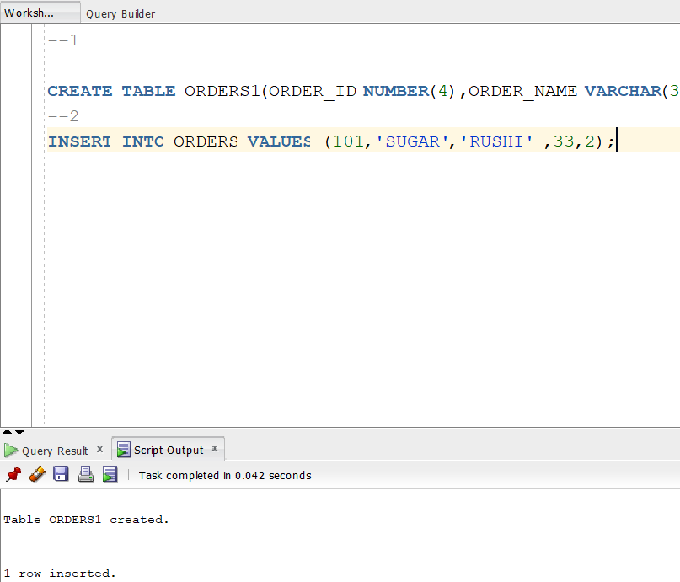

QUERY 3:UPDATE DML COMAND ON ORDERS TABLE
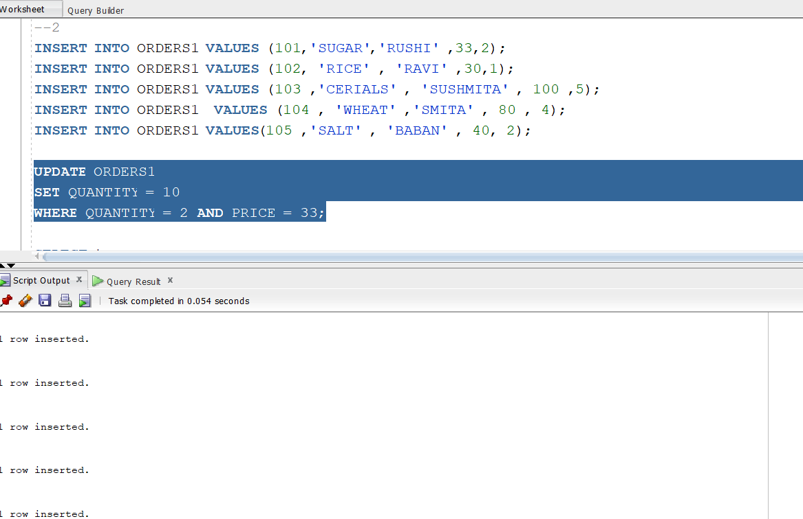

QUERY 4: DML - DELETE QUERY FOR DELETING RECORDS
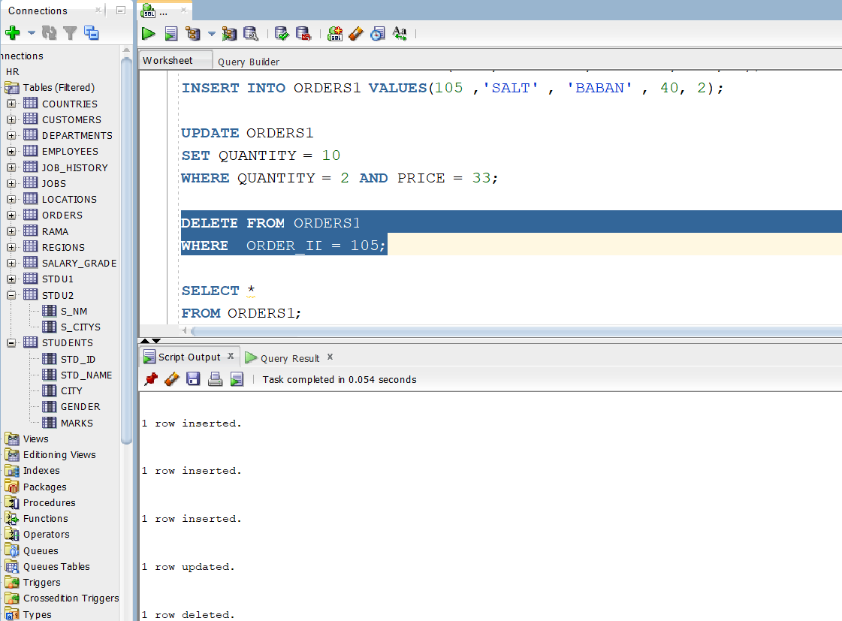

QUERY 5: INSERT USING COLUMN NAMES 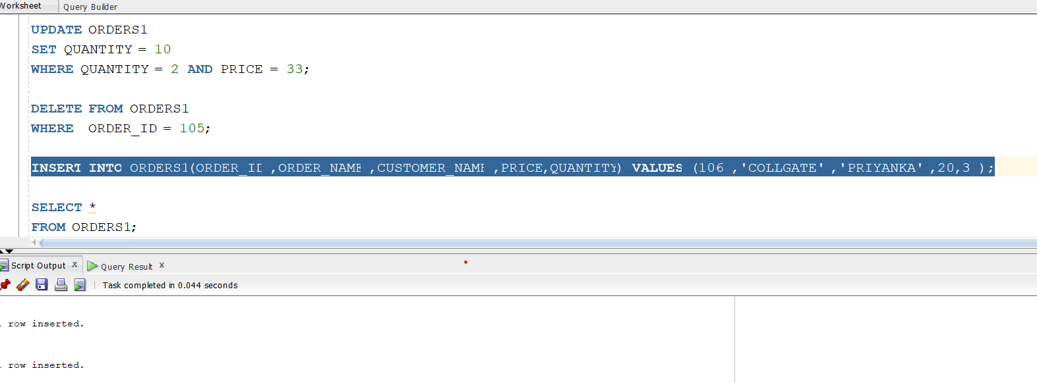

QUERY 6:
CREATE TABLE COMPANY USING DDL
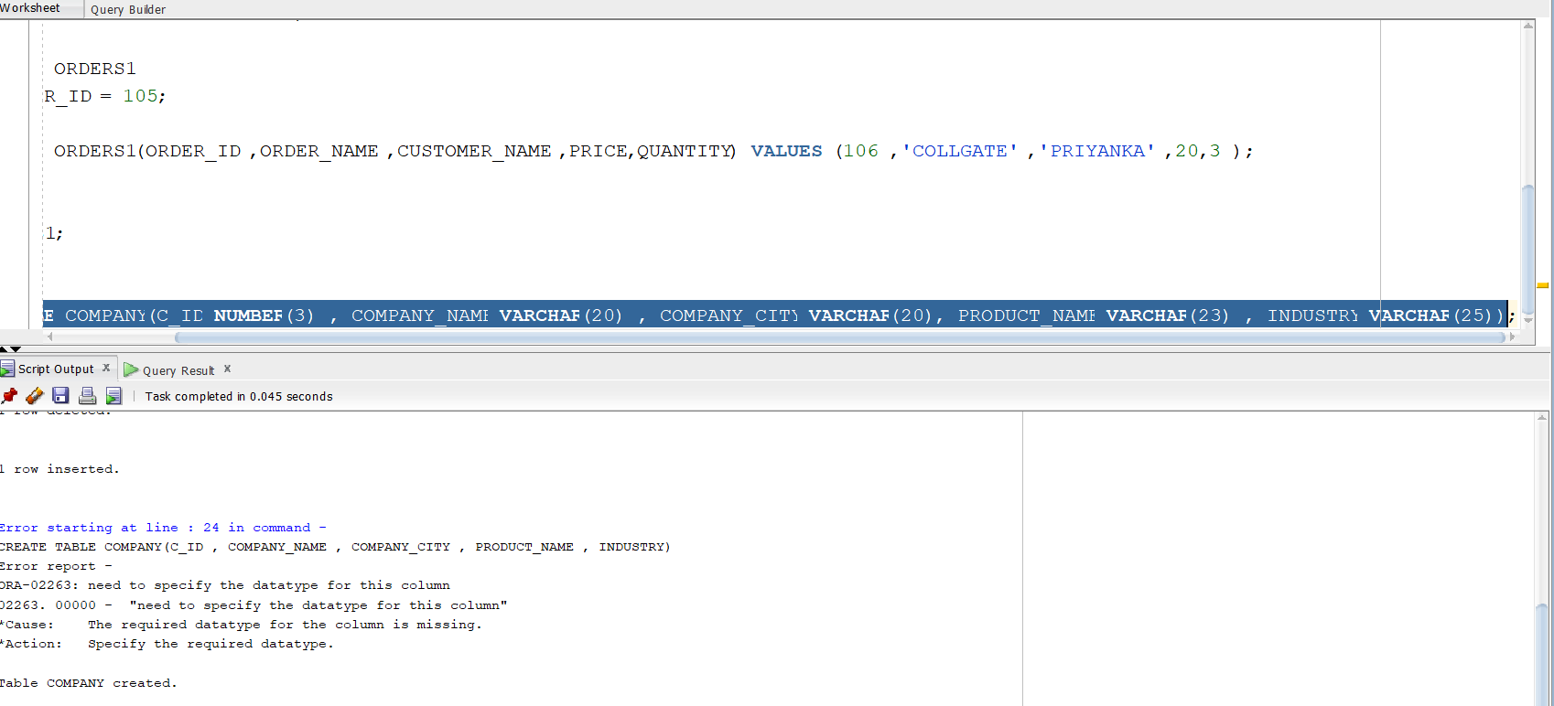

QUERY 7:

--QUERY 7: CREATE DML TO INSERT DATA INTO TABLE COMPANY
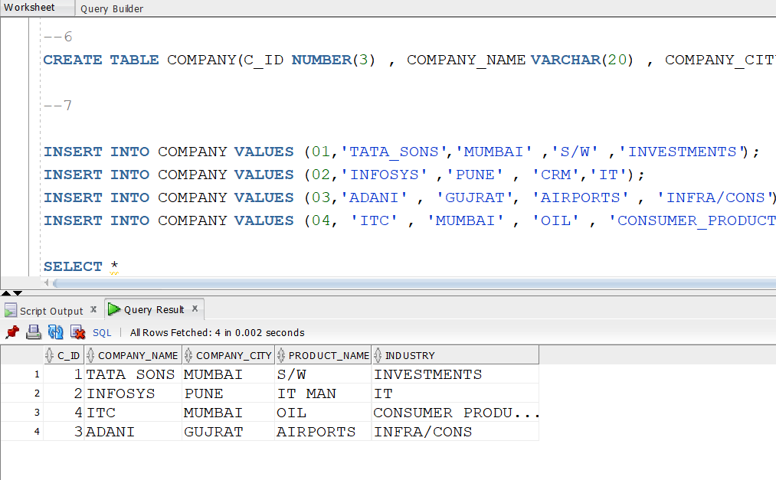

QUERY 8: CREATE UPDATE DML ON COMPANY WHERE CID LIKE 2 AND UPDATE PRODUCT TO IT SERVICES
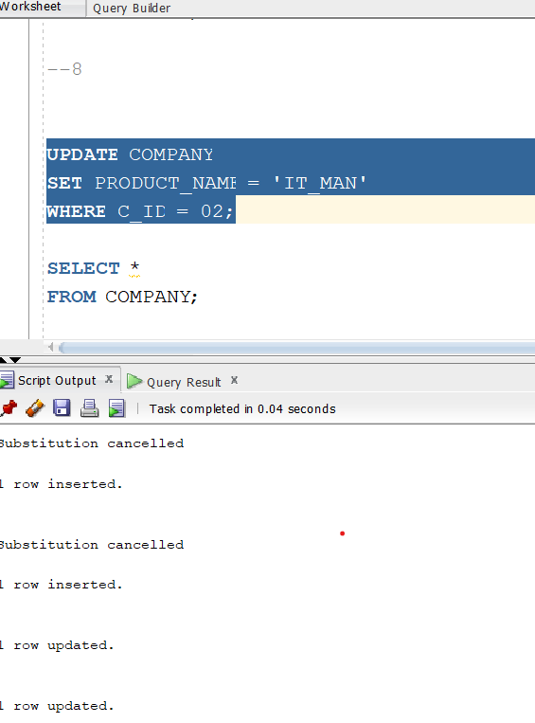

QUERY 9:
DELETE LAST ROW FROM TABLE
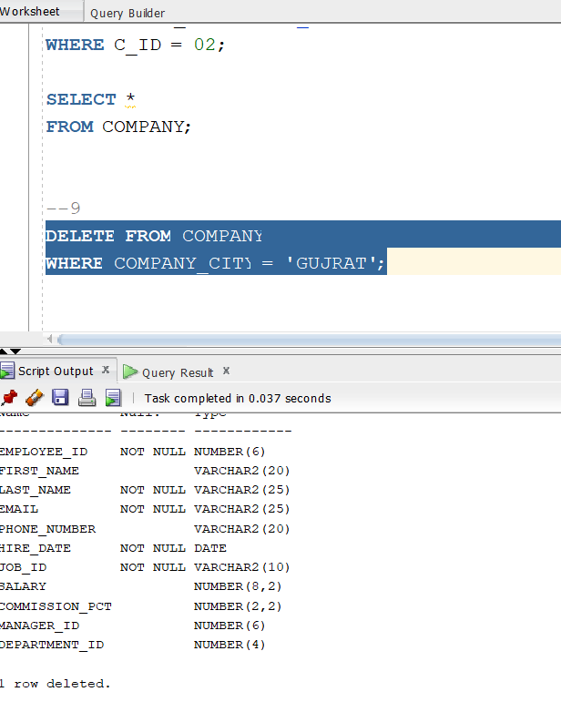

QUERY 10:
INSERT VALUES USING MULTIPLE COLUMNS AND NULL FOR SOME COMPANYS??

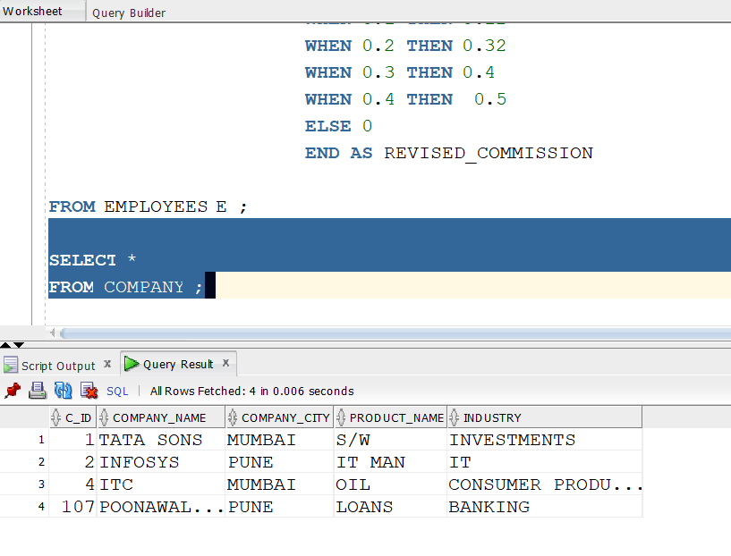

QUERY 11:CREATE TABLE USERS1
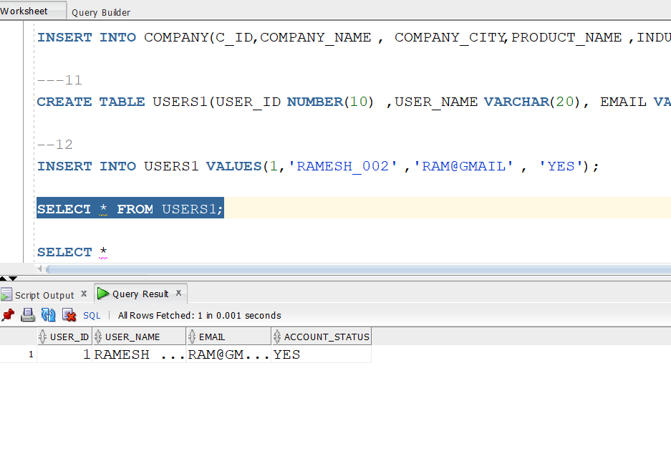

QUERY 12:INSERT INTO USER1 RECORDS
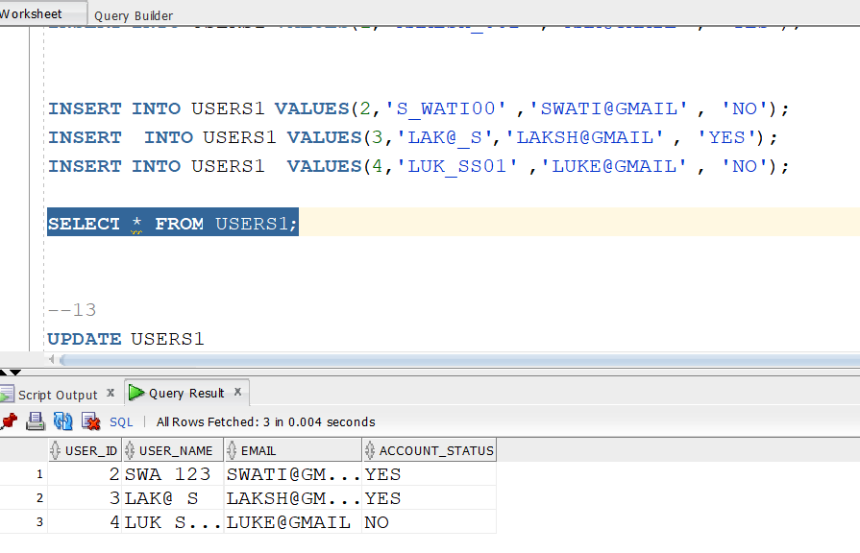

QUERY 13 : UPDATE USERS1 WHERE USER_ID = 2;
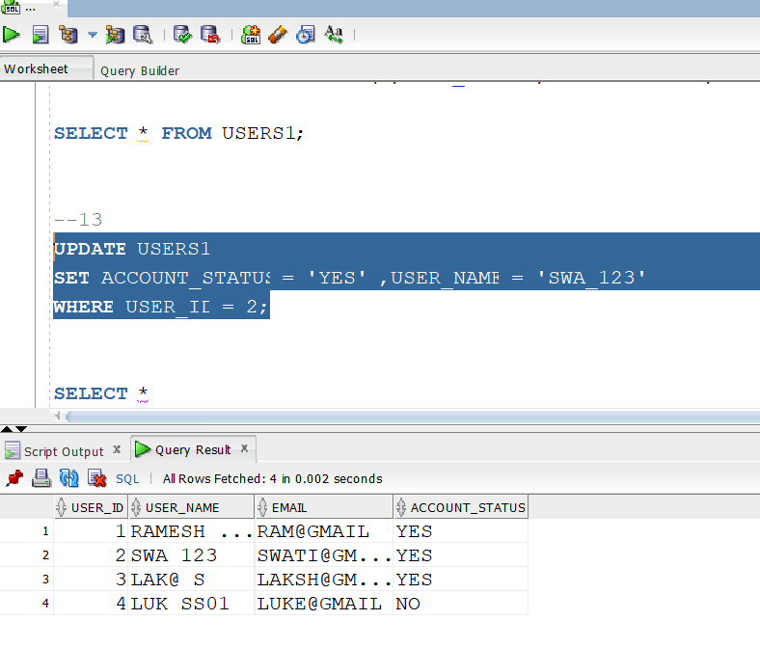

QUERY 14:DELETE A RECORD FROM USER1 WHERE USER_ID IS 1
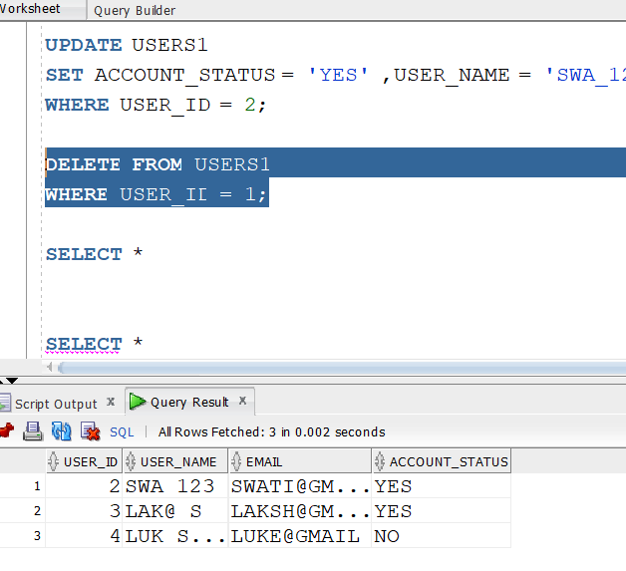

QUERY 15:
CREATE TABLE NAMED TEAMS
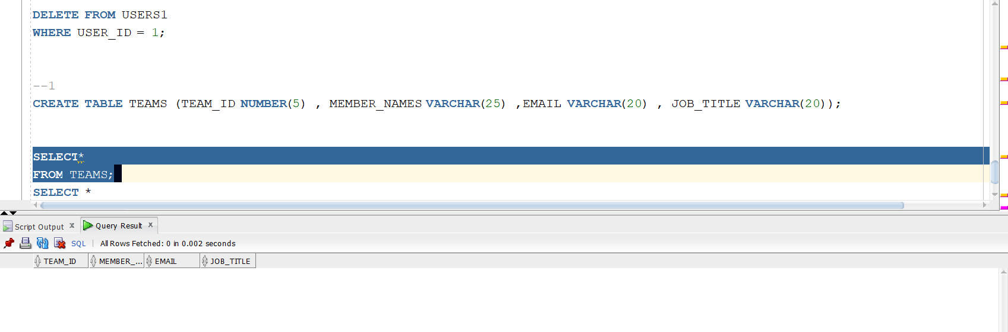
QUERY 16:
INSERT VALUES INTO TEAMS
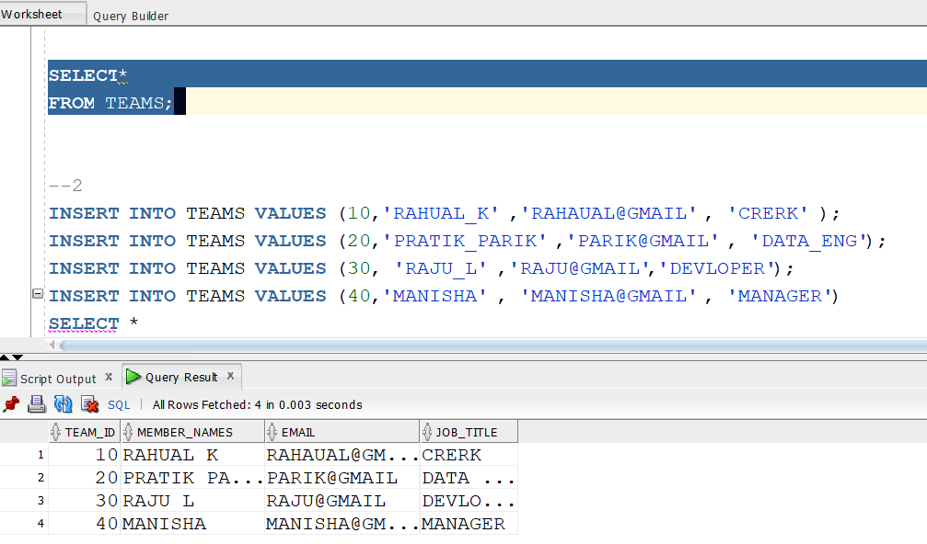

QUERY 17:
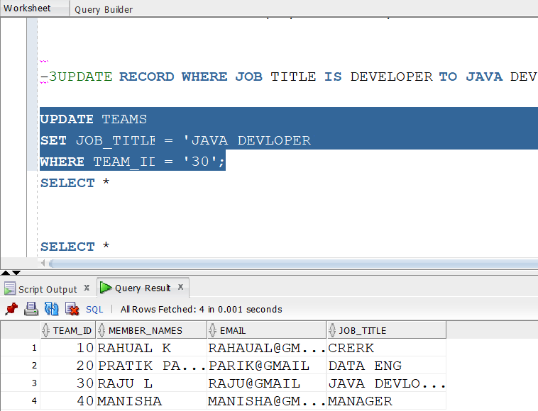

QUERY 18:
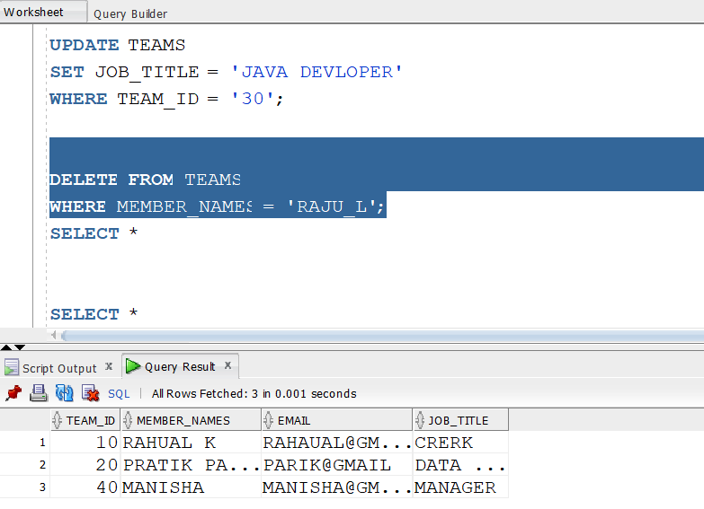

QUERY 19: BACKUP OF TABLE WITH DATA
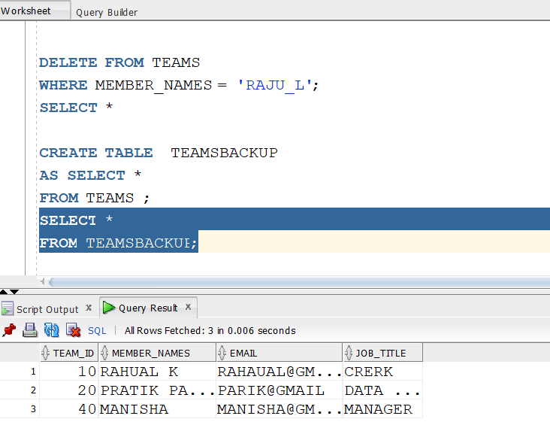

QUERY 20:
COPY STRUCTURE OF TABLE
