QUERY 1ADD COLUMN GRADES TO TABLE STUDENTS
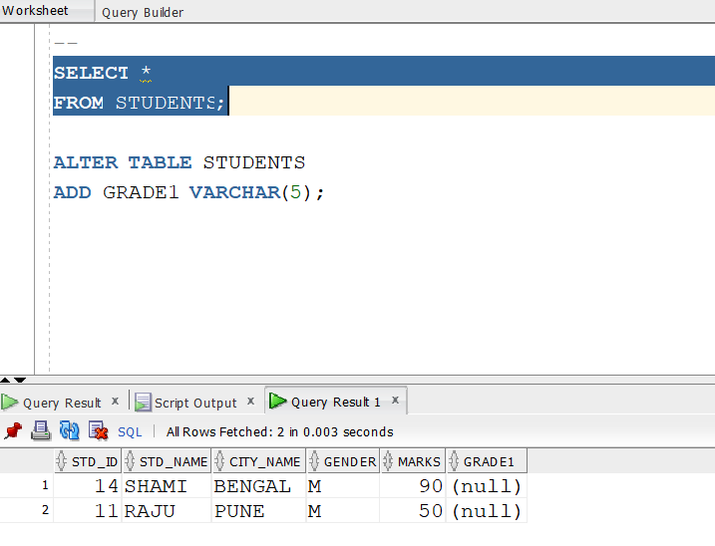

QUERY 2: WAQD THE CGPA COLUMN
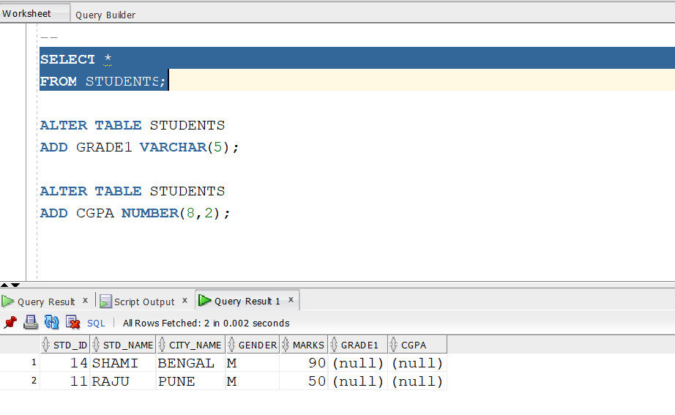
QUERY 3: WAQ TO ALTER CITY_NAME TO CITY
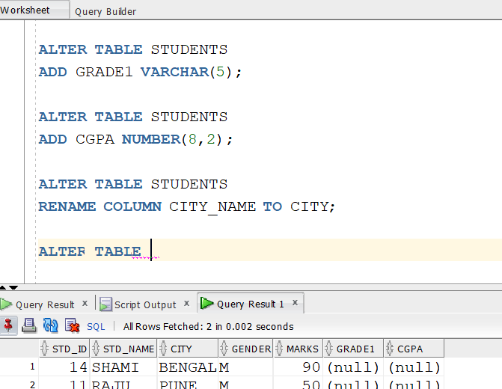

QUERY 4:
CHANGE THE SIZE OF GRADE COLUMN
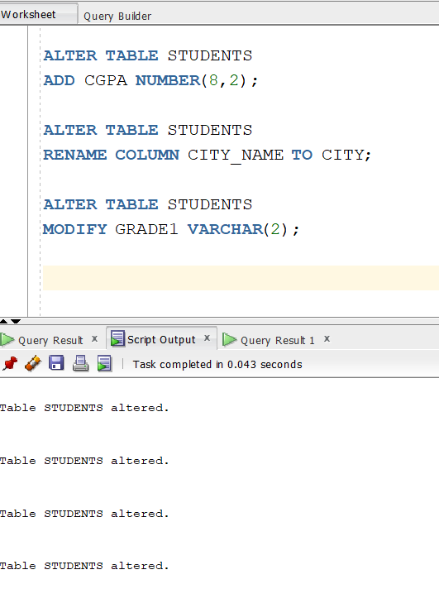

QUERY 5:
RENAME WITHOUT USING ALTER
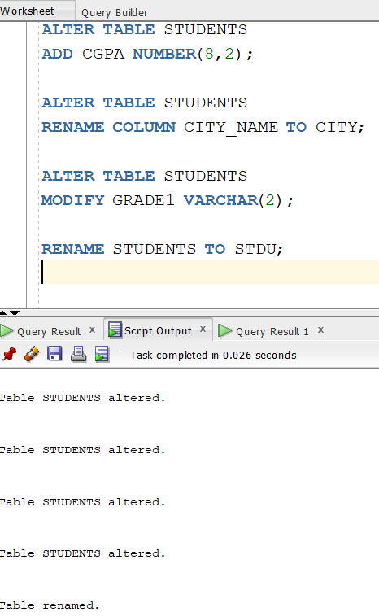

QUERY 6:
RENAME TABLE NAME USING ALTER:
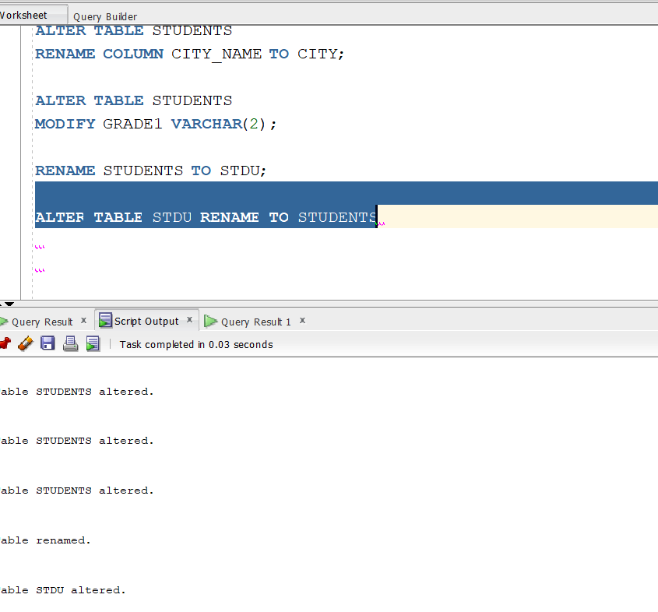

QUERY 7:DDL TO ADD COLUMN TOTAL IN ORDERS TABLE
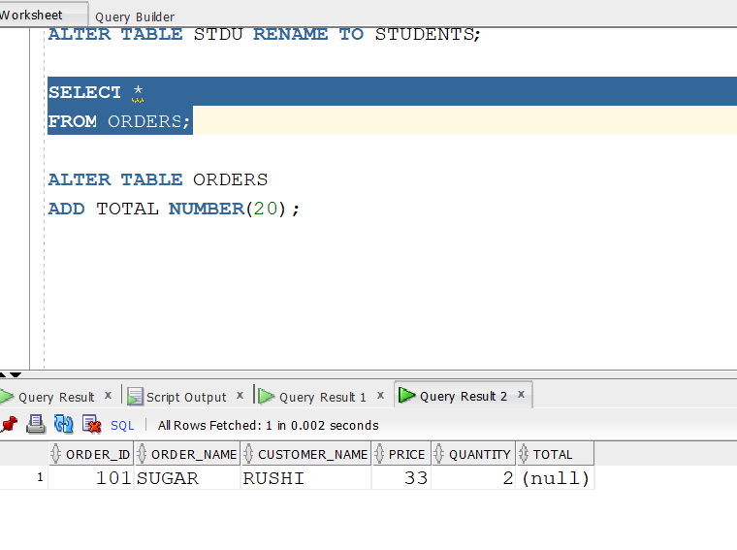

QUERY 8:
RENAME THE TABLE ORDERS WITHOUT USING ALTER
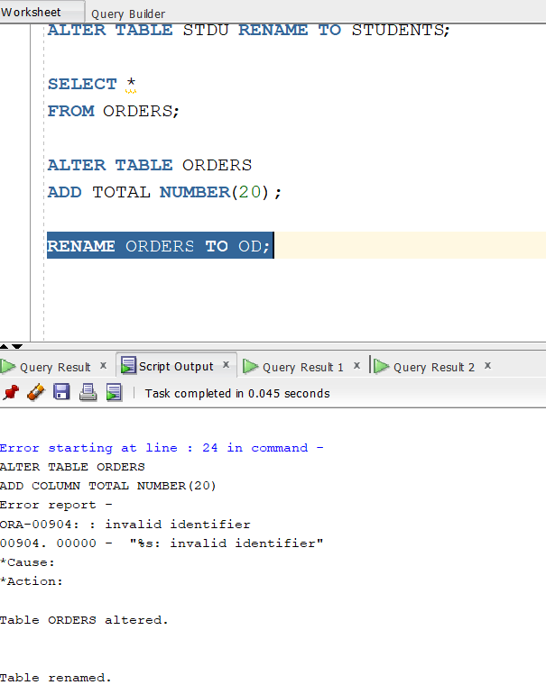

QUERY 9:
ALTER NAME TO RIGNIAL USING ALTER
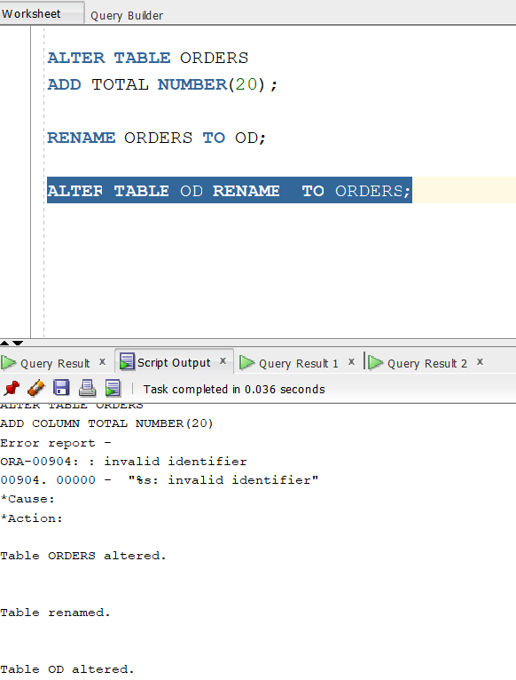

QUERY 10:
MODIFY THE COLUMN CUSTOMER NAME TO CUST_NM
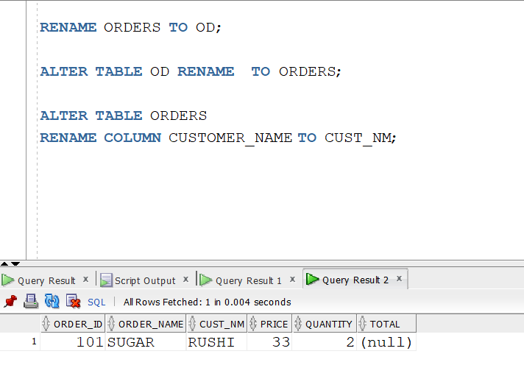

QUERY 11:
ADD COLUMN CUSTOMER ID TO TABLE ORDERS
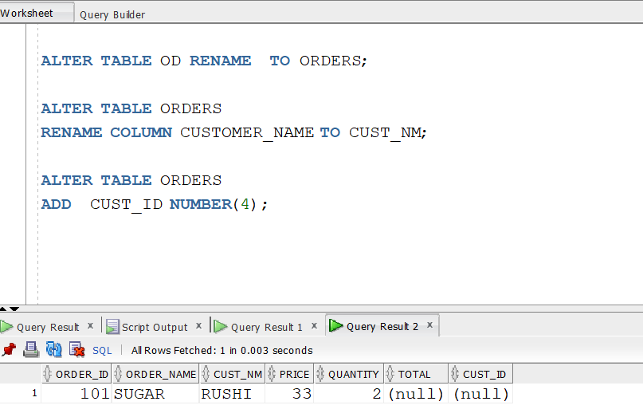

QUERY 12:
DROP TABLE CUST_ID FROM STUDENTS
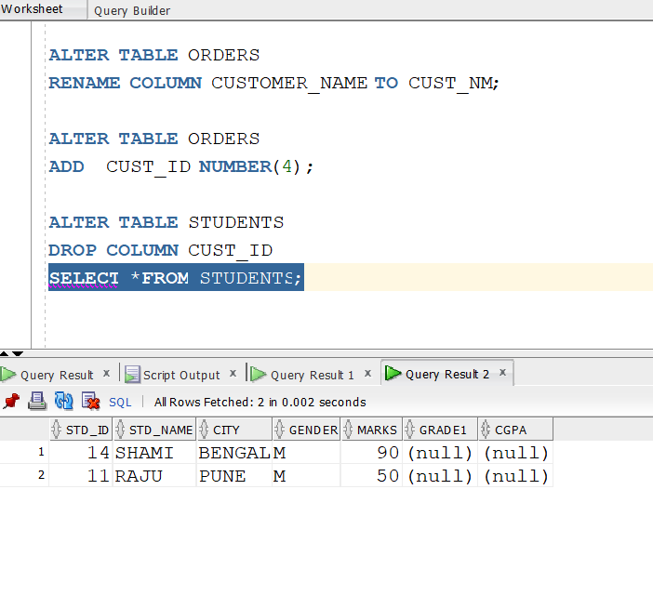
QUERY 13:
DROP THE CUST_ID COLUMN FROM TABLE ORDERS
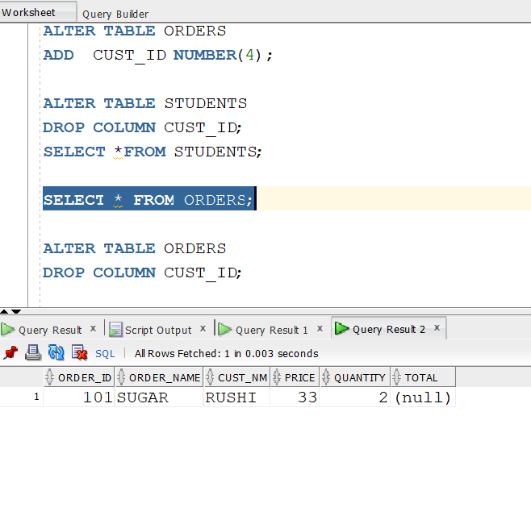

QUERY 14: ADD COLUMN EMP_ID IN TEAMS
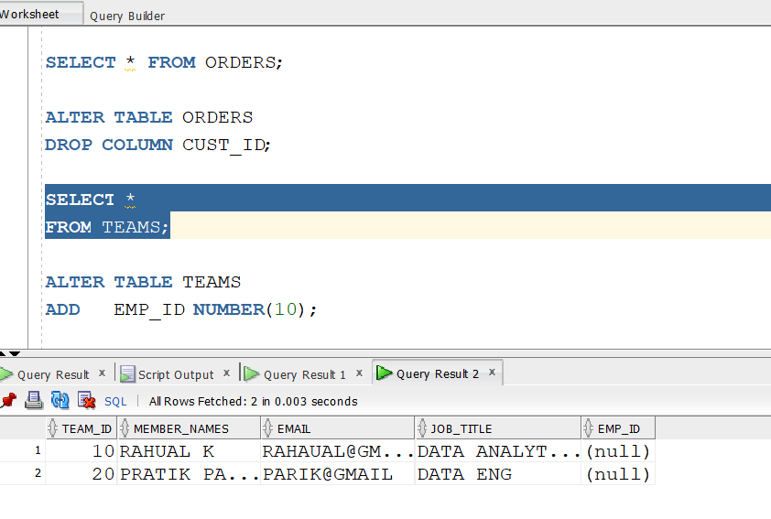

QUERY 15:MODFIY THE EMP_ID COLUMN TO DECRECSE TITS ITS SIZE TO 6
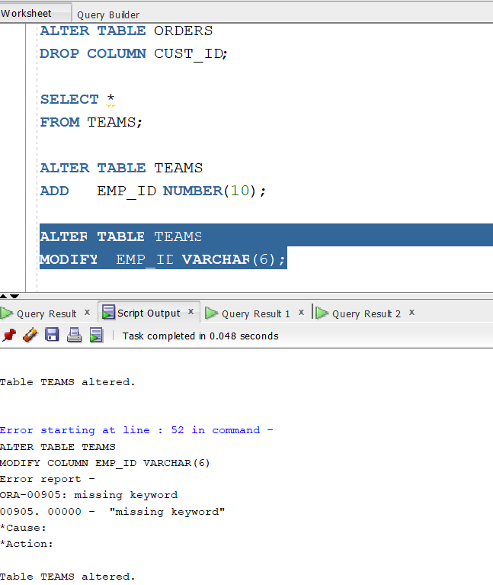

QUERY 16:
RENAME COLUMN EMAIL TO EMAIL_ID
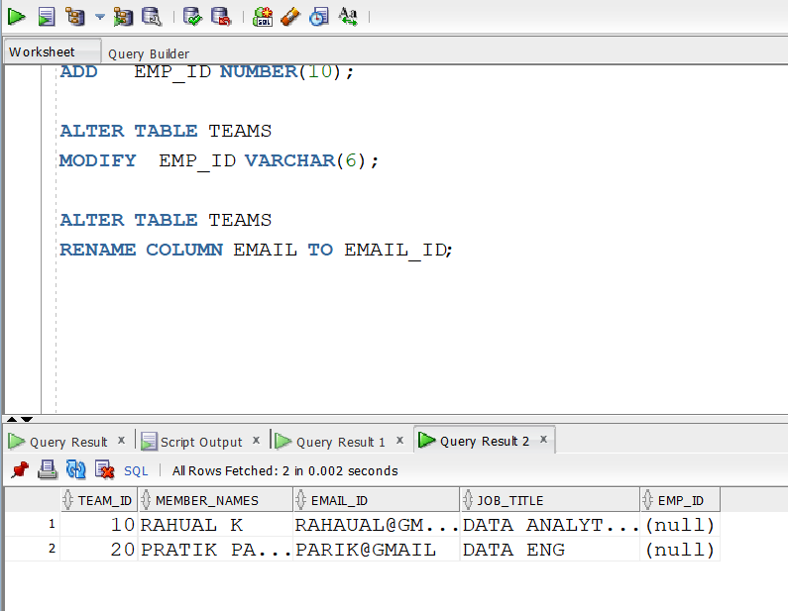

QUERY 17:
WAQ TO DROP EMAIL ID TABLE
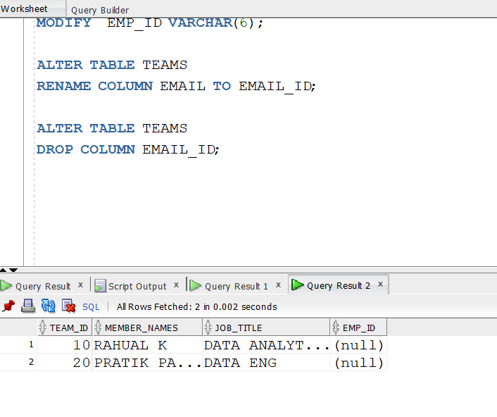
QUERY 18:
WAQD TEAMS AS TEAM1 WITHOUT USING ALTER
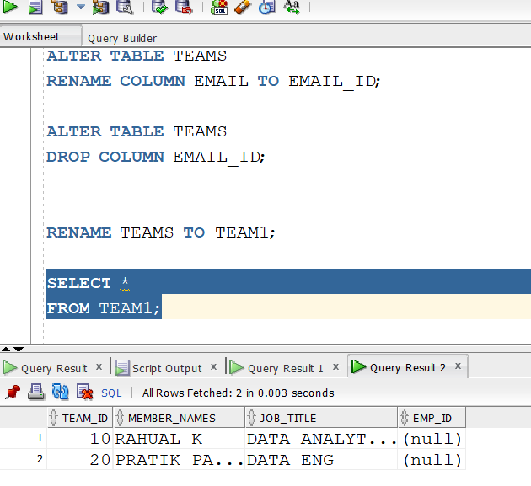

QUERY 19:
WAQ TO CHANGE THE DATA TYPE OF EMP_ID
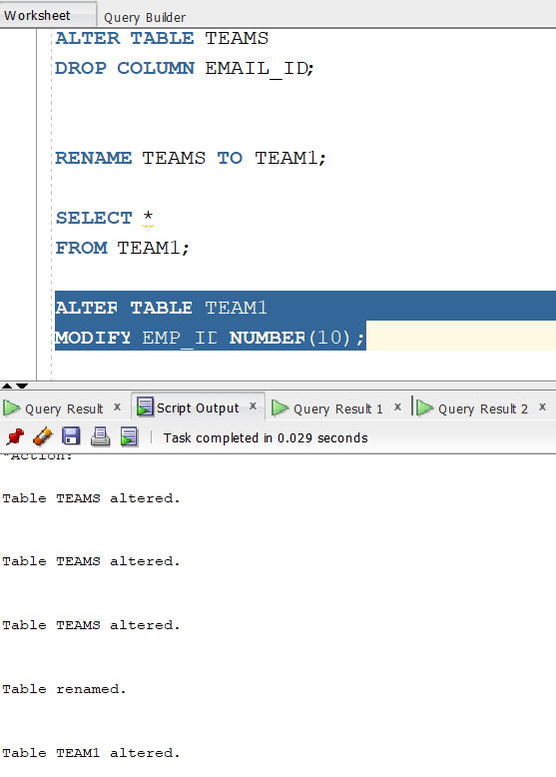

QUERY 20:
WAQ TO ADD EMAIL_ID TABLE TO TEAMS
