QUERY 1 : PRIMARY KEY CONSTRAIN ERROR
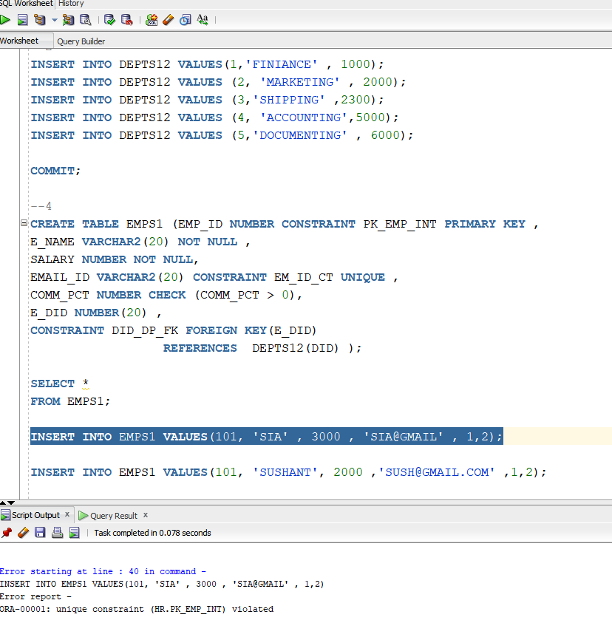

QUERY 2: NO NULL VALUE ERROR IN PRIMARY KEY 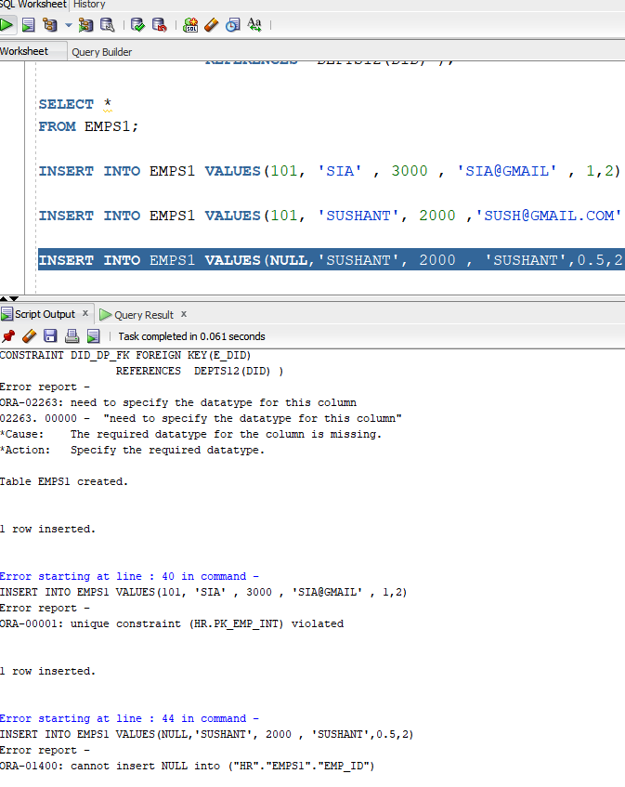

QUERY 3: NOT NULL CONSTRAINT
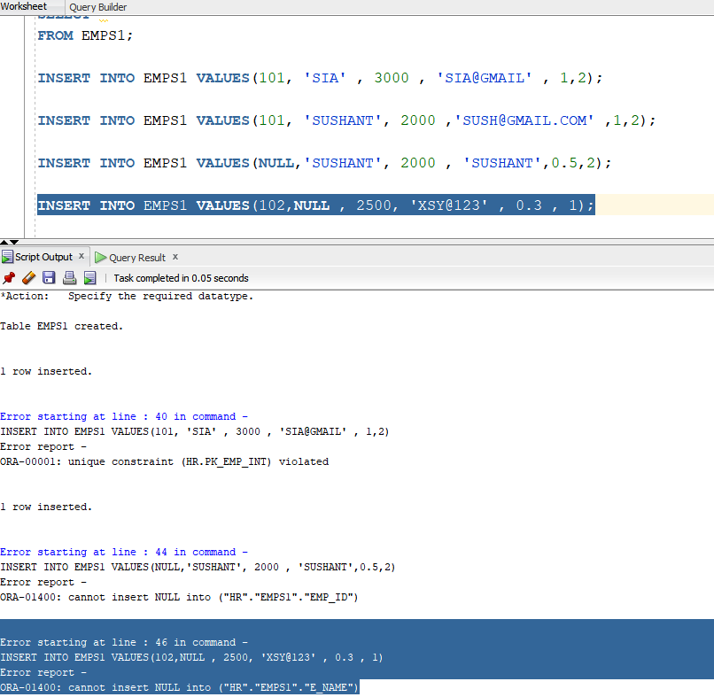

QUERY 4 :UNIQUE VALUE CONSTRAINT
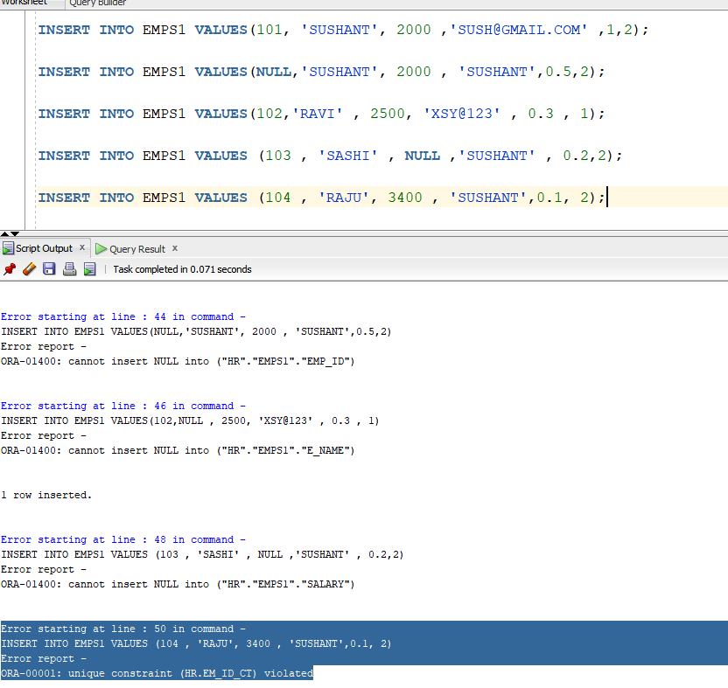

QUERY 5:
CHECK CONSTRAINTS VOILATED
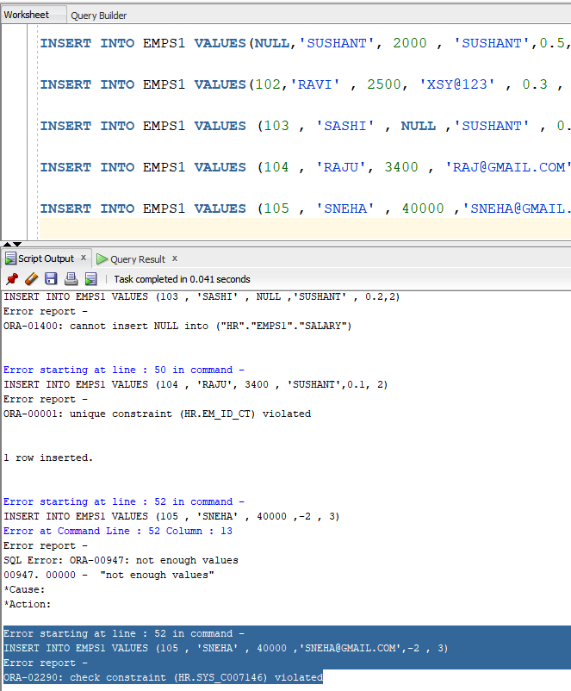

QUERY 6: TWO CONSTRAINTS FOR 1 COLUMN
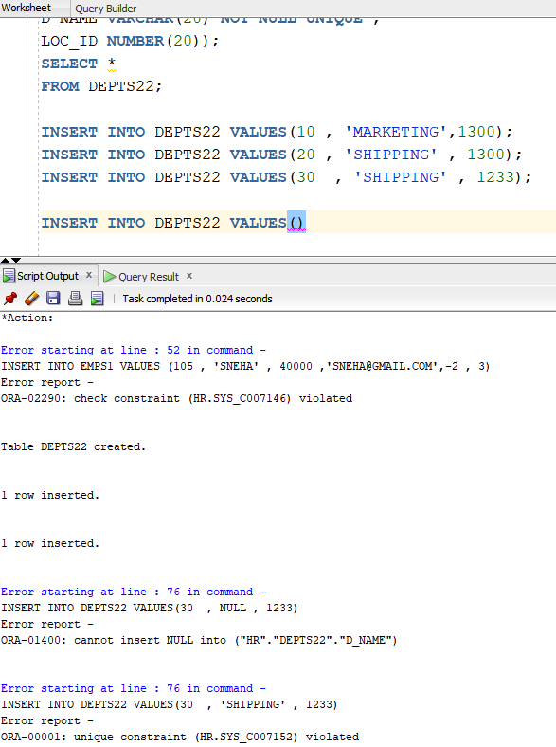

QUERY 7: PARENT KEY NOT FOUND INTEGRITY CONSTAINT ERROR
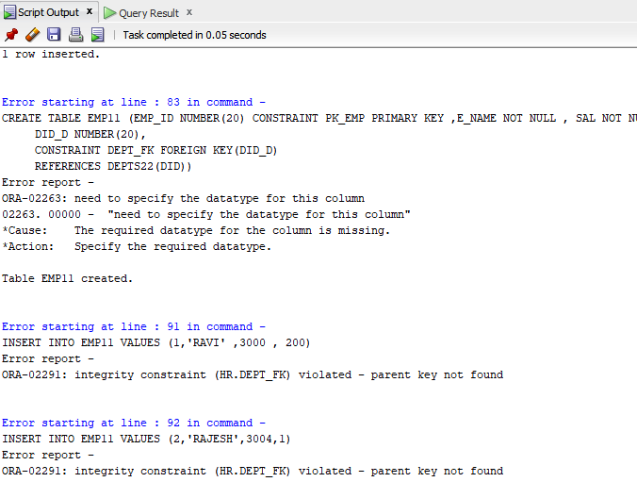

QUERY 8: UPDATE DML COMMAND ON
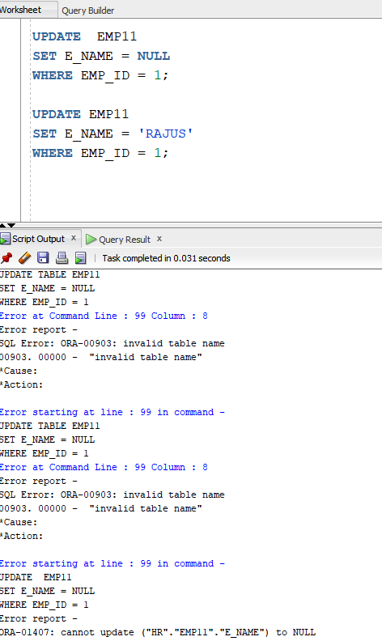

QUERY 9 : CANNOT UPDATE VIEW WHERE TABLE COLUMNS CONSTRAINTS ARE VOILATED
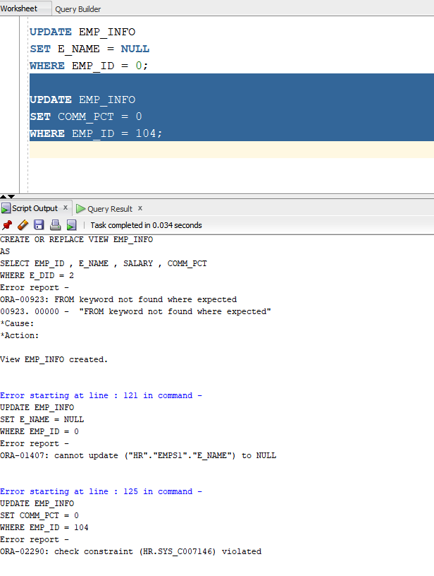

QUERY 10 BACKUP TABLE COPY CONSTAINTS??

