QUERY 1:
GET ALL MANAGER NAME AND CITY FOR EMPLOYEES WORKING AS MANAGER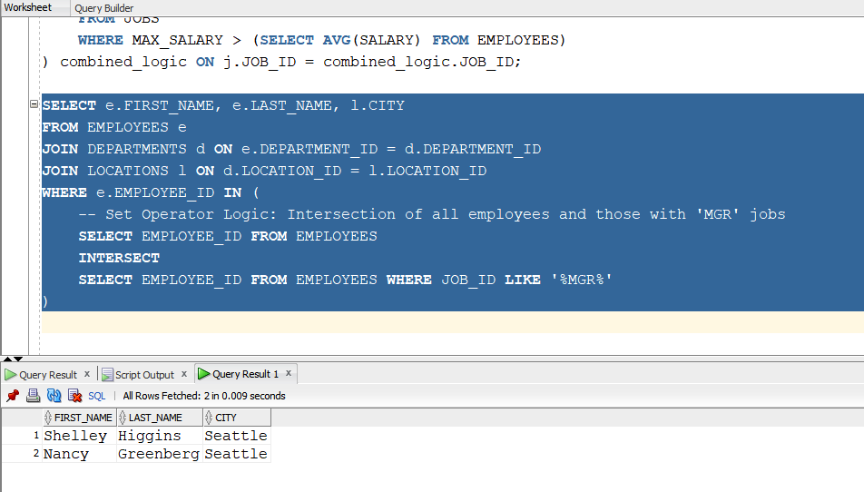

QUERY 2:WAQD THE ALL RECORD OF EMPLOYEES WORKING IN CITY LONDON

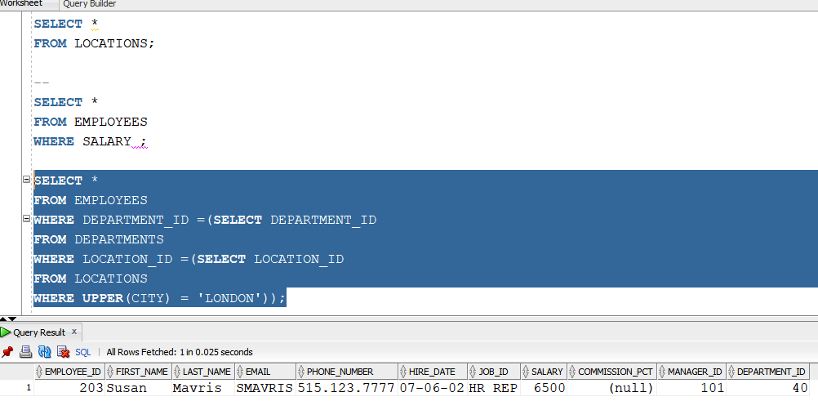

QUERY 3:
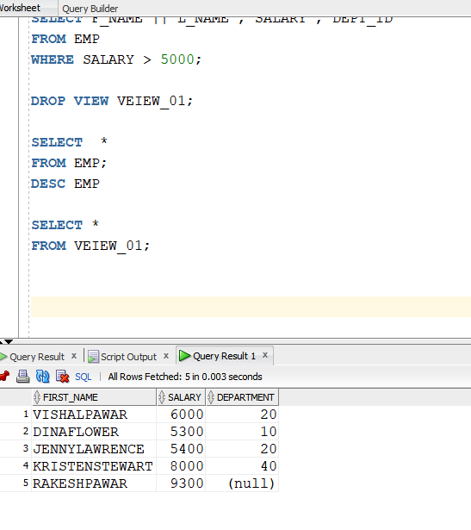

QUERY 4:CITY WISE EMPLOYEES COUNT WHERE COUNT IS MORE THAN 2
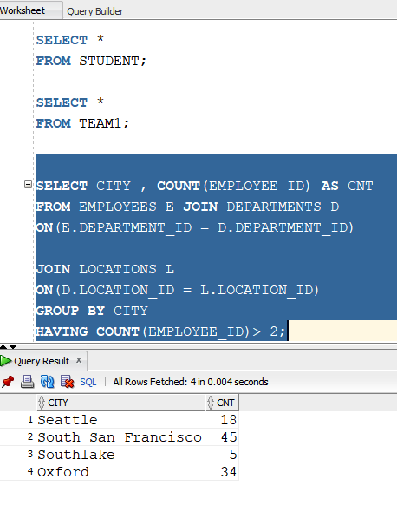
QUERY 5 : THIRD HIGHEST SALARY IN EMPLOYEES TABLE USING SUBQUERY

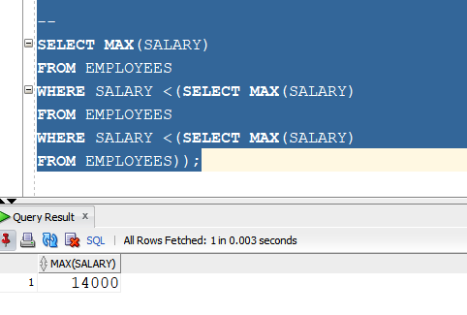
QUERY 6: WAQD JOB_ID WISE MIN , MAX , AVG SALARY FOR EMPLOYEES
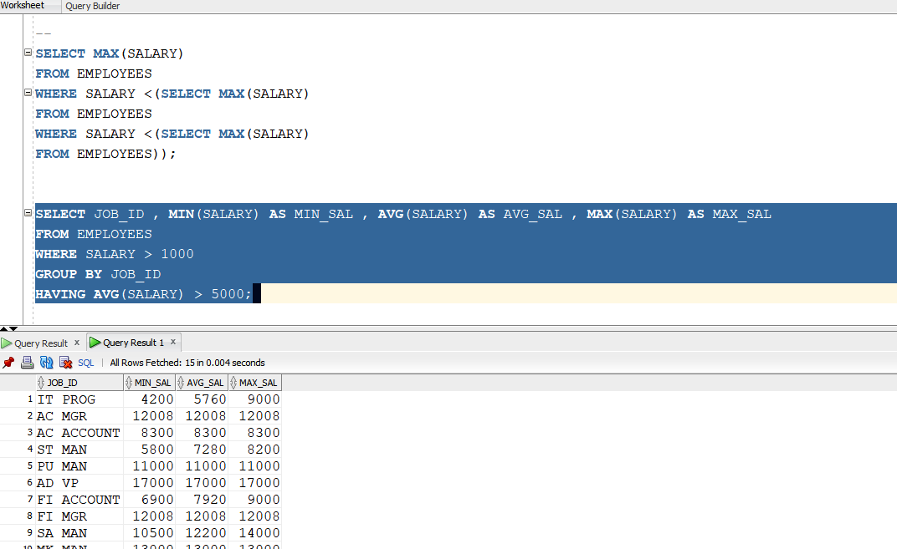

QUERY 7 :SET OPERATORS TO DISPLAY DEPARTMENTS PRESENT IN BOTH EMPLOYEES AND DEPARTMENT TABLE
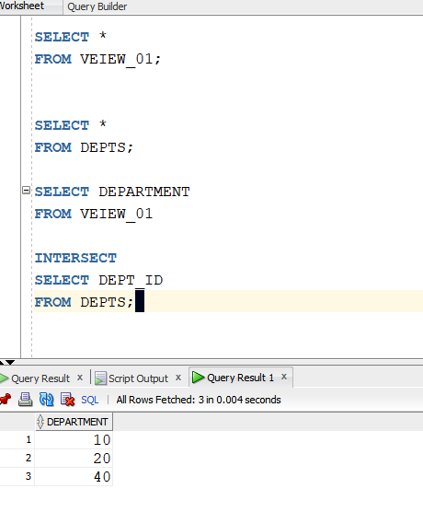
QUERY 8:WAQD THE DEPARTMENT NAMES PRESENT IN VIEWS AND DEPARTMENT
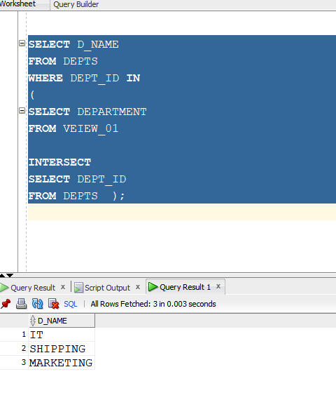
QUERY 9: WAQD THE CUSTOMER NAMES WHO DIDN’T PLCAE ANY ORDER

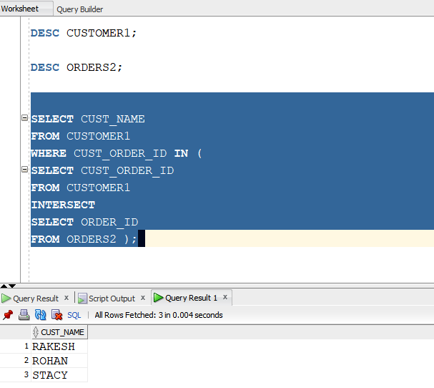

QUERY 10: WAQD THE ALL EMPLOYEES WHO HAVE NOT PLACED ANY ORDER
