QUERRY 1 CREATE TABLE EMP INSERT VALUES AND COMMIT:
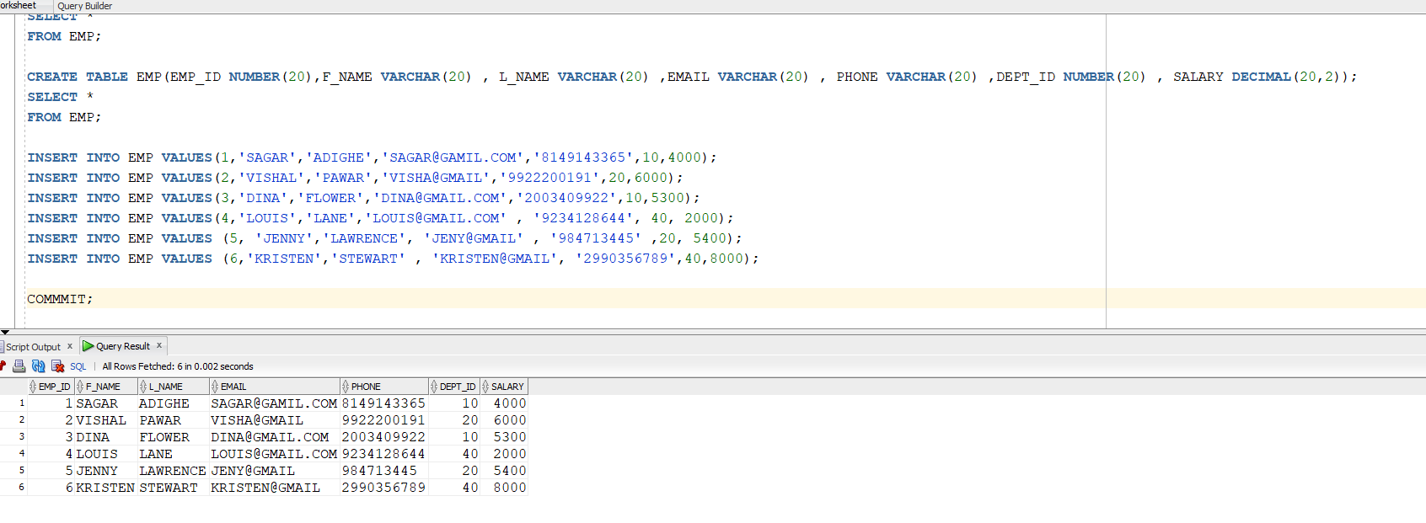
QUERY 2 CREATE THE VIEW ON EMP
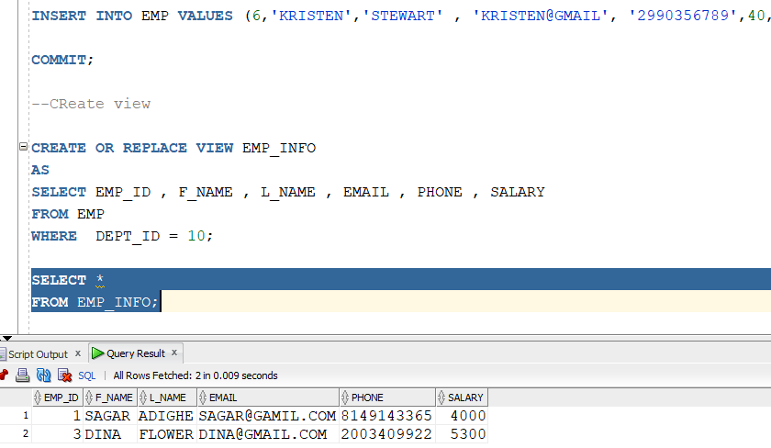

QUERY 3:INSERTING VALUES INTO THE EMPLOYEES TABLE IT IS POSSIABLE THROUGH VIEWS
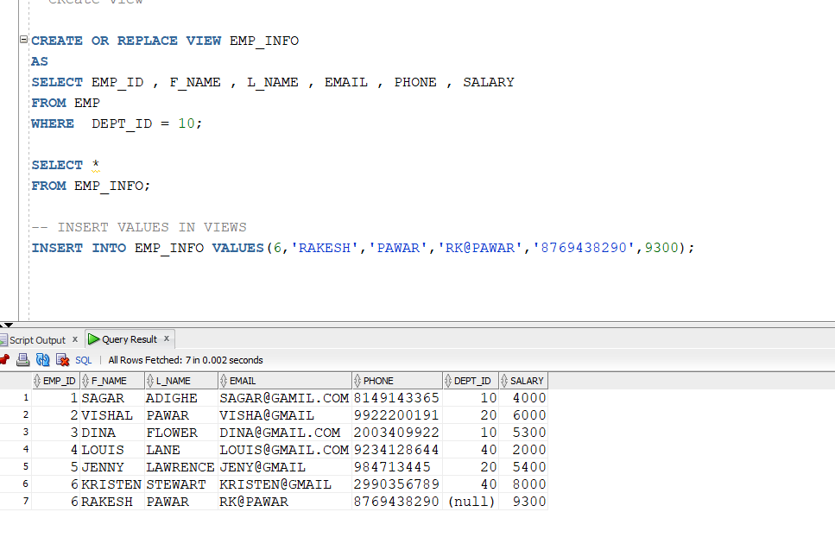

QUERY 4 UPDATING VALUES IN VIEWS
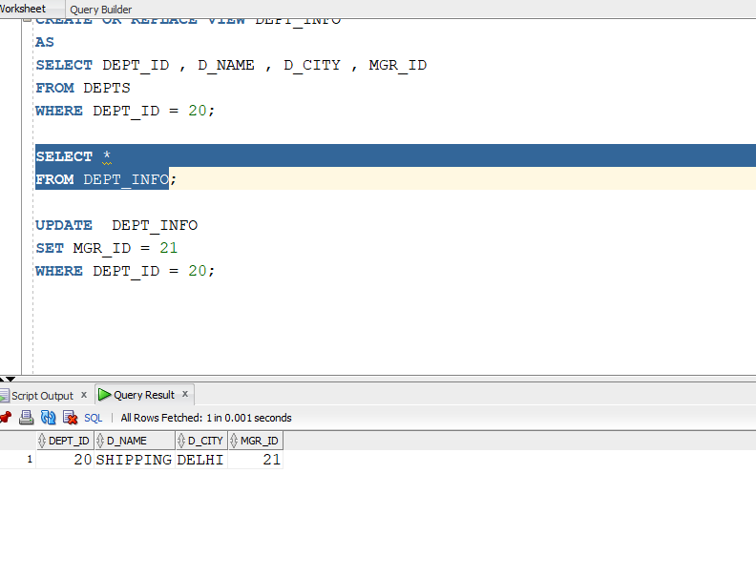

QUERY 4:
JOINS WITH VIEWS:
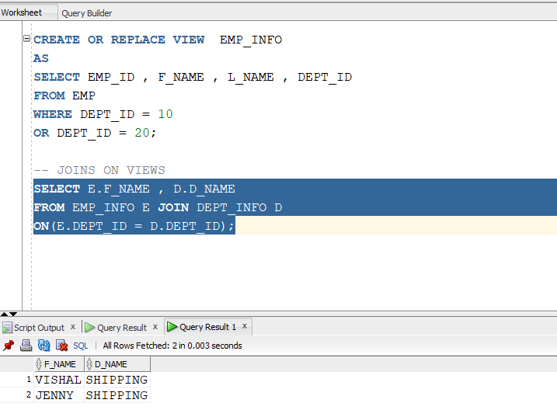

QUERY 5: VIEW AND TABLE JOINS
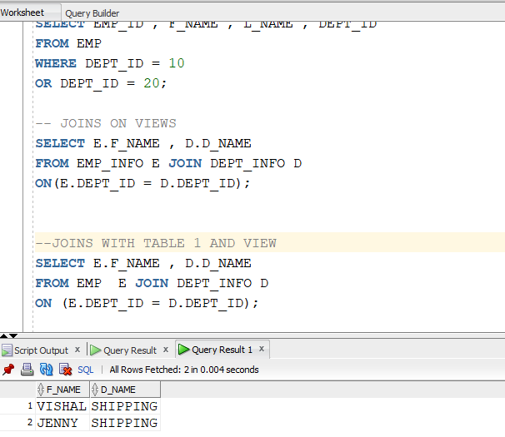

QUERY 6:
CREATING VIEW FROM VIEWS
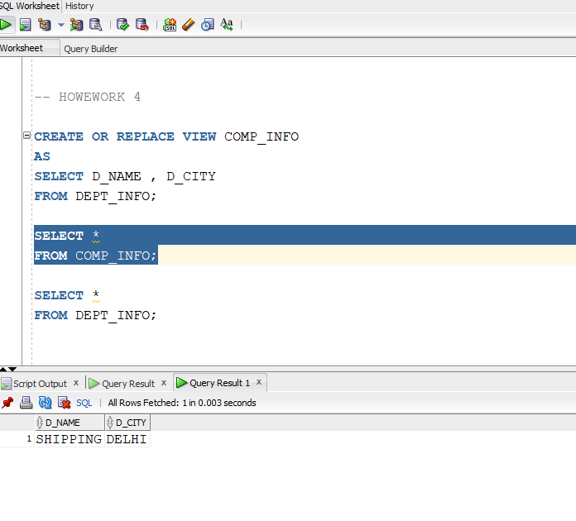
QUERY 7:
CREATING VIEW FROM MULTIPLE TABLE
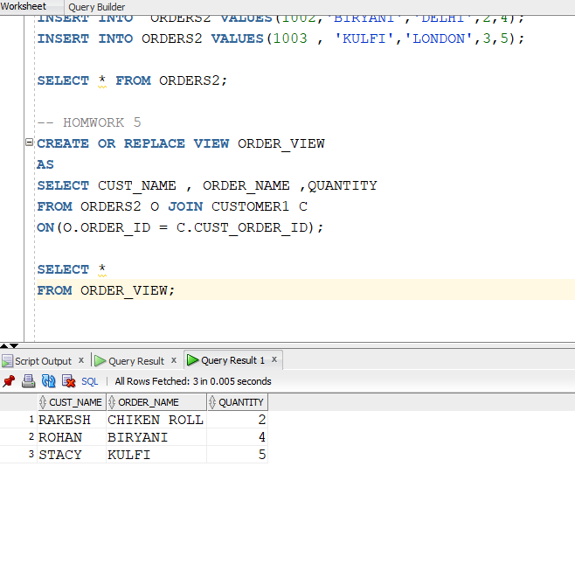

QUERY 8:CREATING VIEW USING GROUP BY
