QUERY 1: USING TABLE 1 TO CREATE TABLE 2
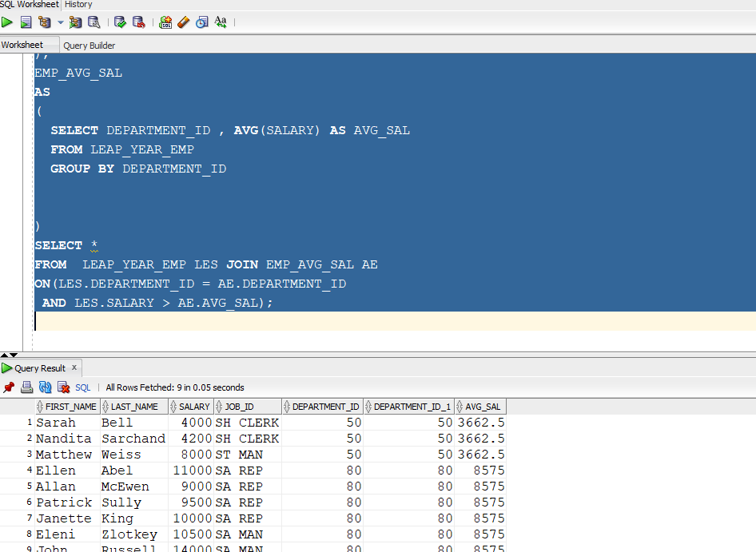

QUERY 2:
WRITE A QUERY TO DISPLAY EMPLOYEES WHO HAVE WORK EXP MORE THAN 6 YRS AND THEIR JOB TITLES ARE PROGRAMER , SALES , PRECIDENT WHO ARE HAVING MAX SALARY MORE THAN 20000

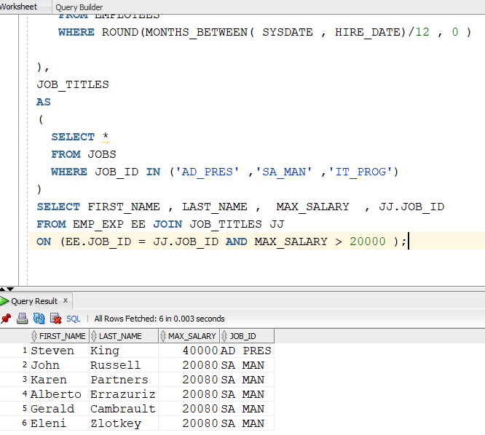

QUERY 3:
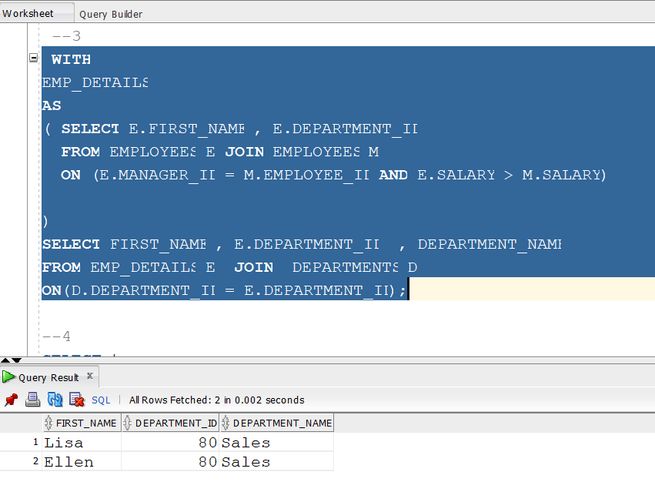

QUERY 4: --- FIND ALL CUSTOMER WHO ORDERED USING CTES

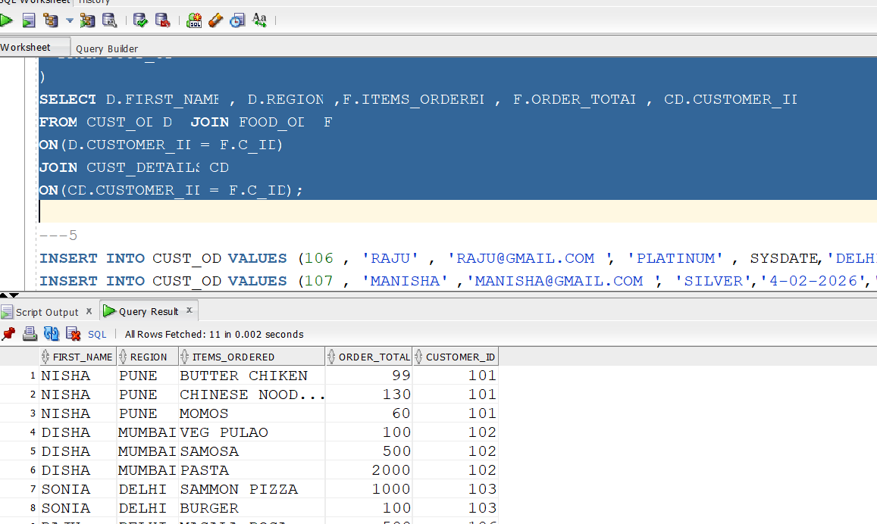

QUERY 5 :
---5 FIND ORDER PLACED BY RAJU ON HIS JOIN DAY AND ONLY THOSE ORDERS WHICH ARE WORTH MORE THAN AVG ORDRS??

