QUERY 1: SHOW DUPLICATES ALONGW WITH ROW_ID:
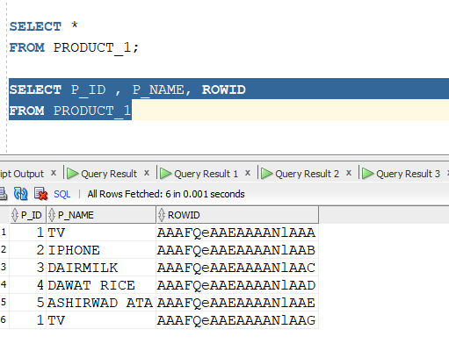
QUERY 2: AFTER EXECUTING DELETE DUPLICATE RECORD FROM TABLE
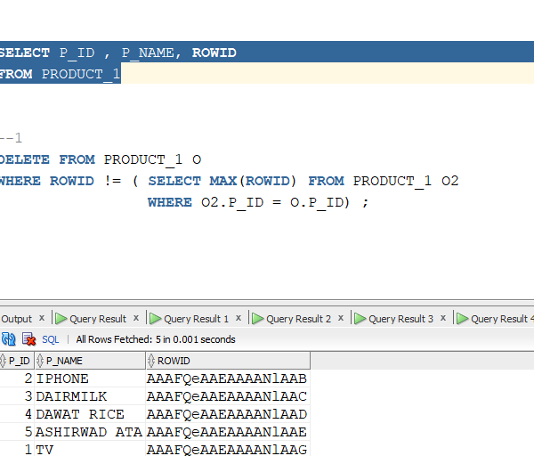

QUERY 3: EXITS OPERATOR TO GIVE DETAILS OF EMPLOYEES WHO ORDERED ATLEAST ONCE AND GOT DILIVERED??

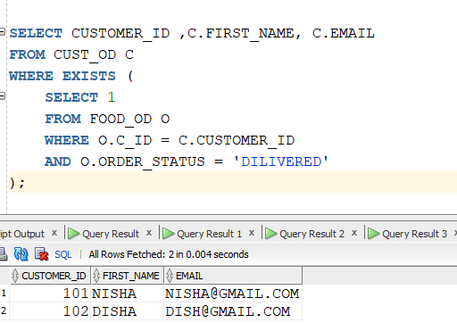

EXECUTION THROUGH JOINS TAKE ROW BY ROW:
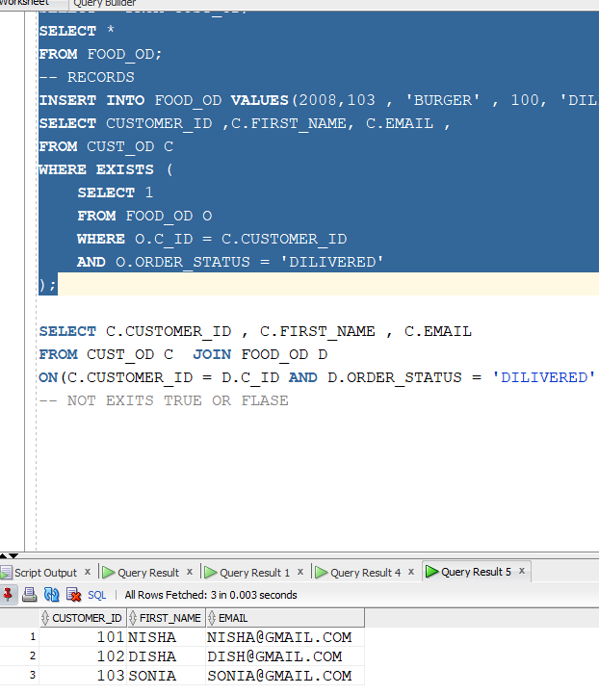

QUERY 4 : NOT EXITS IN
