4-Bit SystemVerilog Calculator Using FSM and Python GUI

Abstract
This project presents the design and verification of a 4-bit calculator using SystemVerilog and Xilinx Vivado. The calculator performs addition, subtraction, multiplication, and division using modular arithmetic circuits controlled by a Finite State Machine (FSM).
The design was verified using Vivado XSim, with the main testbench reporting 14 passed tests and zero failures. Vivado synthesis was used to examine the circuit structure and FPGA resource utilization.
A Python-based graphical user interface (GUI) was developed using Tkinter. Python validates inputs, launches the RTL simulation, retrieves and processes the results, and visualizes the recorded FSM transitions. The arithmetic computation itself is performed by the SystemVerilog RTL within XSim.

1. Introduction
A digital calculator is a useful example of how arithmetic circuits and sequential control logic work together. This project implements a 4-bit calculator using SystemVerilog, with a dedicated FSM to manage calculation requests and operation status.
The calculator supports four arithmetic operations and detects division by zero. Separate arithmetic modules are integrated into a top-level module, making the design modular and easier to understand.
A Python GUI provides an interactive way to enter operands, select operations, view results, and observe the FSM sequence without requiring a physical FPGA for the demonstration.

1.1 Objectives
- Implement addition, subtraction, multiplication, and division using SystemVerilog.
- Design an FSM to control calculation requests and error handling.
- Integrate modular arithmetic circuits into a top-level calculator.
- Verify the design using Vivado XSim.
- Analyze the synthesized schematic and FPGA resource utilization.
- Develop a Python GUI that interacts with the RTL simulation.

2. Theory and Architecture

2.1 Calculator Inputs and Outputs
The calculator accepts two 4-bit operands, A and B, a 2-bit operation selector, and the control signals clk, reset, and start.
Its outputs are an 8-bit result, a 4-bit remainder, a done flag, and an error flag.
The 8-bit result accommodates multiplication results up to (15\times15=225), as well as negative subtraction results represented using 8-bit two's-complement encoding.

2.2 Supported Operations
Operation code | Operation | Function
00 | Addition | A + B
01 | Subtraction | A − B
10 | Multiplication | A × B
11 | Division | Quotient and remainder
For example, subtracting 5 from 3 produces the 8-bit representation 254, corresponding to −2. The Python interface converts this representation to a signed decimal value for display.

3. Finite State Machine Design
The calculator uses a five-state FSM to manage the calculation process.
State | Encoding | Purpose
IDLE | 000 | Waits for a new request
EXECUTE | 001 | Processes the selected operation
DONE | 010 | Indicates successful completion
ERROR | 011 | Indicates division by zero
WAIT_RELEASE | 100 | Waits for the start signal to be released
The state register uses three bits to represent the five states.

3.1 State Operation
- IDLE: Waits until start becomes high.
- EXECUTE: Processes the selected arithmetic operation.
- DONE: Asserts done when the calculation completes successfully.
- ERROR: Asserts error when division by zero is detected.
- WAIT_RELEASE: Prevents a held start signal from triggering the same request repeatedly.
The FSM follows these sequences:
Successful operation:
IDLE → EXECUTE → DONE → WAIT_RELEASE → IDLE
Division by zero:
IDLE → EXECUTE → ERROR → WAIT_RELEASE → IDLE
The done and error outputs are associated with the current FSM state.

4. Modular RTL Design
The top-level module, calculator_top, integrates separate arithmetic modules and the FSM control logic.

4.1 Addition
A 4-bit ripple-carry adder performs addition and generates the corresponding sum and carry information.

4.2 Subtraction
A 4-bit subtractor calculates the difference between the operands. Negative results are represented in the 8-bit output using two's-complement encoding.

4.3 Multiplication
The 4-bit multiplier produces an 8-bit result to accommodate the product of two unsigned 4-bit operands.

4.4 Division
The 4-bit divider produces the quotient and remainder. Division by zero is handled as an error condition.

4.5 Top-Level Integration
The top-level module connects the arithmetic blocks, operation selector, FSM, and status outputs. This modular approach improves readability and allows individual arithmetic components to be reused.

5. RTL Simulation and Verification
The calculator was simulated using Xilinx Vivado XSim. Two SystemVerilog testbenches were used.

5.1 Main RTL Verification Testbench
File: calculator_top_tb.sv
This testbench verifies the calculator independently of the Python GUI. It applies different operands and operation codes, checks arithmetic results, and monitors FSM transitions.
The recorded simulation reported 14 tests passed and 0 tests failed.

5.2 GUI-Specific Testbench
File: calculator_gui_tb.sv
This testbench connects the Python bridge to the calculator RTL. It reads one calculation request, applies it to calculator_top, waits for completion or error, and writes the response and FSM state codes to text files.
The two testbenches have different purposes: the main testbench performs functional verification, while the GUI-specific testbench enables interactive calculations through Python.

6. Simulation Results
The following representative results were recorded during the main RTL simulation.
Test case | A | B | Operation | Expected result | Observed result
Addition | 3 | 5 | 00 | 8 | 8
Subtraction | 3 | 5 | 01 | −2 | 254
Multiplication | 3 | 4 | 10 | 12 | 12
Division | 13 | 4 | 11 | Quotient 3, remainder 1 | 3, remainder 1
Addition boundary | 15 | 15 | 00 | 30 | 30
Multiplication by zero | 0 | 15 | 10 | 0 | 0
Subtraction boundary | 15 | 0 | 01 | 15 | 15
Division with remainder | 15 | 4 | 11 | Quotient 3, remainder 3 | 3, remainder 3
Division by zero | 13 | 0 | 11 | Error | Detected
The testbench also checked held-start behavior, input stability after request acceptance, and recovery after a division-by-zero error.

6.1 FSM Transition Results
For the first addition test, the recorded transitions were:
Time (ns) | Transition
35 | IDLE → EXECUTE
45 | EXECUTE → DONE
55 | DONE → WAIT_RELEASE
65 | WAIT_RELEASE → IDLE
The division-by-zero sequence was:
IDLE → EXECUTE → ERROR → WAIT_RELEASE → IDLE
These results demonstrate the FSM's successful-operation and error-handling sequences.
Simulation summary: 14 tests passed, 0 failed.

7. RTL Simulation Waveform
The waveform was captured from Vivado XSim for calculator_top and its main testbench.
Figure 1: Vivado XSim waveform of the 4-bit calculator.
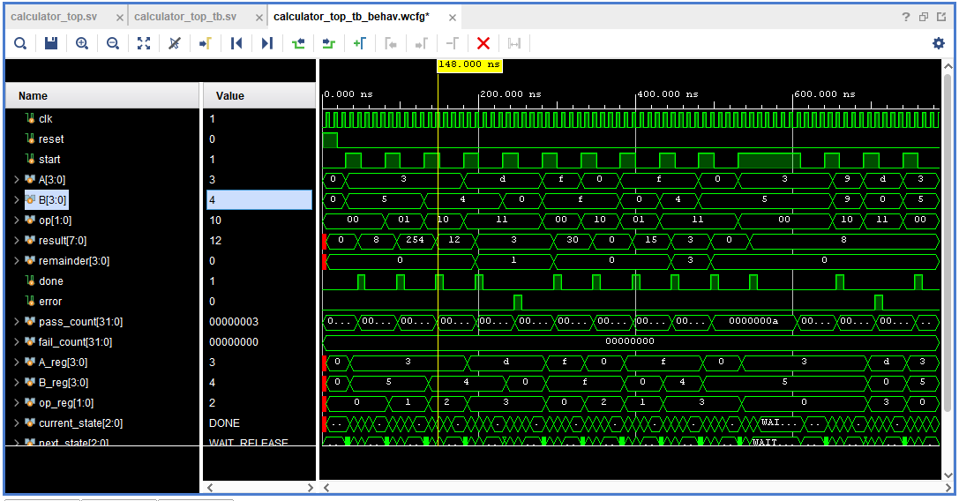The waveform displays the clock, reset, start signal, input operands, operation selector, result, remainder, status flags, and FSM state signals.
It illustrates how the inputs, arithmetic outputs, and FSM transitions relate during simulation. For example, inputs A = 3 and B = 4 with operation code 10 produce the multiplication result 12.

8. Synthesized Schematic and FPGA Resources

8.1 Synthesized Schematic
The RTL design was synthesized using Xilinx Vivado.
The schematic summary reported:
- 135 cells
- 27 I/O ports
- 149 nets

Figure 2: Synthesized schematic of the calculator.
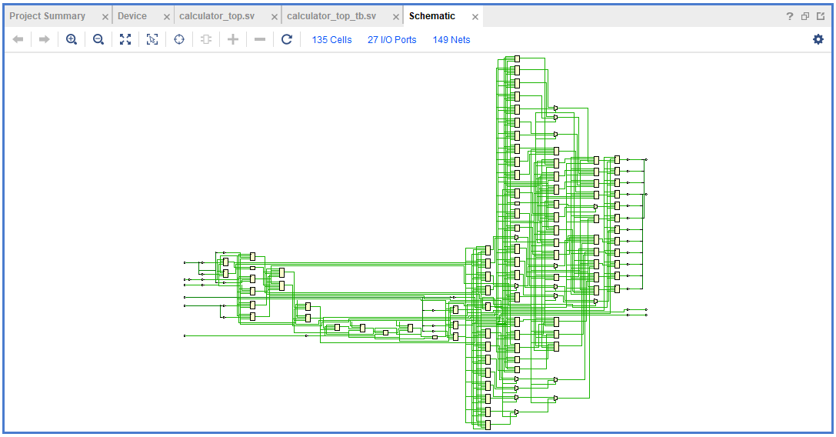The schematic shows the synthesized logic structure and interconnections inferred from the SystemVerilog design.

8.2 Resource Utilization
The Vivado hierarchy report provided the following resource figures.
Resource | Used | Available
Slice LUTs | 59 | 32,600
Slice Registers | 27 | 65,200
F7 Muxes | 12 | 16,300
F8 Muxes | 4 | 8,150
Bonded IOBs | 27 | 210
BUFGCTRL | 1 | 32
Figure 3: FPGA resource utilization report from Vivado.
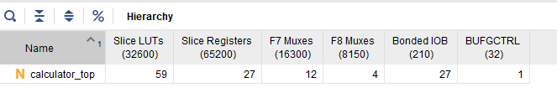The calculator uses 59 Slice LUTs and 27 Slice Registers. LUTs implement combinational logic, while registers support sequential logic such as the FSM. The report also records multiplexer, I/O, and clock-control resource usage.
Relative to the selected device's reported capacity, the Slice LUT and Slice Register utilization is low. These figures describe synthesis resource usage and do not, by themselves, establish post-implementation timing closure or successful operation on a physical FPGA.

9. Python GUI and RTL Integration

9.1 Role of Python
Python does more than provide the calculator's visual interface. It acts as the software control and integration layer that manages each calculation request, starts the RTL simulation, processes the returned data, and presents the results.
The arithmetic computation and FSM execution remain in SystemVerilog within Vivado XSim.

9.2 Python Bridge
File: calculator_bridge.py
The Python bridge uses pathlib and subprocess to manage simulation files and launch XSim.
Its main responsibilities are:
- Validate that A and B are between 0 and 15 and that the operation code is valid.
- Write the operands and operation code to request.txt.
- Remove stale response and transition files.
- Launch the precompiled calculator_gui_snapshot using Vivado XSim.
- Check for simulation errors, missing responses, malformed output, and timeouts.
- Read the result, remainder, done, and error values from response.txt.
- Convert negative subtraction results from their 8-bit representation to signed decimal values.
- Read FSM state codes from fsm_transitions.txt and pass them to the GUI.
For example, a request containing 3 5 0 represents addition of 3 and 5.

9.3 GUI Implementation
File: calculator_gui.py
The GUI is implemented using Python Tkinter and contains three main sections.
Calculator panel: Allows the user to enter operands, select an arithmetic operation, initiate a calculation, and view the result and remainder.
FSM visualization panel: Displays the five FSM states and highlights the recorded transition sequence. The animation uses Tkinter's after() method to display each recorded state for approximately 700 milliseconds.
Execution monitor: Displays the simulator output, state-transition messages, and diagnostic information.
The FSM animation replays the state codes recorded during the XSim simulation; it is not a live, cycle-by-cycle hardware trace.

9.4 Python–SystemVerilog Communication
The GUI and simulator communicate through three text files.
File | Purpose
request.txt | Sends operands and operation code from Python to the testbench
response.txt | Returns result, remainder, done, and error
fsm_transitions.txt | Transfers recorded FSM state codes for visualization

9.5 Complete Computation Workflow
The complete process is as follows:
- The user enters operands and selects an operation in the GUI.
- Python validates the inputs and prepares the request.
- The Python bridge launches the XSim simulation.
- The GUI-specific testbench reads the request and supplies it to calculator_top.
- The SystemVerilog arithmetic modules perform the selected calculation, and the FSM controls its execution.
- The testbench writes the result and status information to response.txt.
- Python retrieves the response and converts the output into a suitable display format.
- Python reads the recorded FSM transitions and animates them in the GUI.
- The GUI displays the result, status, and simulator messages.
Therefore, Python orchestrates the calculation workflow and processes the returned results, while SystemVerilog performs the arithmetic computation and FSM execution in XSim.
The bridge also contains an optional command-line verification routine with six representative cases. This is separate from the 14 tests reported by the main RTL testbench.

10. Conclusion
This project demonstrates the design, verification, and synthesis analysis of a 4-bit calculator using SystemVerilog and a five-state FSM.
The calculator supports addition, subtraction, multiplication, and division, with control logic for successful completion, division-by-zero detection, and request release. The main Vivado XSim testbench reported 14 passing tests and zero failures, covering arithmetic operations and important control conditions.
Vivado synthesis produced a schematic with 135 cells, 27 I/O ports, and 149 nets. The resource report recorded 59 Slice LUTs and 27 Slice Registers, along with the reported multiplexer, I/O, and clock-control resources.
The Python GUI makes the calculator easier to operate and understand. Python validates inputs, launches the simulation, retrieves and interprets the outputs, and visualizes the recorded FSM sequence, while the SystemVerilog RTL performs the actual arithmetic computation.
The project brings together digital design, FSM implementation, RTL verification, FPGA synthesis analysis, and Python-based simulation integration in a single working demonstration.

