4-Bit Unsigned Divider Using Restoring Division Algorithm

1. Objective
To design and verify a 4-bit unsigned binary divider using Verilog HDL and a single-module architecture.
The circuit calculates the quotient and remainder of two 4-bit unsigned inputs and includes a division-by-zero detection flag.

2. Theory
Binary division can be implemented in hardware using the restoring division algorithm. The algorithm processes the dividend from the most significant bit to the least significant bit.
At each stage:
- Shift the partial remainder and bring in the next dividend bit.
- Compare the partial remainder with the divisor.
- If the partial remainder is greater than or equal to the divisor, subtract the divisor and set the corresponding quotient bit to 1.
- Otherwise, retain the partial remainder and set the quotient bit to 0.
The process continues until all dividend bits have been processed. The final quotient and remainder are available at the outputs.
The implementation uses intermediate remainder storage wide enough to preserve the value during shifting. The division logic is written within a single RTL module without using the Verilog division (/) or modulo (%) operators.
A separate status output, DivideByZero, detects when the divisor is zero. In this case, the quotient and remainder are set to zero, and the error flag is asserted.
Input and output signals:
- A[3:0] — Dividend
- B[3:0] — Divisor
- Quotient[3:0] — Division result
- Remainder[3:0] — Remaining value after division
- DivideByZero — Division-by-zero status flag

3. Boolean Equations
For a nonzero divisor:
Quotient = A / B
Remainder = A mod B
These equations describe the mathematical behavior; the hardware RTL implements the restoring division algorithm without using the / and % operators.
The quotient and remainder satisfy:
A = (B × Quotient) + Remainder
with the conditions:
- B ≠ 0
- 0 ≤ Remainder < B
Division-by-zero detection:
DivideByZero = 1 when B = 0
DivideByZero = 0 when B ≠ 0
When B = 0, both Quotient and Remainder are set to zero.

4. TCL Console Output After Simulation
PASS: All 256 divider test cases passed!
The testbench exhaustively verified all 256 combinations of the two 4-bit inputs, including all 16 cases where the divisor is zero.
The division and modulo operators were used only in the testbench to calculate reference results, not in the synthesizable divider RTL.

5. Simulation Waveform
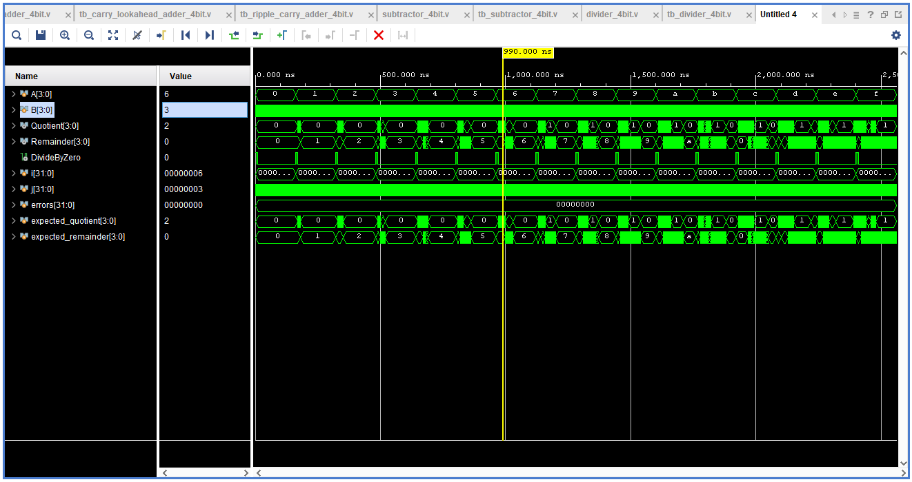Example test case:
- A = 6
- B = 3
- Expected Quotient = 2
- Expected Remainder = 0
- DivideByZero = 0
- Errors = 0
The simulation waveform confirms that the divider produces the correct quotient and remainder and that the divide-by-zero flag remains low for a valid division operation.

6. Synthesized Schematic
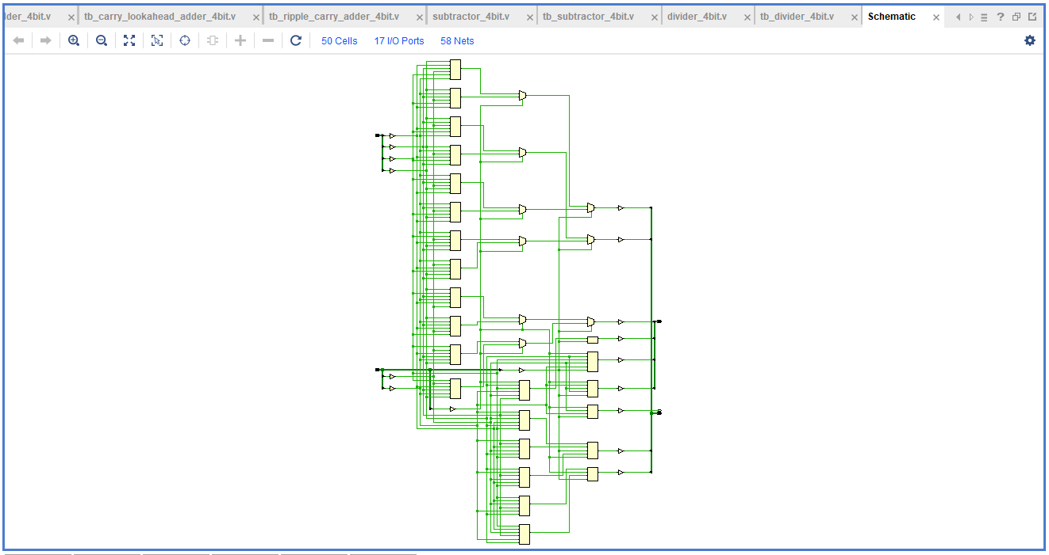Synthesis summary:
Parameter | Result
Total cells | 50
I/O ports | 17
Nets | 58
LUT count | 24
The synthesized schematic shows the combinational logic inferred by Vivado to implement the division algorithm, quotient generation, remainder generation, and divide-by-zero detection.

7. LUT INIT Values
The following LUT INIT values were obtained from the Vivado Tcl Console after synthesis:
DivideByZero_OBUF_inst_i_1 : 16'h0001

Quotient_OBUF[0]_inst_i_4 : 64'hB6FF2400F000F000
Quotient_OBUF[0]_inst_i_5 : 64'h791873738A8A8888
Quotient_OBUF[0]_inst_i_6 : 64'hFBAAFFFB00000000
Quotient_OBUF[0]_inst_i_7 : 64'hA200AAA200000000
Quotient_OBUF[1]_inst_i_1 : 4'h2
Quotient_OBUF[1]_inst_i_2 : 64'h94DDD0880480D088
Quotient_OBUF[2]_inst_i_1 : 64'h0000000040445000
Quotient_OBUF[3]_inst_i_1 : 32'h00001000

Remainder_OBUF[0]_inst_i_4 : 64'h49CC24CC00000000
Remainder_OBUF[0]_inst_i_5 : 64'h86FF75FF18008A00
Remainder_OBUF[0]_inst_i_6 : 64'h02FFFFFFDC000000
Remainder_OBUF[0]_inst_i_7 : 64'h2FFFFFFF40000000
Remainder_OBUF[1]_inst_i_4 : 64'h1080806000000000
Remainder_OBUF[1]_inst_i_5 : 64'h1B4B57D7A0208828
Remainder_OBUF[1]_inst_i_6 : 64'h55A5FFFF88480000
Remainder_OBUF[1]_inst_i_7 : 64'h59FFFFFF00000000
Remainder_OBUF[2]_inst_i_1 : 32'hAFA0C0C0
Remainder_OBUF[2]_inst_i_2 : 64'h22B2FFFF00000000
Remainder_OBUF[2]_inst_i_3 : 64'hD4DDFFFF00000000
Remainder_OBUF[2]_inst_i_4 : 64'h0C046D0482800080
Remainder_OBUF[3]_inst_i_1 : 16'hE200
Remainder_OBUF[3]_inst_i_2 : 64'h1055001000000000
Remainder_OBUF[3]_inst_i_3 : 64'h75FF557500000000
Total LUTs = 24

