REPAIR HUB

Proff. Manoj Patil [1] Prof. Nikhil Raj Gupta [2] Sushant chavan [3] Shivam yadav [4] Pranav gaikwad [5] Shivam singh [6] Omkar kanade [7] Parth puranik [8]

Assistant professor Department of Engineering science Ajeenkya dy patil pune, maharashtra, India [1], [2]

First year students of Departmemt of Engineering science Ajeenkya dy patil pune, maharshtra, India [3], [4], [5], [6], [7], [8]

**Abstract :** Nowadays everyone is busy with busy work as they are worried about the busy process of their daily work. They have no time to enjoy family life. An unexpected problem with our home appliances distracts us from our daily lives and chooses the work that needs to be done. Therefore, it needs to be balanced with family and work life. No one has problems with plumbing, damaged furniture, home problems, etc. He does not want to live in a house or building. As the demand for today's technology increases, people's lives have become easier. The current generation is the largest user of the network expanding home business opportunities. "Home Repair" application is a dedicated phone REPAIRHUB, in addition to providing various home repair services such as repair of electrical appliances, doors, air conditioners, TVs and other repairs. A specialized tool that connects users with experts in the repair of air conditioners, refrigerators and other home appliances. The app simplifies the process of finding experts to repair specialized equipment, ensuring timely and efficient service.

**Keywords** : Home repairs, Maintenance services, Customers, Service engineers,Website, Java , Javascript, python

# I. INTRODUCTION

In today's world, proper functioning of your home appliances is very important to make your home comfortable, convenient and efficient. However, when these devices malfunction or break down, they can cause serious problems and frustrations. REPAIRHUB is a unique mobile application that connects users with experts in the repair of air conditioners, refrigerators and other home appliances. The app simplifies the process of finding experts for the repair of specialized household appliances, ensuring timely and efficient delivery. Our aim is to offer the perfect solution for all your home appliances with a simple, green and most accurate contact form. REPAIR HUB provides the most convenient and hassle-free way to complete your work or a more efficient, hassle-free and tactful way. Just click on the system to fill out the home professional and complete your services time. There is a significant relationship between customers' willingness to pay and their expectation that payment services will be better, as well as the belief that "pay for what you get" is the way to go. Repairhub is a nice website that helps users instantly.

## II. **METHODOLOGY**

The authors of this research project used a combination of quantitative and qualitative methods to gain information about the research study. Using an online survey, use a variety of methods to set goals and identify problems and develope appropriate solution.

# **111. FLOWCHART**

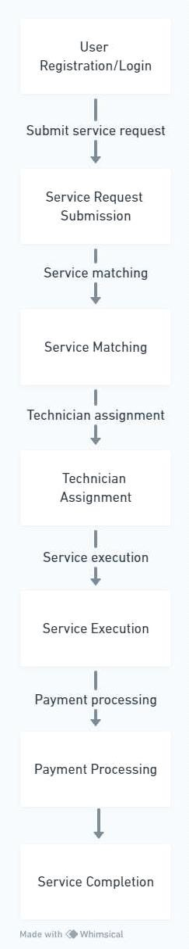

1V. **ARCHITECTURE**

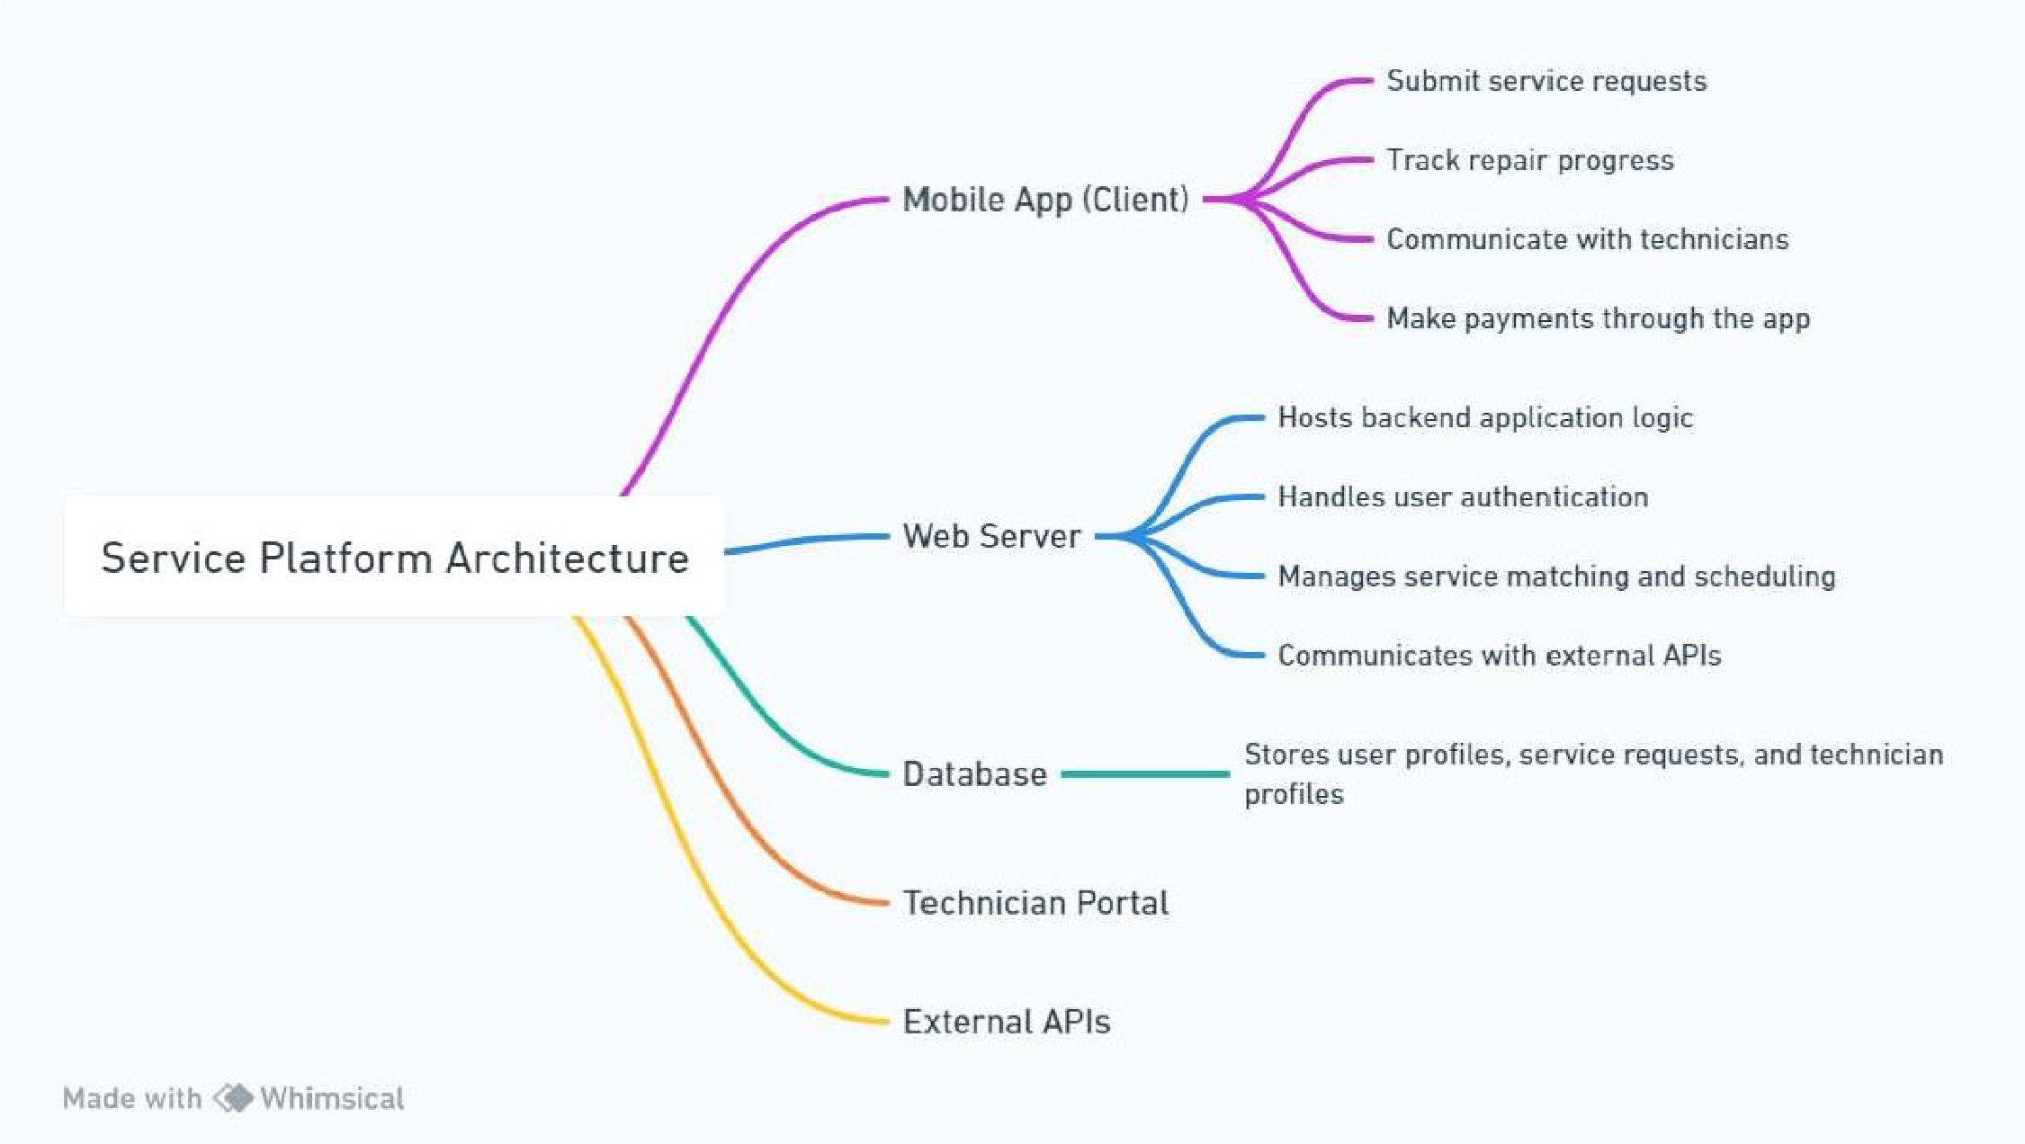

**V. FUTURE SCOPE**

There are many ways to improve and improve our hardware going forward. Here are some

areas to explore in the future:

Services offered: Although our current focus is on the repair of home appliances such as refrigerators and air conditioners, we may expand our services. equipment. This includes washing machines, washing machines, ovens, etc. to meet the needs of the owners. may contain.

Improve predictions: Based on our existing predictive analysis, we can refine and improve our algorithms to provide predictions and better recommendations. This will involve the use of machine learning and artificial intelligence to analyze larger data sets and identify subtle patterns that indicate potential problems.

Partnerships and Environmental Initiatives: Partnerships with manufacturers, recyclers and environmental organizations open opportunities for environmental initiatives. This will include supporting energy efficiency, supporting recycling and supporting sustainable solutions in line with our commitment to environmental responsibility.

Continuous development and user feedback: Above all else, continuing to iterate and improve based on user feedback is crucial to the long-term success of our app. Regularly soliciting user input, reviewing usage data, and running usability tests help identify areas for improvement and highlight areas for future improvement, making our apps important and useful.

VI. **ADVANTAGES**

There are numerous advantages on our topic, some of them are listed below:- Our theme has many advantages, some of them are as follows: - Appliances provides unparalleled convenience by allowing users to schedule repair services from the comfort of their homes, thus eliminating this need. Used for making lots of phone calls or going to the repair shop. These apps connect users with professionals and service providers, making editing programs more accessible to audiences, including those in remote or unserved areas. Users benefit from transparent pricing, service descriptions, and access to experts and reviews, building trust and confidence in service providers. Thanks to features such as instant messaging, automatic reminder time and easy delivery, the digital platform is easy to maintain from service requests to job completion. Many practices pre-screen and professionals; thus allowing users to learn about experts and professionals who can offer customized services.

VII. **CONCLUSION**

Our research and development in equipment repair brings benefits and innovations. REPAIRHUB focuses on transparency, efficiency, reliability and sustainability. It provides transparent pricing, instant messaging, predictive maintenance, augmented reality, intelligent decision-making, and environmental impact to meet the needs of today's users. Compared to other applications, our application stands out in terms of user-friendly design, functionality and development stability.

Although some Website have similar functionality, they often lack usability, reliability or environmental awareness. Our applications set new standards in the digital age by prioritizing user experience, quality service and environmental responsibility. We are committed to improving our applications based on user feedback, technological advances and industry trends. By constantly improving our designs, including understanding customers and knowing the latest technologies, we focus on the home appliance repair market and deliver exceptional value to our customers and stakeholders.

REFERENCES

[1] Li, H., Wang, Q., & Chen, L. (2020). "Efficient Appointment Scheduling in Service Platforms." *ACM Transactions on Intelligent Systems and Technology.*

[2] Zhu, Y., Liu, W., & Zhang, L. (2020). "IoT-enabled Appliance Repair Services: Opportunities and Challenges." *IEEE Internet of Things Journal.*

[3] Kim, S., Lee, H., & Park, J. (2021). "User Experience Design for Home Service Applications." *International Journal of Human-Computer Interaction.*

[4] Chen, Y., Wang, S., & Liu, Z. (2019). "Machine Learning Applications in Predictive Maintenance for Home Appliances." *International Conference on Machine Learning Applications.*

[5] Garcia, E., Martinez, R., & Rodriguez, M. (2020). "Mobile Applications for Home Maintenance Services: A Comparative Study." *International Journal of Mobile Human-Computer Interaction.*

[6] Wang, Y., Zhang, Q., & Liu, H. (2021). "Challenges and Solutions in Real-time Communication for Home Service Platforms." *Proceedings of the ACM on Interactive, Mobile, Wearable and Ubiquitous Technologies.*

[7] Chen, X., Li, J., & Zhang, Y. (2018). "Security and Privacy Considerations in IoT- enabled Home Appliance Repair Services." *IEEE Transactions on Dependable and Secure Computing.*

[8] Park, S., Kim, J., & Lee, D. (2022). "User Satisfaction and Loyalty in Home Service Applications: A Longitudinal Study." *Journal of Service Management.*

[9] Zhang, H., Liu, X., & Wang, Y. (2021). "Environmental Impact Assessment of Appliance Repair Services: Methodology and Case Study." *Environmental Science & Technology*