* **Introduction**

ABC HealthCare is a Web application. It maintains the contact information.

Technology used :

1: .Net core 3.1

2: Dapper

3: MySql

4: Swagger

5: Serilog

6: Dependency Injection

This application contains 2 folder.

1: Business_DataAcccess

2: ViewService

Below is the ScreenShot

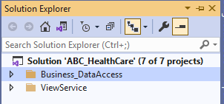

**Flow of the Application**

Ui will communicate with ViewService and ViewService will communicate with Business_Dataaccess.

**ViewSerivce** :

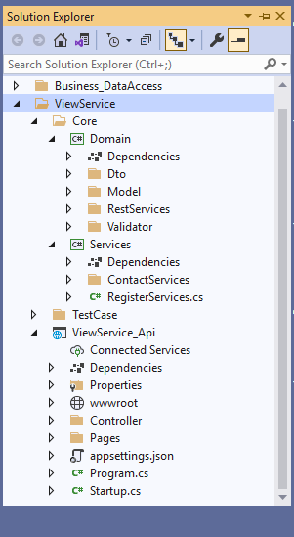

**ViewService_Api** :

Controller folder contains contact controller.

**Core Folder**:  
 A: **Domain**  
 1: Dto folder contains some common class to handle api response.  
 2: Model contains contact model class  
 3: RestSercives contains classes helps to communicate with Business_dataaccess

4: Validatior folder contains fluent validation

B: **Services**  
 it contains interface and the class which has implemented the interface.  
 contact service registerd in the RegisterService.cs using dependency injection

**Business_DataAccess**

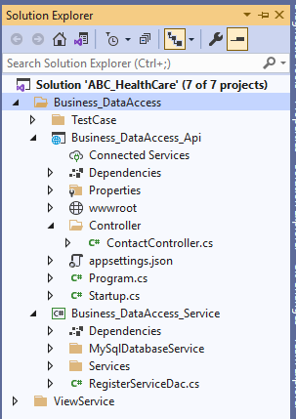

**Business_DataAccess_Api** :

Controller: ViewService communicate with ContactController

MySqlDatabaseService: Communicate with mysql  
Service: contains Interface and the class which has implemented the interface.

**How to Run Application**:   
Right click on solution > go to properites > do the setting as shown in below screenshot.

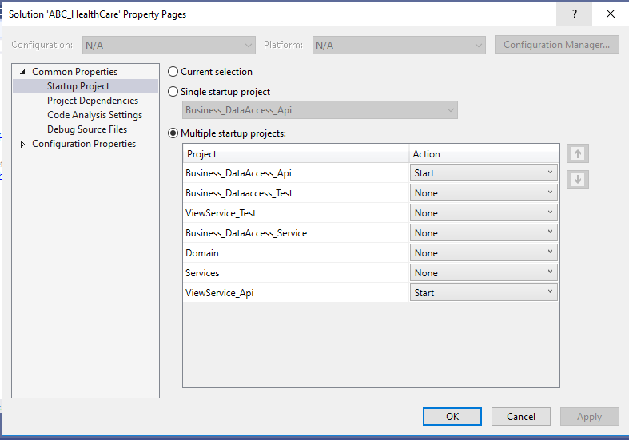

Click Start.