HELPDESK TICKET TRACKER
Excel-Based Ticket Management & Support Analysis Project
Project Documentation

Prepared from the Helpdesk_Ticket_Tracker workbook

1. Project Overview
Helpdesk_Ticket_Tracker is an Excel-based support operations project designed to record, track, analyze, and escalate customer support tickets. The workbook combines ticket-level data, resolution calculations, escalation records, frequently asked questions, and summary analysis in one structured file.
The project demonstrates practical use of Microsoft Excel for helpdesk operations, including Excel Tables, formulas, conditional formatting, PivotTables, charts, filtering, and operational documentation.

2. Project Objectives
- Maintain a centralized list of customer support tickets.
- Track ticket category, status, escalation, resolution date, and resolution notes.
- Calculate the number of days required to resolve completed tickets.
- Identify tickets that require escalation or additional support.
- Provide standard troubleshooting guidance through an FAQ sheet.
- Summarize ticket volume and average resolution time by category.
- Visualize ticket status and category-level workload for operational reporting.

3. Workbook Structure
Sheet | Purpose | Key Content
Tickets | Main ticket tracker | Ticket ID, date created, category, description, priority, status, resolution date, escalation, notes, days to resolve
Escalation Log | Track escalated tickets | Ticket ID, team/person escalated to, reason, date escalated, outcome
FAQ | Standard troubleshooting reference | Common questions, steps to fix, escalation criteria
Summary | Management reporting | Ticket counts, average days to resolve, status counts, chart
Read Me | Workbook guidance | Instructions and usage notes for the tracker

4. Tickets Sheet
The Tickets sheet is the primary operational table. It contains 40 tickets in the displayed summary, with fields that support both day-to-day ticket handling and later analysis.
Field | Description
Ticket ID | Unique identifier such as TKT-1017.
Date Created | Date on which the ticket was raised.
Category | Issue category such as Google Ads, Account Access, Web/HTML, Excel Reporting, Billing/Budget, or Conversion Tracking.
Description | Short description of the customer issue.
Priority | Priority level such as Low, Medium, or High.
Status | Current ticket state such as Open, In Progress, Escalated, or Resolved.
Date Resolved | Date on which a resolved ticket was completed.
Escalated | Indicates whether the ticket was escalated.
Resolution Notes | Actions taken or explanation of the resolution.
Days to Resolve | Calculated resolution duration for completed tickets.

4.1 Resolution Formula
The Days to Resolve column uses a conditional formula so that unresolved tickets remain blank. The formula visible in the workbook is:
=IF(G18="","",G18-B18)
This checks whether the Date Resolved cell is blank. If it is blank, Excel returns a blank result; otherwise it subtracts the Date Created from the Date Resolved to calculate the number of days.

4.2 Tickets Sheet Screenshot
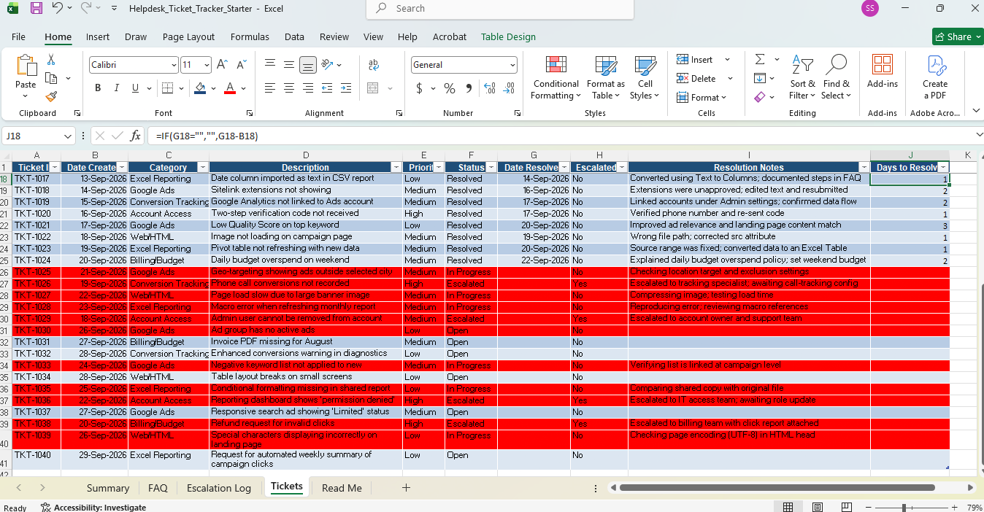
Figure 1. Tickets sheet showing ticket records, status, escalation, resolution notes, and Days to Resolve.

5. Escalation Log
The Escalation Log records tickets that were transferred to another team or specialist. This creates a clear audit trail for escalated issues and makes it easier to follow up on cases that cannot be resolved by the initial support team.
Column | Purpose
Ticket ID | Links the escalation to the original ticket.
Escalated To | Identifies the responsible team or specialist.
Reason | Explains why the ticket was escalated.
Date Escalated | Records when escalation occurred.
Outcome | Tracks the current escalation result, such as Resolved or Awaiting response.
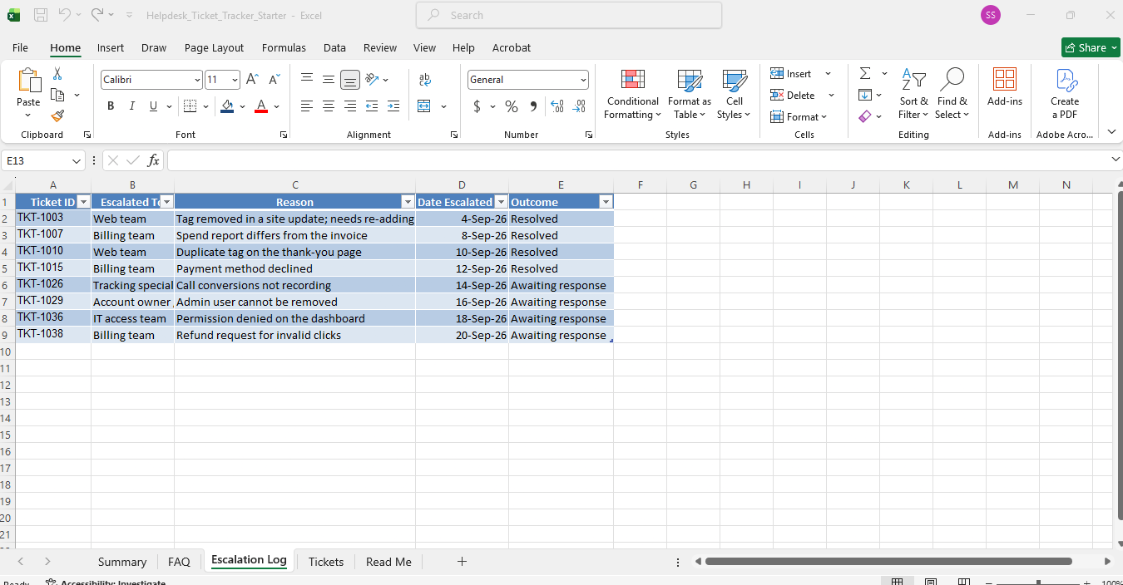
Figure 2. Escalation Log showing escalated tickets, responsible teams, reasons, dates, and outcomes.

6. FAQ Sheet
The FAQ sheet acts as a quick-reference knowledge base for common helpdesk issues. Each issue includes suggested troubleshooting steps and a condition for escalation.
Question | Steps to Fix | Escalate If
Ad disapproved: destination not working | Open the link, correct the destination URL, resubmit the ad | Disapproved again after the page loads
Campaign not getting impressions | Check status, budget, ad approval, and payment | Still no impressions after 24 hours
Conversions showing 0 | Check conversion status, confirm the tag is on the thank-you page, test a conversion | Tag is present but nothing records
Duplicate conversions | Check for duplicate tags, remove duplicates, test a purchase | Tag is managed by another team
VLOOKUP shows #N/A | Use TRIM to remove spaces; use exact match (FALSE) | Errors remain after trimming
Pivot table not refreshing | Right-click; Refresh; convert the source to a Table | Data source is a linked external file
Report total does not match dashboard | Remove duplicates, check date range and currency | Difference remains after checks
Landing page wrong on mobile | Add the viewport meta tag; test on a phone | Problem persists on the live site
Image not loading | Check the src path and file name | File is missing from the server
2-step verification code not received | Check the phone number and re-send the code | User cannot access their recovery phone or email
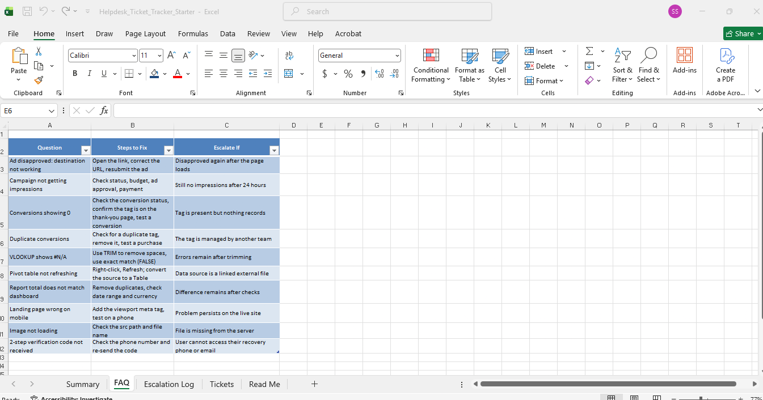
Figure 3. FAQ sheet with standard troubleshooting and escalation guidance.

7. Summary & Dashboard
The Summary sheet converts ticket-level data into management-friendly metrics. The workbook shows a total of 40 tickets and provides category-level ticket counts and average resolution time.

7.1 Category Summary
Category | Ticket Count | Average Days to Resolve
Account Access | 5 | 1.3
Billing/Budget | 5 | 2.0
Conversion Tracking | 5 | 2.3
Excel Reporting | 7 | 1.0
Google Ads | 11 | 1.6
Web/HTML | 7 | 1.3
Grand Total | 40 | 1.5

7.2 Status Summary
Status | Ticket Count
Escalated | 4
In Progress | 6
Open | 6
Resolved | 24
Grand Total | 40
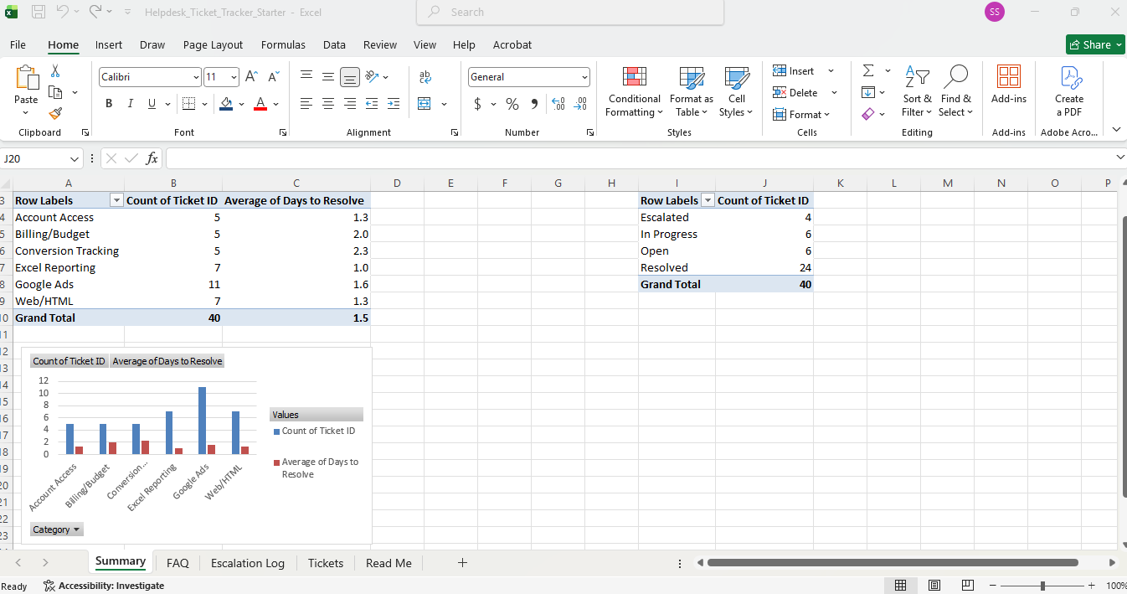
Figure 4. Summary sheet with PivotTables and category-level chart.

8. Key Project Insights
- The tracker contains 40 tickets in the displayed dataset.
- 24 tickets are marked Resolved, while 6 are In Progress, 6 are Open, and 4 are Escalated.
- Google Ads has the highest ticket volume in the summary, with 11 tickets.
- Excel Reporting and Web/HTML each have 7 tickets.
- Conversion Tracking has the highest average resolution time among the listed categories at 2.3 days.
- Excel Reporting has the lowest average resolution time among the listed categories at 1.0 day.
- The overall average Days to Resolve shown in the Summary is 1.5 days.

9. Excel Features Used
- Excel Table for structured ticket data and filtering.
- IF formula for conditional Days to Resolve calculation.
- Date arithmetic for resolution-time measurement.
- Conditional formatting to visually distinguish ticket states and urgent records.
- PivotTables for ticket counts and average resolution time.
- PivotChart/column chart for category-level workload and resolution comparison.
- Filters for category, status, priority, and other ticket attributes.
- Structured FAQ and escalation documentation for support workflow.

10. Suggested Helpdesk Workflow
Step | Process
1. Receive | Create a ticket with Ticket ID, creation date, category, and issue description.
2. Prioritize | Assign Low, Medium, or High priority based on the issue.
3. Troubleshoot | Use the FAQ and standard troubleshooting steps where applicable.
4. Update | Record status, actions taken, and resolution notes.
5. Escalate | If the issue meets an escalation condition, record it in the Escalation Log.
6. Resolve | Enter Date Resolved and confirm the resolution.
7. Analyze | Use the Summary sheet to review ticket volume, status, and resolution performance.

11. Skills Demonstrated
- Microsoft Excel and spreadsheet data management
- Data cleaning and structured data entry
- Excel formulas and date calculations
- PivotTables and data summarization
- Data visualization and dashboard-style reporting
- Helpdesk ticket lifecycle management
- Issue categorization and prioritization
- Escalation tracking and operational documentation
- Basic reporting and KPI interpretation

12. Project Description for Resume / Interview
Helpdesk Ticket Tracker | Microsoft Excel
Developed an Excel-based helpdesk ticket tracking system to manage 40 support tickets, monitor priority and status, track escalations, calculate resolution time using Excel formulas, and create PivotTable-based summaries and charts for ticket volume and resolution performance. Also created an FAQ knowledge base with troubleshooting and escalation guidelines.

13. Conclusion
The Helpdesk_Ticket_Tracker provides a practical end-to-end framework for organizing support tickets and converting operational data into useful reports. It demonstrates how Excel can be used not only for data entry, but also for workflow tracking, escalation management, KPI calculation, and management reporting.

