### **Identity information management Functional Specification document**

**Version 1.0**

**Date: 22-02-2018**

Revision History

|  |  |  |  |
| --- | --- | --- | --- |
| **Date** | **Version** | **Description** | **Author** |
| 22/02/2018 | V1.0 | First Draft | Sushant Attada |

Table of Contents

1. Purpose 3

2. Introduction 3

3. Classes 3

4. Services 3

4.1 Custom Services 3

6. Database Interactions 4

6.1 Custom Database Interactions 4

8. Sequence Flow 5

# Purpose

* The purpose of the document is to show the end to end specifications of the project Identity management system.

# Introduction

* This project help is saving contacts of each user i.e., User name, Password and Display name.

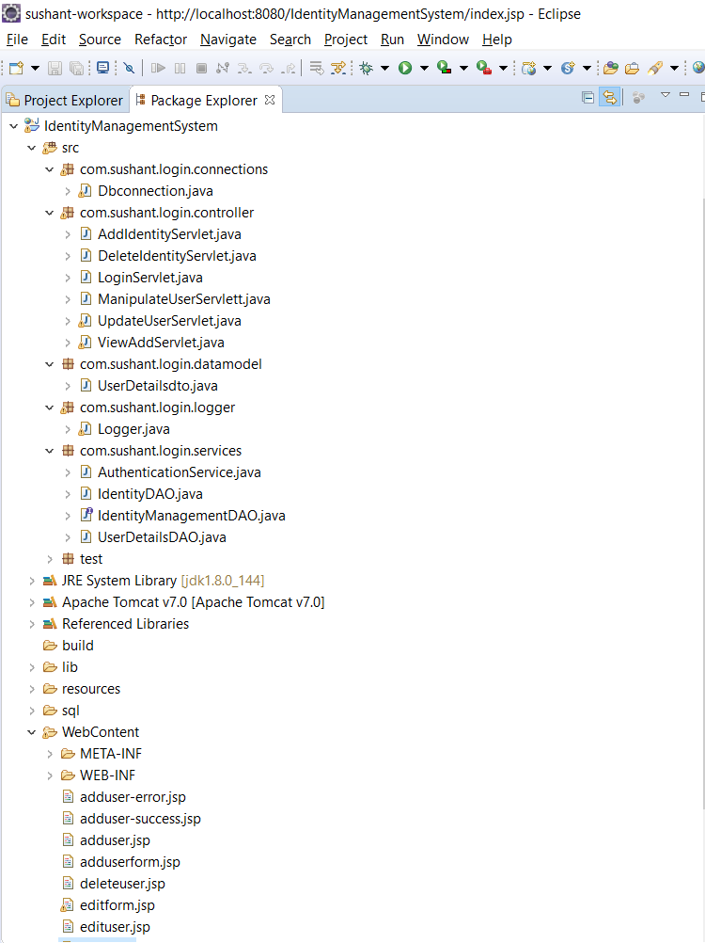

# Classes

# Launcher Class



# Logger

* 

# Data Model classes

* 

# Services

* 

# Database Interactions

# Framework Database Interactions

* Table for user credentials -> user_details

## Table structure for table identities

|  |  |  |  |
| --- | --- | --- | --- |
| **Column** | **Type** | **Null** | **Default** |
| userId | int(11) | No |  |
| userName | varchar(255) | Yes | NULL |
| password | varchar(255) | Yes | NULL |
| displayName | varchar(255) | Yes | NULL |

|  |
| --- |
|  |

* The project uses my sql driver which is provided in the lib folder also.



* Here is the scripts file for the data base (which is also provided in the project files in sql folder)



# Parameters

* The parameters used in this project are user name and password for login credentials and contact name, email and birthdate for contact book

|  |  |  |  |
| --- | --- | --- | --- |
| **Field** | **component** | **Alphabet** | **Number** |
| UserName | Console text |  |  |
| Password | Console text |  |  |
| DisplayName | Console text |  |  |

* User can create update and delete all the above parameters.