1. **Bank Management System**

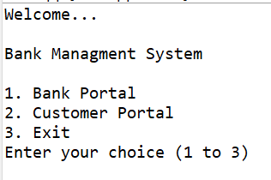

1. **Bank Portal**

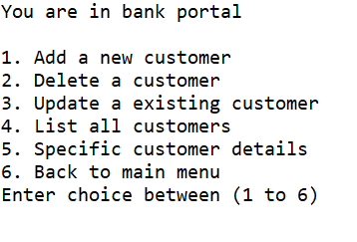

1. **Adding a new customer**

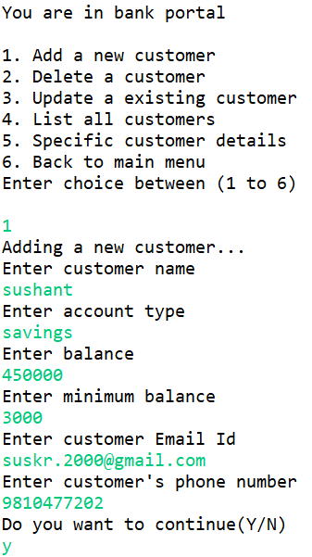

1. **List of all customers**

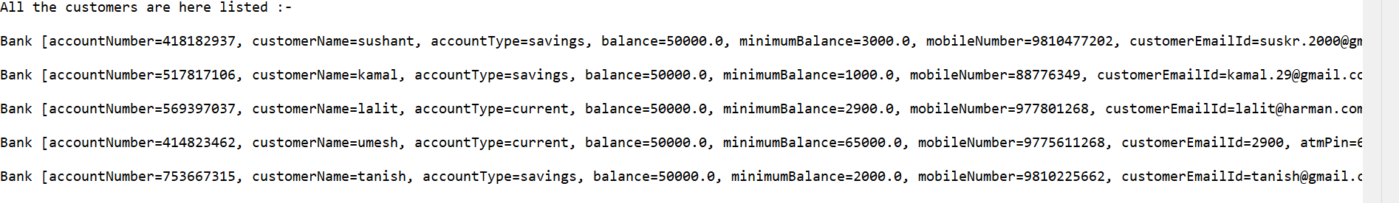

1. **Delete a customer**

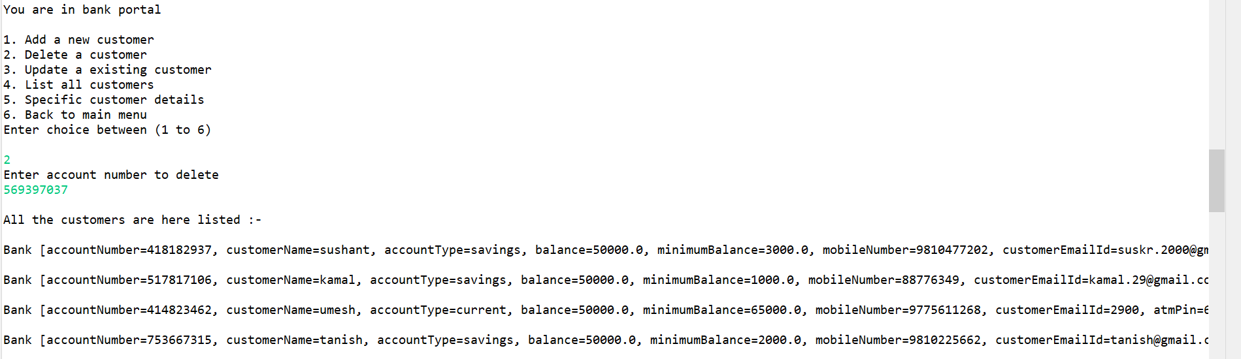

1. **Update a customer**

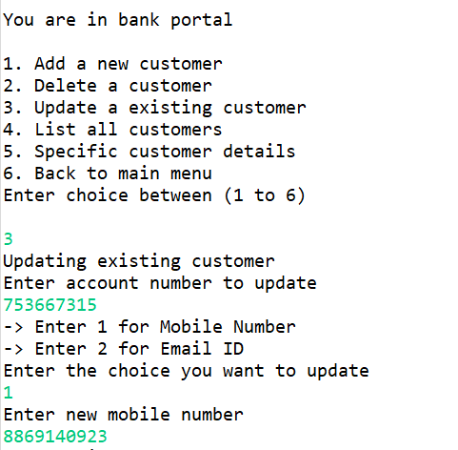

1. **Customer details**

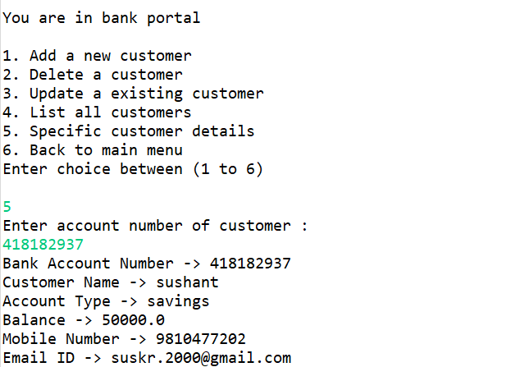

1. **Customer portal**

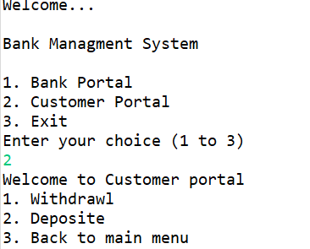

1. **Deposit in account**

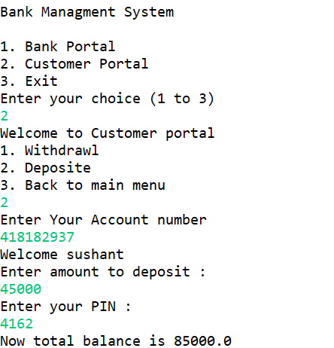

1. **Withdrawl from account**

