***The iperf bits-per-second app***

Provides a web app for executing iPerf commands and displaying the throughput (bits per second) on the client side.

Also provides an option to fetch previous history of results from the MongoDB database.

Angular JS and Python Flask manipulate the UI while Python talks with iPerf and MongoDB.

**Dependencies and Software requirements:**

Platform tested: Windows 10 64-bit

Browsers tested: Firefox, Google Chrome (Clearing history & cache after every run recommended)

Python version tested: 3.4.3

Get it here: <https://www.python.org/downloads/>

Additional resources for installation: <http://www.howtogeek.com/197947/how-to-install-python-on-windows/>

MongoDB version tested: 3.4.2 for Windows 10 64-bit

Get it here: <https://www.mongodb.com/download-center>

Additional resources for installation: <https://docs.mongodb.com/manual/tutorial/install-mongodb-on-windows/>

Python modules needed: flask, subprocess, json, pymongo, datetime

Additional resources for installation of individual modules: <https://packaging.python.org/installing/>

iPerf version tested: 3.1.3 for Windows 10 64-bit

Additional resources for installation: <http://sysadmin.circularvale.com/desktop-config/iperf-installation-on-windows-7/>

**Assumptions:**

1. Python is added to system path variable.

2. Working internet connection is needed for Angular JS to load the necessary javascript libraries.

3. iPerf needs to be downloaded, installed and running on the server machine.

4. iPerf need not be downloaded and installed on the client side as this github repository provides a Windows 10 64-bit portable distribution.

5. The app runs on port number 5000 on the localhost (127.0.0.1).

6. The mongodb runs on default port number (27017) on the localhost (127.0.0.1).

7. All the required folders have necessary read, write and execute privileges.

**Code to setup project:**

Open two command prompt windows to run the Python code and MongoDB database.

1. In first command prompt window, run the downloaded file ‘app.py’ inside the folder ‘iperfapp’. This is done using the following command.

>> python app.py

If everything goes right, you can expect the following screen.

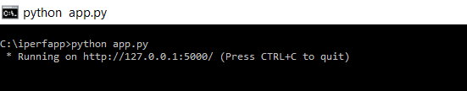

2. In the second command prompt window, run the MongoDB database using the following command.

>> “<path to mongod.exe>” –dbpath <path for data storage>

Example:

>> "C:\Program Files\MongoDB\Server\3.4\bin\mongod.exe" --dbpath C:\mongodb\data

The folders in <path for data storage>, if not physically present already, need to be created.

If everything goes right, you can expect the following screen.

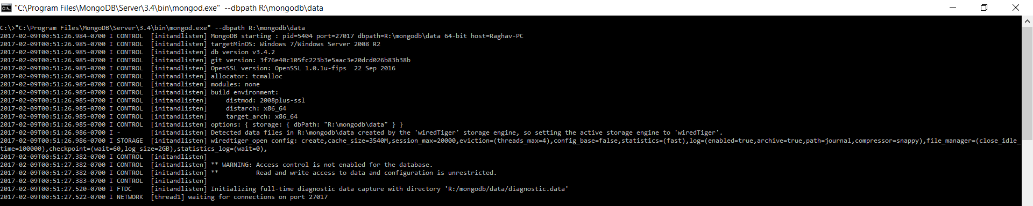

**Additional expected output screens:**

Initial web-app screen:

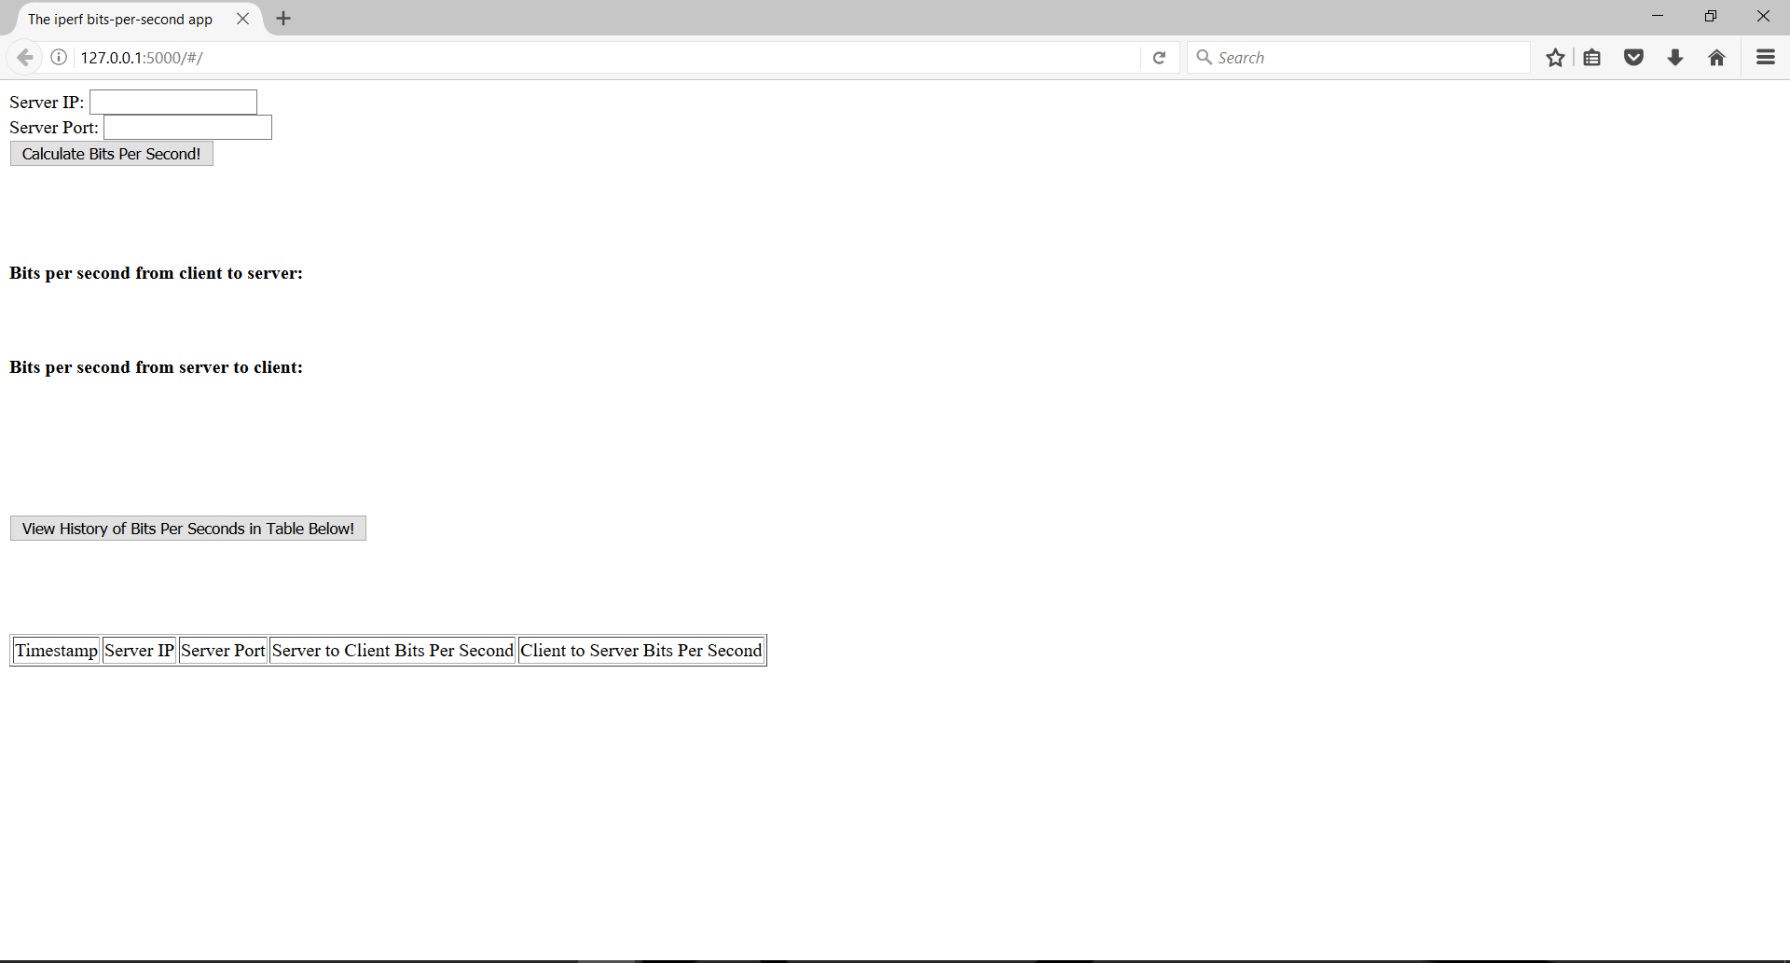

Clicking ‘Calculate Bits Per Second!’:

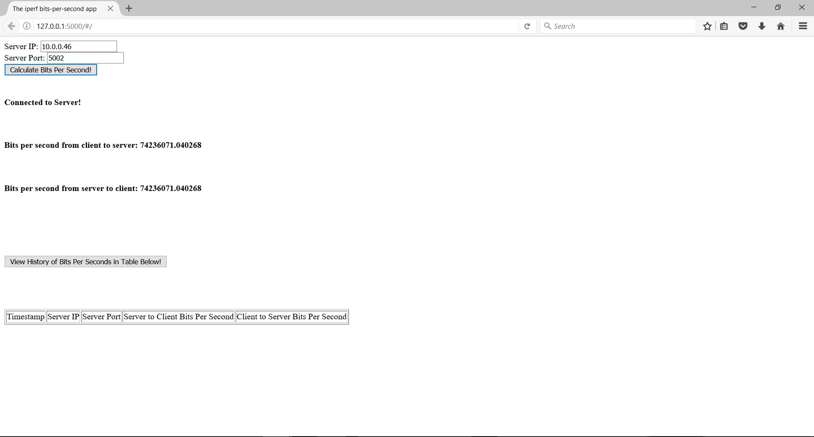

Clicking ‘View History of Bits Per Seconds in Table Below!’:

