Where Grover's Quadratic Advantage Ends:
The Compiled Cost of a Unit-Cost Query
Sushant Paudel
Working paper — August 2026
Abstract
Grover's algorithm finds a marked item among N in Θ(√N) oracle queries, and a matching lower bound establishes that no quantum algorithm does better. Both bounds are stated in queries, a unit that charges one per oracle invocation regardless of what the invocation costs to execute. This paper measures what that assumption conceals, and then uses the measurement to predict rather than merely report where the advantage ends. Transpiling Grover circuits onto a 127-qubit heavy-hexagonal coupling map and regressing two-qubit gate count against iteration count isolates the marginal cost of one Grover iteration. That cost grows as n^{3.68} (95% CI [3.53, 3.83], R² = 0.998) across n = 3 to 10, from 19 two-qubit gates per iteration to 1,566, and the exponent is stable to within 0.4 across transpiler optimization levels 0 through 3. Because n = log₂N, this overhead is polylogarithmic in problem size and does not by itself defeat the square-root speedup. What defeats it is the interaction of that depth with noise. Under a depolarizing model at two-qubit error rate 8 × 10⁻³, the empirical optimum at n = 4 falls to k = 2 where theory prescribes 3, and to k = 1 under the operationally relevant metric of expected queries. A two-term model built from the measured gate counts and the nominal error rate, with no fitted parameters, reproduces the entire measured curve to within 0.019 in probability and predicts both displacements. Extended across n, it places the advantage horizon at n = 5 and gives a direct answer to the question that motivated the study: moving that horizon out by one qubit requires roughly a factor-of-two reduction in two-qubit error rate.
1 Introduction
Grover's algorithm searches an unstructured space of N items in Θ(√N) oracle queries [1], and the Bennett–Bernstein–Brassard–Vazirani bound establishes that Ω(√N) queries are necessary for any quantum algorithm [2]. The pairing is unusual: the speedup is not merely the best known but the best possible. That makes it a claim about the structure available in the problem rather than about any particular machine.
It is also a claim in a unit of account. Query complexity charges one unit per oracle invocation and is silent about what an invocation costs to perform. On paper that abstraction is what makes the proof clean. On hardware an oracle invocation is a circuit, and that circuit must be decomposed into a device’s native gate set and mapped onto a fixed coupling graph. Where the algorithm assumes any pair of qubits may interact, a superconducting device permits interaction only between physically adjacent pairs, and the compiler makes up the difference by inserting SWAP operations [5]. Every inserted gate carries error.
Three questions follow, and they are the hypotheses this study was designed around. Is a query unit-cost after compilation (§4)? Does noise displace the optimal iteration count away from its theoretical value (§5)? And is there a problem size beyond which the algorithm stops being worth running at all (§7)? Section 2 states the condition against which all three are read. Section 6 introduces a model that converts the first measurement into a prediction of the second, which is what makes the third answerable without executing it.
The scope is deliberately narrow: a single marked item, no error mitigation as a research variable, no cross-device comparison, no amplitude-amplification variants, and no wall-clock comparisons between processors. Simulator runtime is recorded but never reported as an algorithmic result.
2 The crossover condition
Grover with k iterations is not a deterministic algorithm but a repeat-until-success protocol. One attempt costs k oracle queries plus one classical verification of the returned candidate, and succeeds with probability p. Expected queries to a correct answer are therefore (k + 1) / p, while classical linear search over a uniformly placed marked item costs (N + 1) / 2. Grover is worth running only when the former is smaller, which rearranges into a threshold on measured success probability:
p > p*(N) = 2(k + 1) / (N + 1).
The threshold is the useful object because its two arguments move in opposite directions. It rises with k, since more iterations mean more queries to amortize over a single success, and it falls as N grows, since classical search becomes more expensive to beat. At N = 8 with k = 2 an implementation must clear 0.667; at N = 128 with k = 8 it need only clear 0.140. Larger problems are more forgiving of a noisy implementation, while deeper circuits are less so. Where those curves cross is a property of a compiler and a device, not of the algorithm, which is why it is worth measuring rather than asserting.
3 Method
3.1 Circuit construction
All circuits come from one module, so every arm of every experiment shares an identical construction path. The iteration count k is a free parameter rather than being fixed at the theoretical optimum ⌊(π/4)√(N/M)⌋ [3]. Both k = 0 and over-rotated k > k_{th} are legal inputs, which is what makes the sweep in §5 possible at all; hard-coding k to its optimum, as most implementations do, renders the question unaskable. The phase oracle conjugates the marked bit pattern into |1…1⟩ with X gates, applies a multi-controlled Z, and undoes the conjugation. The diffuser is H^{⊗n}(2|0⟩⟨0| − I)H^{⊗n}. Both call the same multi-controlled Z, which is the only many-qubit gate in the construction and the point at which transpiled cost concentrates; isolating it gives the §4 result a single identifiable source. Bit-ordering conversion happens in one function, so the endianness convention is stated exactly once.
3.2 The compiled cost of one iteration
Circuits are transpiled to a 127-qubit model of a heavy-hexagonal lattice [4] at optimization level 2 with a fixed transpiler seed. Two-qubit gate count is measured at k = 1, 2, 3 and regressed on k. The slope of that regression is the marginal cost of one Grover iteration, separated from state preparation, measurement, and fixed routing overhead, all of which the intercept absorbs. Taking a count at a single k and dividing would fold that fixed cost in and bias the exponent. Regressing log(slope) on log(n) then yields the scaling exponent $b$ with a t-based 95% confidence interval. The refutation criterion was fixed before the measurement: an interval at or below 1.0 refutes super-linear growth, an interval excluding 1.0 from above does not, and an interval straddling 1.0 is inconclusive.
The case n = 2 is excluded. Grover on N = 4 is exact and periodic in k, so the transpiler cancels whole iterations against one another and the fitted slope comes out negative. That is a property of the special case rather than a defect in the instrument, but including it would corrupt the fit. The exclusion is commented in the source rather than applied as a silent filter.
3.3 Success probability under noise
At n = 4, k is swept from 0 to 6 against three references: the closed form sin²((2k + 1)θ) with θ = arcsin√(M/N), an ideal simulator, and a depolarizing model with one- and two-qubit error rates of 2 × 10⁻⁴ and 8 × 10⁻³ over the basis {rz, sx, x, cz}. The rz gate is excluded from the error model because it is virtual on IBM hardware, implemented as a frame change rather than a pulse; attaching depolarizing noise to it would overstate the error budget. Each configuration is measured over 30 randomized marked-item placements at 4,096 shots, and reported values are means over placements.
Noisy circuits are transpiled to the hardware target first, so they carry heavy-hex routing overhead, and only then re-expressed in the noise basis. The ideal arm is transpiled to the simulator’s own basis with no routing. The difference between arms is therefore attributable to compilation and noise rather than to any difference in circuit construction. The ideal arm doubles as the correctness check: if it did not track the closed form across the sweep, including the collapse past the peak, the oracle, diffuser, or bit ordering would be wrong.
The noise model is deliberately simple and is not calibrated to a specific chip. Its purpose is not device realism but parameterization: the two-qubit error rate is a knob, and §7 turns it.
3.4 Reproducibility
Results were produced at commit 8b43a63 under a frozen environment: Qiskit 2.5.2, Qiskit Aer 0.17.2, Qiskit IBM Runtime 0.49.0, SciPy 1.18.1, NumPy 2.5.2. Transpiler and simulator seeds are fixed at 20260815, the optimization level is held at 2 across every comparison, and each figure is regenerated deterministically from an immutable results CSV. Every series in every figure is encoded in two channels, color together with marker or line style, and checked in greyscale, so no result depends on a reader’s color perception.
Independent replication on different hardware under the same pinned versions reproduced every two-qubit gate count in Table 1 exactly, while transpiled circuit depth differed by up to 0.5% at n ≥ 6. This is worth stating rather than hiding: depth depends on gate scheduling and commutation tie-breaking, which are not fully determined by the transpiler seed, whereas gate count is. The statistic this study rests on is the reproducible one, and that was not known in advance.
4 A query is not unit-cost
Marginal two-qubit cost per Grover iteration rises from 19 at n = 3 to 1,566 at n = 10 (Table 1, Figure 1). A power-law fit gives
per-iteration two-qubit gates ≈ 0.35 n^{3.68}, b = 3.679, 95% CI [3.531, 3.826], R² = 0.9984.
The interval excludes 1.0 by a wide margin, so growth is super-linear by the criterion fixed in advance. The unit-cost query is not merely imprecise: at n = 10 a single "query" is more than fifteen hundred entangling operations, and a one-iteration circuit transpiles to depth 5,286.
n | N | 2q (k=1) | 2q (k=2) | 2q (k=3) | per iteration | depth (k=1)
3 | 8 | 19 | 37 | 57 | 19.0 | 99
4 | 16 | 53 | 109 | 165 | 56.0 | 246
5 | 32 | 123 | 249 | 375 | 126.0 | 576
6 | 64 | 273 | 541 | 807 | 267.0 | 1,242
7 | 128 | 474 | 927 | 1,432 | 479.0 | 1,832
8 | 256 | 757 | 1,489 | 2,307 | 775.0 | 2,560
9 | 512 | 1,018 | 2,032 | 3,060 | 1,021.0 | 3,779
10 | 1,024 | 1,503 | 3,075 | 4,636 | 1,566.5 | 5,286
Table 1. Transpiled two-qubit gate counts at three iteration depths, the per-iteration slope extracted from them, and transpiled depth at k = 1. Heavy-hexagonal coupling map, optimization level 2, seed 20260815.
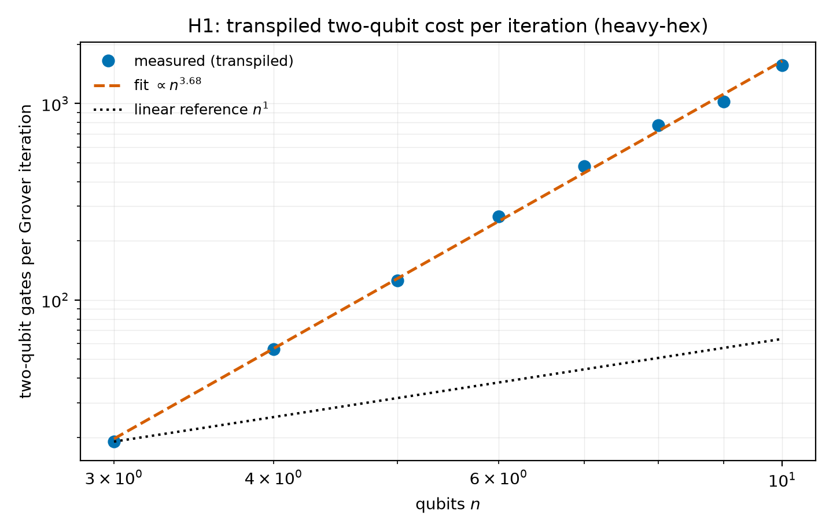
Figure 1. Per-iteration two-qubit cost against qubit count, log–log. The dotted linear reference is what the unit-cost assumption implicitly claims; the points are what the compiler emits.
4.1 Robustness to the transpiler control
The obvious objection to a compilation result is that the optimization level was chosen to flatter it. Repeating the fit at levels 0 through 3 answers this directly (Table 2). The absolute cost moves substantially — level 3 emits roughly half the gates of level 0 at n = 10 — but the exponent moves by less than 0.42 across the whole range, and all four intervals exclude 1.0 by a wide margin. The conclusion is a property of the mapping problem, not of one compiler setting.
optimization level | exponent b | 95% CI | R² | 2q per iteration at n = 10
0 | 4.051 | [3.862, 4.240] | 0.9978 | 3,238
1 | 3.638 | [3.463, 3.813] | 0.9977 | 1,820
2 (used throughout) | 3.679 | [3.531, 3.826] | 0.9984 | 1,566
3 | 3.682 | [3.531, 3.832] | 0.9983 | 1,563
Table 2. Scaling exponent by transpiler optimization level, n = 3 to 10. The prefactor is sensitive to the control; the exponent is not.
5 Noise displaces the optimal iteration count
The ideal arm tracks the closed form to within 0.002 at every k, including the collapse past the peak, so the implementation is verified (Table 3, Figure 2). Under noise the picture changes. Theory prescribes k_{th} = 3; the measured noisy optimum is k* = 2.
The displacement matters more than its size. At k = 3 the measured success probability of 0.317 falls below its threshold of 0.471, and expected queries are 12.64 against classical search’s 8.5 — a 49% penalty for following the prescription. At k = 2 the measured 0.422 clears its threshold of 0.353 and expected queries fall to 7.11, a 16% saving. At n = 4 and this error rate, the textbook iteration count is the difference between losing to linear search and beating it.
A second displacement sits in the same table and is easy to miss. The iteration count that maximizes per-attempt success probability (k = 2) is not the one that minimizes expected queries (k = 1, at 6.10). Once each attempt is charged for the queries it consumes, maximizing p stops being the right objective. Under the operationally relevant metric the optimum lies two iterations below the theoretical value, not one.
k | p (theory) | p (ideal) | p (noisy) | p (predicted) | 2q gates | E[Q] noisy | p*(N)
0 | 0.0625 | 0.0622 | 0.0615 | 0.0625 | 0 | 16.26 | 0.1176
1 | 0.4727 | 0.4716 | 0.3277 | 0.3305 | 53 | 6.10 | 0.2353
2 | 0.9084 | 0.9087 | 0.4217 | 0.4150 | 109 | 7.11 | 0.3529
3 | 0.9613 | 0.9616 | 0.3166 | 0.3013 | 165 | 12.64 | 0.4706
4 | 0.5817 | 0.5796 | 0.1719 | 0.1534 | 217 | 29.08 | 0.5882
5 | 0.1255 | 0.1249 | 0.0855 | 0.0693 | 277 | 70.17 | 0.7059
6 | 0.0204 | 0.0209 | 0.0701 | 0.0595 | 329 | 99.86 | 0.8235
Table 3. Iteration sweep at n = 4, N = 16, ε₂q = 8 × 10⁻³. Means over 30 randomized placements at 4,096 shots. Classical expected queries are 8.5. The predicted column is derived in §6 and uses no fitted parameters.
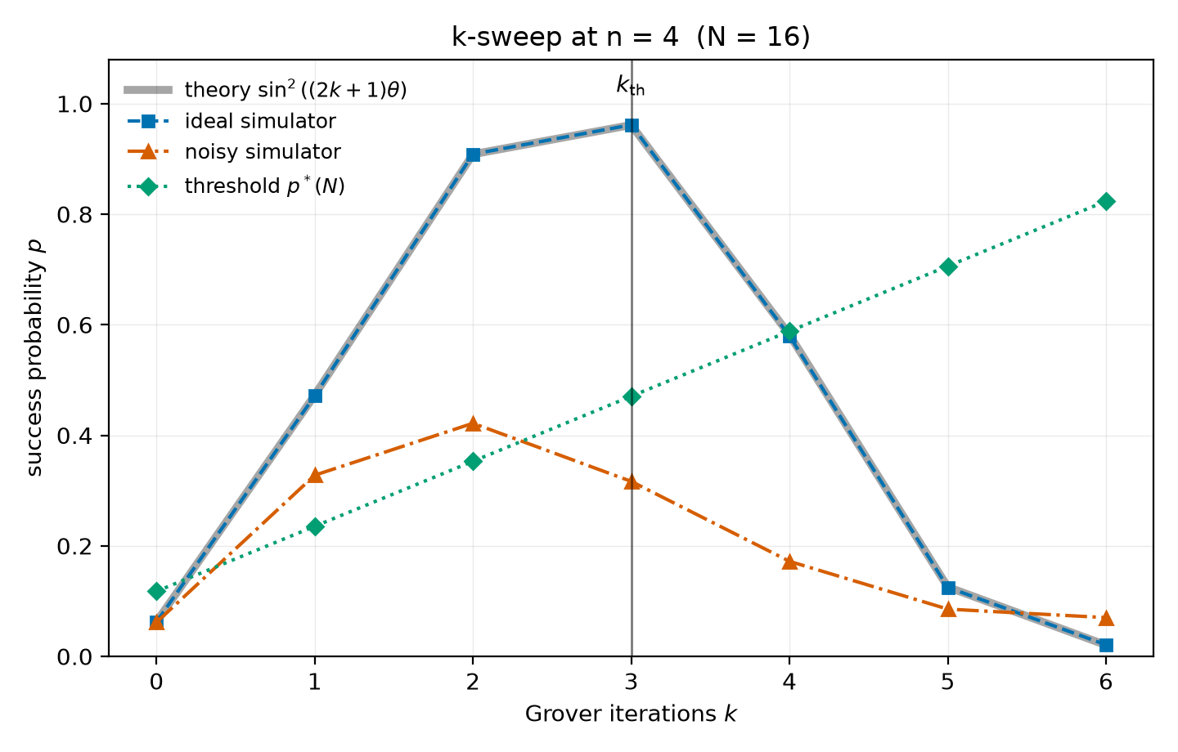
Figure 2. Success probability against iteration count at n = 4. The vertical line marks the theoretical optimum. The noisy curve peaks one iteration earlier and has already crossed below the classical threshold by the time it reaches it.
6 From reporting to predicting
The two measurements above are related, and the relation is strong enough to be predictive. A depolarizing channel acting on a circuit either leaves the computation intact or replaces the register with the maximally mixed state, in which the marked item is still returned with probability 1/N. Treating the accumulated two-qubit error as a single global depolarizing event of surviving fidelity F = (1 − ε)^{G}, where G is the transpiled two-qubit gate count measured in §4, gives
p̂ = F · p_{ideal} + (1 − F) / N.
This is the standard global-depolarizing approximation rather than a new construction, and it is used here only as an instrument. Its inputs are all already in hand: p_{ideal} is closed-form, G is the §4 measurement, and ε is the nominal model parameter. Nothing is fitted.
Against the n = 4 sweep it reproduces the entire measured curve to a maximum absolute residual of 0.0186 and an RMS of 0.0120 (Table 3, Figure 3). More usefully, it recovers both displacements: it places the success-probability optimum at k = 2 and the expected-query optimum at k = 1, matching measurement in both cases. Fitting ε as a free parameter rather than taking it from the model configuration yields 7.67 × 10⁻³, within 5% of the nominal 8 × 10⁻³, and improves the RMS residual only from 0.0120 to 0.0093. The approximation is doing the work, not the calibration.
Residuals are small but systematically negative for k ≥ 2, so the model slightly over-predicts the damage at depth. Two omissions plausibly account for this: single-qubit error is excluded, and the true channel is a sequence of local depolarizing events rather than one global one, which is not exactly equivalent. Neither is corrected here, since the purpose is a usable cost model rather than a faithful channel.
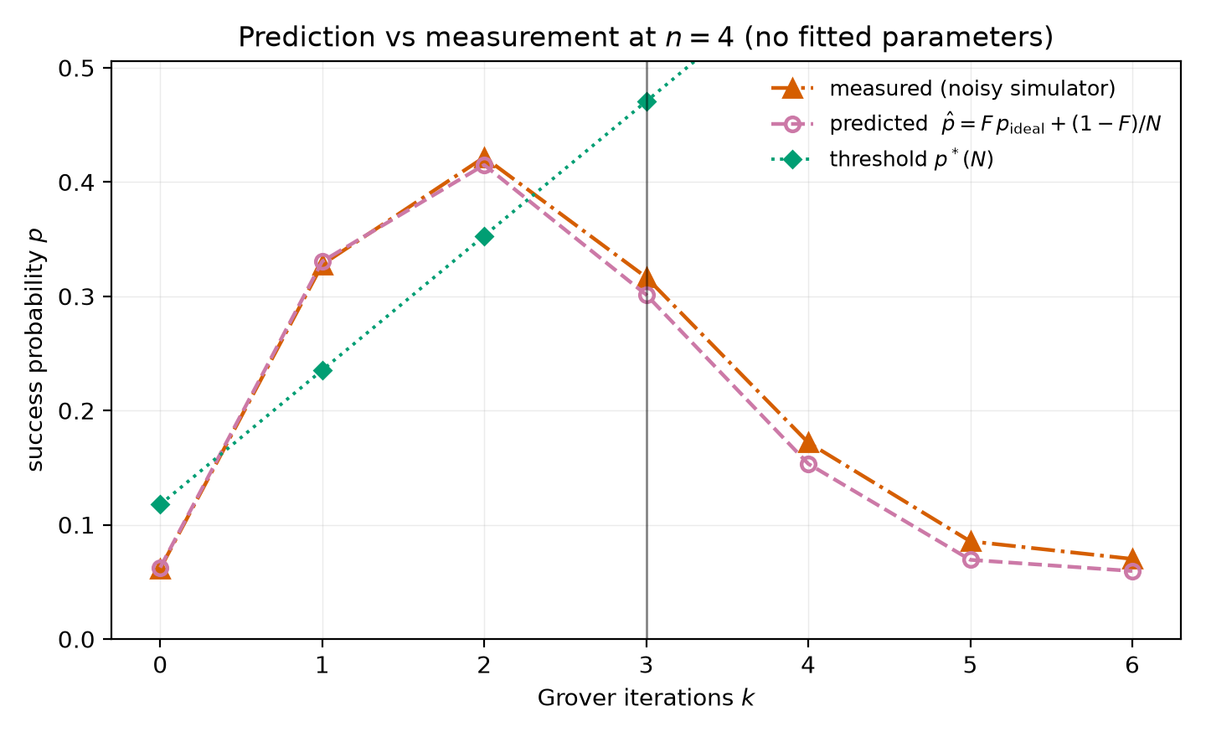
Figure 3. Predicted against measured success probability at n = 4, with no fitted parameters. The model is built from the gate counts of Figure 1 and the nominal error rate.
7 The advantage horizon
A model validated at one problem size can be evaluated at sizes where direct simulation is expensive, which is what turns the third hypothesis from an aspiration into a calculation. Substituting the measured G(n, k) from §4 into the model and comparing the result against p*(N) gives Table 4. Everything in that table is projection rather than measurement and should be read as such.
The projection places the advantage horizon at n = 5. At n = 3 the algorithm clears its threshold even at the textbook iteration count. At n = 4 it fails at k_{th} but succeeds at k = 1, which is what the measured sweep in §5 confirms. From n = 5 onward it fails at every iteration count, and past n = 5 the projected optimum degenerates to k = 0 — the model’s advice is not to run the algorithm at all. A search space of thirty-two items is where a quadratic speedup stops paying for its own compilation at this error rate.
Inverting the same model answers the question the study was built around. Solving for the two-qubit error rate at which each n first clears its threshold gives the last column of Table 4. Moving the horizon out by one qubit costs a factor of 2.3 at the low end and 1.4 at the high end, averaging 1.8 across n = 3 to 10. Roughly, each additional qubit of search space demands a halving of the two-qubit error rate — and since one qubit doubles the search space, the error rate must fall geometrically to keep pace with a problem size growing geometrically. The ratio narrows as n grows, which is the one encouraging feature in the table.
n | N | k_th | p̂ at k_th | p*(N) at k_th | at k_th | at best k | critical ε₂q
3 | 8 | 2 | 0.7312 | 0.6667 | win | win | 3.78 × 10⁻²
4 | 16 | 3 | 0.3013 | 0.4706 | lose | win | 1.62 × 10⁻²
5 | 32 | 4 | 0.0486 | 0.3030 | lose | lose | 7.50 × 10⁻³
6 | 64 | 6 | 0.0156 | 0.2154 | lose | lose | 3.48 × 10⁻³
7 | 128 | 8 | 0.0078 | 0.1395 | lose | lose | 2.08 × 10⁻³
8 | 256 | 12 | 0.0039 | 0.1012 | lose | lose | 1.31 × 10⁻³
9 | 512 | 17 | 0.0020 | 0.0702 | lose | lose | 9.62 × 10⁻⁴
10 | 1,024 | 25 | 0.0010 | 0.0507 | lose | lose | 6.51 × 10⁻⁴
Table 4. Projected advantage horizon (model, not measurement). p̂ is the model prediction at the theoretical iteration count; the verdict columns compare against p*(N) at k_th and at the best available k. The final column is the two-qubit error rate at which each n would first become worth running.
8 What survives and what does not
The results point in different directions, and reporting only the first would misrepresent them.
Section 4 establishes that per-query overhead grows super-linearly in the number of qubits. But n = log₂N. An overhead of Θ(n^{3.68}) is Θ((log N)^{3.68}), and a polylogarithmic factor does not overturn a square-root separation: total two-qubit cost scales as Θ(√N (log N)^{3.68}), still asymptotically below the Θ(N) of classical search. Dropping the unit-cost assumption does not refute the query-complexity result. It relocates the question from asymptotics to constants and to error.
Sections 5 and 7 are where the advantage is actually lost, and the mechanism is the interaction between them. Depth accumulates error, and depth per iteration is what §4 shows growing. At a fixed physical error rate with no error correction, total infidelity grows with √N (log N)^{3.68}, so p decays toward 1/N and the threshold is crossed at finite n — here, at n = 5. The asymptotic claim and the operational claim fail in different regimes because the asymptotic claim quietly assumes error-free execution.
Error correction is what restores that assumption, and it is exactly there that Babbush and co-authors locate their objection [6]. They argue that the constant-factor overhead of surface-code error correction, together with the serial structure of amplitude amplification and the resulting slow logical clock rate, prevents quadratic speedups from delivering a runtime advantage on early fault-tolerant devices. Their analysis and this one address different layers, and the relation between them is worth stating precisely. They assume the logical gate exists and ask what it costs; this work asks what the physical circuit costs before any correction is applied, and finds that the per-query cost is not constant in the first place but grows as the cube-and-a-half power of the qubit count on a fixed-degree lattice. The two obstructions are sequential rather than competing. Without error correction the advantage is lost at n = 5 for the reasons measured here; with error correction it survives that failure and meets theirs instead. Neither result depends on the other, and an implementer faces both.
The honest summary is that the query-complexity separation is intact, the operational advantage is not, and the boundary between them belongs to a compiler, a topology, and an error rate rather than to the algorithm.
9 Limitations
Everything reported here is simulation. No result in this paper has been executed on quantum hardware, and the depolarizing model omits coherent errors, crosstalk, per-qubit rate variation, readout error, and calibration drift, all of which are present on real devices and none of which favor the algorithm. The projections of §7 inherit every one of these omissions and are stated as projections for that reason.
The exponent 3.679 is a local fit over n = 3 to 10, not an asymptotic complexity result. It belongs to a specific triple — this circuit construction, this transpiler, and this coupling map — rather than to Grover’s algorithm. An ancilla-assisted multi-controlled-Z decomposition, a different lattice, or a wider range of n would give a different number. That the exponent is a property of the compilation path is the point of §4, but it also bounds what the number can be claimed to mean.
The sweep of §5 is at a single problem size, so one displacement of k* is one data point, and the model of §6 is validated against that one point. Validation at a second n is the most valuable next measurement and the one that would most change confidence in Table 4. Reported success probabilities are means over 30 placements with no dispersion reported; error bars have not been computed.
Transpilation is stochastic in its seed, and every result here uses one fixed seed. A seed sweep would separate the intrinsic cost of the mapping problem from one heuristic’s luck on one run. The replication note in §3.4 is a partial substitute, not a replacement.
References
[1] L. K. Grover. A fast quantum mechanical algorithm for database search. In Proceedings of the 28th Annual ACM Symposium on Theory of Computing (STOC ’96), pages 212–219, 1996. doi:10.1145/237814.237866.
[2] C. H. Bennett, E. Bernstein, G. Brassard, and U. Vazirani. Strengths and weaknesses of quantum computing. SIAM Journal on Computing, 26(5):1510–1523, 1997. doi:10.1137/S0097539796300933.
[3] M. Boyer, G. Brassard, P. Høyer, and A. Tapp. Tight bounds on quantum searching. Fortschritte der Physik, 46(4–5):493–505, 1998. Earlier version in PhysComp ’96.
[4] C. Chamberland, G. Zhu, T. J. Yoder, J. B. Hertzberg, and A. W. Cross. Topological and subsystem codes on low-degree graphs with flag qubits. Physical Review X, 10:011022, 2020.
[5] G. Li, Y. Ding, and Y. Xie. Tackling the qubit mapping problem for NISQ-era quantum devices. In Proceedings of the 24th International Conference on Architectural Support for Programming Languages and Operating Systems (ASPLOS ’19), pages 1001–1014, 2019.
[6] R. Babbush, J. R. McClean, M. Newman, C. Gidney, S. Boixo, and H. Neven. Focus beyond quadratic speedups for error-corrected quantum advantage. PRX Quantum, 2:010103, 2021.
[7] M. A. Nielsen and I. L. Chuang. Quantum Computation and Quantum Information. Cambridge University Press, 10th anniversary edition, 2010.

