Certification Project II: Problem Statement

A retail company Abstergo Corp. has recently setup an online shopping portal (website) to sell their products. Due to fierce competition, the company wants a solution that can reduce the time and effort it needs to enhance the functionality of their website on a regular basis. They are looking for an automated way to deploy the new code (for new features) to production website whenever they want.

Business Requirements
- The team of developers working on new features will merge their code to a GitHub repo.
- As soon as the code reaches GitHub, using a CI (Continuous Integration) pipeline, setup in Jenkins, automated builds will be triggered.
- The automated builds will frequently deploy new features to the production website.
- Every build will prepare a Docker file and push Docker images to docker-hub.
- Every docker image will be deployed (Continuous Deployment) to a kubernetes-cluster.

Fork the given repository to your own account and use it as the application for your pipeline project
GitHub: https://github.com/bhavukm/cicd-pipeline-train-schedule-autodeploy

Solution:
Above given repository has been forked to https://github.com/deveops-engineer/cicd-pipeline-train-schedule-autodeploy.git

Prerequisite: - Installed Git, java, Jenkins and Kubernetes.
yum install git -y
yum install java-1.8.0-openjdk-devel

config java
copy - /usr/lib/jvm/java-1.8.0-openjdk-1.8.0.282.b08-1.amzn2.0.1.x86_64
vim /etc/profile
edit -
JAVA_HOME=/usr/lib/jvm/java-1.8.0-openjdk-1.8.0.282.b08-
1.amzn2.0.1.x86_64
Export PATH=$JAVA_HOME/bin:$PATH
source /etc/profile
echo $JAVA_HOME
sudo wget -O /etc/yum.repos.d/jenkins.repo https://pkg.jenkins.io/redhat-stable/jenkins.repo
sudo rpm --import https://pkg.jenkins.io/redhat-stable/jenkins.io.key

yum install jenkins
systemctl start jenkins
systemctl status jenkins

vim /etc/hosts
Edit –
172.31.17.72 master-node
172.31.16.97 worker-node
hostnamectl set-hostname master-node
retenforce 0
(on worker node:
vim /etc/hosts
edit –
172.31.17.72 master-node
172.31.16.97 worker-node
hostnamectl set-hostname worker-node
retenforce 0 )
######### on both master and worker ###########
cat <<EOF > /etc/yum.repos.d/kubernetes.repo
[kubernetes]
name=Kubernetes
baseurl=https://packages.cloud.google.com/yum/repos/kubernetes-el7-x86_64
enabled=1
gpgcheck=1
repo_gpgcheck=1
gpgkey=https://packages.cloud.google.com/yum/doc/yum-key.gpg https://packages.cloud.google.com/yum/doc/rpm-package-key.gpg
EOF
yum install -y docker kubelet kubeadm kubectl
systemctl start docker kubelet
systemctl enable docker
systemctl enable kubelet
#########################################
kubeadm init --apiserver-advertise-address=172.31.17.72 --pod-network-cidr=172.168.0.0/16 --ignore-preflight-errors=NumCPU --ignore-preflight-errors=Mem
(run token on worker node)
su -ec2-user
mkdir -p $HOME/kube
sudo cp -I /etc/Kubernetes/admin.config $HOME/kube/config
sudo chown $(id-u)$(id-g)$ HOME/kube/config
kubectl get nodes
kubectl apply -f https://docs.projectcalico.org/v3.3/getting-started/kubernetes/installation/hosted/rbac-kdd.yaml
kubectl apply -f https://docs.projectcalico.org/v3.8/getting-started/kubernetes/installation/hosted/kubernetes-datastore/calico-networking/1.7/calico.yaml
kubectl get nodes
kubectl get pods

Job 1:- Build the code, make docker file and push that docker file to docker hub
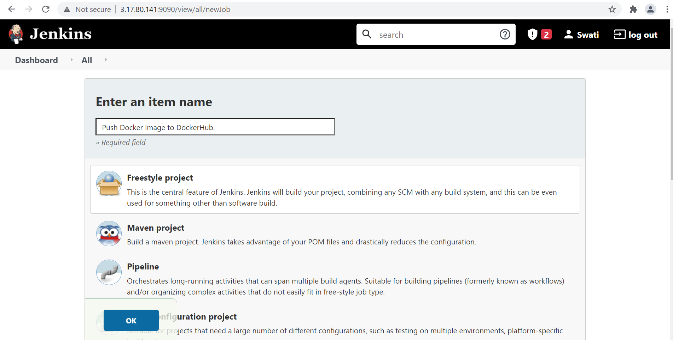

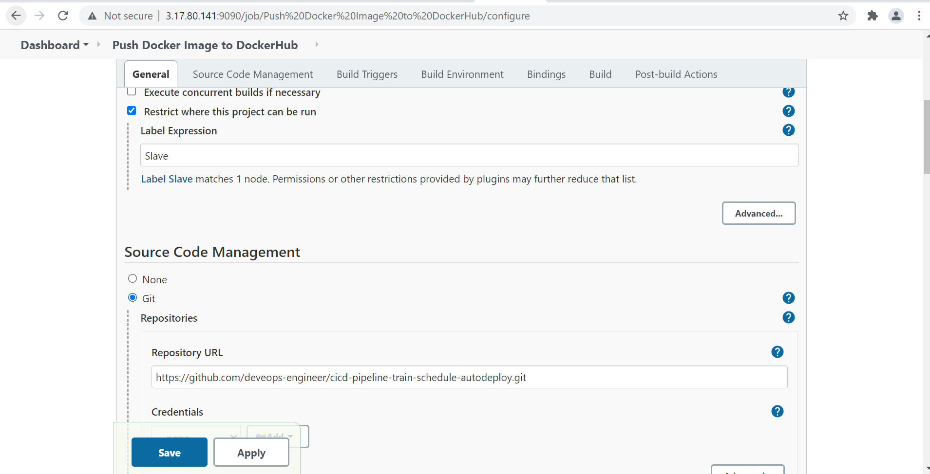

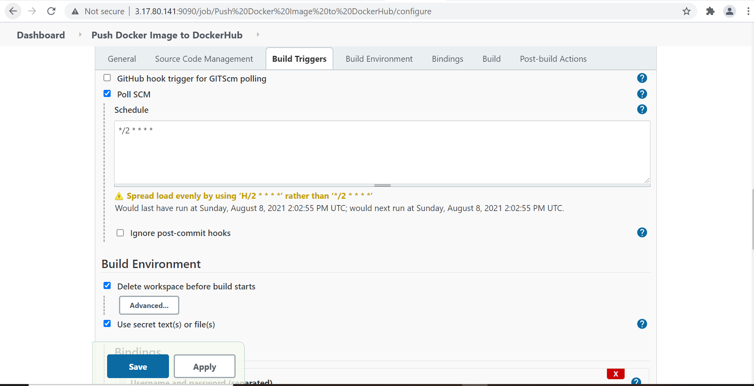

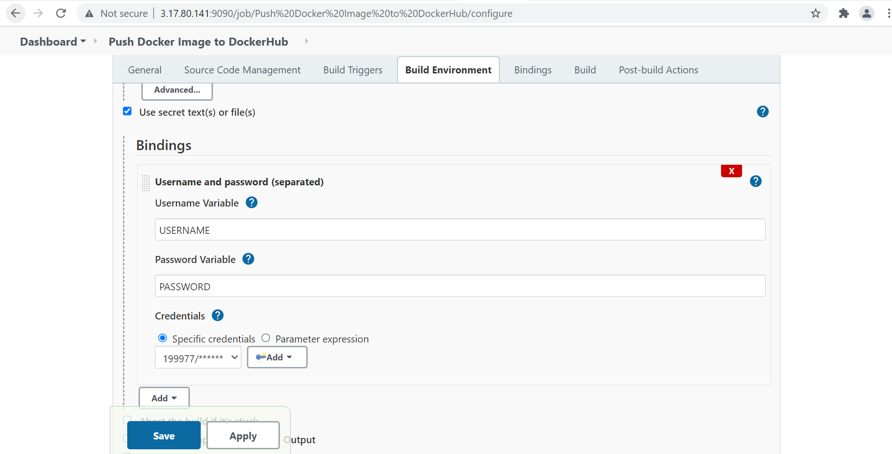

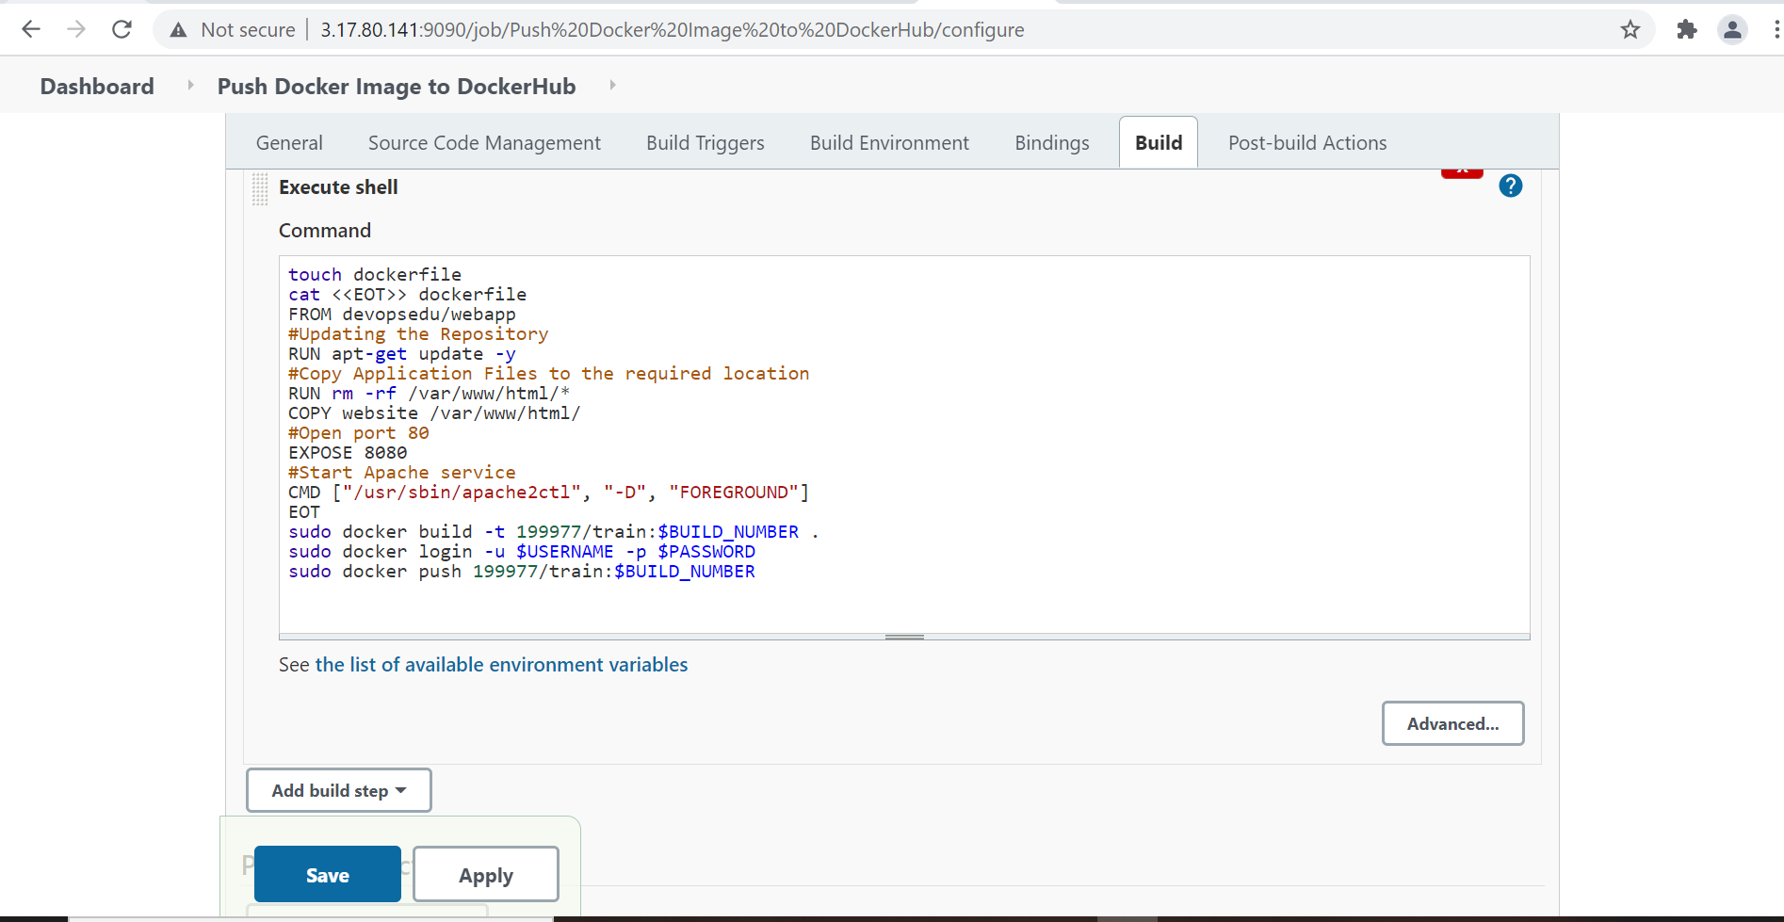

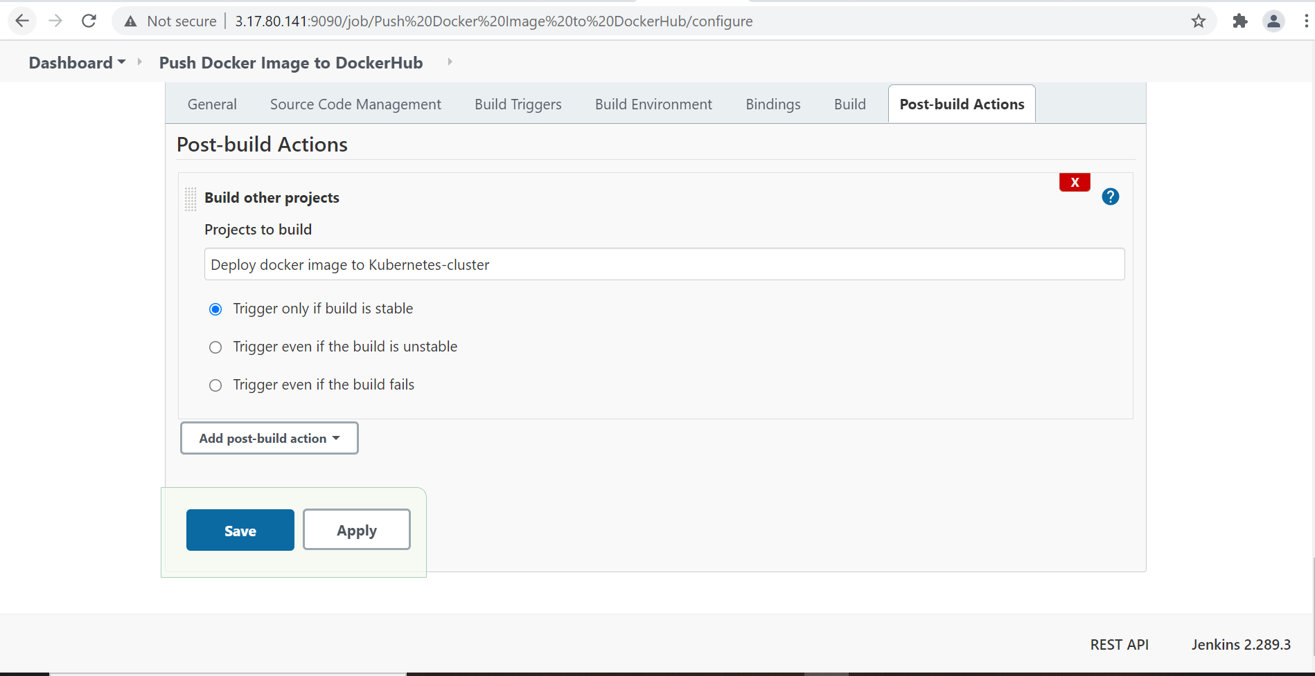

Output:
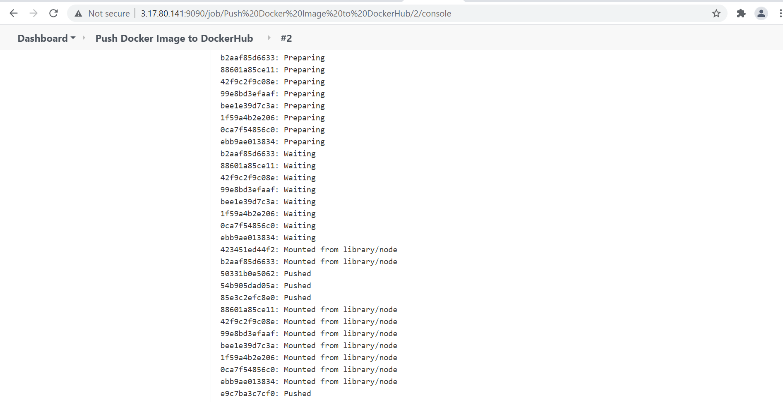

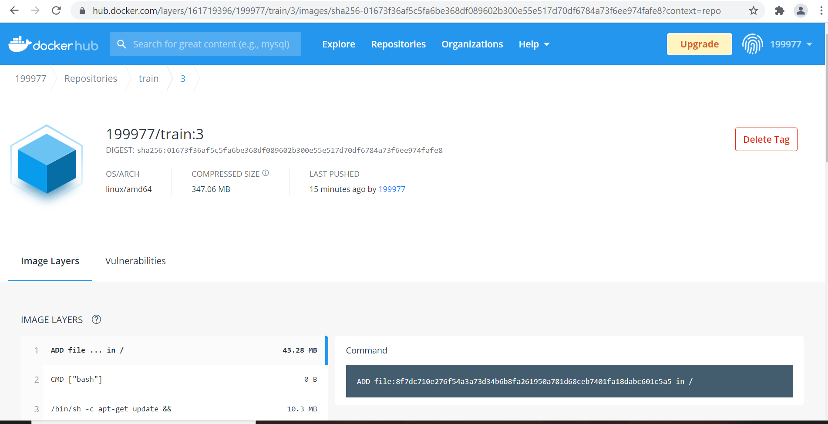

Job 2:- Deploy created docker image to kubernetes-cluster.
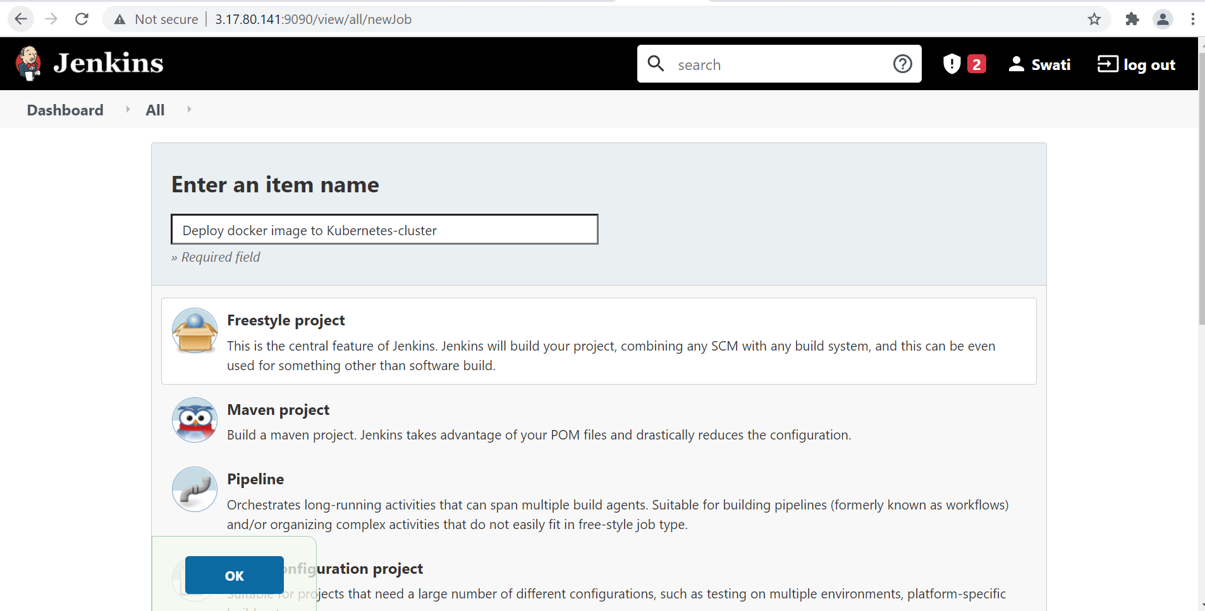

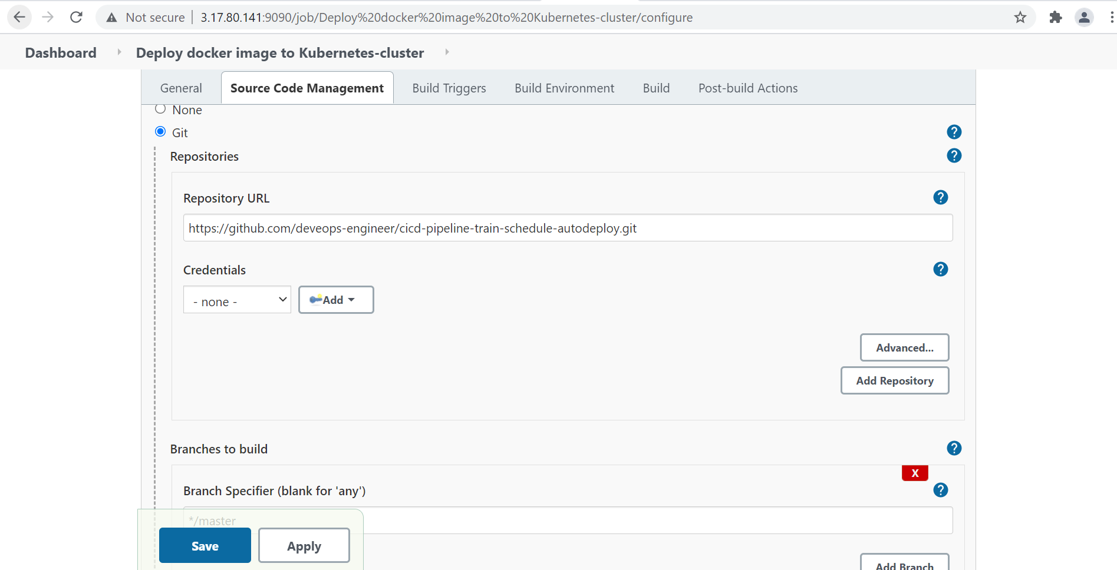

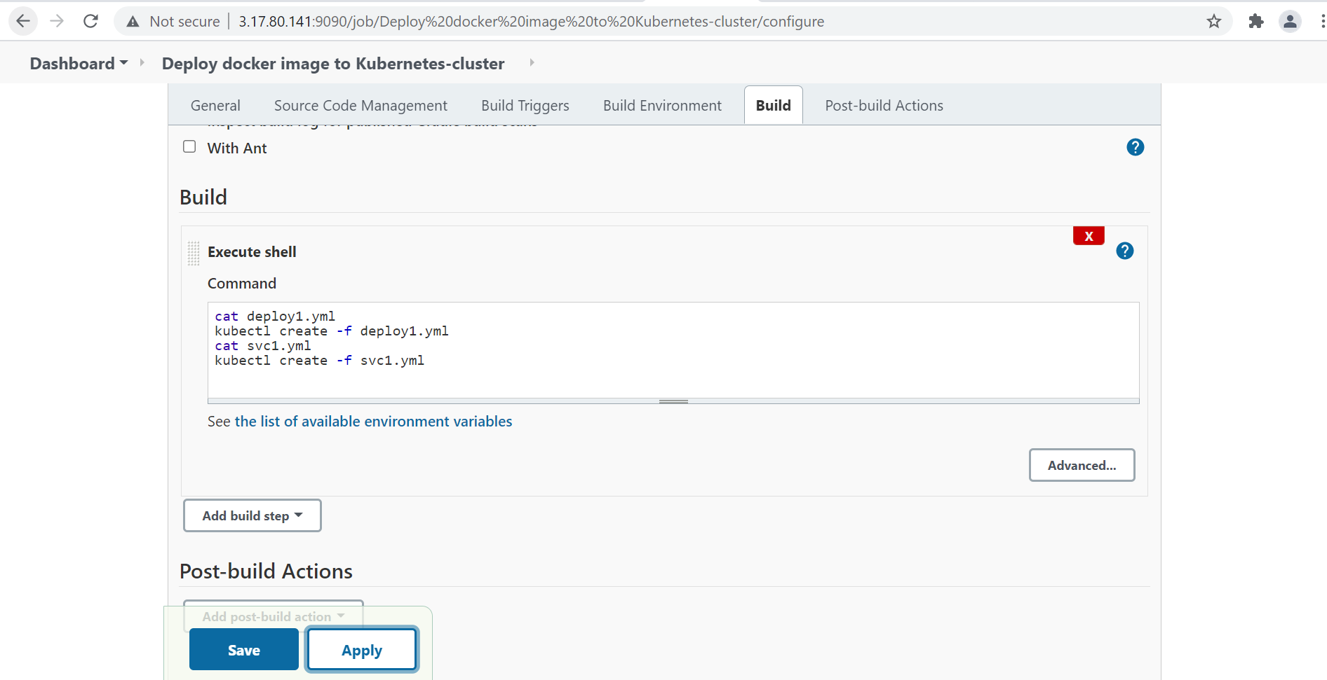

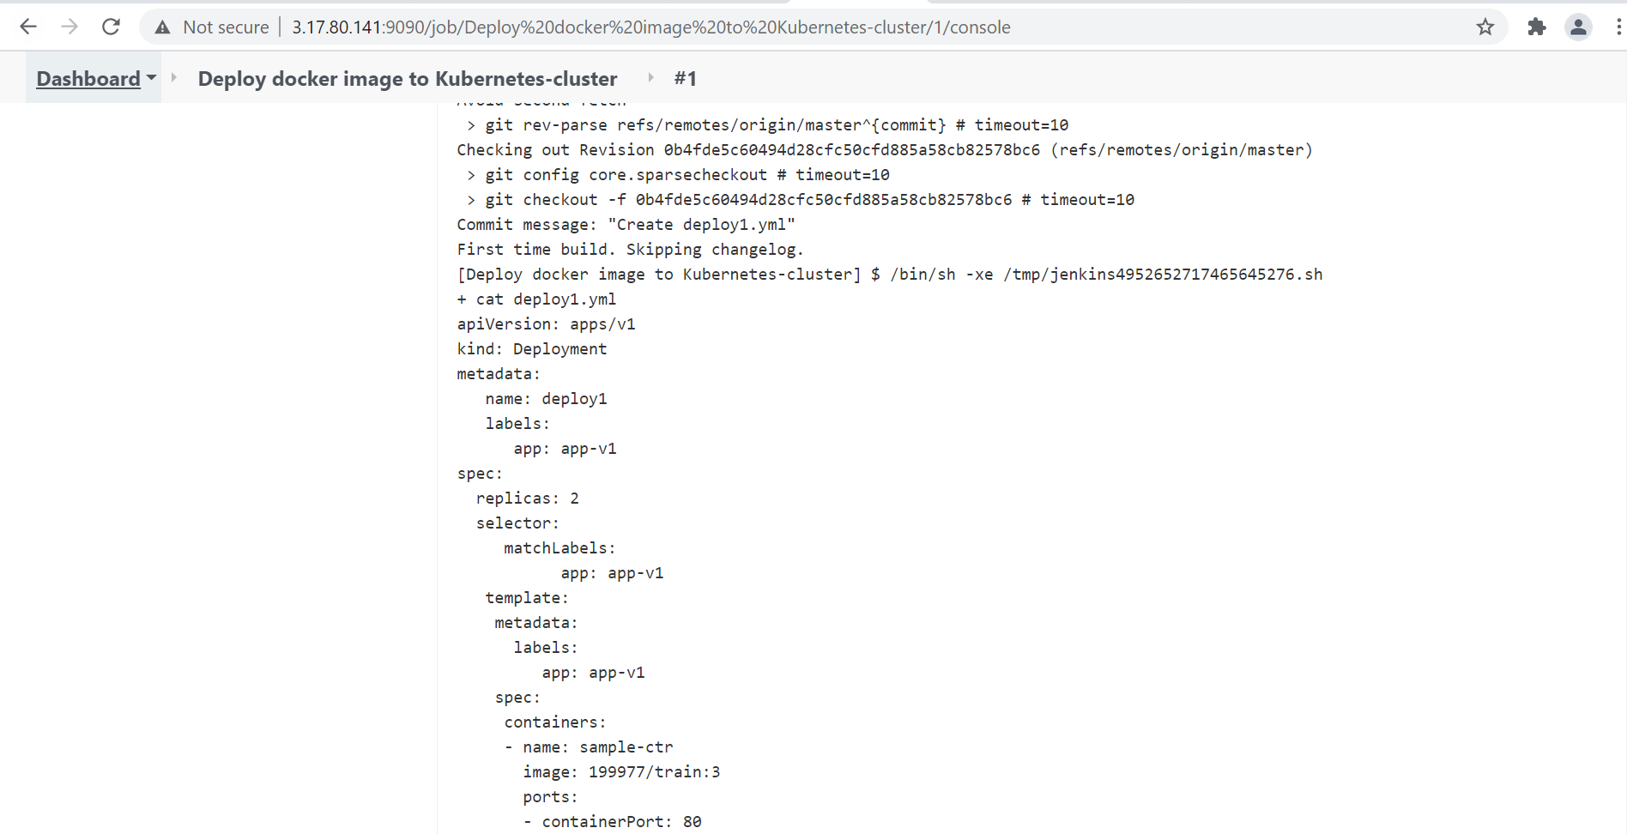

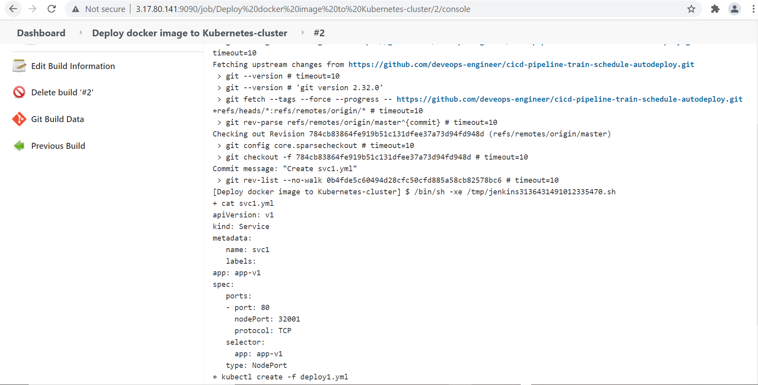

Make pipeline:
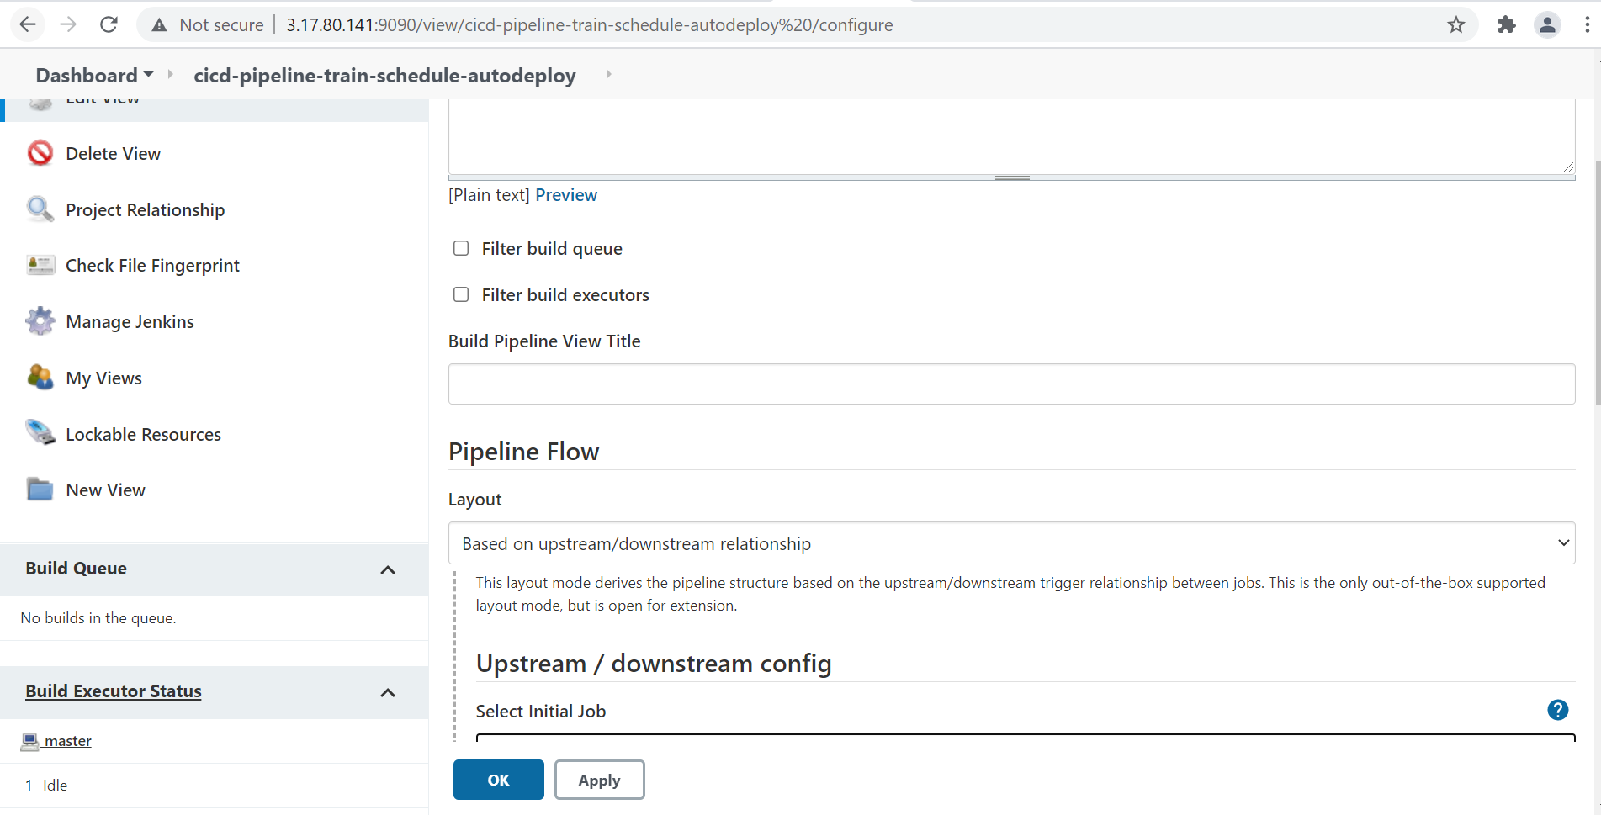

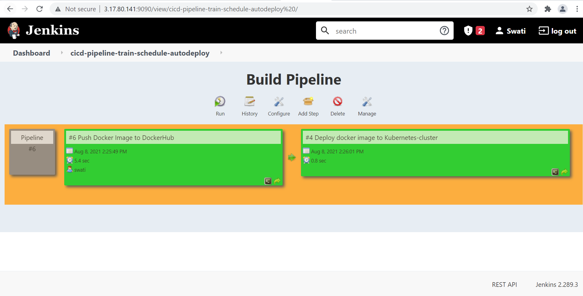
Deployment done :-
