**Random Forest: Variable Importance Plot**

rf = randomForest(lpsa~., data=pros.train, ntree=70)

To represent Variable of Importance graphically, use **varImpPlot()** function.

varImpPlot(rf, main="Variable Importance Plot - PSA Score")

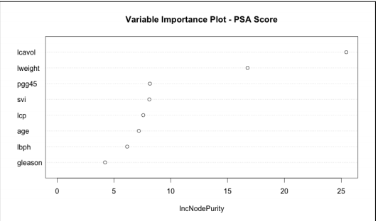

To find out the exact nos, use **importance()** function.

importance(rf)

IncNodePurity

Lcavol 25.446395

lweight 16.758646

age 7.191313

lbph 6.161000

svi 8.114879

lcp 7.580892

gleason 4.218471

pgg45 8.166068

For Regression scenario, the variables are arranged in order of percentage decrease in MSE.

For Classification scenario, the variables are arranged as per their contribution to the mean decrease in the Gini index.

**GBM:**

gbm.pima = gbm(type~., distribution="bernoulli",data=pima.train,n.trees=500,interaction.depth=3,shrinkage=0.01)

**summary()** function in the gbm package produces a table of the relative influence values and a barplot as well.

summary(gbm.pima)

var rel.inf

glu 44.152295

age 16.019096

bmi 13.849614

ped 10.545554

npreg 6.144122

skin 4.908916

bp 4.380403

