Project: |  | BizNotio
Team No.: |  | Team 2
Class: |  | CSE 3310.001 – Summer 2020
Module: |  | System Requirements Analysis (SRA)
Deliverable: |  | SRA Document
Version: |  | [1.0] | Date: | [08/12/2020]

Contributors:
Sushant Gupta
Lamia Chowdhury
Jonathan Ruben Padilla Vences
Sindhu Sudha Parajuli

Revision History
Version number | Date | Originator | Reason for change | High level description of changes
1.0 | mm/dd/yyyy | Sushant Gupta  Lamia Chowdhury  Sindhu Parajuli  Jonathan Padilla | Initial draft
1.1 | mm/dd/yyyy | Name(s) | Revision

TABLE OF CONTENTS
1. Introduction and Project Overview 3
2. Objectives 4
2.1 BUSINESS Objectives 4
2.2 SYSTEM Objectives 4
3. Project Context Diagram 5
4. Systems Requirements 6
4.1 “Home Screen” Requirements 6
4.2 “Login” Requirements 6
4.3 “Search” Requirements 6
4.4 “Member Registration” Requirements 6
4.5 “Buy/Sell/Lend/Exchange” Requirements 6
4.6 “Form Club” Requirements 6
4.7 “Advertisement” Requirements 6
5. Software Processes and Infrastructure 7
5.1 Hardware and Infrastructure 7
5.2 UML Diagrams 7
5.3 Conceptual Data Model - Database 7
5.4 Screen Shots 7
5.5 Test Plan 7
6. Assumptions and Constraints 8
6.1 ASSUMPTIONS 8
6.2 CONSTRAINTS 8
6.3 Out of Scope material 8
7. Delivery and Schedule 9
8. Stakeholder Approval Form 10
Appendix: 11

1. Introduction and Project Overview

Team-2 has been employed to design and implement an android application to connect investors and investees. This will be a platform where people with ideas/business can reach out to investors and vice-versa to find funding. In case of funding received, the application would get a certain commission from the receiving party. This application will be up by the first week of August and will have the features listed below initially. More features will be added per feedback and ideas received in future.
Using the android platform, our application can register users, create profiles for users, share ideas and proposals, chat/call other users, make minimum business goals, upload images/videos and even handle transactions. Our application will serve users to find the project they want to invest and be invested.

2. Objectives

2.1 BUSINESS Objectives
The following is a list of business objectives:
Objective 1: Member Registration: All members must provide the following information prior to using the system:
- First Name, last Name
- Home and mailing addresses
- E-mail address
- Username
- Password

Objective 2: Login functionality: All members must login to the system with a user/password that was established during Member registration stage.

Objective 3: “Account Maintenance” functionality must be supported that allows user to close and edit personal information and includes the following:
- E-mail address
- Password
- Delete Account

Objective 4: “Account Setup”: The user will be able to create a profile with the following features:
- Provide personal information
- Upload picture/video
- Upload a proposal as a word file or pdf
- Provide a minimum business case: goals, cost, schedule, restrictions, assumptions and constraints.

Objective 5: “Search”: The user will be able to search for other profiles registered in the application.

Objective 6: “Notification”: The user will be able to send and receive messages.

Objective 7: “Appointment”: The user will be able to call/video call other users.

Objective 8: “Account Maintenance”: The user will be able to recover their password or username in the event of authorized access or loss of credentials.

Objective 9: “Payments”: The user will be able to send and receive payments to another user via the following methods:
- Card
- Cash
- Check

Objective 10: “Rate and Review”: The user will be able to rate/review other users according to their experience.

2.2 SYSTEM Objectives
The following is a list of system objectives:

Objective 1: System will be an Android application

Objective 2: Kotlin will be used for UI.

Objective 3: Firebase will be used for authentication and database.
Objective 4: Material design theme will be used for interactive UI

3. Project Context Diagram

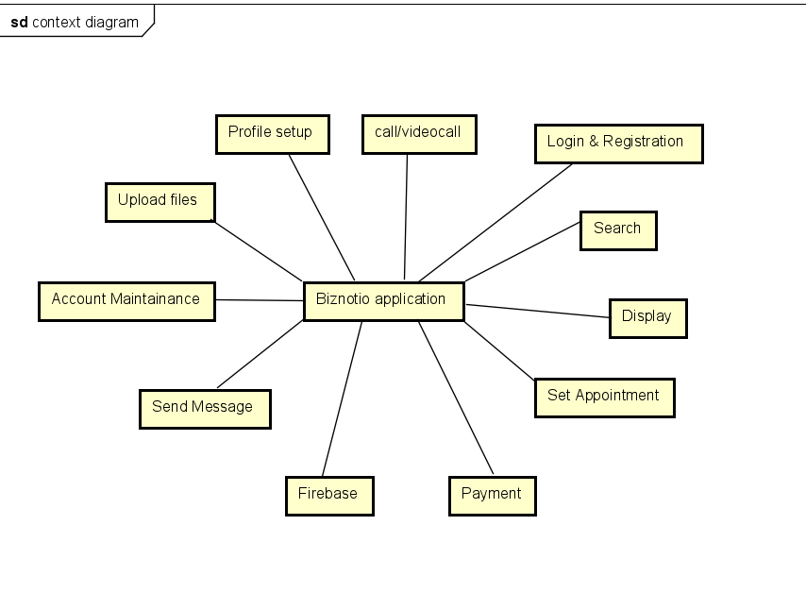
Figure 3.1: Project Context Diagram

4. Systems Requirements

{Introduce the following requirement sections that correspond with the “user” functionality. Keep hardware, database, test data, and android versions to section 5. Add a new section for each category of your requirements. This is the heart of the SRA document, and hence the lengthiest, and should list all requirements of the system. Please use the designated Requirements Form, insert forms below.}

4.1 “Home Screen” Requirements
{List requirements}

4.2 “Login” Requirements
{List requirements}

4.3 “Search” Requirements
{List requirements}

4.4 “Member Registration” Requirements
{List requirements}

4.5 “Buy/Sell/Lend/Exchange” Requirements
{List requirements}

4.6 “Form Club” Requirements
{List requirements}

4.7 “Advertisement” Requirements
{List requirements}

{Add as many sections as necessary, i.e. 4.8, 4.9 etc., each corresponding to a category of user functionality such as examples above.}

5. Software Processes and Infrastructure

5.1 Hardware and Infrastructure
{Any hardware and infrastructure types/issues such as which version of android and other related material go here}

5.2 UML Diagrams
{You can refer to the section number of the UML diagrams in the final binder. Also please feel free to add additional you feel are good additions}

5.3 Conceptual Data Model - Database
{All database material goes here, if any}

5.4 Screen Shots
{Include any screen shots if you have any here. This may take several pages. If nothing available, mention “None available at this time”}

5.5 Test Plan
{Simply mention that a test plan will be provided at a later stage of the project}

6. Assumptions and Constraints

6.1 ASSUMPTIONS
The following is a list of assumptions:
- Ignore collecting money from external advertisement and general accounting
- Ignore compliance issues
- Users are real Investees and Investors with correct information on profile
- User agreement and terms are not required
- Users are 18 years or older
- Ignore taxations on payment made through the application
- Abundant availability of team’s members throughout the project
- Team's members are familiar with all the development tools

6.2 CONSTRAINTS
The following is a list of constraints:
- Team lacks android experience
- Schedule very aggressive
- Team lacks prior Firebase experience
- Team lacks prior Kotlin/Java experience
- Team lacks prior database experience
- Lack of face to face meetings
- New team’s members to each other making difficult communication
- Application needs to be installed on a device

6.3 Out of Scope material
The following is a list of “out of scope” material:
- Post Project maintenance is not covered
- No web version is developed

7. Delivery and Schedule
Task/Milestone Description | Anticipated Start Date | Anticipated End Date | Status | Comments
Prepare Requirements and UML diagram | 06/16/2020 | 07/02/2020 | Completed | Deliverable will be ULM document in PDF format.  Increment 1 Deliverable
SRA document (Includes project objectives, Requirements and UML diagrams) | 07/02/2020 | 07/21/2020 | In Progress | Deliverable will be the SRA document. All stakeholders agree on the content of the SRA by signing in section 8.  Increment 2 Deliverable
Home screen design and implementation | 07/02/2020 | 07/22/2020 | To Be Completed (TBC)
Login and registration design and implementation | 07/22/2020 | 07/25/2020 | TBC
Account setup and maintenance design and implementation | 07/22/2020 | 07/30/2020 | TBC
Appointment management design and implementation | 07/22/2020 | 07/30/2020 | TBC
Proposals management design and implementation | 07/22/2020 | 07/30/2020 | TBC
Individual reviews and ratings design and implementation | 07/22/2020 | 07/30/2020 | TBC
Payment management design and implementation | 07/22/2020 | 07/30/2020 | TBC
Search design and implementation | 07/22/2020 | 07/30/2020 | TBC
Test case design | 07/22/2020 | 07/30/2020 | TBC | Increment 3 Deliverable
External Documentation (i.e. User Manual) | 07/22/2020 | 08/10/2020 | TBC
Project presentation | 08/01/2020 | 08/11/2020 | TBC
Final Milestone: project delivery |  | 08/11/2020 | TBC | Increment 4 Deliverable

8. Stakeholder Approval Form

Stakeholder Name | Stakeholder Role | Stakeholder Comments | Stakeholder Approval Signature and Date
Rodrigo Augusto | Development Mgr
Prajwal Gautam | Project Assistant
Sushant Gupta | Developer
Sindhu Parajuli | Developer
Lamia Chowdhury | Developer
Jonathan Padilla | Developer

Appendix:

None

