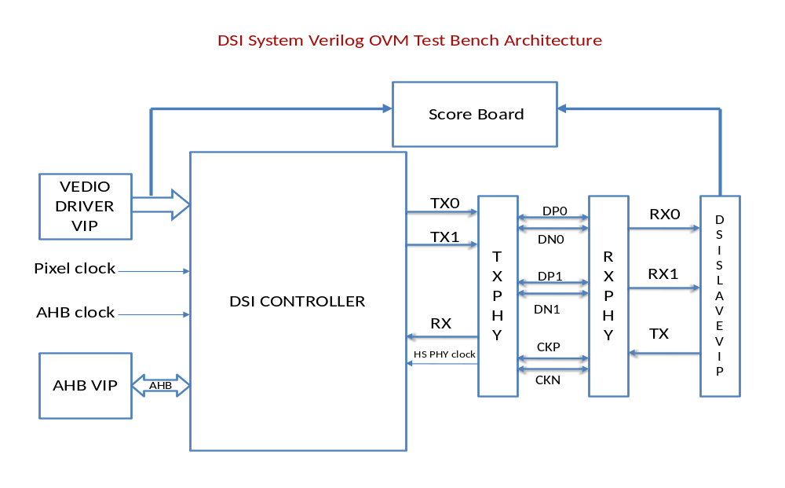

CLK FRQ for 24bpp and single lane
Resolution | Pix clock  Mhz | DSI clock  MHZ | Byte clock  MHZ | Lane clock  MHZ | PLL clock  MHZ
QQVGA(160x120)  QCIF(176x144)  QVGA(320x240)  CIF(352x288)  VGA(640x480)  WVGA(800x480)  XVGA(1024x768)  720p(1280x720) | 1.25  1.75  6  7.75  23.75  29.5  63.5  74.5 | 3.75  5.25  18  23.25  71.25  88.5  190.5  223.5 | 3.75  5.25  18  23.25  71.25  88.5  190.5  223.5 | 30  42  144  186  570  708  1524  1788

Resolution | No of lanes | DSI mode | Output bpp
QQVGA(160x120)  QCIF(176x144)  QVGA(320x240)  CIF(352x288)  VGA(640x480)  WVGA(800x480)  XVGA(1024x768)  720p(1280x720) | Single lane  Double lane | Non burst (sync pulse)  Non burst (sync event)  Burst (sync event) | 24bpp  18bpp  16bpp

