ECA56 – ADVANCED WIRELESS COMMUNICATION SYSTEMS
CO1 INTEGRATED ENGINEERING ANALYSIS AND PLANNING ASSIGNMENT
Evolution, Cellular Planning, Spectrum Use and Interference Management
Student Name: C. Sushanth Register Number: 192412418
Course Outcome: CO1 – Understand and articulate mobile-system evolution, cellular architecture, spectrum utilization and interference management.

Executive Summary
This report evaluates a regional operator’s next-stage mobile network using the assignment’s supplied planning data. The busy-hour offered traffic is 80 Erlangs. Erlang B analysis gives a minimum of 92 traffic channels for blocking at or below 2%; a 100-channel group gives approximately 0.399% blocking under the stated model. Using the regular-hexagon formula, one cell has an idealized area of 10.39 km² and a 19-cell cluster has a geometric area of 197.45 km². For reuse cluster size N = 7, the reuse fraction is 14.29% and the reuse distance is 9.17 km. The combined co-channel and adjacent-channel interference gives an estimated SINR of 13.81 dB, below the 15 dB target. At 100 m, free-space path loss is approximately 71.53 dB at 900 MHz, 83.32 dB at 3.5 GHz and a higher value of 101.39 dB at 28 GHz. The recommended strategy is to optimize the existing low-band coverage first, use 3.5 GHz to add capacity where traffic measurements justify it, and reserve 28 GHz for short-range hotspots. All figures are first-order planning estimates, not substitutes for a site survey or radio-network simulation.

1. Requirements and Planning Data
Parameter | Supplied value
Cell geometry | Hexagonal model; radius r = 2 km; 19-cell planning cluster; reuse cluster size N = 7
Traffic | 1,000 subscribers × 0.08 Erlang each; 100 initial traffic channels; blocking target ≤ 2%
Mobility | 60 km/h; overlap dwell time 6 s; route cell length 1 km; handoff interruption 0.5 s; target-cell unavailability 1%
Interference | Desired signal S = −70 dBm; co-channel I₁ = −85 dBm; adjacent-channel I₂ = −90 dBm; SINR target 15 dB
Spectrum comparison | 900 MHz, 3.5 GHz and 28 GHz at 100 m; c = 3 × 10⁸ m/s

Method: calculations use the equations specified in the assignment. The cell model is idealized, traffic is modeled as circuit-switched offered traffic with Erlang B, and propagation calculations use free-space path loss (FSPL). These assumptions are stated where they affect interpretation.

2. Stage 1 – Evolution of Mobile Systems
Generation / example | Main capability and radio technology | Limitation / engineering significance
1G – AMPS | Analog voice; 800 MHz; 30 kHz FDMA channels | Limited capacity, weaker privacy and service quality; analog channels and reuse required careful interference control.
2G – GSM | Digital voice and messaging; 900 MHz carrier; 200 kHz carrier bandwidth with 8 TDMA time slots | Digital transmission improved spectral efficiency, voice quality and security features; time-slot scheduling improved sharing of a carrier.
3G – UMTS | Mobile data and multimedia; 5 MHz carrier | Higher data rates than 2G, but growing data demand required wider channels and more efficient radio resource management.
4G – LTE | Broadband IP data; OFDMA and MIMO | OFDMA supports flexible resource allocation and MIMO improves spectral efficiency; dense traffic still creates interference and capacity constraints.
5G – NR | eMBB, URLLC and massive IoT; mid-band and mmWave; beamforming | Supports higher capacity and varied service needs. Higher bands have shorter practical coverage and demand denser sites; beamforming helps direct energy.
6G vision | Potential THz operation, AI-native networking, holographic communication, tactile internet and ISAC | Vision-stage concepts remain subject to research, standardization, spectrum availability, energy use and practical propagation constraints.
Engineering interpretation of the generational path. 1G mainly delivered analog voice through FDMA, with relatively limited privacy and capacity. 2G digitized voice and introduced TDMA in GSM, enabling multiple time slots on a carrier and supporting services such as messaging. 3G UMTS broadened the data experience with 5 MHz carriers and packet-oriented services. 4G LTE adopted OFDMA and MIMO to improve spectral efficiency, scheduling flexibility and peak data rates. 5G NR adds flexible numerology, beamforming and service classes such as eMBB, URLLC and massive IoT. The 6G items in the assignment are a vision rather than a universally deployed system; THz links and holographic/tactile applications would require substantial advances in propagation, hardware, synchronization and network intelligence.

Wavelength at 800 MHz: λ = c/f = (3 × 10⁸ m/s)/(800 × 10⁶ Hz) = 0.375 m.
Idealized number of 30 kHz channels in 10 MHz: 10,000 kHz / 30 kHz = 333.33, so at most 333 whole channels by simple division. This is an idealized arithmetic result only: it ignores guard bands, channel-edge constraints and the duplexing arrangement. In an actual AMPS plan, paired uplink/downlink spectrum and regulatory channelization reduce the number of independently usable voice channels.
Overall, each generation has attempted to deliver more capacity and better service from limited spectrum. Digital modulation and scheduling, OFDMA, MIMO, beamforming and more directional antennas have improved resource use, but reuse and dense deployment make interference coordination increasingly important.

3. Stage 2 – Cell Coverage and Frequency Reuse
For a regular hexagonal cell, the area approximation is A = (3√3/2)r². With r = 2 km: A = (3√3/2)(2 km)² = (3√3/2)(4) = 10.392 km² ≈ 10.39 km². The geometric area of a 19-cell cluster is 19 × 10.392 = 197.45 km². This value represents idealized tiled area; it should not be interpreted as a guaranteed service footprint because actual radio coverage depends on terrain, clutter, antenna configuration, interference and service thresholds.
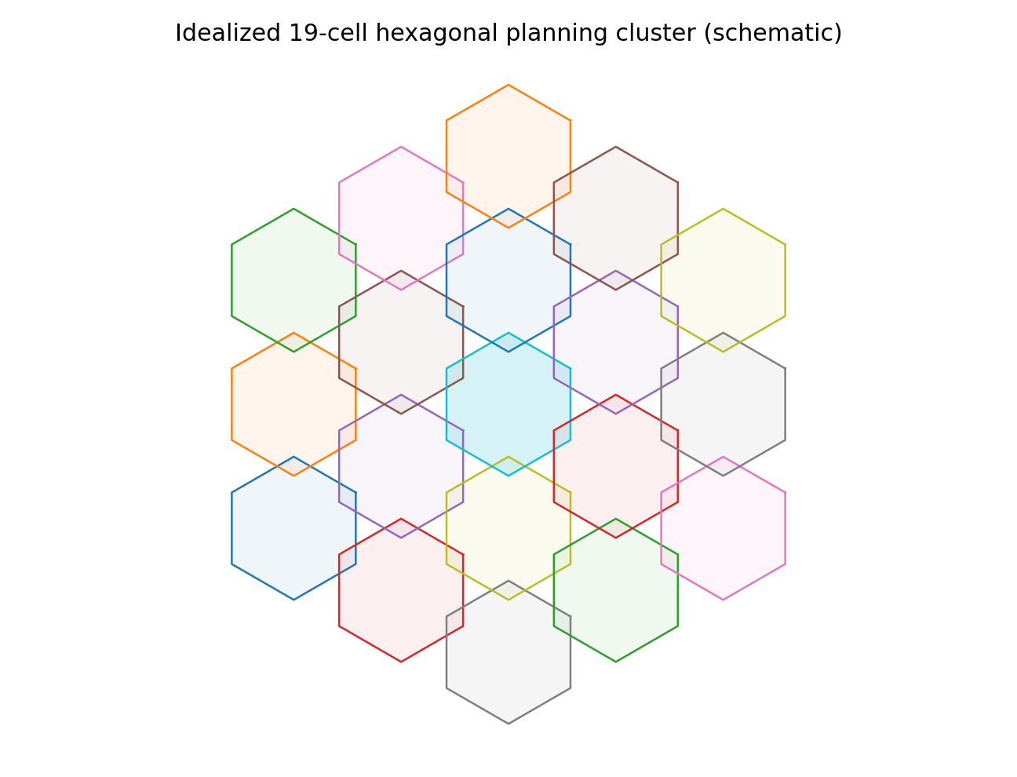
Figure 1. Idealized 19-cell cluster; geometry is illustrative, not a measured coverage map.
For reuse cluster size N = 7, the frequency reuse fraction is 1/N = 1/7 = 0.1429 (14.29%). Reuse distance: D = r√(3N) = 2√21 = 9.17 km.
The hexagonal model tiles a plane without gaps and assumes a simplified regular cell boundary. Real radio coverage is not a guaranteed geometric footprint: terrain, buildings, antenna height and tilt, transmit power, clutter, fading, indoor penetration, interference and user-device capability alter the usable signal area. A planning cluster’s geometric area is not necessarily the exact area of a real 19-site deployment because edge effects and site locations matter.
Technique | Effect on coverage/capacity | Main trade-off
Cell splitting | Divides a busy large cell into smaller cells, increasing spatial reuse. | More sites and handoffs; reuse interference must be re-planned.
Sectoring | Uses directional antennas (e.g., 3 sectors) to reduce the number of dominant interferers. | Can reduce interference but requires antenna/site complexity and careful sector planning.
Microcells | Small outdoor cells in busy streets or local demand zones. | Capacity close to users increases; handoffs and backhaul/site needs increase.
Picocells | Small cells for offices, malls or indoor public areas. | Improves indoor capacity; adds equipment and mobility/load-management complexity.
Femtocells | Very small cells, often for homes or small premises. | Improves indoor service, but access control and interference with nearby macro users require care.

Recommendation: first use sectorization and optimized tilt/power at existing sites, then add targeted microcells in verified high-traffic corridors. This expands capacity without immediately densifying the entire region. Small cells increase handoff frequency and can create new interference boundaries, so neighbor lists, mobility thresholds and backhaul must be planned.

4. Stage 3 – Traffic and Channel Capacity
Offered busy-hour traffic: A = number of subscribers × traffic per subscriber = 1,000 × 0.08 Erlang = 80 Erlangs.
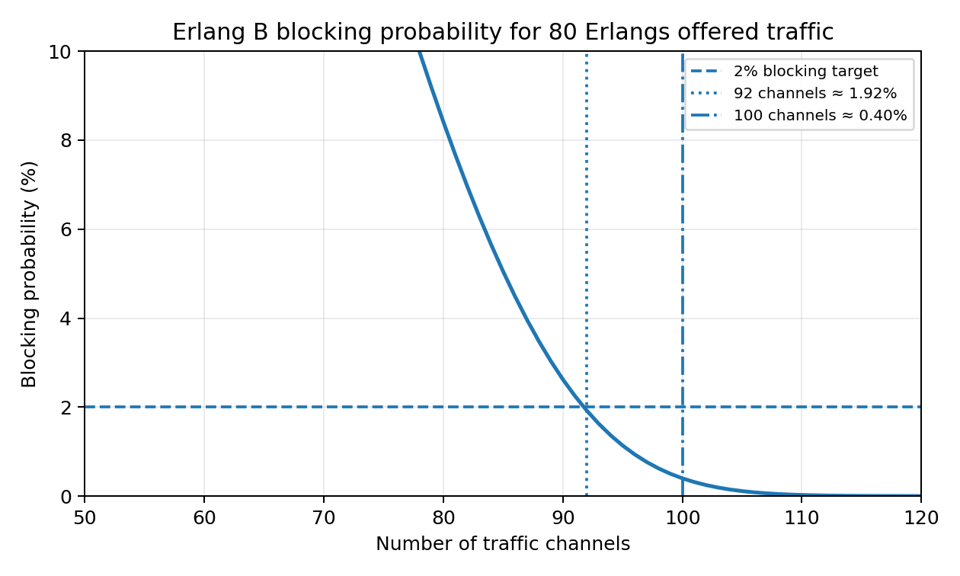
Figure 2. Erlang B blocking probability falls as channel count increases for 80 Erlangs of offered traffic.
Erlang B blocking probability is calculated recursively as B(0,A) = 1 and B(C,A) = [A × B(C−1,A)]/[C + A × B(C−1,A)]. For A = 80 Erlangs and C = 100 channels, B ≈ 0.003992 = 0.399%. This is below the 2% target.
Searching integer channel counts with the same Erlang B recurrence gives C = 92 as the smallest count satisfying the target: B(92,80) ≈ 0.01922 = 1.922%. One fewer channel does not meet the target (the recurrence gives a blocking probability above 2%). Thus the 100-channel group has an 8-channel margin above the modeled minimum.
Estimated 100-channel groups: ceil(92/100) = 1 group for the calculated channel requirement. This is a first-order estimate, not a site plan: traffic is not necessarily evenly distributed, channels may be split across cells/sectors, coverage and frequency reuse constrain channel assignments, and busy-hour traffic varies geographically. A complete plan needs per-cell traffic forecasts, radio-resource assumptions, trunking/grouping details and growth allowance.
The model assumes the 1,000 subscribers collectively offer 80 Erlangs during the busy hour and calls arrive approximately randomly, with independent holding times and no queuing (blocked calls are cleared). Erlang B does not model packet scheduling directly and should not be interpreted as a complete LTE/5G capacity model.

5. Stage 4 – Mobility and Handoff
Speed conversion: 60 km/h = 60,000 m/3,600 s = 16.67 m/s. Distance travelled in the 6 s overlap interval = 16.67 × 6 ≈ 100 m.
If the stated 1 km route cell length means the distance between successive cell-boundary crossings along the route, time per cell = 1,000 m / 16.67 m/s = 60 s. Estimated hard handoffs = 60 s/min ÷ 60 s per cell ≈ 1 handoff per minute. This estimate assumes constant speed and regular boundaries; actual crossings depend on geometry and route.
Handoff type | Connection behavior | Resource / limitation
Hard handoff | Break-before-make: old link is released before the new one is fully established. | Usually uses fewer simultaneous radio links, but interruption or drop risk is higher if target acquisition fails.
Soft handoff | Make-before-break with simultaneous links to multiple base stations (where supported, notably some CDMA systems). | Improves continuity but consumes resources on multiple links and needs combining/control.
Softer handoff | Handoff between sectors of the same base station, typically with sector-level combining. | Can improve continuity within a site; consumes sector resources and depends on implementation.
Handoff interpretation. The estimated one handoff per minute follows only if 1 km represents the distance between successive route boundary crossings. The 100 m travelled during the six-second overlap interval is a useful timing check: the overlap region should provide enough signal and decision time for measurement, target selection and handoff execution. The 0.5 s interruption is not itself a 0.5/60 call-drop probability; the supplied 1% target-cell unavailability is the stated simple probability proxy. Real call-drop probability depends on both radio conditions and handoff protocol behavior.

A simple target-unavailability estimate gives a 1% probability that the target cell is unavailable at a handoff, if the supplied 1% value is interpreted as the probability of being unavailable at the instant of handoff. Therefore the per-handoff failure/drop risk from this factor alone is approximately 1%. The 0.5 s interruption is a duration, not a probability; it represents a service gap during a hard handoff. At one handoff per minute, 0.5 s is about 0.83% of a minute, but that fraction is not itself the call-drop probability.
This is only a simplified estimate. It omits radio link failure, signal quality, handoff preparation, neighbor-list errors, target admission control, correlated outages, speed variation and overlapping coverage. The 6 s overlap (about 100 m travelled) provides a nominal decision window, but measured signal dynamics should set actual handoff thresholds.

6. Stage 5 – Interference and Spectrum Comparison
Co-channel carrier-to-interference ratio using I₁ alone: C/I = S − I₁ = (−70) − (−85) = 15 dB. This equals the required SINR numerically only if noise and other interference are ignored.
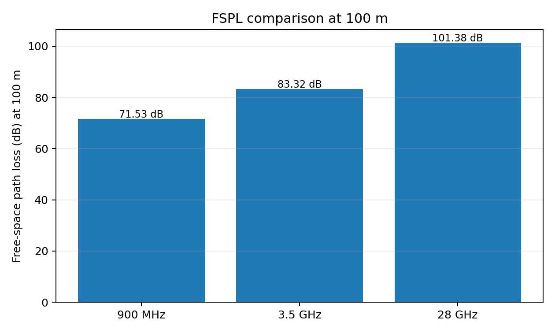
Figure 3. Free-space path-loss comparison at 100 m using the supplied speed of light.
Combine interference in linear power units. For dBm values, P(mW) = 10^(P(dBm)/10). Thus I₁ = 10^(−8.5) mW ≈ 3.162 × 10⁻⁹ mW and I₂ = 10^(−9) mW = 1.000 × 10⁻⁹ mW. The total is 4.162 × 10⁻⁹ mW, equivalent to −83.81 dBm. SINR = S − I_total = −70 − (−83.81) = 13.81 dB, assuming noise is negligible or excluded. The 15 dB target is not met; the shortfall is about 1.19 dB. Including thermal noise would generally lower SINR further.
A suitable mitigation is to reduce dominant interference through antenna tilt/azimuth optimization, sectorization, power control and coordinated frequency planning. For this case, start with a radio-planning audit and antenna optimization, then use sectorization or coordinated scheduling if needed. The trade-off is that more directional planning and lower power can create coverage holes or reduce edge throughput, while sectorization adds equipment and planning complexity.
Because powers in dBm are logarithmic, interference must be summed after converting to linear units; directly adding −85 dBm and −90 dBm would be incorrect. The resulting SINR estimate assumes the supplied interference terms are the dominant impairment and omits receiver thermal noise. If noise is material, the true SINR would be lower, so the 13.81 dB result should be treated as an optimistic estimate.
Band | Wavelength λ = c/f | FSPL at 100 m | Difference from 900 MHz | Likely deployment implications
900 MHz | 0.3333 m (33.3 cm) | 71.53 dB | 0 dB | Generally better diffraction and building penetration; broad-area coverage and rural reach, but less bandwidth may limit peak capacity.
3.5 GHz | 0.0857 m (8.57 cm) | 83.32 dB | +11.80 dB | Mid-band balance of coverage and capacity; suitable for urban/suburban 5G capacity with moderate densification.
28 GHz | 0.0107 m (1.07 cm) | 101.38 dB | +29.86 dB | Very small wavelengths enable compact arrays and beamforming, but blockage and penetration losses are challenging; best for targeted hotspots and line-of-sight-rich areas.

FSPL calculation: λ = c/f and FSPL = 20 log₁₀(4πd/λ), with d = 100 m. The higher-frequency path-loss values are free-space comparisons and do not alone predict network performance. Actual performance also depends on bandwidth, transmit power, antenna gain, beamforming, receiver noise figure, blockage, atmospheric effects, interference, cell density and link adaptation. A high-gain directional array at 28 GHz can offset some link-budget loss, but it cannot remove blockage or indoor penetration challenges.

7. Stage 6 – Spectrum Coordination and Deployment Recommendation
ITU-R is the International Telecommunication Union’s Radiocommunication Sector. It develops technical studies, recommendations and international regulatory material to support compatible use of radio frequencies and satellite or terrestrial services. The World Radiocommunication Conference (WRC) is the treaty-level conference where member states review and revise the Radio Regulations, including international frequency allocations and conditions. The Radiocommunication Bureau (BR) supports the Radiocommunication Sector and WRC process, processes frequency assignments and notifications, maintains relevant international records, and assists with coordination and application of the Radio Regulations.
International coordination matters because national regulators develop band plans and licensing conditions within the international framework. Harmonized bands and technical conditions can improve equipment availability and roaming, while coordination obligations can constrain deployments near borders or where services might cause harmful interference. Operators must follow national licences and applicable technical limits rather than treating an international allocation as an automatic local licence.

8. Integrated, Phased Recommendation
Phase | Recommended action | Engineering justification / checks
Phase 1: stabilize and optimize | Audit existing 900 MHz coverage; optimize antenna azimuth, tilt and power; verify neighbor lists and handoff counters; measure busy-hour traffic and SINR. | 900 MHz provides broad coverage. The calculated SINR is only 13.81 dB, below target, so interference optimization should precede major expansion.
Phase 2: add capacity where needed | Use 3.5 GHz for capacity layers in high-demand towns/corridors; apply sectorization and targeted microcells based on measured traffic. | The 3.5 GHz FSPL is about 11.80 dB above 900 MHz at 100 m, but it offers a useful capacity/coverage compromise. The traffic model needs only 92 channels for 80 Erlangs at ≤2% blocking, while real demand must be assessed per cell.
Phase 3: targeted ultra-high capacity | Trial 28 GHz in hotspots such as venues or dense outdoor zones where short-range, high-throughput service is valuable. | Its 100 m FSPL is about 29.86 dB above 900 MHz and blockage is significant, so it should complement rather than replace broad-area coverage.
Phase 4: evolve and validate | Track 5G performance and prepare for future 6G developments through standards and spectrum monitoring; do not assume 6G vision features are immediately deployable. | Validate capacity, mobility, energy use, equipment maturity, spectrum rights and business case before scaling.

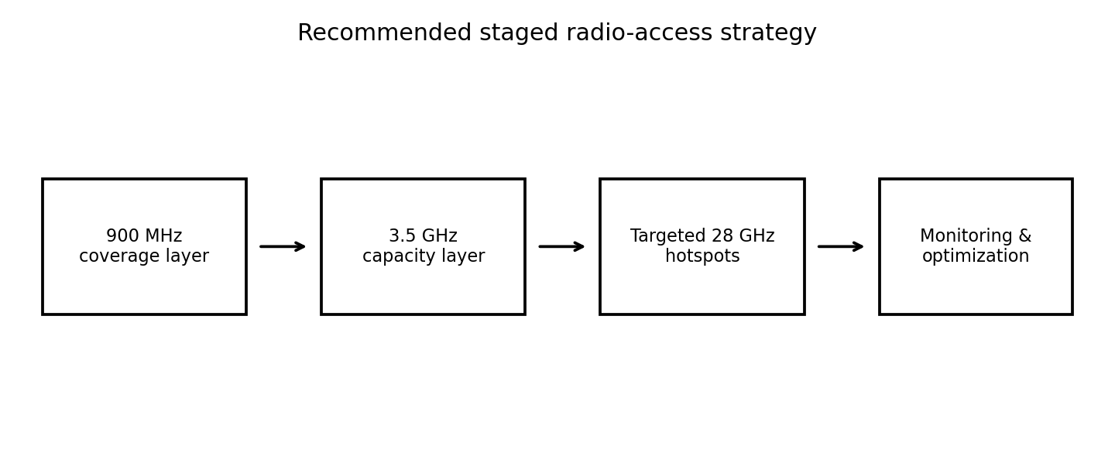
Figure 4. Suggested layered deployment sequence for coverage, capacity and targeted hotspots.
Before implementation, verify: (1) whether 0.08 Erlang per subscriber is representative of the busy hour and whether traffic is geographically uniform; (2) actual channelization, duplexing and spectrum licence constraints; (3) real cell geometry, terrain, building penetration and antenna parameters; (4) noise contribution and all relevant interferers; (5) handoff success/drop statistics and target-cell admission behavior; (6) backhaul, power, site availability, equipment cost and subscriber growth; and (7) national spectrum rules and any international coordination requirements.
Integrated engineering checks and implementation risks. The numerical results should be read together rather than independently. A 100-channel trunk group appears sufficient for the aggregate 80-Erlang traffic assumption, but aggregate sufficiency does not guarantee that every cell or sector has adequate capacity. Likewise, the 9.17 km reuse distance is a geometric planning result; actual co-channel performance depends on antenna patterns, propagation and traffic distribution. The SINR shortfall of about 1.19 dB indicates that the current illustrative interference case needs improvement before claiming that the 15 dB requirement is met. Antenna optimization and coordinated planning should be tested first because they may improve SINR without adding spectrum, although excessive power reduction or aggressive tilt can create coverage holes. A field measurement campaign should capture busy-hour load, RSRP/RSRQ or equivalent radio metrics, SINR, dropped calls, handover failures, indoor coverage and backhaul utilization. These measurements can then calibrate a propagation model and guide exact site placement.

Conclusion
The calculations support a layered, phased network rather than a single-band solution. The 100-channel group meets the supplied Erlang B blocking target for 80 Erlangs, while the minimum modeled requirement is 92 channels. The idealized seven-cell reuse plan has a 14.29% reuse fraction and approximately 9.17 km reuse distance, but real radio coverage and interference require field validation. The interference calculation fails the 15 dB SINR target at 13.81 dB, so optimization is a priority. Retain 900 MHz for coverage, use 3.5 GHz to add capacity, and deploy 28 GHz selectively for hotspots. This strategy connects historical evolution with the current engineering priorities of capacity, mobility, spectrum efficiency and interference control.
Key assumptions and limitations
• The hexagonal grid assumes equal-sized regular cells on a flat plane; real sites are irregular and may overlap.
• The Erlang B model assumes a loss system with no waiting queue, statistically independent call arrivals and a representative busy-hour load. It is a circuit-traffic approximation and does not directly size packet-based LTE/5G throughput.
• The FSPL equation assumes unobstructed far-field propagation in free space. Buildings, foliage, rain at some bands, diffraction, reflections, antenna gains and beamforming are not included.
• The simple handoff-risk estimate treats the 1% target-cell unavailability as a probability at the handoff instant. It does not model the full probability of a call drop.
• The assignment provides no terrain map, site coordinates, subscriber distribution, traffic growth forecast, licensed bandwidth, antenna data or backhaul constraints. These inputs are required for a detailed engineering design.

References
1. ECA56 Advanced Wireless Communication Systems, CO1 Integrated Engineering Analysis and Planning Assignment, supplied planning data and task requirements.
2. ITU-R, Radiocommunication Sector: https://www.itu.int/itu-r/
3. ITU, World Radiocommunication Conference (WRC): https://www.itu.int/wrc/
Note: The numerical calculations are derived from the supplied assignment data and stated equations. External references are included for spectrum-coordination context.

