**AI ASSISSTED CODING:**

**LAB EXAM-1:**

**TASK-1:**

PROMPT:

generate a python function that checks whearther a string is palindeome or not if it is return true else false and take input as madam,malayalam,karthik,hello

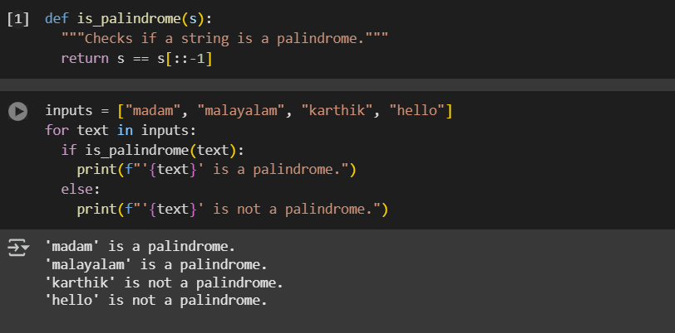

EXPLANATION:

* def is_palindrome(s):: This line defines a function named is_palindrome that takes one argument, s.
* """Checks if a string is a palindrome.""": This is a docstring, which explains what the function does.
* return s == s[::-1]: This is the core of the function.
  + s[::-1] creates a reversed version of the string s. The slicing [::-1] means start from the end, go to the beginning, with a step of -1.
  + s == s[::-1] compares the original string s with its reversed version. If they are the same, the expression evaluates to True, indicating the string is a palindrome. Otherwise, it evaluates to False. The function then returns this boolean value.
* inputs = ["madam", "malayalam", "karthik", "hello"]: This line creates a list named inputs containing several strings.
* for text in inputs:: This line starts a for loop that iterates through each item in the inputs list. In each iteration, the current item is assigned to the variable text.
* if is_palindrome(text):: This line calls the is_palindrome function with the current text from the loop. It checks if the function returns True.
* print(f"'{text}' is a palindrome."): If the if condition is true (meaning the text is a palindrome), this line prints a formatted string indicating that the text is a palindrome. The f"..." syntax allows you to embed variables directly within the string.
* else:: This keyword indicates the block of code to execute if the if condition is false.
* print(f"'{text}' is not a palindrome."): If the if condition is false (meaning the text is not a palindrome), this line prints a formatted string indicating that the text is not a palindrome.

Let me know if you'd like a more detailed explanation of any specific part!

**TASK-2:**

PROMPT:

EXPLANATION:

