AI ASSISTED CODING

TASK-1:

Use Google Gemini in Colab to write a Python function that reads  
a list of numbers and calculates the mean, minimum, and  
maximum values.  
Expected Output #1  
● Functional code with correct output and screenshot.

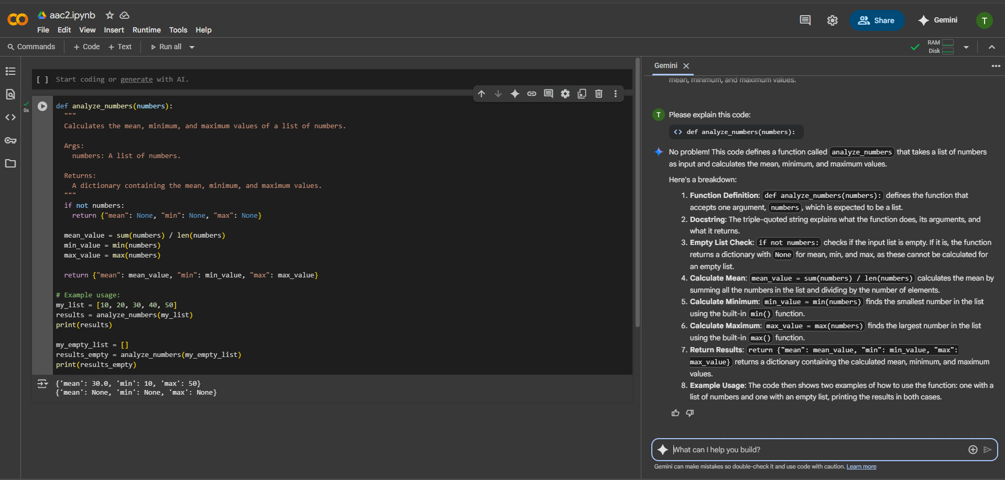

TASK-2:

Compare Gemini and Copilot outputs for a Python function that  
checks whether a number is an Armstrong number. Document the  
steps, prompts, and outputs.

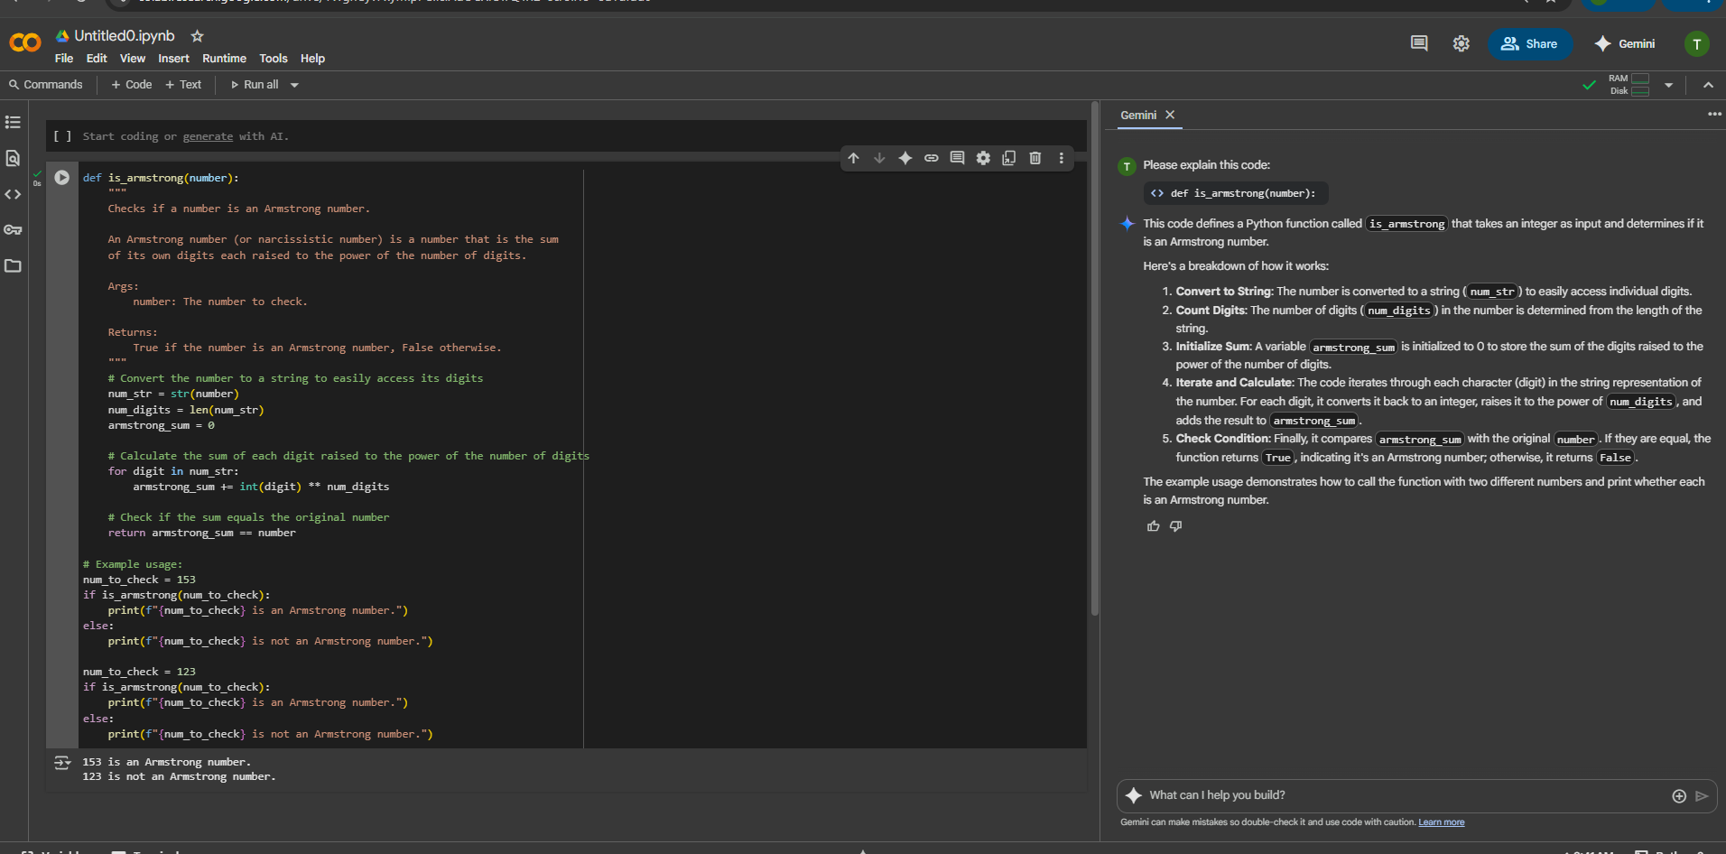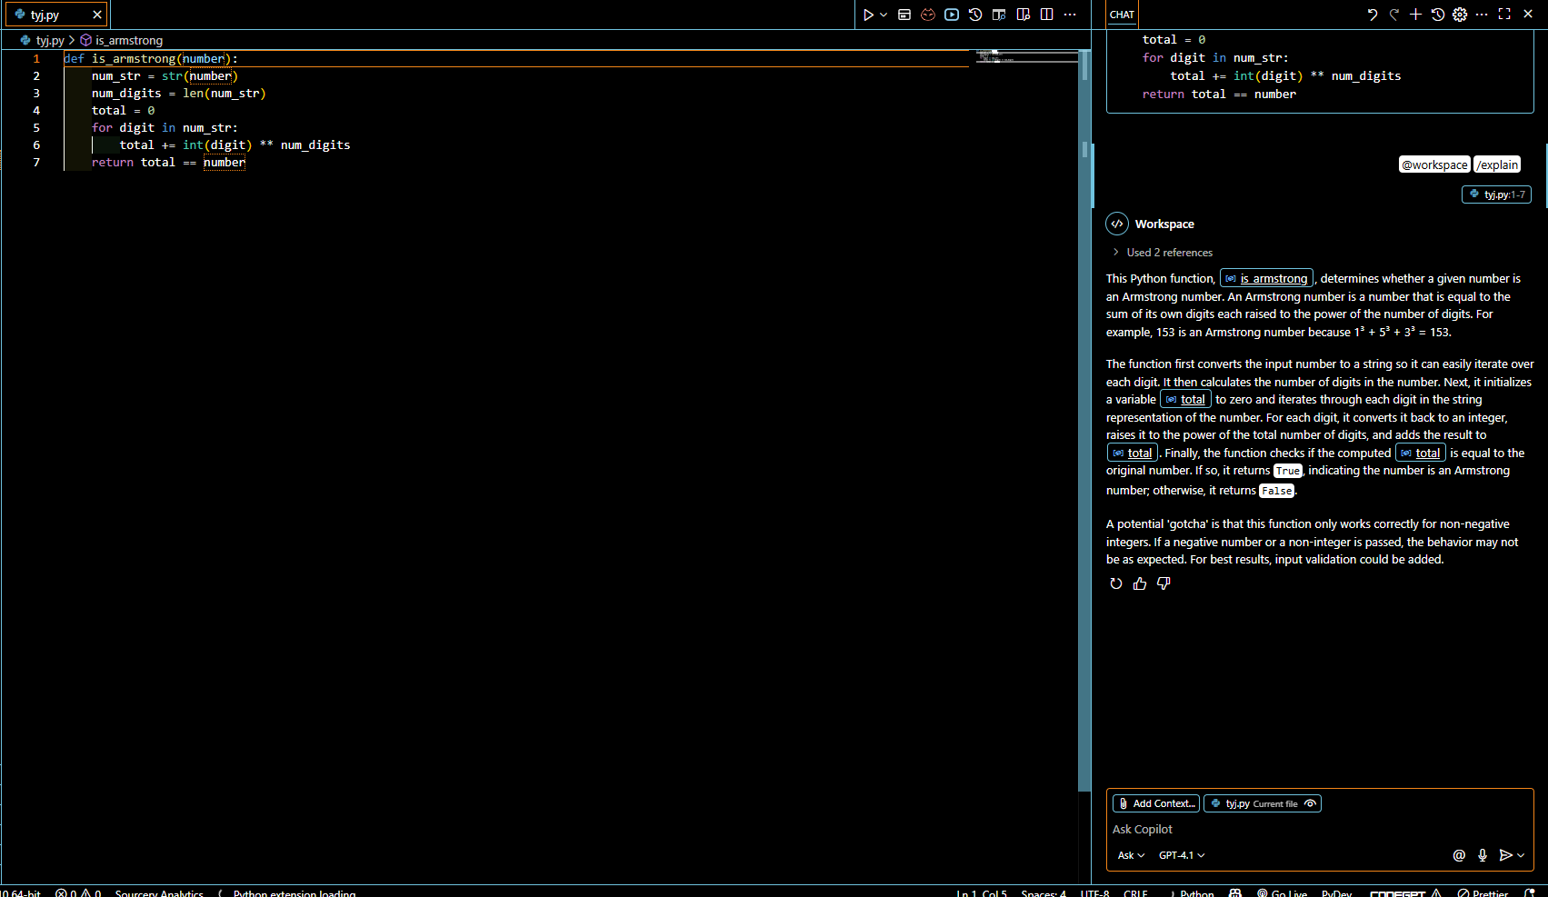

TASK-3:

Ask Gemini to explain a Python function (e.g., is_prime(n) or  
is_palindrome(s)) line by line.  
● Choose either a prime-checking or palindrome-checking function  
and document the explanation provided by Gemini.

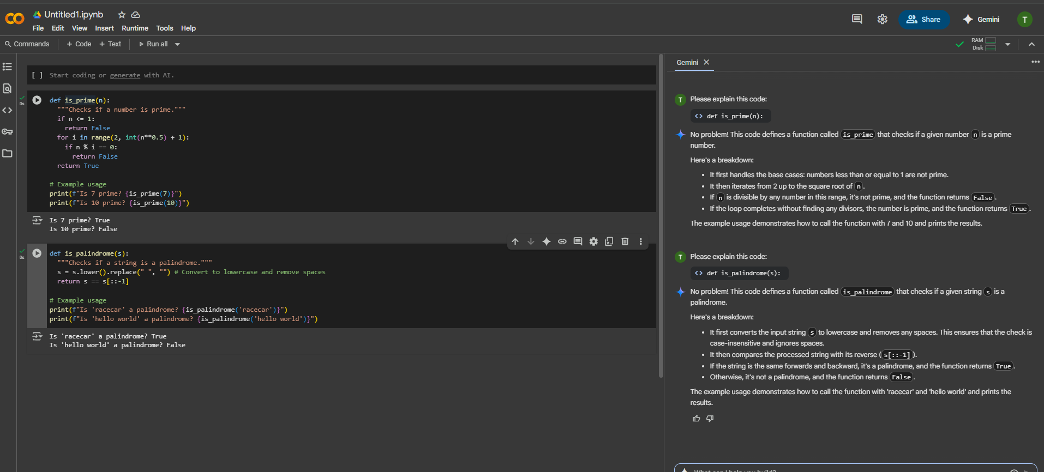

TASK-4:

nstall and configure Cursor AI. Use it to generate a Python  
function (e.g., sum of the first N natural numbers) and test its  
output.  
● Optionally, compare Cursor AI’s generated code with Gemini’s  
output.  
Expected Output #4  
● Screenshots of Cursor AI setup, prompts used, and generated  
code with output

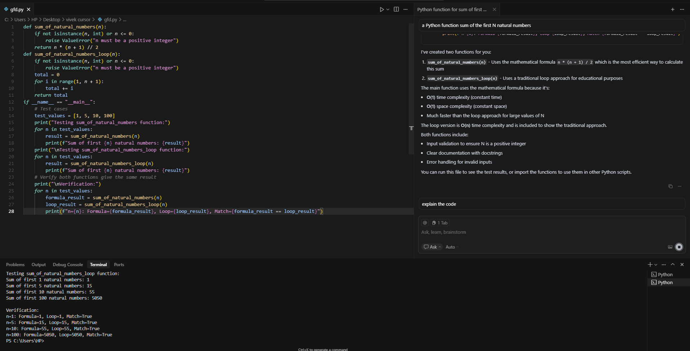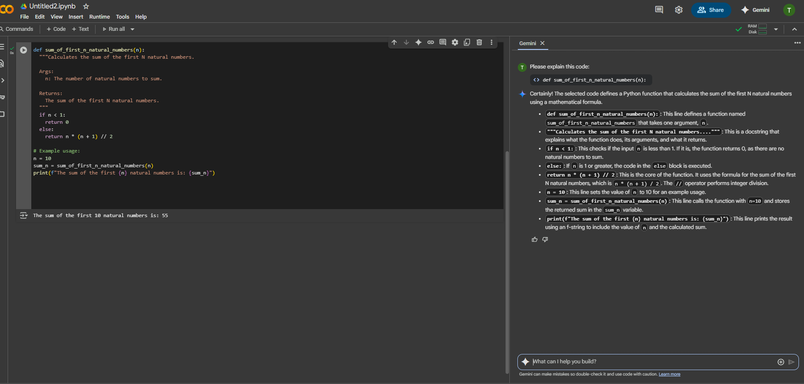

TASK-5:

Students need to write a Python program to calculate the sum of  
odd numbers and even numbers in a given tuple.  
● Refactor the code to improve logic and readability.  
Expected Output #5  
● Student-written refactored code with explanations and output  
screenshots

