**AI ASSISSTED CODING:19**

**TASK-1:**

**: Translate a Simple Program (Python → JavaScript)**

* **Instructions:**
  + Write a Python function print_numbers() that prints the first 10 natural numbers using a loop.
  + Translate the function into JavaScript as a reusable function printNumbers().
  + Call the function in both languages to display results.

**PYTHON**

**JAVA:**

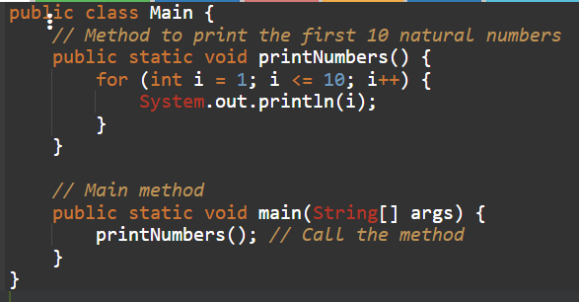

**EXPLANATION:**

Here's a breakdown:

* **public class main { ... }**: This defines a class named main. In Java, all code resides within classes. public means the class is accessible from anywhere.
* **public static void main(String[] args) { ... }**: This is the main method, the entry point of the program.
  + public: Accessible from anywhere.
  + static: Belongs to the main class itself, not an instance of the class.
  + void: This method does not return any value.
  + main: The name of the method, which is special because the Java Virtual Machine (JVM) looks for a method with this name to start the program.
  + String[] args: An array of strings that can be used to pass command-line arguments to the program.
* **for (int i = 1; i <= 10; i++) { ... }**: This is a for loop that iterates from 1 to 10.
  + int i = 1: Initializes an integer variable i to 1.
  + i <= 10: The loop continues as long as i is less than or equal to 10.
  + i++: Increments i by 1 after each iteration.
* **System.out.println(i);**: This line is inside the loop and is executed in each iteration.
  + System.out: Refers to the standard output stream.
  + println(i): Prints the value of i to the console, followed by a new line.

So, the loop starts with i as 1, prints 1, then i becomes 2, prints 2, and so on, until i is 10, prints 10, and then the loop terminates

**TASK-2:**

**Convert Conditional Statements (Java → Python)**

* **Instructions:**
  + Write a Java method checkNumber(int num) that checks if a number is positive, negative, or zero.
  + Translate the method into a Python function check_number(num).

Call the function/method with different inputs and compare outputS

**PYTHON:**

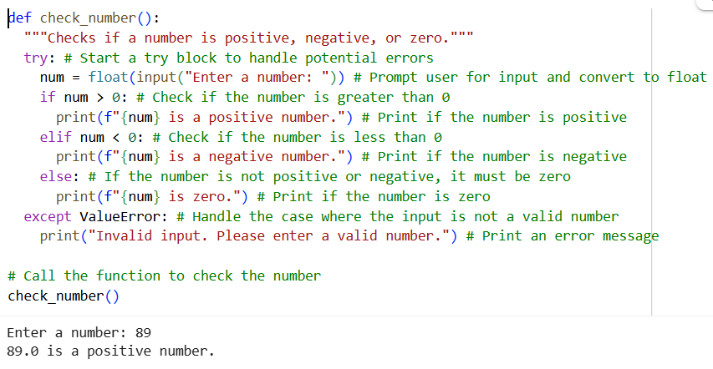

**JAVA:**

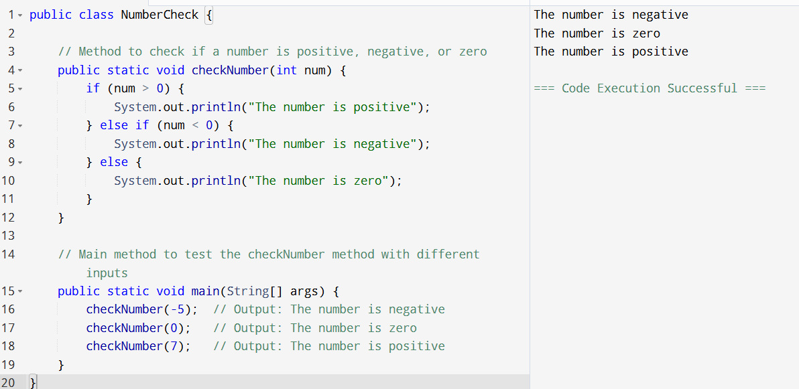

**TASK-3:**

**: Translate Recursive Function (Python → C++)**

* **Instructions:**
  + Write a Python function factorial(n) that calculates factorial of a number using recursion.
  + Translate the same into a C++ function int factorial(int n).

Call the function in both languages with inputs 5 and 0.

**PYTHON:**

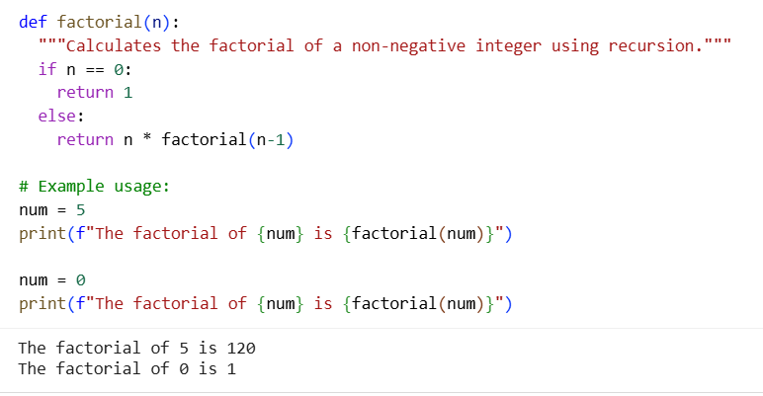

**C++:**

**TASK-4:**

**: Data Structures with Functions (JavaScript → Python)**

* **Instructions:**
  + Write a JavaScript function printStudents(students) that takes an array of student names and prints each name.
  + Translate it into a Python function print_students(students) using a list.
  + Test both functions with sample student names.

**JAVASCRIPT:**

**PYTHON:**

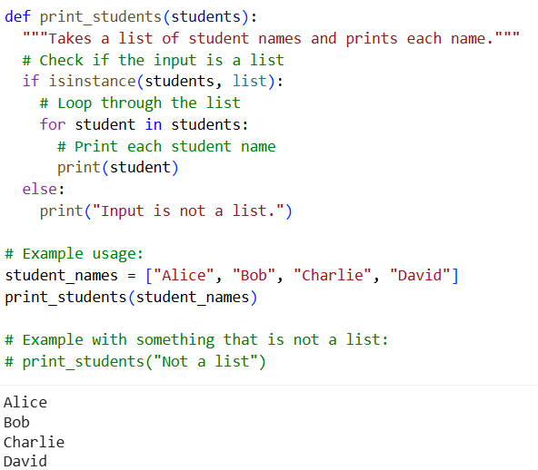

**TASK-5:**

**Class & Object Translation (Python → Java)**

* **Instructions:**
  1. Write a **Python class** Car with attributes: brand, model, year.
  2. Add a **method** display_details() that prints car details.
  3. Translate the same into a **Java class** Car with attributes and a **method** displayDetails().
  4. Create an object in both languages and call the method.

**PYTHON:**

**JAVA:**



