**AI ASSISTED CODING LAB EXAM 2:**

Subgroup K  
K.1 — [S05K1] Rotate NxN matrix 90° clockwise  
Scenario (fintech payments):  
Context:  
A fintech payments UI component rotates square glyphs; engineers want an in-place matrix rotation  
utility.  
Your Task:  
Rotate an NxN matrix 90° clockwise, preferably in-place, with coverage for 1x1 and 2x2.  
Data & Edge Cases:  
Example 3x3 shown in sample.  
AI Assistance Expectation:  
Use AI to outline layer-by-layer swaps or transpose+reverse approach; add tests.  
Constraints & Notes:  
Include tests for small N.  
Sample Input  
[[1, 2, 3], [4, 5, 6], [7, 8, 9]]  
Sample Output  
[[7, 4, 1], [8, 5, 2], [9, 6, 3]]  
Acceptance Criteria: In-place behavior correct  
K.2 — [S05K2] Compute added/removed lines  
Scenario (fintech payments):  
Context:  
Change review in fintech payments needs a function to show added/removed lines between versions.  
Your Task:  
Given `old` and `new` lists of lines, return (added, removed) preserving the display order.  
Data & Edge Cases:  
No duplicates in outputs; do not modify input.  
AI Assistance Expectation:  
Ask AI for an approach using sets but keep stable ordering via list comprehensions.  
Constraints & Notes:  
Do not show unchanged items.  
Sample Input  
old=['a','b','c'], new=['b','c','d']  
Sample Output  
added=['d'], removed=['a']  
Acceptance Criteria: Stable ordering; correct diff  
------------------------------------------------------------

**K-1:**

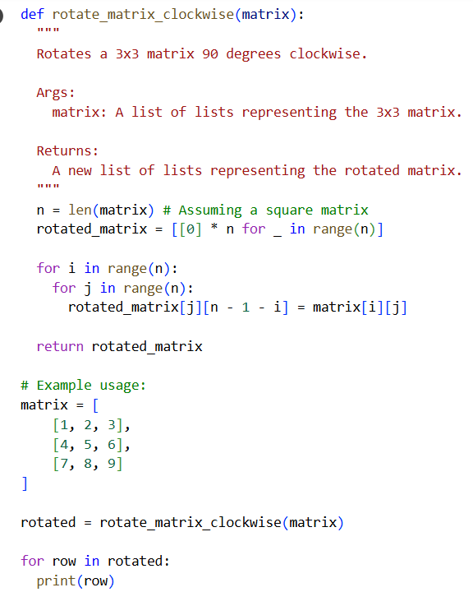

OUTPUT:

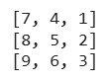

**EXPLANATION:**

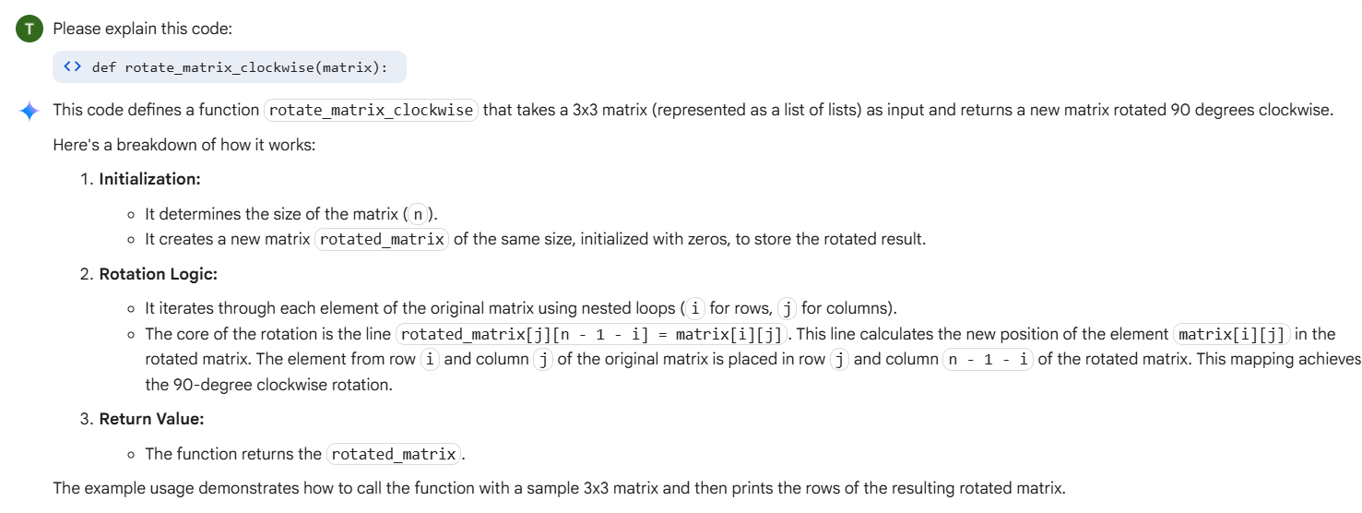

**K-2:**

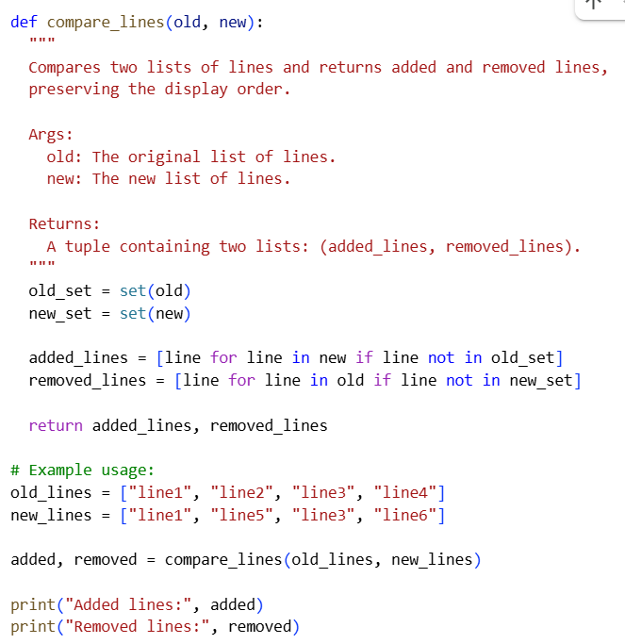

OUTPUT:



**EXPLANATION:**

