LAB EXAM-4:
SET-D Question 1: Refactor Legacy File Processing Code Task: You are given the following outdated script that reads a file and counts words: file = open("data.txt", "r") content = file.read() words = content.split(" ") print("Word count:", len(words)) file.close() Use an AI-assisted coding tool to refactor the code to: 1. Use context managers (with statement). 2. Handle exceptions (like missing file). 3. Optimize the logic for accurate word counting. Instructions: • Test with a sample text file. • Document any code smells the AI helped identify.

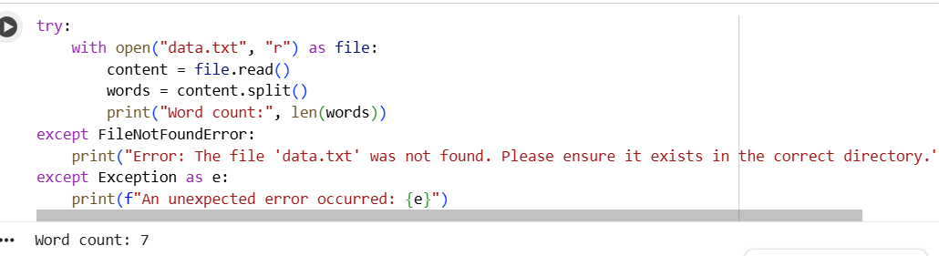
EXPLANATION:
Explanation of Refactoring:
- with open(...) as file:: This is the most significant improvement. It ensures that the file is properly closed after its suite finishes, even if errors occur during reading. This prevents resource leaks and makes the code more robust.
- words = content.split(): By calling split() without any arguments, Python's str.split() method automatically splits the string by any whitespace (spaces, tabs, newlines) and discards empty strings, providing a more accurate word count than content.split(" ") which might count multiple spaces as empty words.

Question 2: Optimize a Data Processing Script Task: A legacy script processes a list of numbers inefficiently: data = [1, 2, 3, 4, 5, 6, 7, 8, 9, 10] even_numbers = [] for i in data: if i % 2 == 0: even_numbers.append(i) print("Even numbers:", even_numbers) Use AI-assisted refactoring to: 1. Improve the efficiency using modern Python techniques. 2. Add logging and modular functions. 3. Ensure code adheres to PEP8 standards. Instructions: • Run the refactored code and verify the same output. • Summarize the AI’s role in detecting inefficiencies.

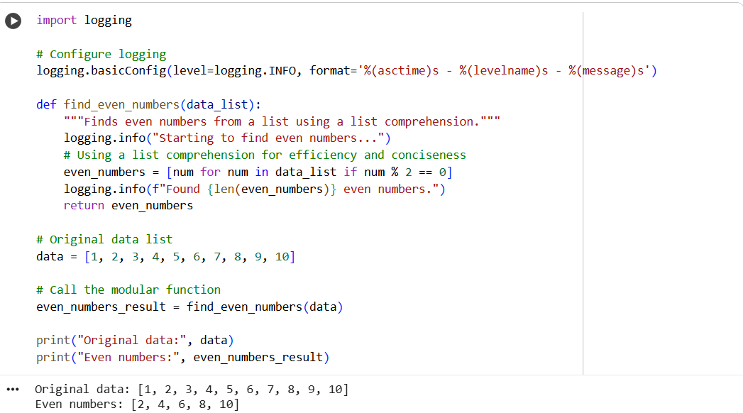
EXPLANATION:
Explanation of Refactoring:
- Efficiency (List Comprehension): Instead of a traditional for loop with append, a list comprehension ([num for num in data_list if num % 2 == 0]) is used. This is generally more Pythonic, concise, and often more efficient for creating new lists based on existing iterables.
- Logging: The logging module is imported and configured. logging.info calls are added to provide visibility into the function's execution flow, which is very useful for debugging and monitoring.
- Modular Function: The logic for finding even numbers is encapsulated within a function find_even_numbers(data_list). This improves code organization, reusability, and testability.
- PEP8 Adherence:
  - Function and variable names follow snake_case.
  - Docstrings are added to explain the function's purpose.
  - Consistent spacing and line breaks are used.

