Phase 1 — Netropy VE Test Lab Architecture Note
Netropy VE Provisioning Intern Project

1. Purpose
This lab is an automated Netropy Virtual Edition (VE) test environment on a single virtualization host. It exists so engineers can stand up a repeatable network-emulation setup without manually creating VMs in a hypervisor or cloud console.
The lab has three virtual machines on one host:
- Netropy VE — network emulator; traffic passes through it and emulation (delay, loss, bandwidth limits, etc.) is applied between its two data ports.
- Linux-1 — Ubuntu traffic endpoint; runs iperf3 to generate and measure traffic.
- Linux-2 — Ubuntu traffic endpoint; the other end of the test path.
All test traffic stays on the host. Linux-1 and Linux-2 do not share a data subnet; they talk to each other only through Netropy.

2. Networks
Three isolated subnets connect the VMs. See also: project_objective/netropy-topology.svg.
Network | CIDR | Members | Purpose
Management | 192.168.100.0/24 | Netropy mgmt, Linux-1 mgmt, Linux-2 mgmt | SSH to Linux hosts; Netropy web UI / CLI
Data Subnet-1 | 192.168.101.0/24 | Netropy Data Port-1, Linux-1 data NIC | Traffic from Linux-1 into the emulator
Data Subnet-2 | 192.168.102.0/24 | Netropy Data Port-2, Linux-2 data NIC | Traffic from the emulator toward Linux-2
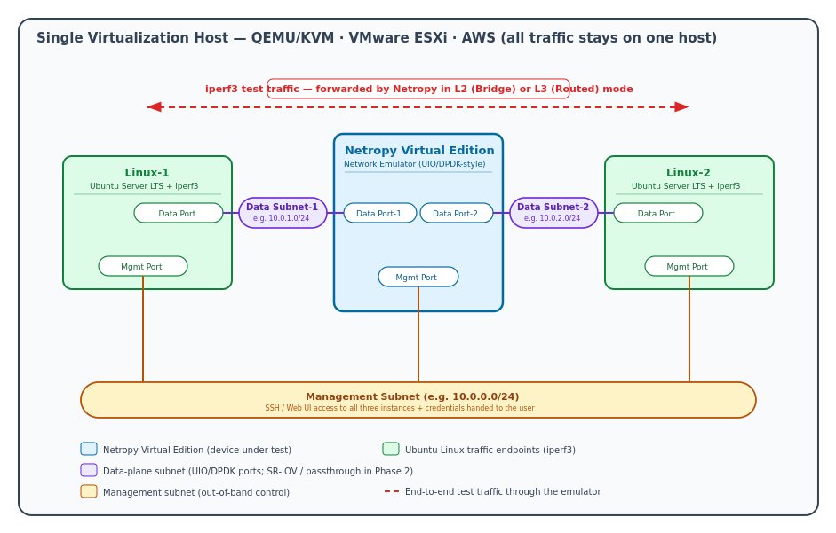
Netropy VE test-setup topology (see project_objective/netropy-topology.svg)

3. Seven Network Interfaces
# | VM | Interface | Subnet | IP address
1 | Linux-1 | Mgmt | Management | 192.168.100.21
2 | Linux-1 | Data | Data Subnet-1 | 192.168.101.21
3 | Linux-2 | Mgmt | Management | 192.168.100.22
4 | Linux-2 | Data | Data Subnet-2 | 192.168.102.22
5 | Netropy VE | Mgmt | Management | 192.168.100.10
6 | Netropy VE | Data Port-1 | Data Subnet-1 | 192.168.101.10
7 | Netropy VE | Data Port-2 | Data Subnet-2 | 192.168.102.10

# | Role of this interface
1–2 | Linux-1: admin access (mgmt); test traffic (data)
3–4 | Linux-2: admin access (mgmt); test traffic (data)
5 | Netropy: out-of-band configuration
6–7 | Netropy: ingress from Linux-1 side; egress toward Linux-2 side

4. Traffic Path
Linux-1 → Netropy → Linux-2 (forward path):
- Linux-1 sends packets from its data NIC (192.168.101.21) on Data Subnet-1.
- Packets reach Netropy Data Port-1 (192.168.101.10).
- Netropy applies emulation and forwards between its two data ports.
- Packets leave Netropy Data Port-2 (192.168.102.10) on Data Subnet-2.
- Packets arrive at Linux-2 data NIC (192.168.102.22).
The reverse path is the same chain in the opposite direction. The management subnet is not used for test traffic — only for SSH and Netropy configuration.

5. Netropy Forwarding Modes
Mode | Layer | What it does (beginner view)
Bridge | Layer 2 | Forwards Ethernet frames between the two data ports, like a bridge. MAC addresses stay visible end-to-end.
Routed | Layer 3 | Routes IP packets between the two data ports, like a router between the two data subnets.

The user chooses Bridge or Routed after the lab is provisioned, via the Netropy management interface.

6. Data Port Considerations
Netropy data ports use UIO/DPDK-style userspace I/O drivers. The Netropy software binds directly to the data-port NICs and bypasses the normal Linux kernel network stack for performance.
For Phase 1 provisioning, data ports are attached as emulated paravirtualized NICs (e.g. virtio on KVM). The provisioning tool must attach the correct NIC type to the correct subnet — this is a first-class design concern, not an afterthought.

7. Open Questions

7.1 Image & boot

Question | Tag | Why
Approved image format for KVM (qcow2? raw?) and where to get it | Assumed + Needs Product Confirmation | Project spec and variables.tf assume qcow2. Phase 0 says image comes from Apposite team and is not integrated yet. No image in images/.
Minimum vCPU / RAM / disk for the VE | Assumed | main.tf hardcodes 2 vCPU, 4 GiB RAM, 4 GiB disk — placeholder, not from Netropy docs.
Special boot/firmware (BIOS vs UEFI) | Assumed + Needs Product Confirmation | Code uses pc machine type (legacy BIOS-style). Not confirmed with Netropy team.

7.2 NICs

Question | Tag | Why
NIC model for mgmt vs data (virtio, e1000, other) | Assumed + Needs Product Confirmation | Project spec §7.4 and main.tf use virtio for all 3 NICs. Product team must confirm the VE image accepts that.
NIC order fixed (mgmt = eth0, data1 = eth1, data2 = eth2) | Assumed + Needs Product Confirmation | Terraform attaches mgmt → data1 → data2 in that order. Guest naming/order inside Netropy is not verified
Emulated virtio OK for Phase 1? | Assumed | Project spec Phase 1 explicitly allows emulated virtio. Still unproven until a real Netropy VM boots.

7.3 Management access

Question | Tag | Why
Reach mgmt via web UI, SSH, or CLI only? | Assumed | Project spec says mgmt supports SSH / web UI / CLI. No live Netropy tested yet.
Default credentials for a fresh VE? | Unknown + Needs Product Confirmation | Spec says tool should print credentials, but no default username/password documented anywhere.
Mgmt reachable at assigned IP 192.168.100.10? | Assumed + Needs Product Confirmation | Your lab design assigns that IP via DHCP reservation. Phase 0 notes Netropy bootstrap may differ from Ubuntu cloud-init.

7.4 Forwarding & traffic

Question | Tag | Why
Bridge vs Routed set manually or pre-configured? | Assumed (manual for Phase 1) | Phase 1 doc + project spec: user configures after login. Pre-config is only a stretch goal.
L2/L3 requirements for iperf3 on emulated NICs? | Assumed + Needs Product Confirmation | Topology implies iperf3 works in Bridge (L2) or Routed (L3). No Netropy-specific traffic rules documented.
Static routes on data ports in Routed mode? | Unknown + Needs Product Confirmation | Not mentioned in your docs. Depends on how Netropy implements Routed mode

7.5 Provisioning tool scope

Question | Tag | Why
Tool configures Netropy or only attaches NICs? | Assumed (strong — from project spec) | Project section 5: configuring emulation is out of scope; user configures Netropy after login. Tool only provisions/wires VMs.
API/automation for post-boot configuration? | Unknown + Needs Product Confirmation | Stretch goal mentions an API “where allowed” — nothing confirmed in repo

8. Hands-on networking evidence

8.1 Host checks
Test | Results | Notes
Ping Linux-1 mgmt  (192.168.100.21) – Figure 1 | Success - 3/3 packets received, 0% packet loss | Management interface reachable; low, consistent latency (avg ~0.31 ms) - confirms Linux-1's mgmt NIC is correctly wired to the management subnet
Ping Linux-2 mgmt  (192.168.100.22) – Figure 2 | Success - 3/3 packets received, 0% packet loss | Management interface reachable; low, consistent latency (avg ~0.33 ms) - confirms Linux-2's mgmt NIC is correctly wired to the management subnet

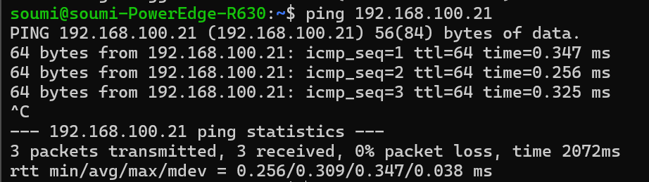
Figure 1 - Linux_1 - ubuntu@192.168.100.21

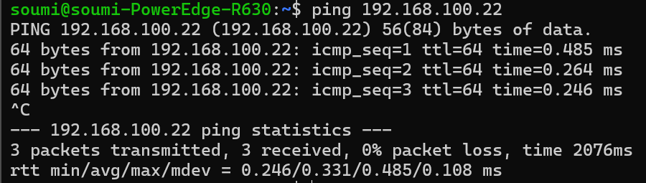
Figure 2 - Linux_2 - ubuntu@192.168.100.22

8.2 Linux-1 (ubuntu@192.168.100.21)

Test | Results | Notes
ip link on Linux-1 - Figure 3 | ens3: UP · ens4: DOWN | Two NICs present as designed. Mgmt MAC 52:54:00:10:00:21; data MAC 52:54:00:10:01:21 matches architecture table (§3)
ip addr on Linux-1 - Figure 4 | ens3: 192.168.100.21/24 · ens4: no IP (DOWN) | Mgmt IP matches. Data NIC not configured yet — expected before Netropy / Phase 5 data-path setup
ip route on Linux-1 - Figure 5 | Default via 192.168.100.1 dev ens3; local route 192.168.100.0/24 | Management subnet used for default route; source IP 192.168.100.21
Ping Linux-2 from Linux-1 (192.168.100.22) - Figure 6 | Success — 3/3 packets received, 0% packet loss | VM-to-VM mgmt connectivity works; avg RTT ~0.48 ms (min 0.442 ms, max 0.519 ms)

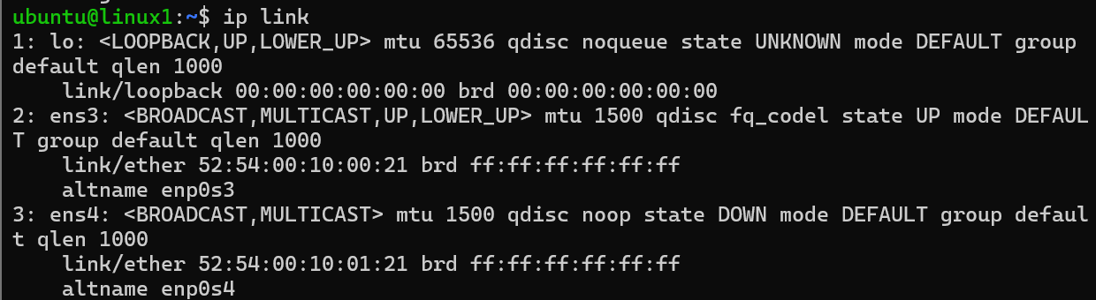
Figure 3

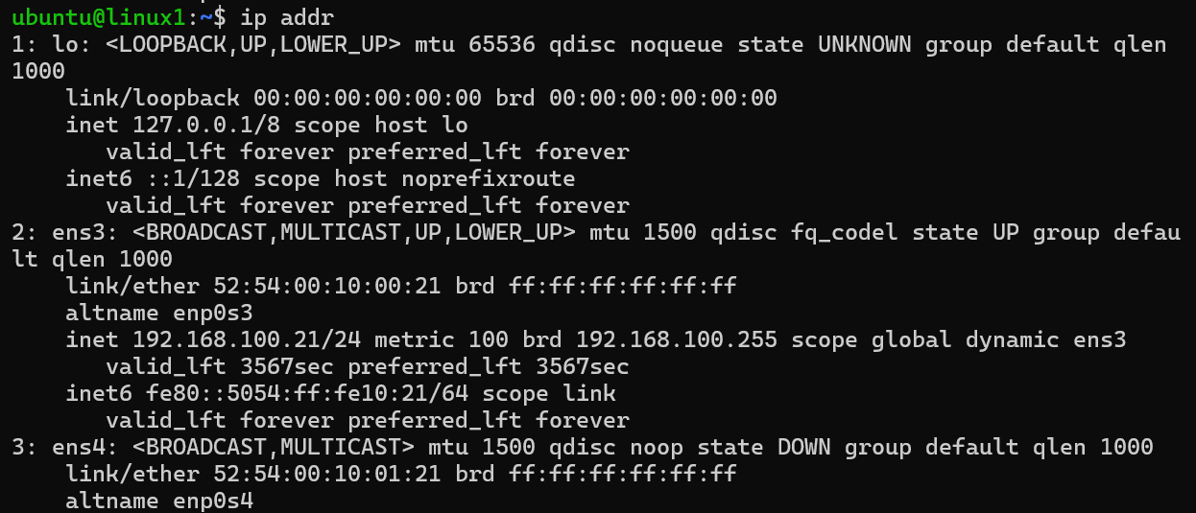
Figure 4

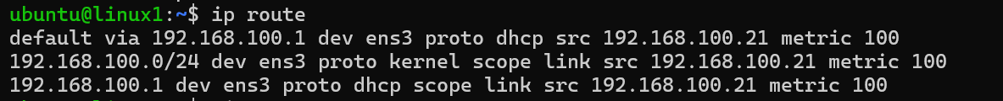
Figure 5
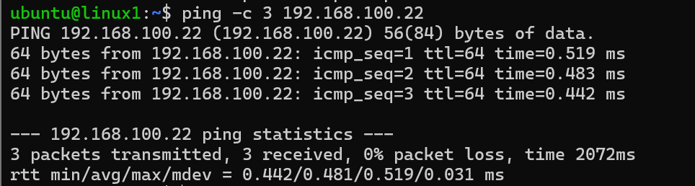
Figure 6

8.3 Linux-2 (ubuntu@192.168.100.22)

Test | Results | Notes
ip link — Figure 8 | ens3: UP · ens4: DOWN | Two NICs present. Mgmt MAC 52:54:00:10:00:22; data MAC 52:54:00:10:02:22
ip addr — Figure 9 | ens3: 192.168.100.22/24 · ens4: no IP (DOWN) | Mgmt IP matches. Data NIC not configured yet — expected before Netropy / Phase 5 data-path setup
ip route — Figure 10 | Default via 192.168.100.1 dev ens3; local route 192.168.100.0/24 | Management subnet used for default route; source IP 192.168.100.21
Ping Linux-1 mgmt (192.168.100.21) — Figure 11 | Success — 3/3 packets received, 0% packet loss | Reverse path confirmed; avg RTT ~0.50 ms (min 0.479 ms, max 0.517 ms)

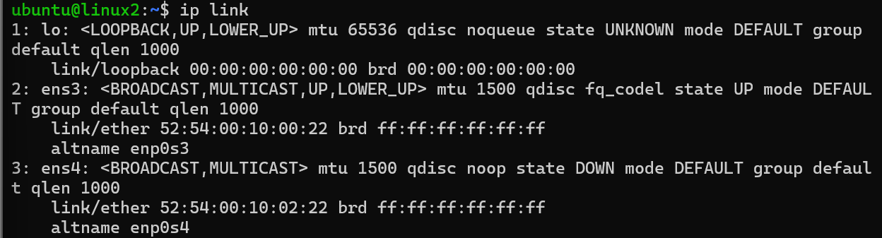
Figure 7
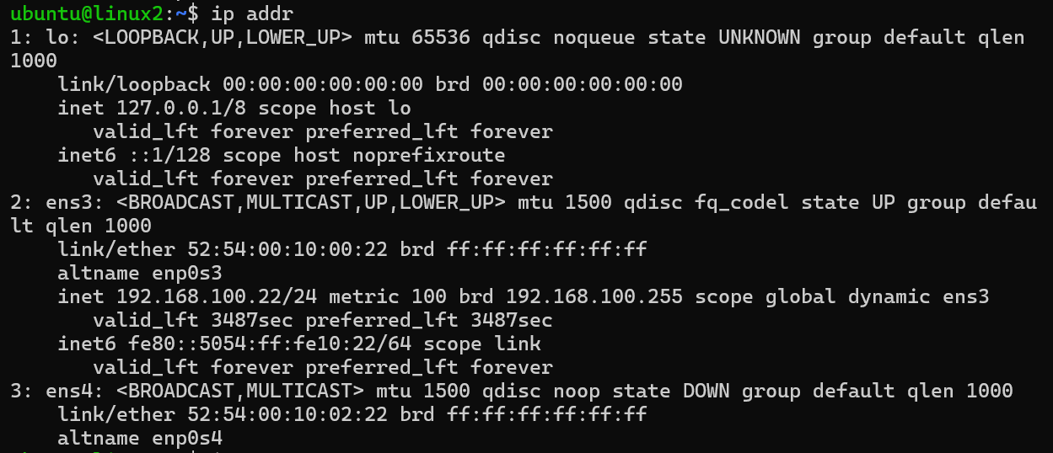
Figure 8

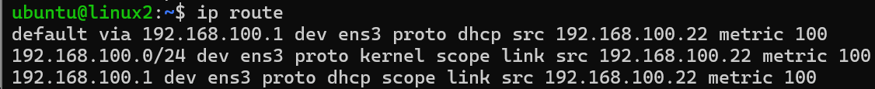
Figure 9

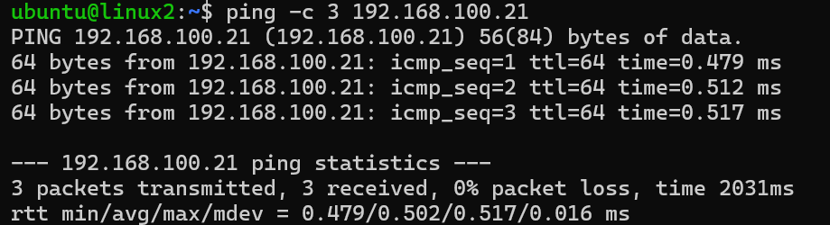
Figure 10

8.5 Observation

Both Linux VMs are reachable on the management subnet via SSH and ping. Each VM has two interfaces: ens3 (management, UP) with the correct IP from §3, and ens4 (data, DOWN) with no data-subnet IP yet. Default routing on both VMs uses gateway 192.168.100.1 on ens3. Ping between Linux-1 and Linux-2 on the management subnet succeeded with 0% packet loss in both directions. Full data-path testing (Linux-1 → Netropy → Linux-2) was not performed because Netropy VE is not provisioned yet and data NICs are not active.

9. Verified/Assumed/Unknown/Needs Product Confirmation

9.1 Verified

Both Linux VMs reachable via SSH on mgmt subnet.

Linux-1 mgmt IP: 192.168.100.21/24 on ens3; Linux-2: 192.168.100.22/24 on ens3.

Ping tests (host→VM and VM↔VM) succeeded with 0% packet loss.

Each VM has ens3 (mgmt, UP) and ens4 (data, DOWN); MACs match Section 3.

Default route on both VMs via 192.168.100.1 on ens3.

9.2 Assumed

ens4 will be configured with data-subnet IPs in Phase 5.

End-to-end iperf3 through Netropy will work once Netropy VE is provisioned.

Tool scope is wiring/provisioning only; user configures Netropy after login.

Bridge vs Routed is selected manually after boot (Phase 1).

9.3 Unknown

Exact timing/method for data NIC (ens4) IP assignment on current VMs.

Netropy default credentials and management access details.

Routed-mode routing requirements on Netropy data ports.

Existence/details of Netropy automation API.

9.4 Needs Product Confirmation

See Section 7 (Open Questions) — image format/source, sizing, NIC requirements, credentials, bootstrap, and API items pending Apposite/Netropy team input.

