SMART IOT AUTOMATION SYSTEM (TASK–3)
Smart Lighting System using ESP32
Name: D. Sushanth
Title
Smart Lighting System Using ESP32 and LDR Sensor Module
Objective
The objective of this project is to develop a Smart Lighting System that automatically controls a light based on the surrounding light intensity. The system uses an LDR sensor module to detect ambient light and an LED to simulate a lighting device. The ESP32 continuously monitors the light level and automatically turns the LED ON or OFF based on predefined conditions. This project demonstrates automation, sensor interfacing, and basic IoT-style monitoring using embedded systems.

Components Required
- ESP32 Development Board
- LDR Sensor Module (LM393 Based)
- LED
- 220 Ω Resistor
- Jumper Wires
- Wokwi Simulator

Theory
A Light Dependent Resistor (LDR) is a sensor whose resistance changes according to the intensity of light falling on it. When the light intensity is high, the resistance of the LDR decreases. When the light intensity is low, the resistance increases.
The LDR sensor module used in this project contains an LM393 comparator IC and provides both Analog Output (AO) and Digital Output (DO). The Analog Output (AO) is connected to the ESP32 to obtain real-time light intensity values.
The ESP32 reads the sensor values and compares them with a predefined threshold value. Depending on the light intensity, the LED is automatically turned ON or OFF.

Circuit Connections:
Sensor Module | ESP32
VCC | 3V3
GND | GND
AO | GPIO34
LED Connections
LED Terminal | ESP32
Anode (+) | GPIO2 through 220 Ω resistor
Cathode (-) | GND

Circuit Diagram
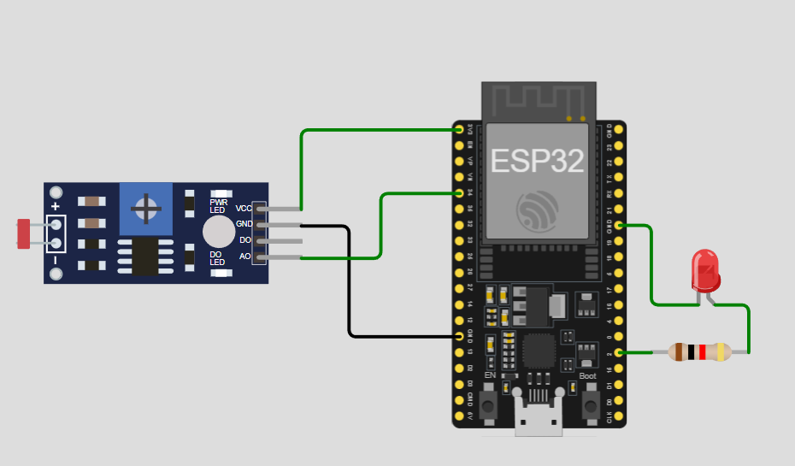

Working Principle
The LDR sensor continuously senses the ambient light intensity and sends an analog signal to the ESP32 through GPIO34.
The ESP32 reads the analog value from the sensor and compares it with a predefined threshold value. If the surrounding environment becomes dark, the sensor value falls below the threshold value. The ESP32 detects this condition and automatically turns ON the LED connected to GPIO2.
When sufficient light is available, the sensor value rises above the threshold value. The ESP32 then turns OFF the LED. This process happens continuously without requiring any human intervention.
The sensor values and LED status are displayed on the Serial Monitor, enabling real-time monitoring of the system. Thus, the project demonstrates automation using IF-ELSE decision-making logic and basic IoT-style monitoring.

Automation Logic
The system uses IF-ELSE logic for decision making.
If LDR Value < Threshold:
- LED ON
- Dark Environment
If LDR Value ≥ Threshold:
- LED OFF
- Bright Environment

Program Code
const int ldrPin = 34;
const int ledPin = 2;
int threshold = 2000;

void setup()
{
Serial.begin(115200);
pinMode(ledPin, OUTPUT);
}

void loop()
{
int ldrValue = analogRead(ldrPin);

Serial.print("LDR Value: ");
Serial.println(ldrValue);

if (ldrValue < threshold)
{
digitalWrite(ledPin, HIGH);
Serial.println("LED ON - Dark Environment");
}
else
{
digitalWrite(ledPin, LOW);
Serial.println("LED OFF - Bright Environment");
}

delay(500);
}

Sample Output
Bright Environment
LDR Value: 3250
LED OFF - Bright Environment

Dark Environment
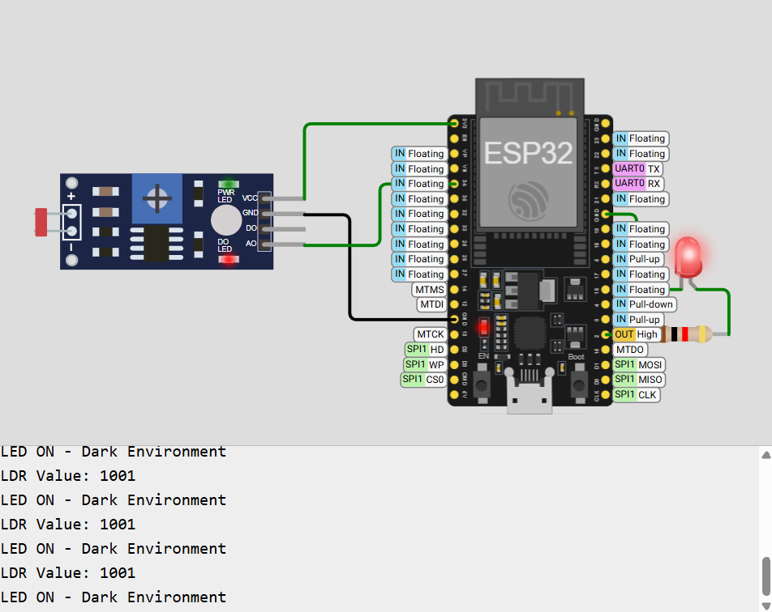
IoT Extension
The project was implemented using ESP32 and simulated in the Wokwi platform. The sensor values were continuously displayed on the Web Serial Monitor, enabling real-time monitoring of environmental light conditions.
This demonstrates the basic concept of IoT systems where sensor data is collected, processed, and monitored in real time. The project can be further extended by integrating cloud platforms such as ThingSpeak or Blynk for remote monitoring and control.

Applications
- Smart Home Lighting Systems
- Automatic Street Lights
- Garden Lighting Automation
- Building Automation Systems
- Energy Conservation Systems
- Industrial Lighting Control

Advantages
- Reduces power consumption.
- Operates automatically without human intervention.
- Low-cost implementation.
- Easy to install and maintain.
- Improves energy efficiency.
- Provides real-time monitoring.

Result
The Smart Lighting System was successfully implemented using an ESP32 and an LDR sensor module. The system automatically controlled the LED based on ambient light conditions and displayed real-time sensor values on the Serial Monitor.

Conclusion
The Smart Lighting System using ESP32 and an LDR sensor module was successfully designed and implemented. The system automatically responds to changes in ambient light by controlling the LED. Real-time monitoring through the Serial Monitor demonstrates the concepts of automation, sensor interfacing, decision-making logic, and basic IoT functionality. This project serves as a foundation for more advanced IoT-based smart home applications.

