Task-4
IoT Cloud Integration & Real-Time Remote Monitoring
Project Title
Smart Lighting System using ESP32, LDR Sensor and ThingSpeak Cloud
Name: D. Sushanth

Abstract
The Internet of Things (IoT) enables embedded devices to communicate over the internet and share data in real time. In this project, a Smart Lighting System is developed using an ESP32 microcontroller, an LDR (Light Dependent Resistor) sensor, an LED, and the ThingSpeak cloud platform. The LDR sensor continuously measures the ambient light intensity, while the ESP32 processes the sensor data and controls an LED based on the measured light level. The ESP32 uses its built-in WiFi module to upload the sensor readings to the ThingSpeak cloud platform. The uploaded data is displayed as a live graph on the dashboard, allowing users to monitor the lighting conditions remotely from any location. This project demonstrates the practical implementation of IoT technology for smart automation and cloud-based monitoring systems.

1. Introduction
The Internet of Things (IoT) is a technology that allows physical devices to communicate with each other through the internet. IoT systems collect data using sensors, process the information using embedded controllers, and upload it to cloud platforms for remote monitoring and analysis. This technology is widely used in smart homes, industries, healthcare, agriculture, and environmental monitoring.
In this project, a Smart Lighting System is designed using an ESP32 microcontroller and an LDR sensor. The LDR sensor detects the surrounding light intensity, and the ESP32 reads the sensor values through its analog input pin. Depending on the light intensity, the ESP32 controls an LED that represents a lighting system. At the same time, the ESP32 connects to a WiFi network and uploads the sensor values to the ThingSpeak cloud platform. ThingSpeak stores the received data and displays it as a real-time graph, enabling users to monitor the system remotely.
The project demonstrates how embedded systems can be integrated with cloud services to create an efficient and intelligent IoT monitoring system.

2. Objectives
The objectives of this project are:
- To develop an IoT-based Smart Lighting System using ESP32.
- To measure ambient light intensity using an LDR sensor.
- To establish wireless communication through the ESP32 WiFi module.
- To upload sensor readings to the ThingSpeak cloud platform.
- To display real-time sensor data on an online dashboard.
- To understand cloud-based monitoring and IoT communication.

4. Components Used
Component | Quantity
ESP32 Development Board | 1
LDR Sensor Module | 1
LED | 1
220 Ω Resistor | 1
Wokwi Simulator | 1
ThingSpeak Cloud Platform | 1

5. Software Requirements
- Wokwi Simulator
- ThingSpeak IoT Cloud

7. Circuit Connections
LDR Sensor
LDR Pin | ESP32 Pin
VCC | 3.3V
GND | GND
AO | GPIO34

LED
LED Pin | ESP32 Pin
Anode (+) | GPIO2 through 220 Ω resistor
Cathode (-) | GND

Circuit Diagram
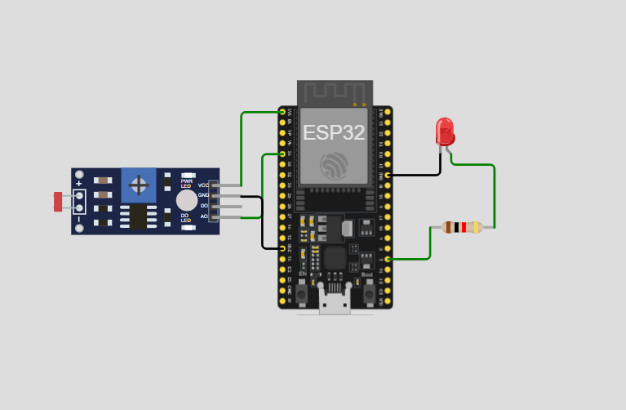

9. Code
#include <WiFi.h>
#include <HTTPClient.h>
// WiFi Credentials (Wokwi)
const char* ssid = "Wokwi-GUEST";
const char* password = "";

// ThingSpeak API Key
String apiKey = "YOUR_WRITE_API_KEY";
// Pins
const int ldrPin = 34;
const int ledPin = 2;
void setup() {
Serial.begin(115200);
pinMode(ledPin, OUTPUT);
WiFi.begin(ssid, password);
Serial.print("Connecting to WiFi");
while (WiFi.status() != WL_CONNECTED) {
delay(500);
Serial.print(".");
}
Serial.println();
Serial.println("WiFi Connected");
Serial.print("IP Address: ");
Serial.println(WiFi.localIP());
}
void loop() {
// Read LDR value
int ldrValue = analogRead(ldrPin);
Serial.print("LDR Value = ");
Serial.println(ldrValue);
// LED ON when dark
if (ldrValue < 2000) {
digitalWrite(ledPin, HIGH);
}
else {
digitalWrite(ledPin, LOW);
}
// Send data to ThingSpeak
if (WiFi.status() == WL_CONNECTED) {
HTTPClient http;
String url = "http://api.thingspeak.com/update?api_key=" +
apiKey +
"&field1=" +
String(ldrValue);
http.begin(url);
int httpCode = http.GET();
if (httpCode > 0) {
Serial.print("Data Sent Successfully. HTTP Code: ");
Serial.println(httpCode);
}
else {
Serial.print("Error Sending Data. HTTP Code: ");
Serial.println(httpCode);
}
http.end();
}
else {
Serial.println("WiFi Disconnected");
}
// ThingSpeak Free Version: Minimum 15 sec delay
delay(20000);
}

11. Results
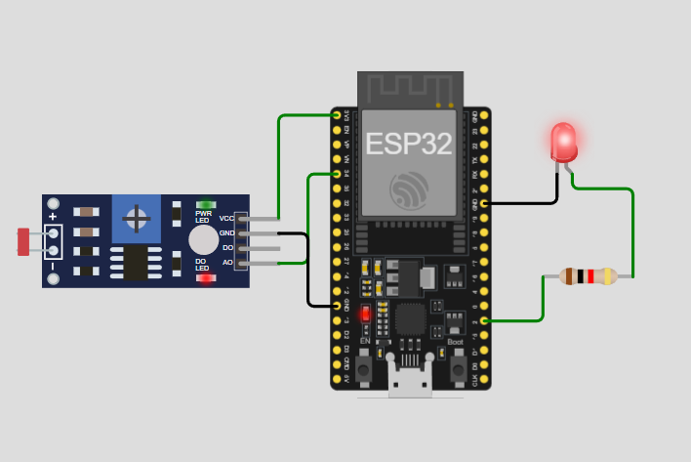
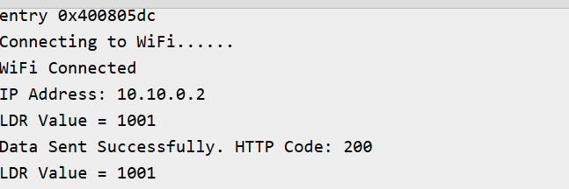
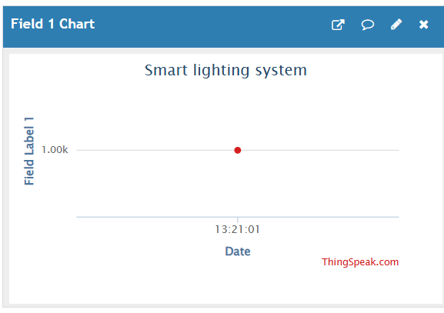

12. Advantages
- Provides real-time monitoring of light intensity.
- Enables remote monitoring through the internet.
- Supports automatic lighting control.
- Reduces unnecessary energy consumption.
- Easy to implement and expand.
- Low-cost IoT solution.
- Suitable for educational and industrial applications.

13. Applications
- Smart Home Lighting Systems
- Automatic Street Lighting
- Smart Buildings
- Industrial Lighting Control
- Energy Management Systems
- Environmental Monitoring
- IoT Research and Learning

14. Conclusion
The Smart Lighting System using ESP32, LDR Sensor, and ThingSpeak successfully demonstrates the integration of embedded systems with cloud-based IoT technology. The ESP32 continuously acquires light intensity data from the LDR sensor, processes the readings, controls the LED according to the surrounding light conditions, and uploads the sensor data to the ThingSpeak cloud platform using its built-in WiFi module. The ThingSpeak dashboard provides real-time graphical visualization of the collected data, enabling remote monitoring from any internet-connected device. This project highlights the practical implementation of IoT technology for smart automation and cloud-based monitoring and provides a strong foundation for developing more advanced IoT applications.

