

DATA STRUCTURES & ALGORITHMS
23CSE203
LAB MANUAL
Submitted By
Name | Sushanth ch
Roll No. | AV.SC.U4CSE25023
Year/Sem/Section | 2nd year /Sem-3/CSE-A
Credits | 05

S.No. | Title | Page No.
1) | Week-1:  1A) Rocket launch systems display the countdown of before launch instead of using a loop implement the countdown using the recursion write a recursion Python program to display the countdown from n to 1 followed by launch.  1B) Banks calculate the growth of an investment using compound interest. The formula requires calculating powers, which can be implemented recursively. Write a recursive Python program to calculate P^n (power), where P = Principal growth factor, n = number of years.  1C) An HR department stores employee IDs in a list. Develop a recursive program to search for a given employee ID. Write a recursive function to search for an employee ID in a list.  1D) In a logistics company, the number of possible ways to arrange n different parcels is calculated using the factorial formula. Develop a recursive program to calculate the factorial of a given number.  1E) Write a recursive Python program to print the first n terms of a Fibonacci series. | 3-12
INDEX

WEEK-1

1A) Aim: Rocket launch systems display the countdown of before launch instead of using a loop implement the countdown using the recursion write a recursion Python program to display the countdown from n to 1 followed by launch.

Program:
def print_countdown(n):
if n < 0:
return
print(n)
print_countdown(n-1)

print_countdown(10)
print("LAUNCH")
Output:
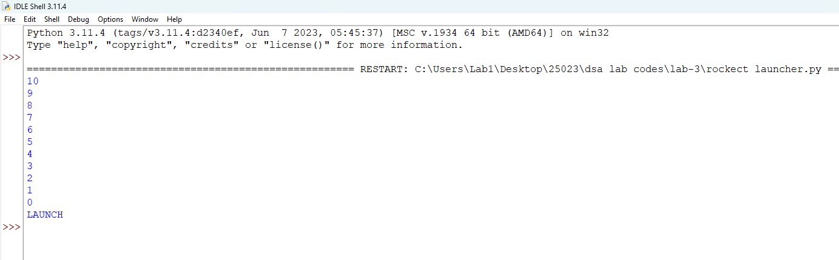

Explanation:
- def defines the countdown() function.
- input() accepts the countdown value from the user.
- int() converts the input into an integer.
- countdown() starts the recursive countdown process.
- if checks the base case (n == 0).
- else executes when the condition is False.
- print(n) displays the current countdown number.
- countdown(n - 1) recursively calls the function with the value decreased by 1.
- print("Launch!") displays the launch message when the countdown reaches 0.
- The program demonstrates the use of functions, recursion, conditional statements, input, and output to perform the countdown.
Error Table:
S.No. | Errors Observed | Rectification
1) | Count down does not stop | Check the condition when n reaches to zero.
2) | Program starts from a very large number | Cjeck the condtion when n reaches to zero
3) | incorrect indentation leading to an Indentation Error | Maintain proper Python indentation.

1B) Aim: Banks calculate the growth of an investment using compound interest. The formula requires calculating powers, which can be implemented recursively. Write a recursive Python program to calculate P^n (power), where P = Principal growth factor, n = number of years.

Program:
def power (n,p):

if p == 0:
return 1
return n * power(n,p-1)
print(power(5,3))
Output:
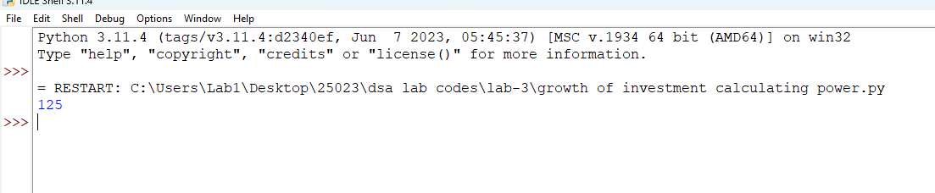

Explanation:
- power() is the recursive function that computes n raised to p.
- The base case is p == 0, which returns 1 (any number to the power 0 is 1).
- The recursive case multiplies p with power(p, n - 1), reducing n by 1 on each call.
- float() allows the principal growth factor to be a decimal value.
- input() collects the values of P and n from the user.
- Each recursive call is stacked until the base case is reached, then the results are multiplied back up the call stack.
- print() displays the final computed value of P^n.
Error Table:
S.No. | Errors Observed | Rectification
1) | Missing base case (n == 0) causing infinite recursion. | Include the base case to stop recursion.
2) | Entering a negative value for n causes the recursion to never reach 0. | Restrict input to non-negative integers or handle negative n separately.
3) | Using int() for P truncates decimal growth factors. | Use float() to accept decimal values for P.
4) | Incorrect indentation leading to an IndentationError. | Maintain proper Python indentation.
5) | Calling power(p, n) instead of power(n, p - 1), causing infinite recursion. | Decrease n by 1 in each recursive call using power(n, p- 1).

1C) Aim: An HR department stores employee IDs in a list. Develop a recursive program to search for a given employee ID. Write a recursive function to search for an employee ID in a list.
Program:
def search(arr,target,s):

if (arr[s]==target):
return s
if(s==0 and arr[s]!=target):
return -1

return search(arr,target,s-1)

arr = [3,45,233,5,6,89,32,4,23,32]
print(search(arr,10,len(arr)-1))
Output:
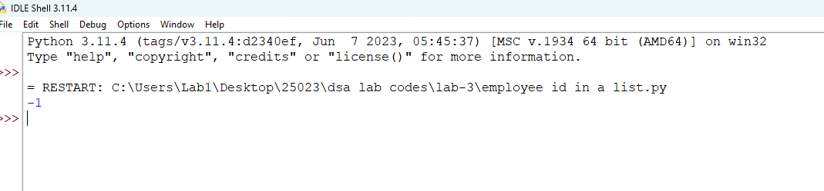
Explanation:
- search_employee() is the recursive function that searches the list one index at a time.
- The base case index == len(emp_list) means every element was checked and the ID was not found, so it returns -1.
- The second condition checks if the current element matches the employee ID being searched.
- If not matched, the function calls itself with index + 1, moving to the next employee in the list.
- employee_ids is the list of employee IDs stored by the HR department.
- input() and int() collect the employee ID to search for from the user.
- The if-else block reports whether the employee ID was found and at which position.
Error Table:
S.No. | Errors Observed | Rectification
1) | Invalid (non-numeric) input entered by the user. | Enter a valid integer as input.
2) | Incorrect indentation leading to an IndentationError. | Maintain proper Python indentation.
3) | Searching an empty list without handling it, giving a confusing result. | Add a check for an empty list before searching.

1D) Aim:In a logistics company, the number of possible ways to arrange n different parcels is calculated using the factorial formula. Develop a recursive program to calculate the factorial of a given number.
Program:
def fact(n):

if(n==0):
return 1
return n*fact(n-1);
print(fact(7))
Output:
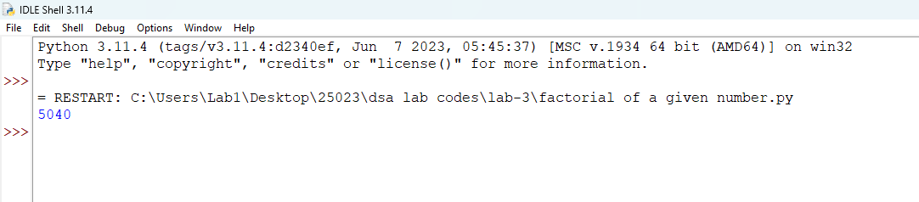

Explanation:
- factorial() is the recursive function that computes n! (n factorial).
- The base case is n == 0 or n == 1, both of which return 1.
- The recursive case multiplies n with factorial(n - 1), reducing n by 1 on each call.
- input() and int() collect the number whose factorial is to be found.
- Each recursive call is stacked until the base case is reached, then the results are multiplied back up the call stack.
- print() displays the number of possible arrangements (the factorial value).
Error Table:
S.No. | Errors Observed | Rectification
1) | Missing base case (n == 0 or n == 1) causing infinite recursion. | Include the base case to stop recursion.
2) | Entering a negative number, for which factorial is undefined. | Restrict input to non-negative integers.
3) | Invalid (non-numeric) input entered by the user. | Enter a valid integer as input.
4) | Incorrect indentation leading to an IndentationError. | Maintain proper Python indentation.
5) | Calling factorial(n) instead of factorial(n - 1), causing infinite recursion. | Decrease n by 1 in each recursive call using factorial(n - 1).

1E) Aim:Write a recursive Python program to print the first n terms of a Fibonacci series.

Program:
def fib(n):

if n==1:
return 0
if n==2:
return 1

return fib(n-1) + fib(n-2)
def fibseries(n):
for i in range (1,n+1):
print(fib(i))

return "Done"

print(fibseries(5))

Output:
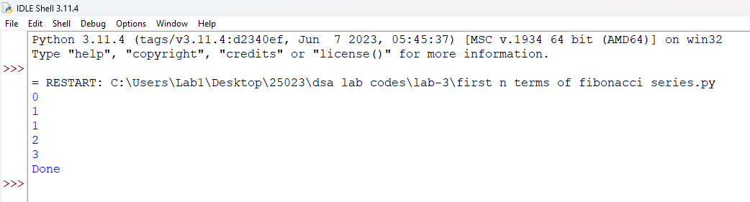

Explanation:
- fibonacci() is the recursive function that returns the nth Fibonacci term.
- The base cases are n == 0 (returns 0) and n == 1 (returns 1).
- The recursive case adds fibonacci(n - 1) and fibonacci(n - 2), following the Fibonacci rule.
- input() and int() collect the number of terms to be printed.
- The for loop calls fibonacci(i) for each index from 0 to n - 1.
- print(..., end=" ") displays each term on the same line, separated by a space.
Error Table:
S.No. | Errors Observed | Rectification
1) | Missing base cases (n == 0 and n == 1) causing infinite recursion. | Include both base cases to stop recursion.
2) | Entering a negative number of terms. | Restrict input to non-negative integers.
3) | Invalid (non-numeric) input entered by the user. | Enter a valid integer as input.
4) | Incorrect indentation leading to an IndentationError. | Maintain proper Python indentation.
5) | Using fibonacci(n - 1) - fibonacci(n - 2) instead of addition, giving wrong terms. | Use addition, fibonacci(n - 1) + fibonacci(n - 2), as per the Fibonacci rule.

WEEK-2

2A) Aim: Write a python program to perform linear search on the given input.
Program:
def linear_search(arr):
key=int(input("enter a number to check:"))
found =False
for i in range (len(arr)):
if arr[i] == key:
print(f"{key} is found at index",i)
found=True
break
if found == False:
print(f"{key} is not found")

l=int(input(f"enter total numbers of elements:"))
arr=[]

for i in range(l):
a=int(input("enter the element found to be :"))
arr.append(a)
linear_search(arr)
Output:

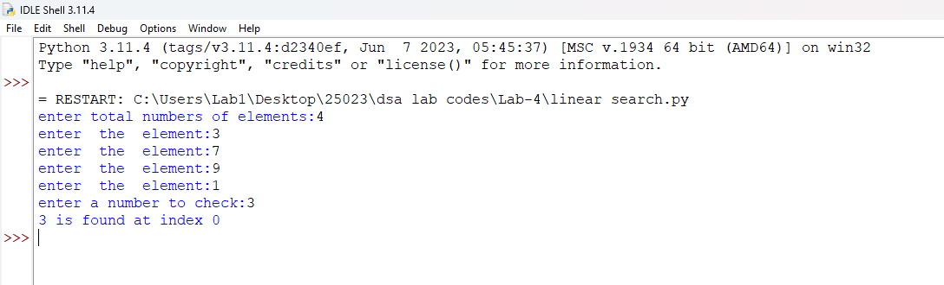

Explanation:
- linear_search(arr, target) sequentially iterates through arr to check each element against target.
- for i in range(n): iterates through array indices from 0 to n-1 sequentially.
- if arr[i] == target: checks for a match and returns index i if found.
- return -1 executes when the target element is absent from the array.
- arr.append(int(input())) converts user input to integers and builds the array.
- if (result != -1): displays the index where the element is found or prints a "not found" message.
Error Table:
S.No. | Errors Observed | Rectification
1) | Invalid (non-numeric) input entered by the user. | Entered a valid integer as input.
2) | Incorrect indentation leading to an Indentation Error | Maintained proper Python indentation.
3) | Missing colon (:) after def, for, if, or else. | Added the required colon (:) after statements.
4) | ValueError when passing non-integer strings to int(input()). | Ensure user input consists of valid integer characters.
5) | IndexError caused by accessing an array index out of bounds. | Ensure loop bounds do not exceed len(arr) - 1.

2B) Aim: Write a python program to perform binary search on the given input.Verify by taking sorted array and unsorted array as input.
Program:
def binary_search(arr):
low=0
high=len(arr)-1
key=int(input("enter a number to search:"))
found=False

while low <= high:

mid= (low+high)//2
if arr [mid] ==key:
print(f"{key} is found at index:",mid)
found=True
break
elif arr[mid] > key:
high =mid-1

elif arr[mid] < key:
low=mid+1

if found == False:
print(f"{key} is not found")

l= int(input("enter a total number of elemants:"))
arr = []

for i in range (l):
a=int(input(f"Enter {i+1}st elements:"))
arr.append(a)
arr.sort()

binary_search(arr)
Output:
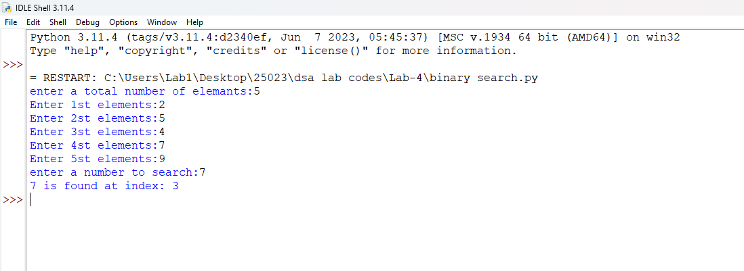
Explanation:
- binary_search(arr, target) uses a divide-and-conquer strategy on a sorted array.
- while low <= high: runs as long as the search boundary contains valid elements.
- mid = (low + high) // 2 computes the middle index using integer division.
- if arr[mid] == target: returns mid if the target is found at the middle index.
- elif arr[mid] < target: updates low = mid + 1, otherwise sets high = mid - 1.
- arr.sort() ensures the input array is sorted before executing binary search.
Error Table:
S.No. | Errors Observed | Rectification
1) | Performing binary search on an unsorted array leading to incorrect results. | Sort the array using arr.sort() before applying binary search.
2) | Using floating-point division / instead of integer division // for calculating mid, causing a TypeError. | Use mid = (low + high) // 2 for integer index calculation.
3) | Incorrect loop condition (low < high instead of low <= high), missing target when low == high. | Change the condition to while low <= high:.
4) | Incorrectly updating pointers like low = mid or high = mid causing an infinite loop. | Use low = mid + 1 and high = mid - 1.
5) | Invalid (non-numeric) input entered by the user. | Enter a valid integer as input.

