**LABORATORY PROGRAM – 1**

Write a program to simulate the working of stack using an array with the following: a) Push b) Pop c) Display The program should print appropriate messages for stack overflow, stack underflow

**OBSERVATION :**

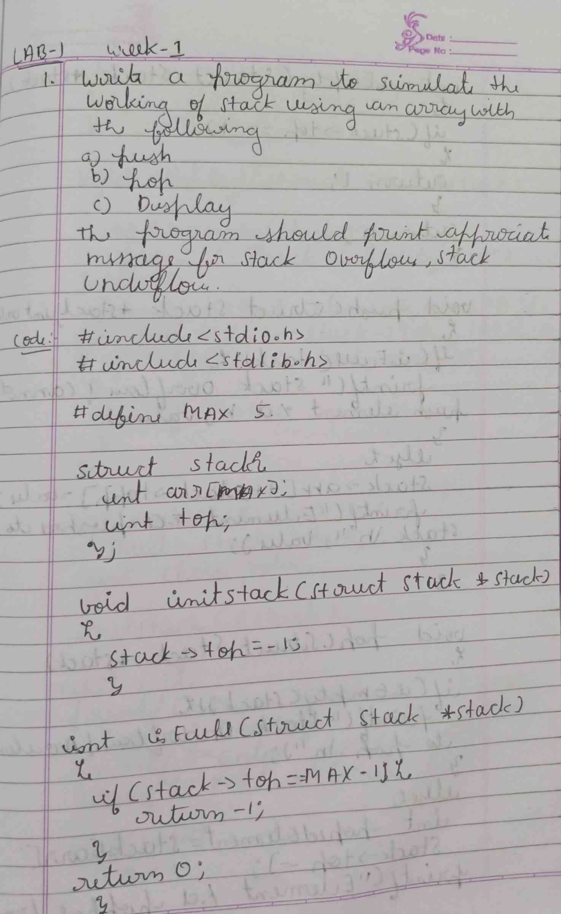

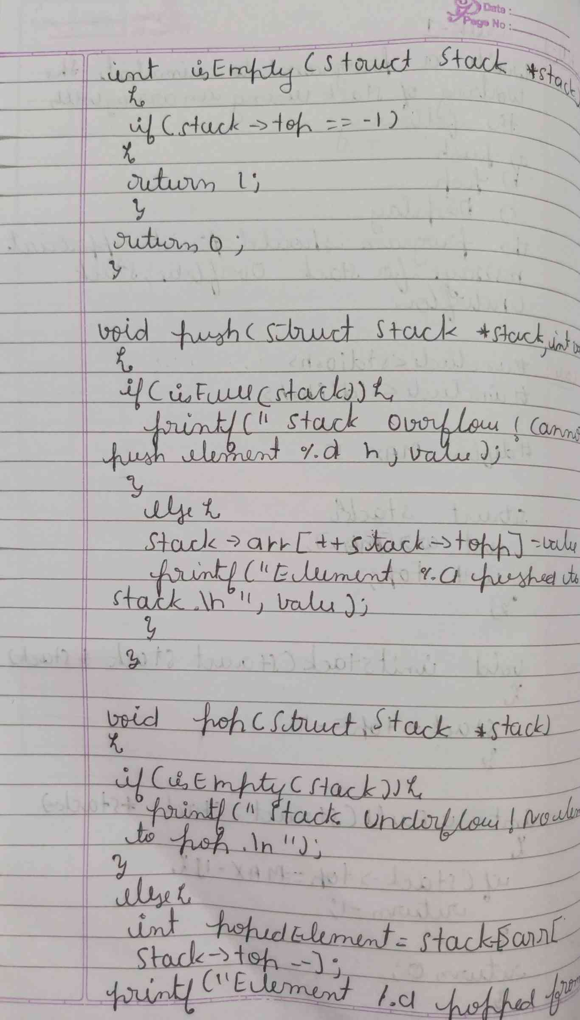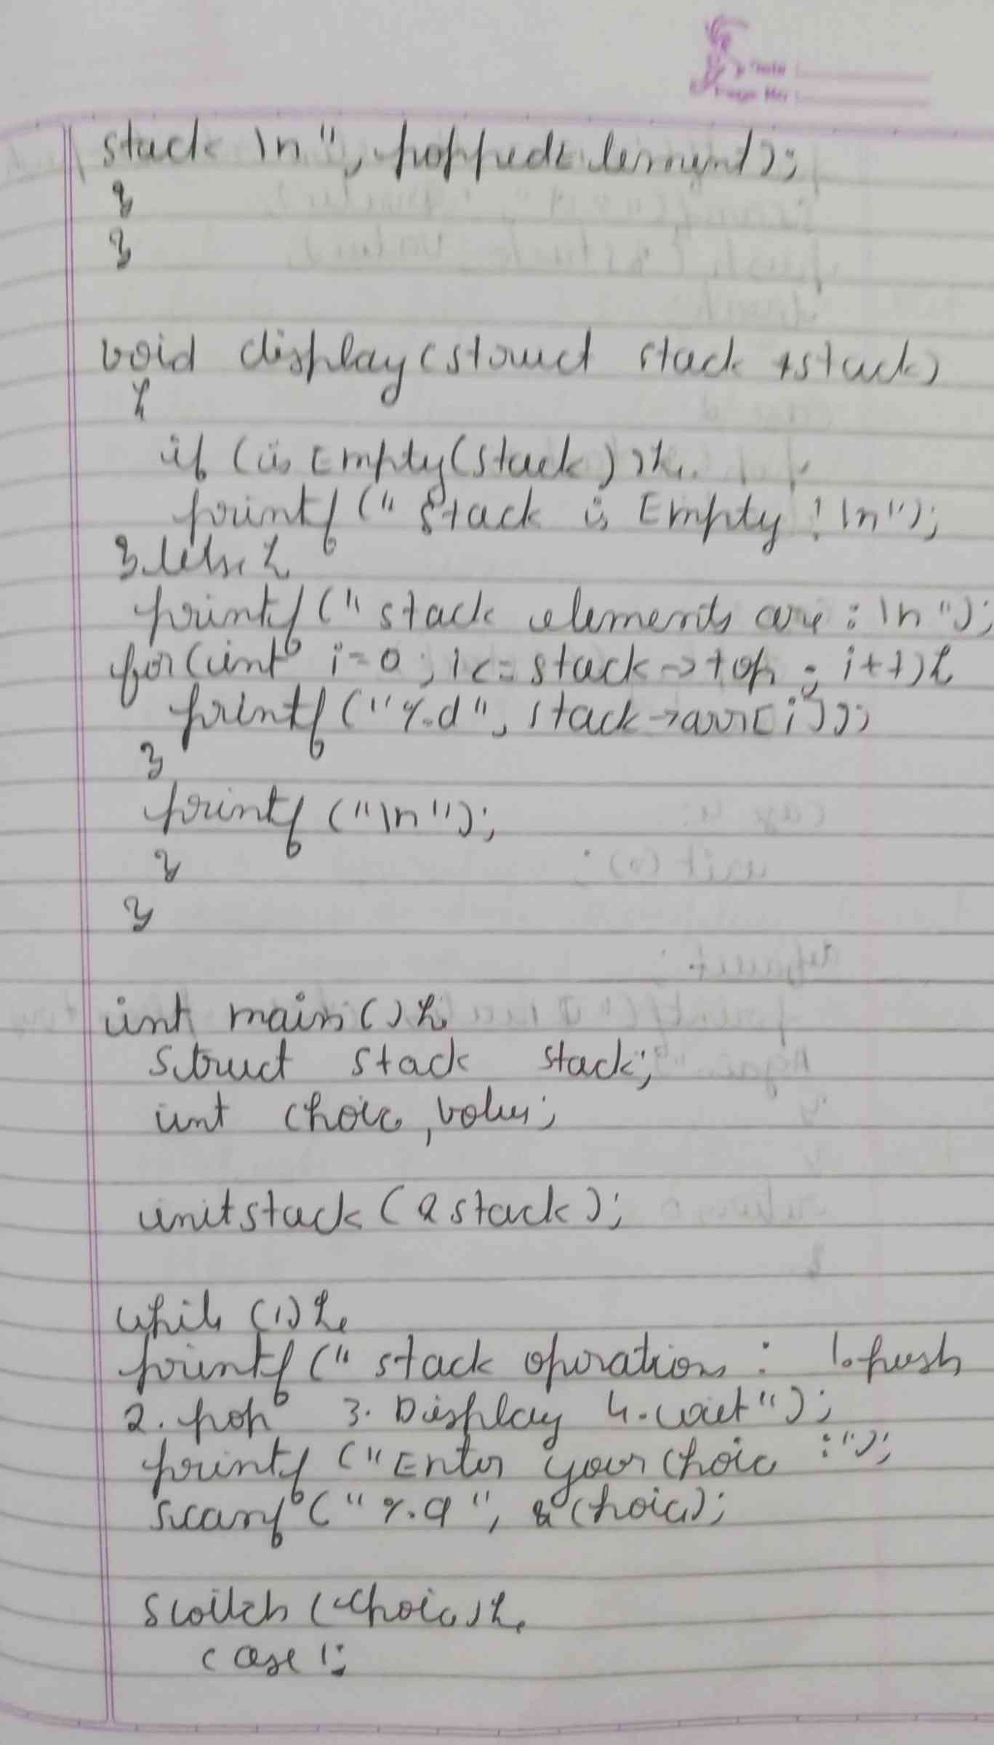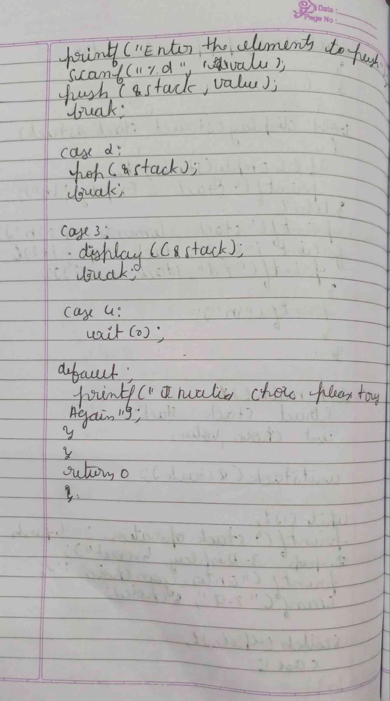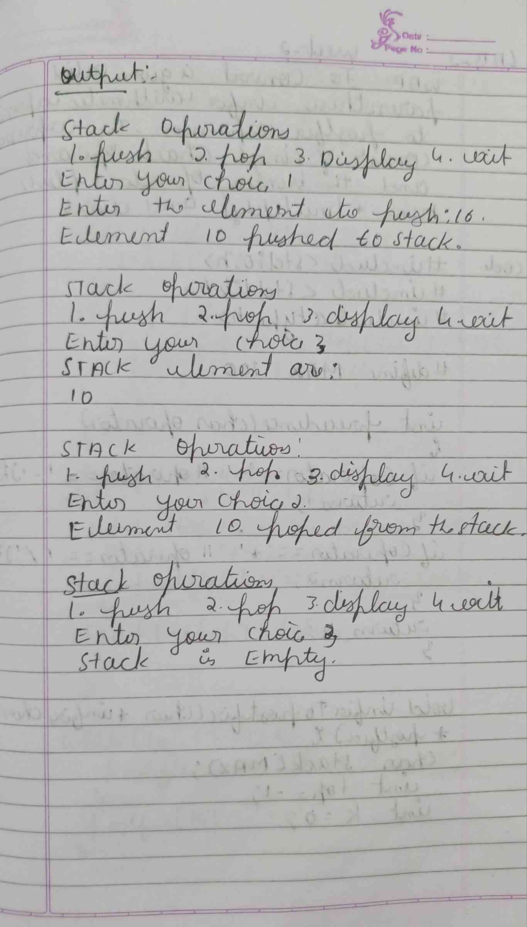

**CODE :**

**#include <stdio.h>**

**#define MAX 5**

**int stack[MAX];**

**int top = -1;**

**void push(int value) {**

**if (top == MAX - 1){**

**printf("Stack Overflow! Cannot push %d\n", value);**

**}**

**else{**

**top++;**

**stack[top] = value;**

**printf("Pushed %d onto the stack.\n", value);**

**} }**

**void pop() {**

**if (top == -1)**

**{**

**printf("Stack Underflow! Cannot pop from an empty stack.\n"); }**

**else  {**

**printf("Popped %d from the stack.\n", stack[top]);**

**top--;** **}}**

**void display() {**

**if (top == -1)  {**

**printf("The stack is empty.\n");**

**}**

**else  {**

**printf("Stack elements: ");**

**for (int i = 0; i <= top; i++)  {**

**printf("%d ", stack[i]); }**

**printf("\n"); }**

**}**

**int main() {**

**int choice, value;**

**while (1)**

**{**

**printf("\nStack Operations:\n");**

**printf("1. Push\n");**

**printf("2. Pop\n");**

**printf("3. Display\n");**

**printf("4. Exit\n");**

**printf("Enter your choice: ");**

**scanf("%d", &choice);**

**switch (choice)**

**{**

**case 1:**

**printf("Enter the value to push: ");**

**scanf("%d", &value);**

**push(value);**

**break;**

**case 2:**

**pop();**

**break;**

**case 3:**

**display();**

**break;**

**case 4:**

**printf("Exiting program.\n");**

**return 0;**

**default:**

**printf("Invalid choice! Please enter a number between 1 and 4.\n");**

**}**

**}**

**}**

**OUTPUT :**

