**LABORATORY PROGRAM – 1**

Develop a Java program that prints all real solutions to the quadratic equation ax2 +bx+c = 0. Read in a, b, c and use the quadratic formula. If the discriminate b2 -4ac is negative, display a message stating that there are no real solutions.

**OBSERVATION :**

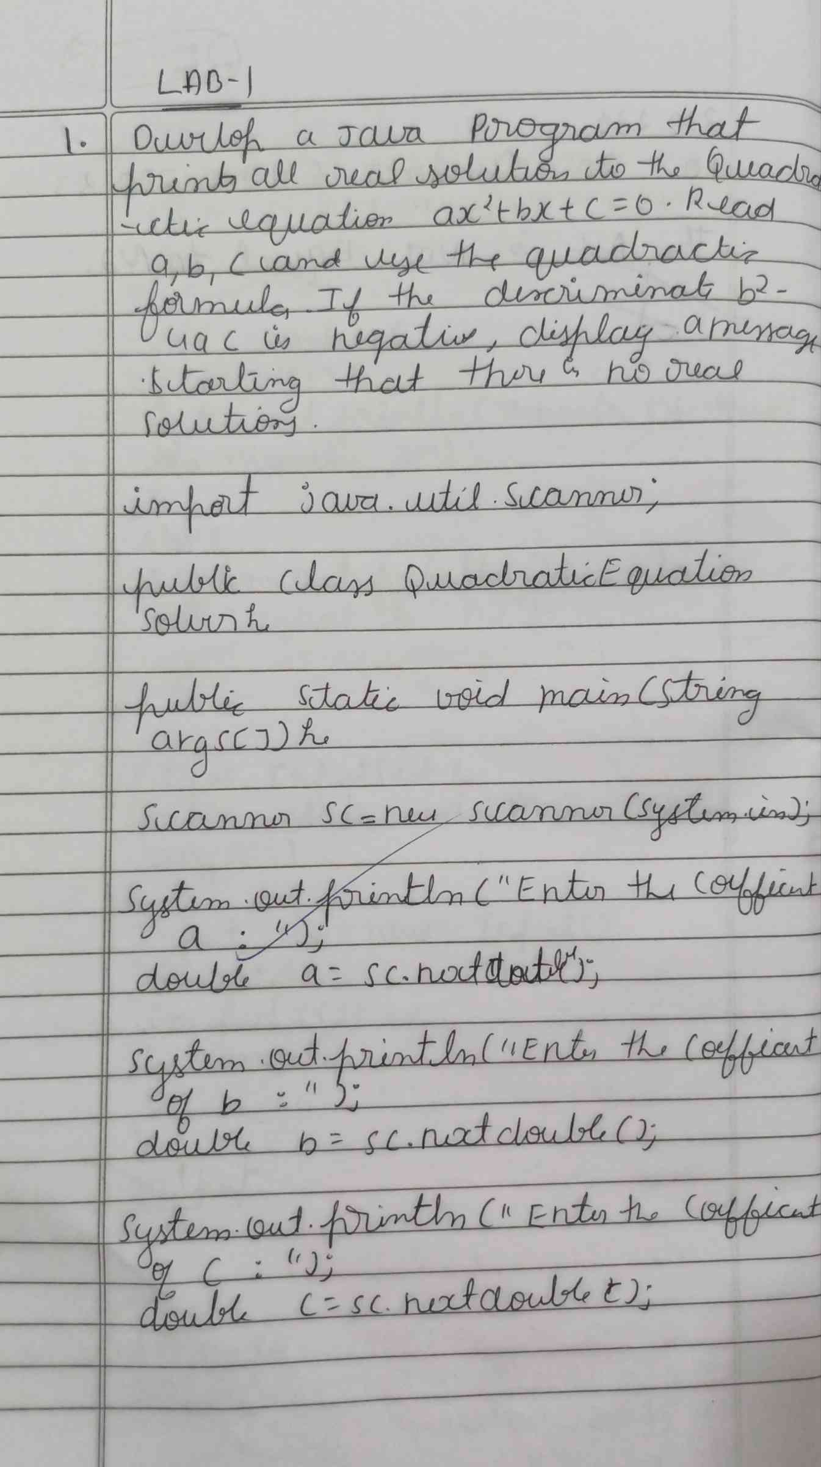

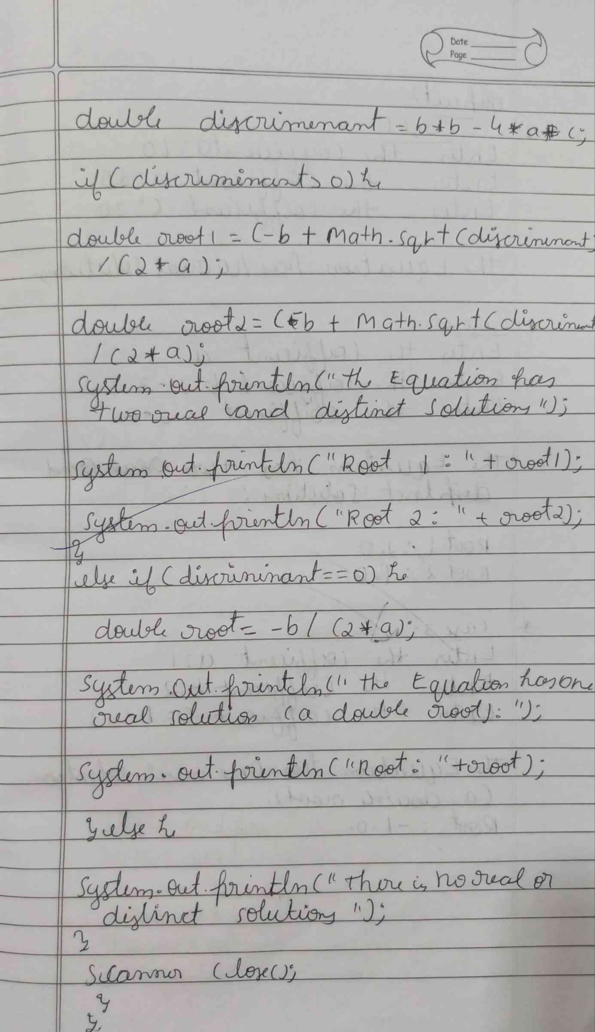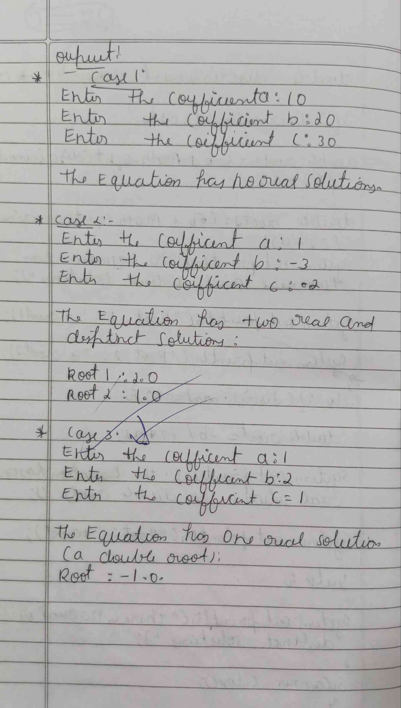

**CODE :**

**import java.util.Scanner;**

**public class QuadraticEquationSolver {**

**public static void main(String[] args) {**

**Scanner scanner = new Scanner(System.in);**

**System.out.print("Enter the coefficient a: ");**

**double a = scanner.nextDouble();**

**System.out.print("Enter the coefficient b: ");**

**double b = scanner.nextDouble();**

**System.out.print("Enter the coefficient c: ");**

**double c = scanner.nextDouble();**

**double discriminant = b * b - 4 * a * c;**

**if (discriminant > 0) {**

**double root1 = (-b + Math.sqrt(discriminant)) / (2 * a);**

**double root2 = (-b - Math.sqrt(discriminant)) / (2 * a);**

**System.out.println("The equation has two real and distinct solutions:");**

**System.out.println("Root 1: " + root1);**

**System.out.println("Root 2: " + root2);**

**} else if (discriminant == 0) {**

**double root = -b / (2 * a);**

**System.out.println("The equation has one real solution (a double root):");**

**System.out.println("Root: " + root);**

**} else {**

**System.out.println("The equation has no real solutions.");**

**}**

**scanner.close();**

**}**

**}**

**OUTPUT :**

